**Task Id – 146 – Inventory Page Errors**

**Issues Identified:**

1. At ‘Add Vendor Category’ pop up text box for ‘Vendor Category Name’ does not allow special characters.
2. Product Category - Add/Edit/Delete feature does not always work - Debug.
3. Justin Grove > Human Resources > All (Human Resources is mapped improperly and/or poorly) it is not to be under this category, but is supposed to be under Overhead> Human Resources> All – Fix.

**Probable fixes for above identified issues are:**

1. We should add ASCII code for special characters in the condition as well, in the below javascript function so that it allows special characters to be keyed in at JG.Master, InstallerMaster.Master and other required places.

For this Changes File to be updated is – SR_app.master

Code Changes:

function isAlphaKey(e) {

var k;

document.all ? k = e.keyCode : k = e.which;

/*Old Code*/ //return ((k > 64 && k < 91) || (k > 96 && k < 123) || k == 8 || k == 32 || (k == 46));

/*New Code*/ return ((k > 64 && k < 91) || (k > 96 && k < 123) || k == 8 || k == 32 || (k == 46) || ( k > 31 && k < 42) || (k == 44) || (k == 64));

}

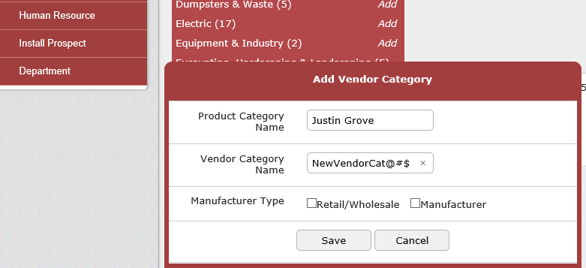

1. Product Category - Add/Edit/Delete feature looks to be working fine. Debugged the code and added a new subcategory then further edited that and deleted as well.

Please refer below screen shot for reference and the highlighted subcategory for addition and update on that:

Added a new sub category:

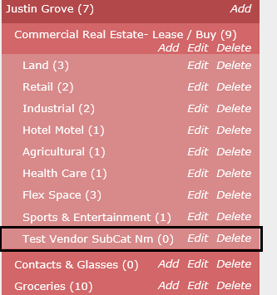

Edited that sub category:

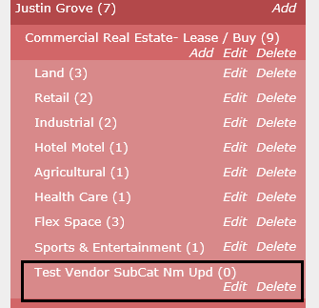

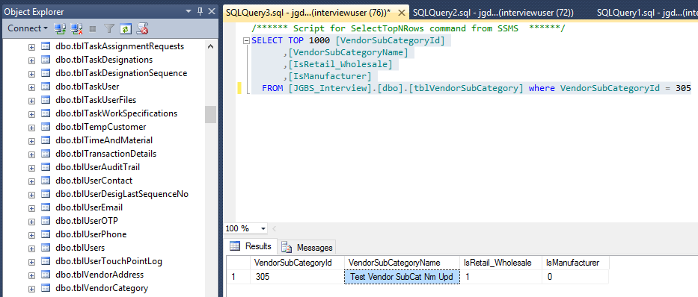

Deleted that sub category:

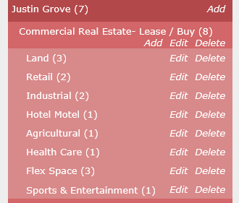

1. Improper relation of Product and its Vendor Category can be updated thru database changes. Vendor Category – ‘Human Resources Expenses’ should be removed from ‘Justin Grove’ Product Category and added to ‘Overhead’.

Justin Grove ProductCategoryId= 63 and Human Resources Expenses VendorCategpryId= 224

So this relation should be removed from [tblProductVendorCat] table

Script should have delete statement:

USE [JGBS_Interview]

GO

DELETE FROM [JGBS_Interview].[dbo].[tblProductVendorCat]

WHERE [VendorCategoryId] = 224

GO