需要linux环境

<https://blog.csdn.net/lu_embedded/article/details/109006380>

开始

<https://www.xncoding.com/2017/01/22/fullstack/readthedoc.html>

pip install sphinx sphinx-autobuild sphinx_rtd_theme

简单版？

<https://www.jianshu.com/p/d1d59d0cd58c>

这个就是教你怎么部署，没教怎么写

**windows一样弄**

DeepChromeHiC

官方文档，大概看看

<https://doclikecode.readthedocs.io/zh_CN/latest/1_sphinx/sphinx101.html>

e:

cd E:\iu\DeepChromeHiC\readthedoc

make html

书写语言教程

<https://iridescent.ink/HowToMakeDocs/Basic/intro.html>

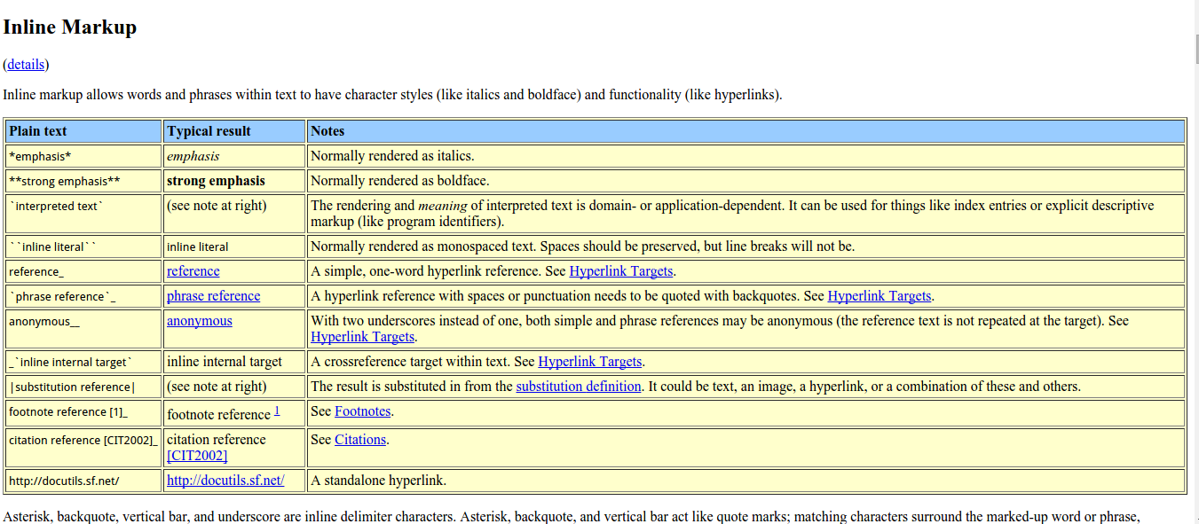

说明

<https://zh-sphinx-doc.readthedocs.io/en/latest/index.html>

文档

<https://www.osgeo.cn/sphinx/usage/restructuredtext/basics.html>

英文文档 很好

<https://docutils.sourceforge.io/docs/ref/rst/directives.html#attention>

<https://docutils.sourceforge.io/0.4/docs/ref/rst/directives.html>

<https://sublime-and-sphinx-guide.readthedocs.io/en/latest/packages.html>