**Webpage**

A **web page** or **webpage** is a document, commonly written in [HTML](https://www.computerhope.com/jargon/h/html.htm), that is viewed in an Internet [browser](https://www.computerhope.com/jargon/b/browser.htm). A web page can be accessed by entering a [URL](https://www.computerhope.com/jargon/u/url.htm) address into a browser's [address bar](https://www.computerhope.com/jargon/a/addrebar.htm). A web page may contain text, graphics, and [hyperlinks](https://www.computerhope.com/jargon/h/hyperlink.htm) to other web pages and files.

**WebSite**: A website is a collection of several web pages. These pages are linked together with hyperlinks. A website has a unique domain name, and we can access it by entering that domain name in the URL.

**A domain name** is a string of characters that identifies a website. It is what users type in their browser to visit your site.

**Web hosting** is a service that provides space on a server for your website files, allowing it to be available on the internet. When visitors access your domain name, the hosting provider will transfer those files to their web browsers.

**Two types of website**

| **Static website** | **Dynamic Website** |
| --- | --- |
| **A Static Website** (sometimes called a flat or stationary page) is displayed in a web browser exactly as it is stored. It contains web pages with fixed content coded in HTML and stored on a web server. It does not change, it stays the same, or "static" for every viewer of the site. | A dynamic website (also referred to as a database-driven site) contains information and content that changes, depending on factors such as the viewer of the site, the time of the day, the time zone, or the native language of the country the viewer). The content of your site (text/images) is stored on a database or content management system. When the information is updated or changed within the database, it changes on the site. |
| Using simple languages such as HTML, CSS, or JavaScript. | **A Dynamic Website** requires web programming and database design. (PHP, ASP.NET, Node.js etc.) |
|  |  |

**Search Engine:** A search engine is an internet service that helps users find any information available on the internet. Some examples of search engines are **Google, Yahoo, Bing, DuckDuckGo, Ask.com, AOL, Baidu, Talk to Books, etc..** It is usually accessed with the help of Web browser.

**Web Browser:** A web browser or simply browser is application software used to access the internet. Some examples of Web browsers are **Google Chrome, Microsoft Internet Explorer, Safari, Brave, Tor etc**. It does two things:

It connects to a web server on the internet and requests a page that the user wants to view; once it finds that page, it displays it on its device.

It can interpret the set of HTML tags within a page to display the page in the correct format.

**Webserver:** A web server can be understood as a computer that hosts or provide a website on the internet. It contains webserver software and component files of a website such as ***HTML document, images, CSS stylesheet, and JS files.***

**web development framework (WDF)**

A web development framework is a set of resources and tools for software developers to build and manage web applications, web services and websites.

**Difference between website and web application**

| Interactivity | The first point to start ‘web application vs. website’ differentiation with is interactivity. A website provides visual and text content that the user can see and read, but not affect in any way. In the case of a web application, the user can not only read the page content but also manipulate the data on this page. The interaction takes the form of a dialog: the user clicks a button or submits a form and gets a response from the page. This response may take a form of a document download, online chat, electronic payment and more. |
| --- | --- |
| Integration | Integration means bringing together different components to build a more comprehensive system. Both websites and web applications can be integrated with other software (CRM, ERP, etc.). Still, integration is more typical for web applications, because their complex functionality often requires interaction with extra systems.  Take integration of a business web application (say, an e-shop) with a CRM (Customer Relationship Management) system. A CRM stores all customer data in one place, providing easy access to them for the employees. The integration will allow automatic collection of web application user data and storing it in the CRM. This way, your team will get access to a full set of data about customers, their inquiries, communication, and feedback. This enables exploring customer behavior and buying habits, as well as settle their claims faster. Moreover, any change in customer data will be reflected in the CRM instantly. Always staying up to date with your customer preferences, you will reduce churn rates and increase sales.  A website also can be integrated with a CRM. This allows providing users with more personalized content. However, for a website, it’s rather a rarely implemented feature than a part of the core functionality. |
| Authentication | Authentication is the procedure that involves entering a user’s login and password to get access to the system. It is a must for the web software that requires any personal information. User accounts must be secured to prevent unauthorized access and leakage of sensitive data.  Web applications mostly require authentication, as they offer a much broader scope of options than websites. Consider an example of social networks. When you register, you create an account and get a unique identification number. The system warns you if your login and password are weak. If you leave them unchanged, hackers may reach your account and steal your information, as well as irritate other users with junk emails under your name.  Authentication is not obligatory for informational websites. The user may be offered to register to get access to additional options unavailable to unregistered website visitors. For example, you may look through news and featured articles on a news website without bothering to register. However, if you want to leave a comment you will have to log in. This way, users confirm their identity allowing the system to block spammers.  As you can see, both websites and web applications may require authentication. However, for web applications, it is obligatory due to security reasons. |

**What is Web Design?**

Web design consists of the design of a digital product (websites and apps). It may encompass several fields, such as User Interface (UI), User Experience (UX), and even Search Engine Optimization (SEO). Overall, web design must acknowledge the usability of a website or app, considering its layout (i.e., the structure), visual aesthetics (e.g., colors and fonts), and sometimes the content.

**Responsive Web Design**

Responsive web design makes your web page look good on all devices. Responsive web design uses only HTML and CSS. Responsive web design is not a program or a JavaScript.

Web pages should not leave out information to fit smaller devices, but rather adapt its content to fit any device:

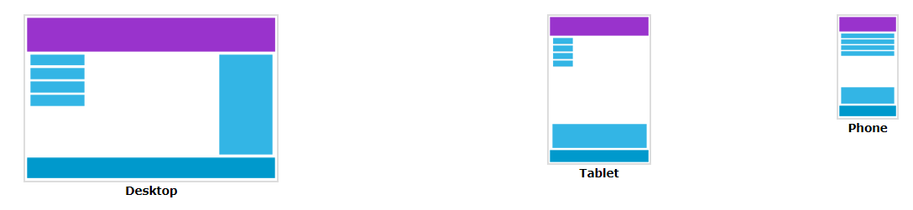

**Good Designer GuideLine**

1. **Concentration**
   1. **বন্ধুর দাওয়াত**
   2. **ফেসবুক নোটিফিকেশন**
2. **গবেষণা** 
   * 1. **company size**
     2. **company competitor work**
     3. **company color choice**
     4. **company target audience**
     5. **company target audience age**
     6. **company competitor website**
     7. **create mood board based on company and its competitor website**
     8. **sketch**
3. **Follow other designer work**
4. **Uptodate design tools and trend**
5. **about color code**

**What is Web Development?**

Web Development is the process of developing websites and applications for the internet or intranets (private networks). As a process, web development can include various specializations, such as working on the webserver, web engineering, network security configuration, and even web design. However, the everyday use of the term "web development" typically refers to coding or writing markups and does not often include design aspects.

**There are three types of developers: back-end, front-end, and full-stack.**

The [**back-end developer**](https://www.imaginarycloud.com/blog/backend-developer/) is responsible for the server-side and for everything that communicates between the database and the browser;

The **front-end developer** is the one working on the client-side of software development, thus focusing on how users see the product;

**Full-stack developers** are developers who have both back-end and front-end skills.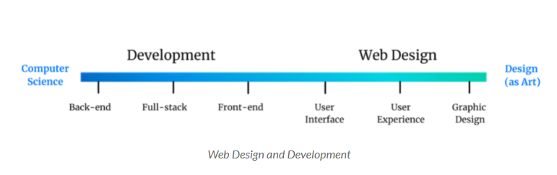

**Most Commonly Used Languages**

* HTML - **HyperText Markup Language**
* CSS - **Cascading Style Sheets**
* JavaScript
* SQL - **Structured Query Language**
* PHP **- Hypertext Preprocessor**
* Java
* Python
* .NET
* Angular

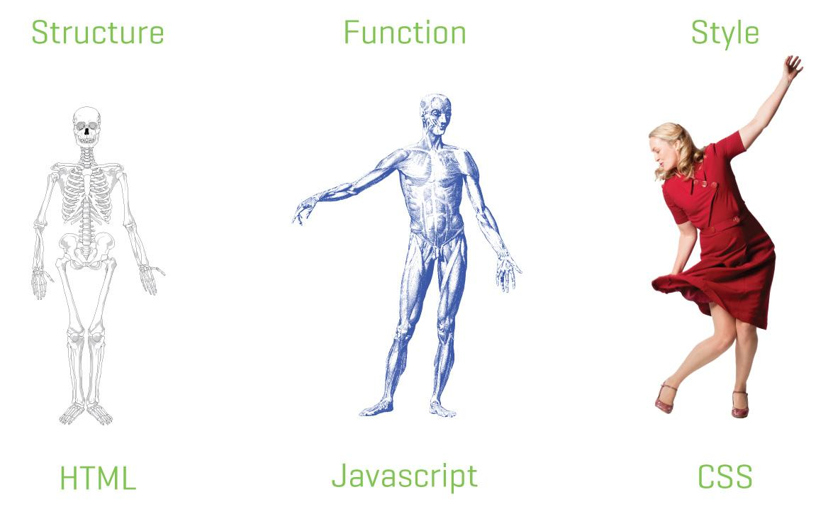

**EDITOR**

1. [Notepad ++](https://notepad-plus-plus.org/downloads/)
2. [Atom](https://atom.io/)
3. [Sublime Text 3](https://www.sublimetext.com/)
4. [Dreamweaver](https://www.adobe.com/products/dreamweaver.html)
5. VS code

The **<HTML>** is a markup language that is used by the browser to manipulate text, images, and other content to display it in the required format.

Html inventor : **Tim Berners-Lee** in 1993

Latest version : HTML 5.0 which was published in the year 2012

**Why Learn HTML?**

HTML is the foundation of all web pages. Without HTML, you wouldn’t be able to organize text or add images or videos to your web pages. HTML is the beginning of everything you need to know to create engaging web pages!

**Is HTML a programming language?**

HTML is called as a markup language that is different from a programming language. Its full form is Hypertext Markup Language.

**Hyper** **Text:** Hypertext simply means "Text within Text." A text has a link within it, is a hypertext. Whenever you click on a link which brings you to a new webpage, you have clicked on a hypertext. Hypertext is a way to link two or more web pages (HTML documents) with each other.

**Markup language:** A markup language is a computer language that is used to apply layout and formatting conventions to a text document. Markup language makes text more interactive and dynamic. It can turn text into images, tables, links, etc.

***In conclusion,*** HTML is not a programming language. A programming language uses logic to produce a result, it uses conditional statements, variables, functions, etc. Whereas HTML is a markup language, that create structures using tags for the data presentation. There is no logic or algorithm involved.

**Tags in HTML:** Tags are one of the most important part in an HTML Document. HTML uses some predefined tags which tells the browser about content display property, that is how to display a particular given content.

*For Example,* to create a paragraph, one must use the paragraph tags(<p> </p>) and to insert an image one must use the img tags(<img />).

There are generally two types of tags in HTML: 

1. **Paired/opening and closing Tags**: These tags come in pairs. That is they have both opening (< >) and closing(</ >) tags.
2. **Null/Empty/Singular Tags**: These tags do not require to be closed.

**List of some paired tags in HTML:** 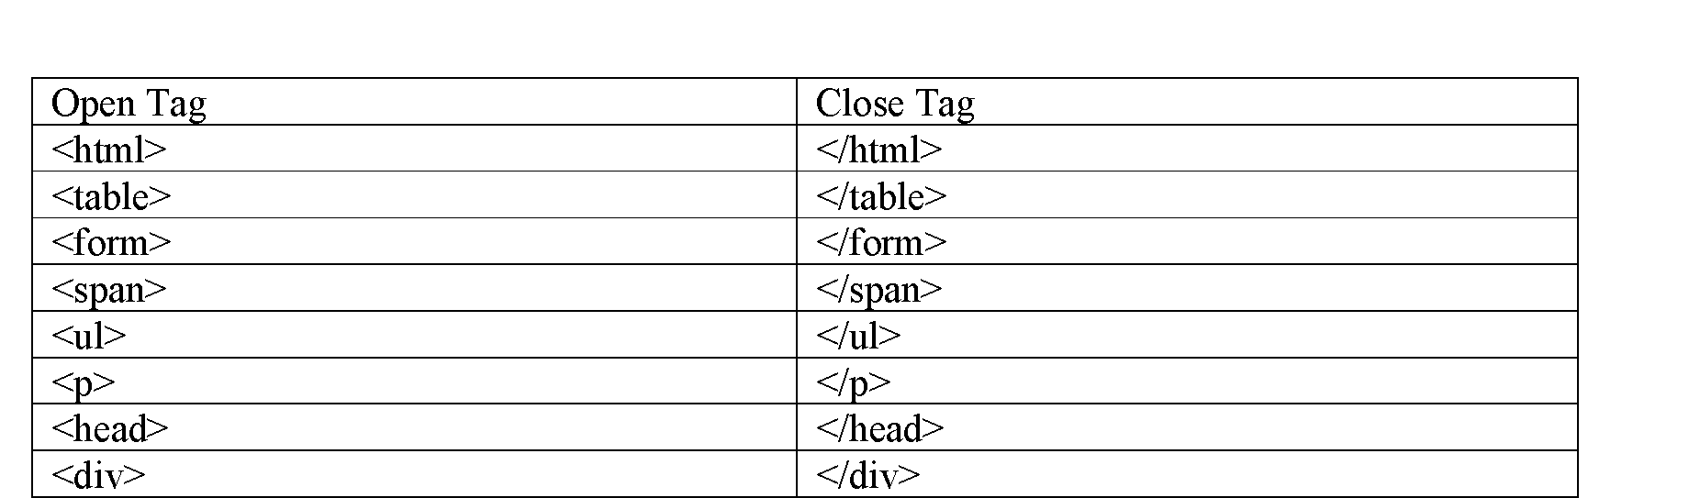

**Some Unpaired Tags are:**

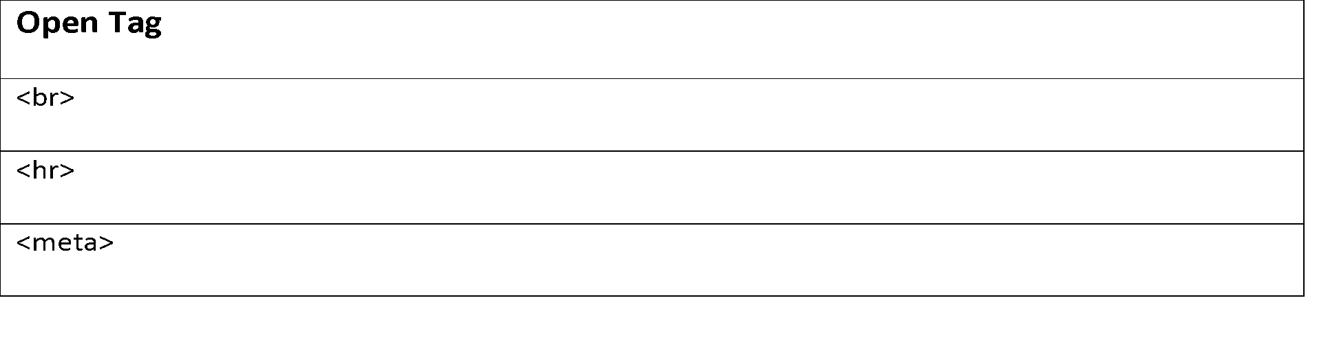

**HTML Structure**

<!DOCTYPE html>

<**html**>

    <**head**>

        <**title**>

        </**title**>

    </**head**>

    <**body**>

    </**body**>

</**html**>

**<!DOCTYPE html>:** Doctype stands for Document Type Declaration. It informs the web browser about the type and version of HTML used in building the web document. This helps the browser to handle and load it properly.

**<html>:** This is called HTML root element and used to wrap all the code.  
**<head>:** Head tag contains metadata, title, page CSS etc. All the HTML elements that can be used inside the <head> element are:

**<body>:** Body tag is used to enclose all the data which a web page has from texts to links. All the content that you see rendered in the browser is contained within this element.

**Printing Hello World**

Open your text editor, and type the below code in it and save it with the name “index.html”.

Note: HTML files are saved with the file extension .html

<!DOCTYPE html>

<**html**>

    <**head**>

        <**title**> </**title**>

    </**head**>

    <**body**>

        Hello World!

    </**body**>

</**html**>

**Output:** On opening the file in a web browser, you will see the below output.

**Background Color in HTML**

<!DOCTYPE html>

<**html**>

    <**head**>

        <**title**> </**title**>

    </**head**>

    <**body** style="background-color:powderblue;" >

        Hello World!

    </**body**>

</**html**>

**Some Color code in html**

[**https://www.w3schools.com/html/html_colors_hex.asp**](https://www.w3schools.com/html/html_colors_hex.asp)

**Heading Tags:** There are six levels of headings defined by HTML. These six heading elements are h1, h2, h3, h4, h5, and h6; with h1 being the highest level and h6 the least.

<!DOCTYPE html>

<**html**>

    <**head**>

        <**title**>

            First Web Page

        </**title**>

    </**head**>

    <**body**>

        <**h1**>Hello World!</**h1**>

        <**h2**>Hello World!</**h2**>

        <**h3**>Hello World!</**h3**>

        <**h4**>Hello World!</**h4**>

        <**h5**>Hello World!</**h5**>

        <**h6**>Hello World!</**h6**>

    </**body**>

</**html**>

| **HTML element** | **rank** | **example text** | **pixel height** |
| --- | --- | --- | --- |
| **<h1>** **</h1>** | 1 | h1 | 32 px |
| **<h2>** **</h2>** | 2 | h2 | 24 px |
| **<h3>** **</h3>** | 3 | h3 | 18.72 px |
| **<h4>** **</h4>** | 4 | h4 | 16 px |
| **<h5>** **</h5>** | 5 | h5 | 13.28 px |
| **<h6>** **</h6>** | 6 | h6 | 10.72 px |

**Syntax of HTML Comments :**

<!-- Write your comments here -->

**Define Some TAG**

<b>This text is bold</b> <br>

<em>This text is emphasize</em><br><!--emphasize -->

<u>This text with underline</u><br><!--underline -->

<small>This text with small font</small><br><!--small font -->

<big>This text is big font</big><br><!--big font -->

<strong>strong text</strong><br><!-- strong text -->

<mark>hilight text</mark><br><!-- hilight text -->

<b>H<sub>2</sub>O, A<sup>2</sup></b><br>

<hr width="100%" height="5" color="red">

<abbr title="Worl Wide Web">WWW</abbr><br><!--abbreviation-->

<p> use br tag for line break </p></br><!—paragraph-->

<pre> **preformatted text** which preserves the text spaces, line breaks, tabs, and other formatting characters </pre> <!--  preformatted text - ->

<q>represent with quation inside text</q> </br><!-- represent with quation ->

<del> draw a line throw a text</del> </br>

**Work with Table in html**

<table>  
  <tr>  
    <td>Month</td>  
    <td>Savings</td>  
  </tr>  
  <tr>  
    <td>January</td>  
    <td>$100</td>  
  </tr>  
</table>

**Table Height width and border**

<table align="center" width=500, height=500 border=2>

<tr>

<tr>Month</tr>

<tr>Savings</tr>

</tr>

<tr>

<td>January</td>

<td>$100</td>

</tr>

<tr>

<td>February</td>

<td>$80</td>

</tr>

</table>

**Table Content Align**

Put this code into head section

<style>

table, td, th {

border: 1px solid black;

}

table {

border-collapse: collapse;

width: 100%;

}

td {

text-align: center; <!- - horizontal align: center, left, right-->

}

td {

vertical-align: bottom; <!- - Vertical align: bottom, top, middle -->

}

</style>

**Table Heading and caption**

<table align="center" width=500, height=500 border=2>

<caption style="caption-side:bottom">My savings</caption>

<tr>

<th>Month</th>

<th>Savings</th>

</tr>

<tr>

<td>January</td>

<td>$100</td>

</tr>

<tr>

<td>February</td>

<td>$80</td>

</tr>

</table>

**Table background Using inline CSS**

<table style="background-color:pink;">

<tr style="background-color:gray;color:red;">

<th>Table Header</th><th>Table Header</th>

</tr>

<tr>

<td>Table cell 1</td><td>Table cell 2</td>

</tr>

<tr>

<td>Table cell 3</td><td>Table cell 4</td>

</tr>

</table>

**Table background Using internal CSS Classes**

<!-- Start Styles. Move the 'style' tags and everything between them to between the 'head' tags -->

<style type="text/css">

.myTable { background-color:#eee;border-collapse:collapse; }

.myTable th { background-color:#000;color:white;width:50%; }

.myTable td, .myTable th { padding:5px;border:1px solid #000; }

</style>

<!-- End Styles -->

<table class="myTable">

<tr>

<th>Table Header</th>

<th>Table Header</th>

</tr>

<tr>

<td>Table cell 1</td>

<td>Table cell 2</td>

</tr>

<tr>

<td>Table cell 3</td><td>Table cell 4</td>

</tr>

</table>

**HTML Table Colspan & Rowspan**

| <!DOCTYPE html>  <html>  <head>  <style>  table, th, td {  border: 1px solid black;  border-collapse: collapse;  }  </style>  </head>  <body>  <h2>Cell that spans two rows</h2>  <p>To make a cell span more than one row, use the rowspan attribute.</p>  <table style="width:100%">  <tr>  <th>Name</th>  <td>Jill</td>  </tr>  <tr>  <th rowspan="2">Phone</th>  <td>555-1234</td>  </tr>  <tr>  <td>555-8745</td>  </tr>  </table>  </body>  </html> |
| --- |
|  |
| <!DOCTYPE html>  <html>  <head>  <style>  table, th, td {  border: 1px solid black;  border-collapse: collapse;  }  </style>  </head>  <body>  <h2>Cell that spans two columns</h2>  <p>To make a cell span more than one column, use the colspan attribute.</p>  <table style="width:100%">  <tr>  <th colspan="2">Name</th>  <th>Age</th>  </tr>  <tr>  <td>Jill</td>  <td>Smith</td>  <td>43</td>  </tr>  <tr>  <td>Eve</td>  <td>Jackson</td>  <td>57</td>  </tr>  </table>  </body>  </html> |
|  |

**HTML Images Syntax**

The HTML <img> tag is used to embed an image in a web page.

The <img> tag has two required attributes:

* src - Specifies the path to the image
* alt - Specifies an alternate text for the image

**Syntax**

<img src="*url*" alt="*alternatetext*">

**Image tag with style**

<img src*="img_girl.jpg"* alt="Girl in a jacket"  style*="width:500px;height:600px;">*

**Images in Another Folder**

<img src="/images/html5.gif" alt="HTML5 Icon" style="width:128px;height:128px;">

**Image as a Link**

To use an image as a link, put the <img> tag inside the <a> tag:

<a href="default.asp">  
  <img src="smiley.gif" alt="HTML tutorial" style="width:42px;height:42px;">  
</a>

**HTML Lists**

HTML lists allow web developers to group a set of related items in lists.

**Unordered HTML List**

An unordered list starts with the <ul> tag. Each list item starts with the <li> tag.

<ul>  
  <li>Coffee</li>  
  <li>Tea</li>  
  <li>Milk</li>  
</ul>

////////////

<ul style="list-style-type:disc;"><!—disc, circle, square, none -->  
  <li>Coffee</li>  
  <li>Tea</li>  
  <li>Milk</li>  
</ul>

**Nested HTML Lists**

<ul>  
  <li>Coffee</li>  
  <li>Tea  
    <ul>  
      <li>Black tea</li>  
      <li>Green tea</li>  
    </ul>  
  </li>  
  <li>Milk</li>  
</ul>

**Ordered HTML List**

An ordered list starts with the <ol> tag. Each list item starts with the <li> tag.

<ol>  
  <li>Coffee</li>  
  <li>Tea</li>  
  <li>Milk</li>  
</ol>

/////////////////////

<ol type="1"> <!-- type=a,A,i,I,1 - ->  
  <li>Coffee</li>  
  <li>Tea</li>  
  <li>Milk</li>  
</ol>

//////////control start

<ol type="1" start=3> <!-- type=a,A,i,I,1 - ->  
  <li>Coffee</li>  
  <li>Tea</li>  
  <li>Milk</li>  
</ol>

**HTML Description Lists**

A description list is a list of terms, with a description of each term.

<dl>  
  <dt>Coffee</dt>  
  <dd>- black hot drink</dd>  
  <dt>Milk</dt>  
  <dd>- white cold drink</dd>  
</dl>

* Use the HTML <dl> element to define a description list
* Use the HTML <dt> element to define the description term
* Use the HTML <dd> element to describe the term in a description list

**HTML Links - Hyperlinks**

HTML links are hyperlinks.

You can click on a link and jump to another document.

When you move the mouse over a link, the mouse arrow will turn into a little hand.

HTML Links – Syntax

<a href="*url*">*link text*</a>

////////////////////////////

<h2>Absolute URLs</h2>  
<p><a href="https://www.w3.org/">W3C</a></p>  
<p><a href="https://www.google.com/">Google</a></p>  
  
<h2>Relative URLs</h2>  
<p><a href="html_images.asp">HTML Images</a></p>  
<p><a href="test.html">CSS Tutorial</a></p> <!—file in same folder -->

<p><a href="./ttt/student_form.html">CSS Tutorial</a></p> <!—file in different folder -->

//////////////////////// put in head section for different style of link

<style>

a:link {

color: green;

background-color: transparent;

text-decoration: none;

}

a:visited {

color: pink;

background-color: transparent;

text-decoration: none;

}

a:hover {

color: red;

background-color: transparent;

text-decoration: underline;

}

a:active {

color: yellow;

background-color: transparent;

text-decoration: underline;

}

</style>

//////////////////////////////

**The Marquee Tag**

The <marquee> tag is a container tag of HTML is implemented for creating scrollable text or images within a web page from either left to right or vice versa, or top to bottom or vice versa. But this tag has been **deprecated in the new version of HTML, i.e., HTML 5**.

<marquee behavior="scroll" direction="up" scrollamount="1">Slow Scrolling</marquee>

<marquee behavior="Alternate" direction="right" scrollamount="12">Alternate</marquee>

<marquee behavior="scroll" direction="left" scrollamount="20">Fast Scrolling</marquee>

<marquee behavior="scroll" direction="right" scrollamount="50">Very Fast scrolling</marquee>