
Yenepoya (Deemed To Be University)

PROJECT – HIGH LEVEL DESIGN
ON

PREDICTIVE MODELLING FOR SUPPLY CHAIN SUCCESS

Student Name: Najah Sulthana
23BCDSBA25

Industry Mentor:  Mr.Ujjwal Kumar | Guided by:  Ms.Raksha Adyanthaya

Table of Contents
1. Introduction 3
1.1. Scope of the document 3
1.2. Intended Audience 3
1.3. System Overview 3
1.4. Business Use Cases 3
2. System Design 4
2.1. Application Design 4
2.2. Process Flow 4
2.3. Information Flow 4
2.4. Components Design 4
2.5. Feature Importance Analysis 5
2.6. Key Design Considerations 5
2.7. API Catalogue 6
3. Data Design 6
3.1. Data Model 6
3.2. Data Access Mechanism 6
3.3. Data Retention Policies 6
3.4. Data Migration 7
4. Interfaces 7
5. State and Session Management 7
6. Caching 7
7. Non-Functional Requirement 7
7.1. Security Aspects 7
7.2. Performance Aspects 8
8. Limitations 8
9. References 8

- Introduction
  - Scope of the document
This High-Level Design document describes the overall architecture and major components of the Supply Chain Sales Prediction System. It explains the system functionality, how the major components interact, and the key design decisions involved.
The document focuses on a high-level perspective of the system and does not include implementation-level details.

  - Intended Audience
- Academic evaluators and project guides
- Final-year students learning machine learning workflows
- Developers interested in predictive analytics.

  - System Overview
The system is developed using the DataCo Supply Chain Dataset, containing 180,519 records and 53 attributes.

The objective is to build a predictive model for estimating sales using historical supply chain data, while also identifying key factors affecting sales and analysing issues such as delivery delays. The model provides insights to support decision-making in demand forecasting, inventory management, and logistics optimization. It also highlights trends such as high late delivery rates (~55%) and variations in profit across product categories.

To avoid over-reliance on dominant features like product price, additional experiments were conducted to ensure the model captures broader patterns.

The current implementation is a Jupyter Notebook-based prototype, which can be extended into a web-based application or API in future versions.

  - Business Use Cases
The developed system can be applied in real-world supply chain scenarios such as:
- Demand Forecasting: Predict future sales to optimize inventory levels
- Inventory Management: Reduce overstocking and stockouts
- Logistics Optimization: Identify delays and improve delivery efficiency
- Profit Optimization: Understand which products and regions generate higher revenue

These applications demonstrate the practical value of the predictive model beyond academic use.

- System Design
  - Application Design
The application is designed as a modular machine learning pipeline following the CRISP-DM methodology (Business Understanding → Data Understanding → Data Preparation → Modelling → Evaluation).
Each stage of the pipeline is logically separated to improve clarity, maintainability, and scalability. The current implementation is notebook-based for ease of experimentation and can be extended into Python modules or a web-based dashboard in future.

  - Process Flow
The system operates through the following high-level steps:
- Load the dataset from the CSV source
- Perform data cleaning and preprocessing (removal of irrelevant columns and handling missing values)
- Apply feature engineering techniques such as deriving temporal features and delivery-related attributes
- Train and compare multiple machine learning models (Linear Regression, Random Forest, XGBoost)
- Evaluate model performance using standard evaluation metrics
- Generate predictions along with business insights such as late delivery analysis and feature importance.

  - Information Flow
- Raw Data (CSV) is loaded into memory and validated for completeness.
- Cleaned Data: missing values are forward-filled, duplicates removed, and Sales outliers filtered using the IQR method.
- Feature-Engineered Data: new attributes such as Delivery_Delay, Total_Price, Shipping_Duration, Order_Month, and Order_Weekday are derived.
- Model Training: features are scaled and fed into Linear Regression, Random Forest, and XGBoost models.
- Predictions: the best-tuned XGBoost model generates sales forecasts on the test set.
- Evaluation Results and Visualizations: R², MAE, feature importance charts, and actual vs predicted plots are produced.

  - Component Design
The system is designed using a layered architecture to ensure clear separation of concerns and modularity.

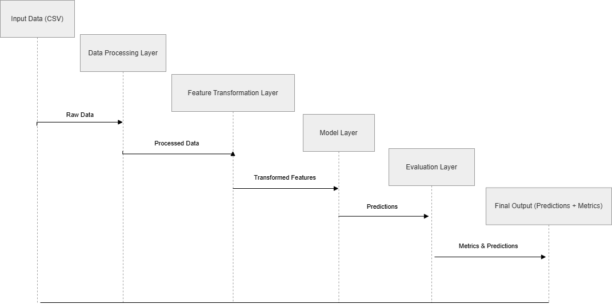
Figure 2.1: System Component Architecture
The major components include:
- Data Processing Layer: Responsible for cleaning and preparing raw input data
- Feature Transformation Layer: Creates meaningful features such as delivery delay and temporal attributes
- Model Layer: Trains machine learning models and generates predictions
- Evaluation Layer: Evaluates model performance and produces final outputs.
This layered architecture improves system clarity, maintainability, and scalability.

  - Feature Importance Analysis
Feature importance analysis was performed using the XGBoost model to identify the most influential variables affecting sales prediction.

The top contributing features include:
- Product Price → Directly impacts total sales value
- Order Quantity → Higher quantity leads to higher sales
- Delivery Delay → Indicates operational inefficiencies
- Order Month → Captures seasonal demand patterns.
This analysis helps in understanding both model behaviour and key business drivers.

  - Key Design Considerations
- Reproducibility: Fixed random seeds are used to ensure consistent results across runs
- Scalability: The modular pipeline allows extension to larger datasets using tools such as Dask or Spark
- Business Relevance: Features are selected based on supply chain domain understanding, including delivery delay and order timing
- Model Selection: XGBoost was selected after comparative evaluation due to its ability to efficiently handle complex and non-linear relationships while maintaining strong performance.
- Feature Influence Awareness: Special consideration is given to highly influential features such as product price to ensure the model does not rely solely on direct relationships.

  - API Catalogue
The current prototype does not include API integration. However, in a production environment, the following REST API endpoints can be implemented:
- POST /predict_sales → Accepts order features and returns predicted sales
- GET /insights/late_delivery → Provides statistics on late deliveries.
- GET /model/performance → Returns current model evaluation metrics including R² score and MAE.

- Data design
  - Data Model
The system uses a denormalized data model stored in a single CSV file (DataCoSupplyChainDataset.csv), where each row represents a supply chain transaction.

Key entities include Orders, Customers, Products, and Shipments. Important attributes such as shipping details, product information, customer segment, and financial fields are retained. The target variable is Sales.

Additional features such as Delivery_Delay, Order_Month, and other derived attributes are included to enhance model performance.

  - Data Access Mechanism
Data is accessed from a local CSV file using the Pandas library (pd.read_csv()). Intermediate cleaned and transformed datasets are stored separately to support reproducibility and debugging.

  - Data Retention Policies
- Raw dataset is retained for future reference and model retraining
- Processed datasets and trained models are versioned with timestamps
- Older versions may be archived after a defined retention period.

  - Data Migration
Data migration is not required for the current implementation. However, future versions may migrate the dataset to a relational database (e.g., PostgreSQL) with structured tables and indexing for improved performance.

- Interfaces

- Current Interface: Jupyter Notebook with visualizations and outputs
- Future Interface: Web dashboard (e.g., Streamlit) for interactive predictions and insights
No external system integrations are currently implemented.

- State and Session Management
The system is currently stateless, where each execution is independent. Trained models are saved using serialization techniques (e.g., joblib) for reuse.
The trained XGBoost pipeline is serialized using joblib.dump() and can be reloaded at any time using joblib.load() without retraining. This ensures that predictions can be generated on new data independently of the training environment.
Future implementations may include session management for user-based interactions.

- Caching
During execution, Pandas DataFrames are held in memory between pipeline stages, acting as an in-process cache. For example, the cleaned DataFrame and the feature-engineered DataFrame are stored as separate variables (df) to avoid redundant recomputation. In future implementations, caching mechanisms such as Redis or joblib's Memory module can be used for persistent caching across sessions.

- Non-Functional Requirements
  - Security Aspects
- Sensitive fields such as customer email and password are removed from the dataset.
- Only relevant business data is used for modelling.
- Future implementations may include authentication and access control mechanisms.

  - Performance Aspects
- Model achieved an R² score of approximately 0.82, indicating strong predictive performance
- Mean Absolute Error (MAE) was used to measure average prediction error in real-world units
- Cross-validation was performed to ensure model consistency across different data splits
- Training and testing scores were compared to ensure that the model does not suffer from overfitting
- Prediction time is sub-second for individual records
- The system can scale to larger datasets using distributed frameworks.

- Limitations
- Model performance depends on data quality; missing or inconsistent entries in shipping dates or product prices can directly reduce accuracy.
- High-cardinality categorical features such as Product Name and Customer City are not fully optimized — one-hot encoding was not applied to these columns due to dimensionality concerns, and target/frequency encoding is reserved for future work.
- The system does not support real-time prediction as it operates on a static CSV dataset.
- Performance may degrade for unseen or rare data patterns, particularly low-frequency product categories with insufficient training samples.

- References

- Scikit-learn Developers. Scikit-learn: Machine Learning in Python. Available at: https://scikit-learn.org.
- DataCo Global Supply Chain Dataset. Supply Chain Dataset for Predictive Analytics. Available via Kaggle.
- IBM Innovation Center for Education. Big Data Analytics Project Guidelines. Yenepoya (Deemed to Be University), 2024.
- Chen, T., & Guestrin, C. XGBoost Documentation. https://xgboost.readthedocs.io.

