
Yenepoya (Deemed To Be University)

PROJECT – LOW LEVEL DESIGN
ON
PREDICTIVE MODELLING FOR SUPPLY CHAIN SUCCESS

Student Name: Najah Sulthana
23BCDSBA25

Industry Mentor:  Mr.Ujjwal Kumar | Guided by:  Ms.Raksha Adyanthaya

Table of Contents
1. Introduction 3
1.1. Purpose and Scope 3
1.2. Project Overview 3
1.3. Intended Audience 3
1.4. Constraints 3
1.5. Glossary 3
2. System Design 4
2.1. Pipeline Overview 4
2.2. Process Flow 4
2.3. Information Flow 5
3. Components Design 5
3.1. Data Preprocessing Component 5
3.2. Feature Engineering Component 6
3.3. Model Component 6
3.4. Evaluation Component 6
3.5. Error Analysis 7
3.6. Design Considerations 7
4. Data Design 7
5. Testing Strategy 7
6. Non-Functional Requirements 8
7. Future Enhancements 8
8. References 9

- Introduction
  - Purpose and Scope
This document presents the Low-Level Design (LLD) of the Supply Chain Sales Prediction System. It explains in detail how the system processes raw supply chain data and builds a machine learning model to predict sales values. The focus of this document is on the internal workflow of the system, including preprocessing, feature engineering, model training, and evaluation.

  - Project Overview
The system is developed using a structured dataset that contains information related to product pricing, order details, and shipping operations. The main objective is to identify patterns in historical data and use them to predict future sales. The system follows a step-by-step pipeline approach to ensure clarity, consistency, and reproducibility.

  - Intended Audience
• Academic evaluators and project guides
• Final-year students learning machine learning workflows
• Developers interested in predictive analytics.

  - Constraints
• The system operates on a static dataset and does not support real-time processing.
• All computations are performed locally within a Jupyter Notebook environment.
• System performance depends on available CPU and memory resources.
• Model accuracy depends on data quality and feature relevance.
• The system does not include deployment or integration with external applications.

  - Glossary
Term | Definition
Data Preprocessing | Process of cleaning and preparing raw data before analysis
Feature Engineering | Creation or transformation of features to improve model performance
Cross Validation | Technique used to evaluate model performance across multiple data splits
K-Fold Cross Validation | Method where data is split into k parts and evaluated multiple times
Randomized search CV (randomCV) | Technique to optimize model parameters using random combinations
Pipeline | Sequential workflow from preprocessing to prediction
Outliers | Extreme values that differ significantly from other data points
R2 score | Metric that measures how well predictions match actual values
MAE (mean absolute error) | Metric that calculates average prediction error.

- System Design
  - Pipeline Overview
The system follows a structured pipeline where each stage processes the data before passing it to the next stage.

Stage | Description
Data Ingestion | Load dataset using pandas
Data Cleaning | Handle missing values and inconsistencies
Feature Engineering | Create new meaningful features
Model Training | Train and tune machine learning models
Evaluation | Compare model performance

  - Process flow
The system follows a structured sequence of operations:
- Data loading: The dataset is loaded from a csv file into pandas dataframe.
- Data cleaning and preprocessing: Missing values, duplicates, and inconsistencies are handled.
- Outlier handling: Extreme values are identified and treated to improve model stability.
- Feature engineering: New features such as delivery delay and time-based attributes are created. This helps model capture hidden patterns in the data.
- Train-test-split: The dataset is divided into training and testing sets.

- Model training & validation: Multiple models are trained and validated using cross-validation.
- Model evaluation: Models are compared using performance metrics.
- Final prediction: The best-performing model is used to generate predictions.

  - Information flow
Raw Data → Cleaned Data → Feature Engineered Data → Scaled Features → Model Input → Predictions → Evaluation Results and Visualizations.
The data moves through the system in clear layers as shown below:

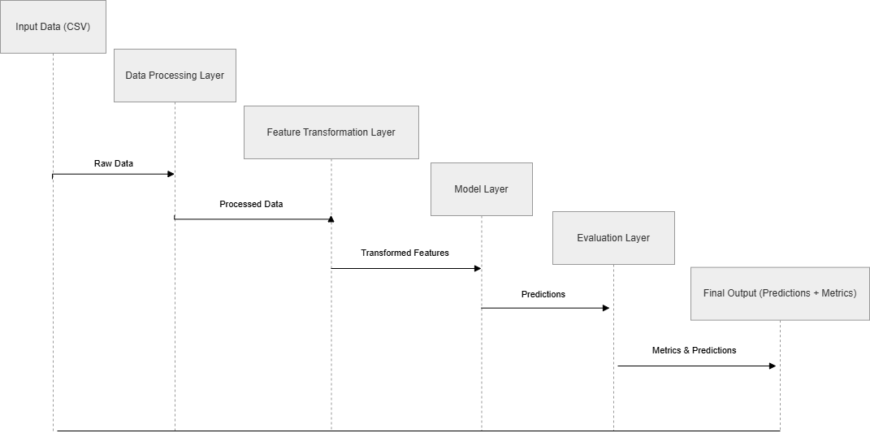
Figure 2.1: Information Flow through System Layers

This diagram shows how raw input data flows from the CSV file through the Data Processing Layer, Feature Transformation Layer, Model Layer, and finally to the Evaluation Layer, producing predictions and metrics.

- Components Design
  - Data preprocessing component
This component prepares the dataset by handling missing values, removing duplicates, and ensuring overall data quality. Proper preprocessing helps in improving model accuracy.
- Removal of irrelevant columns (Customer Email, Customer Password, Product Description, Order Zipcode).
- Handled minor missing values in Customer Lname (8 missing) and Customer Zipcode (3 missing).
- Identified outliers in the Sales column using a boxplot, which showed a long right tail with some very high-value orders.
- Outlier removal used a 3×IQR threshold (Q1 − 3×IQR to Q3 + 3×IQR) rather than the standard 1.5×IQR, as the Sales distribution had a long right tail with legitimate high-value bulk orders that would have been incorrectly removed at the tighter threshold.

  - Feature engineering component
Feature engineering enhances the dataset by creating meaningful features.

Feature type | Example
Derived feature | Delivery delay
Time-based feature | Order month, weekday
Numerical feature | Price, quantity

This step is important because raw data alone may not represent meaningful patterns. These new features were created because shipping performance and time-based patterns strongly influence sales values in the supply chain data.
The most influential features include product price, order quantity, delivery delay, and temporal attributes such as order month.

  - Model component
This component is responsible for training machine learning models. Using multiple models allows comparison between simple and complex approaches.

Model type | Purpose
Linear regression | Baseline model
Random forest | Captures non-linear patterns
XGBoost | Improves performance using boosting

All models were trained inside a Scikit-learn Pipeline with StandardScaler. Hyperparameters for XGBoost were tuned using RandomizedSearchCV (5 iterations, 3-fold cross validation). XGBoost was finally selected because it gave the highest accuracy and handled outliers well.

  - Evaluation component
Model performance is evaluated using standard metrics.
- R2 score measures how well the model explains variance in sales
- MAE measures average prediction error in real-world units
- Cross validation ensures model consistency across different data splits.
The model achieved an R² score of approximately 0.82, indicating strong predictive capability.
Comparison between training and testing scores shows that the model generalizes well and does not exhibit significant overfitting.
Among the models tested, XGBoost demonstrated the best performance due to its boosting mechanism, ability to capture non-linear relationships, and robustness to outliers.

  - Error analysis
Error analysis was conducted to evaluate model performance in different scenarios.
- Higher prediction errors were observed for extremely high-value orders (outliers)
- Lower accuracy was noted for rare product categories due to limited training data
These observations indicate areas for improvement, particularly in handling outliers and rare cases.

  - Design considerations
- Prevention of data leakage using Scikit-learn Pipeline
- Ensuring model generalization
- Reproducibility through fixed random_state=42
- Selecting relevant features.

- Data design

The system uses structured tabular data where each row represents an order and each column represents a feature.
- Input features - product, order, and shipping details
- Target variable - sales value
- Encoding Strategy - One-hot encoding for low-cardinality; frequency/target encoding planned for high-cardinality columns (City, Product Name).
Proper separation between input features and target variable is maintained to avoid data leakage.

- Testing strategy

Testing is performed to ensure that the system works correctly.
- Unit Testing: Individual functions (preprocessing, feature engineering) tested with sample data.
- Integration Testing: Full pipeline tested end-to-end.
- Model Validation: 5-fold KFold cross-validation to ensure stability.
- Performance Testing: Compared baseline models against XGBoost.

- Non-functional requirements

The system is designed to ensure reliable performance, ease of use, and maintainability while working with structured supply chain data. These requirements focus on how well the system operates rather than what it does.
- Performance: The system is capable of processing moderate-sized datasets efficiently within a reasonable time using standard computing resources.
- Scalability: The design allows the system to be extended to handle larger datasets or additional machine learning models with minimal structural changes.
- Reliability: The system produces consistent and stable results, supported by validation techniques such as cross-validation.
- Usability: The workflow is simple and easy to understand, making it suitable for users with basic knowledge of data science and machine learning.
- Maintainability: The modular structure of the system makes it easier to update, debug, and improve individual components without affecting the entire pipeline.

- Future enhancements

- Model improvements
- Explore advanced models such as deep learning
- Apply deeper hyperparameter tuning techniques
- Experiment with additional ensemble models.

- Feature engineering enhancements
- Incorporate domain-specific features
- Use external datasets such as seasonal trends
- Apply automated feature selection.

- Scalability and performance
- Optimize for large datasets
- Improve processing efficiency
- Introduce parallel execution.

- Real-time capabilities
- Enable real-time prediction support
- Integrate streaming data pipelines.

- System deployment
- Deploy using Flask or Streamlit
- Build a user interface for predictions
- Enable integration with external systems.

- Reference

- Scikit-learn Developers. Scikit-learn: Machine Learning in Python. Available at: https://scikit-learn.org.
- DataCo Global Supply Chain Dataset. Supply Chain Dataset for Predictive Analytics. Available via Kaggle.
- IBM Innovation Center for Education. Big Data Analytics Project Guidelines. Yenepoya (Deemed to Be University), 2024.

