Syracuse University School of Information Studies
M.S. Applied Data Science
Portfolio Milestone

Najah Bell
[SUID: 283406406]

GITHUB

Table of Contents
1. Executive Summary 3
2. Education 3
3. Skills 4
4. IST 718: Big Data Analytics 5
a. Project Description
b. Reflection & Learning Goals
5. IST 722: Data Warehousing 8
a. Project Description
b. Reflection & Learning Goals
6. IST 652: Scripting for Data Analysis 11
a. Project Description
b. Reflection & Learning Goals
7. IST 707: Data Analytics 14
a. Project Description
b. Reflection & Learning Goals
8. IST 664: Natural Language Processing 16
a. Project Description
b. Reflection & Learning Goals
9. Conclusion 19

1. Executive Summary
I am Najah Bell, an aspiring Data Scientist graduating from Syracuse University’s M.S. in Applied Data Science program, passionate about using data to uncover actionable insight and support evidence-based decision-making across business, financial, and operational contexts. My coursework spans predictive modeling, data warehousing, natural language processing, and applied machine learning, and I am seeking a role where I can apply these skills to solve real-world problems with measurable impact.
Among my key projects, I built a Random Forest classifier that predicted flight arrival delays with nearly 80% accuracy using real-world Bureau of Transportation Statistics records and developed a 5-fold cross-validated email spam classifier that combined lexical, syntactic, and stylometric features to improve robustness over a single-feature baseline. I also designed a Snowflake-based dimensional data warehouse and BI dashboard that translated cross-company customer satisfaction data into actionable investment recommendations for executive stakeholders.

2. Education
M.S., Applied Data Science: Syracuse University, School of Information Studies, June 2026.
B.S., Mathematics: Langston University, School of Arts and Science, December 2020.

3. Skills

Languages: Python, R, SQL
Machine Learning: scikit-learn, Random Forest, Logistic Regression, Linear Regression, K-Means Clustering, Davies-Bouldin evaluation, classification and clustering model design.
Natural Language Processing: NLTK, VADER sentiment analysis, text classification, feature engineering (unigrams, bigrams, POS tagging, stylometric features), 5-fold cross-validation.
Time Series Forecasting: ARIMA, LSTM, ETS (Exponential Smoothing), live data ingestion via APIs.
Data Engineering & Warehousing: Snowflake, dimensional modeling, SQL-based database administration, BI dashboard design.
Data Collection & Wrangling: Web scraping, API data ingestion, data cleaning and integrity validation, Pandas-based preprocessing.
Other Relevant Skills: statistical modeling, experimental design, data ethics and bias mitigation, technical and executive-level communication.

4. IST 718: Big Data Analytics

a. Project Description
Predictive modeling and exploratory data analysis techniques were applied to LLM-generated Apple historical sales data spanning January 2020 through November 2024. The project investigated three key business questions: whether specific months yield stronger product launch performance, which store locations demonstrate the strongest sales, and whether future sales can be forecasted at the store or country level.
The exploratory data analysis phase employed bar plots and aggregate analyses to identify seasonal patterns across all twelve months and across a portfolio of products including accessories, laptops, smartphones, tablets, smart speakers, desktops, subscription services, audio products, wearables, and streaming devices (Fig. 1). Key findings revealed that January, March, and July/August/October performed as the highest-revenue months, while November and December, typically expected to peak due to Black Friday and the holiday season, ranked lowest. This result was attributable to the synthetic nature of the data and surfaced important questions about data provenance.
At the store level, heatmaps of monthly sales quantity for the top 10 and bottom 10 performing stores revealed that Apple Central World consistently generated the highest revenue throughout the year. Counterintuitively, despite the United States ranking as the highest-performing country overall by a wide margin, only one US location appeared among the top ten performing stores, while four of the ten lowest-performing stores were in the United States (Fig. 2-3). This contradiction between aggregate national performance and individual store performance represents a significant analytical insight for resource allocation strategy.
The predictive modeling component addressed next-month sales forecasting using two models: a Random Forest Regressor and a Linear Regression model. Features included lagged sales values and cyclical month encoding. Performance was evaluated using Root Mean Square Error (RMSE). Linear Regression achieved an RMSE of 717 units (14.1% error rate), outperforming the Random Forest which produced an RMSE of 841 units (16.5%) (Fig. 4). This finding demonstrated a core data science principle: on smooth, synthetic datasets, simpler linear models can outperform ensemble methods that overfit to noise.
Fig. 1: Total Sales by Month – All Years Combined
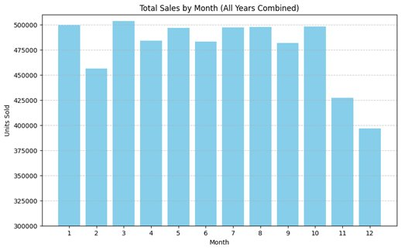
Fig. 2-3: Heatmap of Top 10 and Worst 10 Performing Stores by Month
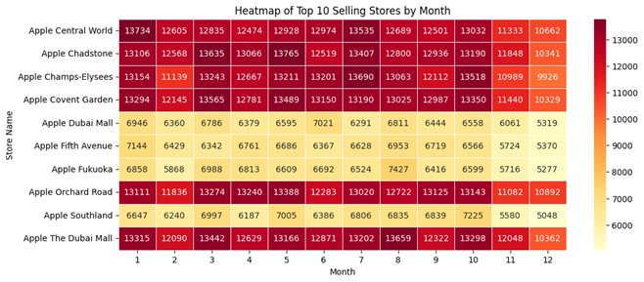
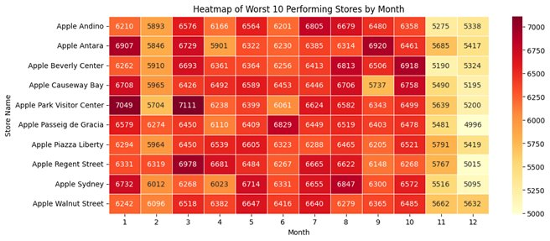
Fig. 4: Actual vs. Predicted Monthly Sales and Residuals vs. Predicted Sales – Linear Regression
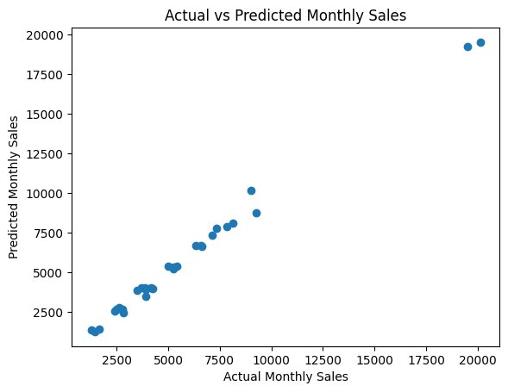

b. Reflection & Learning Goals
The exercise of applying predictive modeling to a business analytics problem revealed the importance of interrogating the derivation and quality of data before drawing conclusions. The LLM-generated dataset used in this project exhibited unrealistically uniform patterns, with holiday months underperforming contrary to real-world expectations. Recognizing and transparently communicating this limitation, rather than presenting the findings as applicable to real Apple operations, reflects the obligation of a data scientist to contextualize results within the conditions under which they were produced.
The counterintuitive result that Linear Regression outperformed Random Forest reinforced the importance of testing multiple approaches rather than defaulting to the most complex model available. In practice, model selection must account for the character of the data itself. This project contributed to the successful application of program learning outcomes through the collection and organization of sales data, the identification of patterns via visualization and time series analysis, the development of alternative modeling strategies, and the communication of findings to a business audience in presentation format.

5. IST 722: Data Warehousing

a. Project Description
Dimensional modeling and data integration concepts were applied in the design and implementation of a unified data warehouse consolidating customer rating data from two merging companies, FudgeMart, a retail operation, and FudgeFlix, a streaming service. The final solution was deployed in Snowflake with a business intelligence reporting layer.
The business context required bridging two structurally incompatible systems. Fudge Mart customers rated physical products after purchase, while FudgeFlix subscribers rated streaming titles after viewing. Each company used independent customer IDs, different category classification systems (FudgeMart organized by retail departments; FudgeFlix by streaming genres), and different rating submission formats. A unified data warehouse model was required to enable cross-company customer satisfaction analysis.
The technical design centered on a pure star schema with a central fact table, item rating, capturing every rating event at the grain of one row per rating event. Six dimension tables were designed to provide analytical context (Fig. 5). This atomic grain definition ensured consistent aggregation across both businesses and prevented double-counting in analytical queries.
The transformation layer was built in dbt (data build tool), with SQL models using union all to merge FudgeMart products and FudgeFlix streaming titles into a single structure. To resolve the identity conflict between the two companies’ independent customer ID systems, surrogate keys were generated on a combination of source IDs and a source system attribute. The dbt lineage graph illustrated the full dependency chain from source models through unified dimensions to the central fact table (Fig. 6).
The final analytical layer, delivered through a Snowflake-connected BI dashboard, revealed that the streaming division (FudgeFlix) maintained an average rating of 2.72, led by the Disney content category, while physical retail (FudgeMart) showed a lower average of 2.49, led by the Housewares category. Both divisions fell below the 3.0 strategic satisfaction benchmark, with less than 50% of offerings meeting the target (Fig. 7). Actionable recommendations were developed to close the quality gap, implement cross-platform loyalty incentives, and optimize underperforming content segments.
Fig. 5: Star Schema Overview – Item Rating Fact Table with Six Dimension Tables
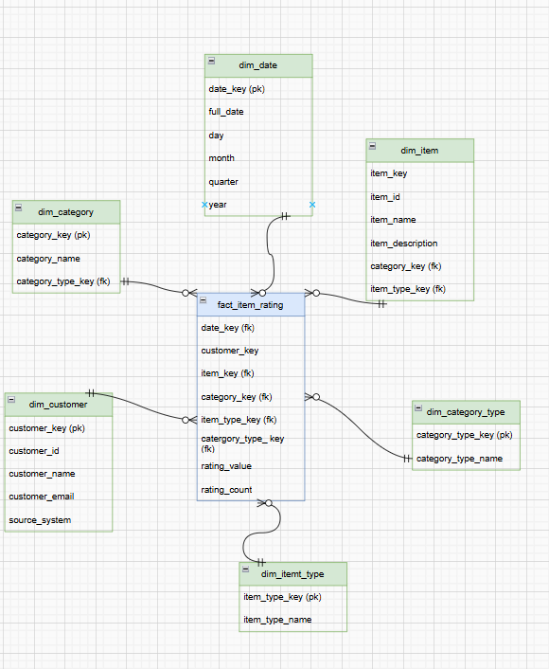
Fig. 6: dbt Lineage Graph – Source-to-Fact Dependency Chain
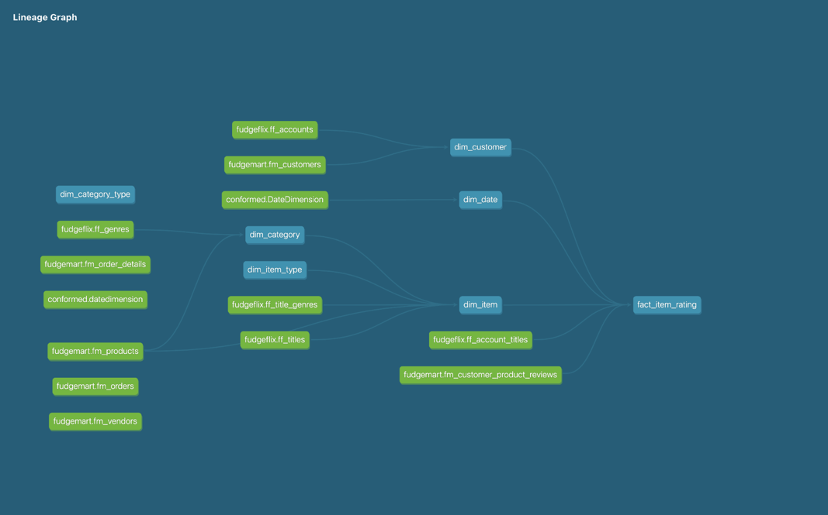
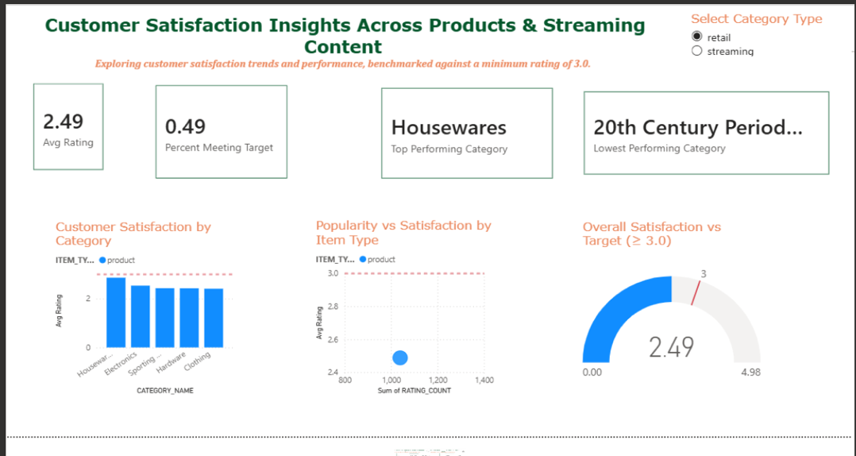
Fig. 7: Customer Satisfaction Dashboard – Retail vs. Streaming

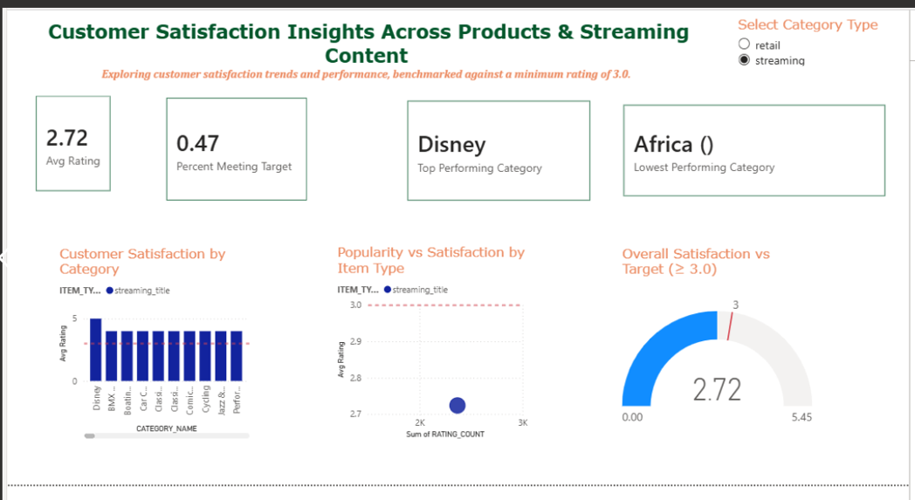

b. Reflection & Learning Goals
The exercise of designing a unified data warehouse from two incompatible source systems revealed the foundational role of data architecture in enabling downstream analytics. Every design decision made at the warehouse level, including the definition of the grain, the structure of dimension tables, the handling of key conflicts, directly determined the quality and reliability of every insight that could be derived from the system. A poorly designed warehouse cannot be corrected by sophisticated analysis, so it is important that the architecture is correct first.
The decision to separate the category and category type dimension was to preserve the semantic distinction between FudgeMart’s retail department structure and FudgeFlix’s genre classification. This is an example of a design choice that honored the integrity of the source data rather than forcing a false equivalence. This project contributed to the program learning outcomes through the design and implementation of a data collection and storage system, the development of actionable cross-company insights, the communication of findings through a BI dashboard, and the application of data governance principles in handling personally identifiable customer records across two previously independent systems.

6. IST 652: Scripting for Data Analysis

a. Project Description
Python was applied as the primary tool for financial data collection, time series forecasting, web scraping, and natural language processing in the project. We analyzed daily historical price data for the four major U.S. stock indices, the Dow Jones Industrial Average (^DJI), the Nasdaq Composite (^IXIC), the S&P 500 (^GSPC), and the Russell 2000 (^RUT). Data was sourced directly from Yahoo Finance via the yfinance Python package. The data window spanned January 1, 2020 to the current date, with the end date dynamically set using Python’s date.today() function to ensure the most up-to-date data was incorporated each time the script was executed. Variables analyzed included closing price, highest price, lowest price, opening price, and trading volume.
The preprocessing pipeline verified data integrity, checking for missing values, duplicated dates, correct datetime indexing, and valid numeric types for price and volume fields. For the text analysis component, each article was scraped from the web using BeautifulSoup, HTML artifacts were stripped, and content was normalized to lowercase for tokenization. Three time series forecasting models were evaluated: ARIMA, LSTM, and ETS (Exponential Smoothing). ETS was selected for its combination of automatic trend and seasonality handling, interpretability, and computational efficiency appropriate to the project’s scope (Fig. 8).
The ETS model with additive trend and no seasonality was applied to each index, producing 30-day forecasts. Across all four indices, forecasts suggested continued modest gains: Dow Jones at 45,850 (1.44% growth), Nasdaq at 22,120 (3.12%), S&P 500 at 6,520 (1.08%), and Russell 2000 at 2,520 (2.89%), with the Russell showing the strongest relative upside attributed to small-cap rotation dynamics (Fig. 9).
The text mining component analyzed one financial news article per index using NLTK for tokenization and frequency analysis, BeautifulSoup for web scraping, and VADER for compound sentiment scoring. Sentiment scores closely aligned with actual market performance for three of four indices. The exception was the S&P 500, where VADER misclassified a clearly negative article as positive due to its tendency to overweight terms such as “strong” and “rally” even when used in negative contexts. This is a known limitation of general purpose sentiment models applied to domain-specific financial language.
Fig. 8: ETS Model Selection Table – ARIMA vs. LSTM vs. ETS Comparison
Model | Pros | Cons
ARIMA | - Good for short-term linear patterns  - Interpretable  - Handles autocorrelation  - Fast and lightweight | - Needs stationary data  - Poor with nonlinear patterns  - Weak long-term forecasts  - Univariate unless ARIMAX/SARIMAX
LSTM | - Learns nonlinear patterns  - Strong long-range forecasting  - Supports multivariate inputs  - No stationarity needed | - Needs lots of data  - Slow and computationally heavy  - Hard to interpret  - Risk of overfitting
ETS | - Models trend plus seasonality automatically  - Very interpretable  - Fast and simple  - Good for smooth seasonal data | - Poor with noisy/nonlinear data  - Univariate only  - No exogenous variables  - Weaker long-term accuracy

Fig. 9: 30-Day ETS Forecast Metrics – All Four U.S. Stock Indices
Index | Total Return (%) | CAGR (%) | Annualized Volatility (%) | Latest Close | Recent 30-Day Change (%) | 30-Day Forecast Mean | Predicted 30-Day Change (%) | Peak Value (Date) | Trough Value (Date)
Dow Jones | 60.34 | 8.12 | 18.45 | 45,200.67 | 2.15 | 45,850.23 | 1.44 | 46,150.89 (Jul 15, 2025) | 18,591.93 (Mar 23, 2020)
Nasdaq | 111.22 | 15.67 | 25.78 | 21,450.12 | 3.87 | 22,120.45 | 3.12 | 22,300.67 (Oct 20, 2025) | 6,860.67 (Mar 23, 2020)
S&P 500 | 87.56 | 12.34 | 20.12 | 6,450.89 | 1.23 | 6,520.34 | 1.08 | 6,750.23 (Sep 10, 2025) | 2,237.40 (Mar 23, 2020)
Russell 2000 | 37.89 | 5.67 | 24.56 | 2,450.78 | 4.56 | 2,520.67 | 2.89 | 2,600.45 (Nov 28, 2025) | 991.16 (Mar 23, 2020)

b. Reflection & Learning Goals
The exercise of building a Python-based analytical pipeline from data collection through forecasting to NLP revealed the extent of tasks a data scientist must orchestrate in a single project. The decision to use the yfinance package to pull live data via API, rather than working with a static dataset, introduced real-world considerations of data freshness, rate limits, and the need for dynamic end-date logic, all skills directly applicable to production data pipelines.
The VADER misclassification of the S&P 500 article carries ethical weight beyond a mere technical error. If deployed in a production trading system without proper validation, a model that systematically misreads negative financial sentiment as positive could generate recommendations with serious financial consequences for end users. This case reinforced the importance of domain-specific model validation and epistemic humility when applying general-purpose NLP tools outside their intended context. This project contributed to the program learning outcomes through the use of Python for data collection, preprocessing, forecasting, and NLP, the identification of patterns in financial time series data, and the communication of model limitations to both technical and non-technical audiences.

7. IST 707: Applied Machine Learning

a. Project Description
Classification and clustering techniques were applied to predict flight departure and arrival delays using data from the U.S. Department of Transportation’s Bureau of Transportation Statistics for 2015. The dataset comprised 258,772 observations and 31 features covering flight-level attributes including airline, origin and destination airport, scheduled and actual departure and arrival times, delay durations by cause, and cancellation status. After removing cancelled, diverted, and null-delay flights, the working dataset contained 252,733 observations and 15 features.
K-Means clustering was applied to determine the optimal number of delay categories. The elbow method identified two as the statistically optimal number of clusters, though three categories were implemented for analytical interpretability, early/on-time, delayed, and severely delayed. The Davies-Bouldin index confirmed that while three clusters showed slightly more overlap than two, no egregious mixing was observed (Fig. 10).
Classification models were then built and evaluated on both departure and arrival delay prediction tasks. All models performed substantially better on arrival delay prediction than departure delay prediction, with the Random Forest Classifier achieving nearly 80% accuracy on arrival delays compared to 62% on departure delays. Following fine-tuning, the model was tested on a hypothetical scenario. A Southwest Airlines flight from Chicago to Los Angeles scheduled for 2:00 PM on Wednesday, December 25th, with a 10-minute departure delay was classified as “Delayed” in its predicted arrival category.
Fig. 10: K-Means Cluster Selection
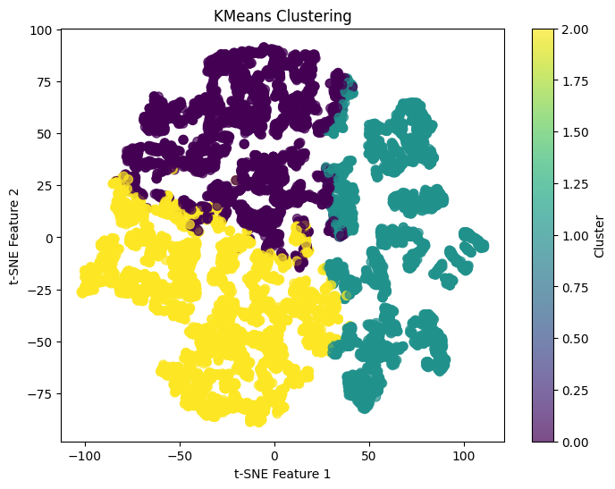

b. Reflection & Learning Goals
The significant performance gap between arrival delay prediction and departure delay prediction revealed an important structural insight. Arrival delays are more predictable than departure delays because they are partially determined by the propagation of earlier delays along a flight’s route. A causal chain that departure delays, which depend more heavily on external and real-time factors, cannot capture in the same way. This understanding of why a model performs the way it does, not merely how accurately, reflects the kind of analytical depth required in professional data science practice.
The use of a concrete hypothetical scenario to demonstrate the model’s real-world utility was a deliberate communication choice that made the abstract accuracy metric tangible for a general audience. This project contributed to the program learning outcomes through the application of classification and clustering techniques to a large, real-world dataset, the identification of structural patterns in delay behavior, and the communication of model performance in terms accessible to non-technical stakeholders.

8. IST 664: Natural Language Processing

a. Project Description
Text classification techniques were applied to the Enron Email Spam Corpus to build a binary email classifier distinguishing spam from ham. The project implemented five distinct feature engineering experiments evaluated using 5-fold cross-validation, with Logistic Regression as the primary classifier throughout. The Enron Email Spam Corpus provided a well-established benchmark dataset for spam detection research, consisting of real email messages labeled as spam or legitimate. The classification pipeline was implemented entirely in Python using scikit-learn for model training and evaluation, and NLTK for text preprocessing and feature extraction. The use of 5-fold cross-validation ensured that performance estimates were robust and not dependent on a single train/test split.
Five feature engineering experiments were implemented and compared. The first experiment applied a bag-of-words unigram representation, using individual word tokens as features, and established the baseline classification accuracy. The second experiment extended this to bigrams, incorporating two-word sequences to capture simple phrasal patterns. The third experiment used part-of-speech (POS) tag distributions as features, leveraging grammatical structure rather than lexical content as a signal for spam detection. The fourth experiment applied stylometric features, including email length, punctuation density, capitalization rate, and special character usage, to capture the writing style signature of spam messages independent of their vocabulary. The fifth experiment combined the full feature set with Logistic Regression, evaluating whether the combination of multiple feature types produced superior classification performance.
The baseline unigram model achieved strong classification accuracy, and Logistic Regression matched this performance when applied to the combined feature set. A notable finding was that adding bigram features to the Naive Bayes baseline slightly degraded performance. This result is attributable to the independence assumption underlying Naive Bayes, which is increasingly violated as feature sets grow larger and more interdependent. This analytical observation illustrated a fundamental principle of machine learning: model architecture and feature engineering choices are not independent decisions, and the interaction between them determines the final performance.

b. Reflection & Learning Goals
The exercise of building a text classification pipeline from raw email corpora through feature engineering to cross-validated evaluation revealed the central role of feature design in NLP tasks. Stylometric features capturing how an email is written rather than what words it contains represent a qualitatively different kind of signal than bag-of-words representations. The capitalization rate, punctuation density, and special character usage of a spam email are behavioral artifacts of its author’s intent, not merely incidental properties of its vocabulary. Recognizing this distinction required moving beyond the default feature representations and applying domain knowledge about the nature of spam communication.
The finding that bigrams degraded Naive Bayes performance carries a broader methodological lesson, a more expressive feature set does not automatically yield a better model. The independence assumption of Naive Bayes is already a simplification for unigrams. Extending it to bigrams, where co-occurrence dependencies are more pronounced, compounds the violation and undermines the model’s probabilistic estimates. This case reinforced the importance of understanding the assumptions embedded in every modeling choice and validating that those assumptions hold for the specific data and feature representation in use.
This project contributed to the program learning outcomes through the application of Python and scikit-learn for text classification, the use of rigorous cross-validation methodology, the identification of feature-model interaction effects, and the communication of findings in both a written code walkthrough document and a formal project submission. The ethical dimensions of spam classification were also present.

9. Conclusion
This portfolio has demonstrated the successful implementation of the Applied Data Science program’s learning outcomes across five courses and projects. Data was collected and managed using live API connections, web scraping, SQL-based database administration, and dimensional warehouse design. It was then analyzed using statistical methods, machine learning models, and natural language processing for tasks spanning forecasting, classification, clustering, and sentiment analysis.
Various data visualizations were paired with modeling techniques to identify patterns that directed each analysis, and actionable recommendations were developed to reflect tangible business decisions. For example, the Snowflake BI dashboard built in the Data Warehousing course was designed explicitly for executive decision-makers, translating dimensional model outputs into cross-company customer satisfaction metrics that enabled targeted investment recommendations without requiring technical literacy from the audience.
Communication skills were developed and displayed across all six projects, from formal slide deck presentations to written technical documentation and executive dashboards, each tailored to the needs of its specific audience. The ethical dimensions of data science practice were reinforced through transparent disclosure of synthetic data limitations, identification of the operational risks of VADER misclassification in financial contexts, application of data governance principles in cross-company customer data integration, and deliberate exclusion of demographic variables from clustering models to prevent bias from shaping segmentation outcomes.
Syracuse University’s School of Information Studies has provided the opportunity to synthesize the collection, management, and analysis of data with the delivery of actionable insights using the full range of data science techniques. The skills developed across this program have cultivated a multifaceted approach to solving both structured and unstructured data problems, as well as strategies for improving organizational efficiency and decision-making. The program has fostered a practice of transparency, reproducibility, and ethical data management that promotes integrity within an analytics team. Using the methods learned at the School of Information Studies, I am equipped to tackle a wide range of applied data science problems and to communicate those findings clearly to a variety of stakeholders and business professionals.

