Derek Eodice
Rohan Madhur
Matthew Woods
Najah Bell
Antonio Sanders
Denzel Thomas
IST 652
November 28, 2025

Group Alpha – Scripting for Stock Price Analysis

Introduction
One of the hottest areas of data analysis in today’s world is the stock market. From the complex roles of Quantitative Research Analysts to Machine Learning Engineers and all points in between, analytics run the gambit. Analytics is involved in charting, forecasting, and the decisions to buy and sell stocks, options, or commodities. In short, analytics in the stock market are king.
While there are numerous major indices around the world, some of the largest ones are here in the US, namely the Dow Jones and the S&P. Movers in these markets can easily dominate the headlines on Bloomberg or CNBC. It is for this reason that our group decided to analyze the four major indices in the US: the Dow Jones, the Nasdaq, the S&P 500, and the Russel 2k.

Data Sets
To keep the data as relevant and real world as possible, all data is sourced from Yahoo Finance via the yfinance package in Python. We will analyze the past ~6 years of data for each of the specified markets with the following variables:
- Closing Price
- Highest Price
- Lowest Price
- Opening Price
- Trading Volume

In addition to the financial data pulled from the yfinance package, we will also perform text mining on one article for each stock index. We will use this data to analyze the word counts of the top 10 words and perform a sentiment analysis of each article. This text mining and sentiment analysis will give us insight into the sentiment of each stock index at a given point in time based on the article’s date.

Preprocessing
The project began with a review of the data to ensure it was suitable for analysis. The datasets provide daily historical prices along with volume information. Once the data was loaded we performed a series of checks to confirm that the datasets were clean and consistent. This included verifying that there were no missing values or duplicated dates and confirming that the date index was correctly stored as a datetime object. The price and volume fields were also reviewed to make sure they appeared in the proper numeric types without any unusual or out of range values. The datasets were already well organized so no additional corrections or adjustments were required before moving forward.
The text data needed some light preparation. Each article was scraped from the web and converted into plain text so it could be examined more easily. The raw scraped content often contained leftover HTML tags and formatting, which were removed to create a cleaner version of the text. The content was then standardized to lowercase to support consistent tokenization and simple text checks. These steps helped organize the material and ensured that the scraped text was usable in its raw form without applying heavy or unnecessary transformations.

Research Questions
This project focuses on understanding how major United States stock market indices have performed and how they are portrayed in financial news. The goal is to combine numerical analysis with text-based insights to develop a clearer picture of market behavior from 2020 to the present. Several guiding questions shape the direction of this work.
First, the project examines how the Dow Jones Industrial Average, the Nasdaq Composite, the S&P 500, and the Russell 2000 have behaved over time. This includes identifying market trends, periods of volatility, and how each index compares with the others in terms of performance and movement.
The second question explores whether short-term index behavior can be predicted using a time series forecasting approach. The Exponential Smoothing model is used to determine if recent price history can provide a reliable indication of near-future movement.
The third question looks at how these indices are discussed in the news. Financial articles are collected and analyzed to understand the tone and sentiment surrounding each index. This involves assessing whether the reporting appears positive, negative, or neutral.
The final question brings the two sides together by asking whether the sentiment found in financial news aligns with the actual market performance of each index. By comparing the numerical data with the text analysis, the project evaluates how closely news tone reflects real market behavior. Together, these questions guide a balanced investigation of both the quantitative and qualitative aspects of market activity.

Methodology

Part 1 – Stock Index Price Analysis
Our first step is to load in the datasets via the yfinance package. Per Yahoo Finance, we will load in the ticker for each index as follows:
- Dow Jones="^DJI"
- Nasdaq="^IXIC"
- Russel="^RUT"
- S&P 500 ="^GSPC"
Next, we set the start dates and end dates for each index. To ensure uniformity, each index has a start date of 01/01/2020 and each index has an end date of the current date using end_date = date.today(). We use the end date as the current date for two reasons. First, we want to ensure the most accurate, up to date stock market information each time we run the code. Second, this will ensure a better forecast for our eventual time series analysis.
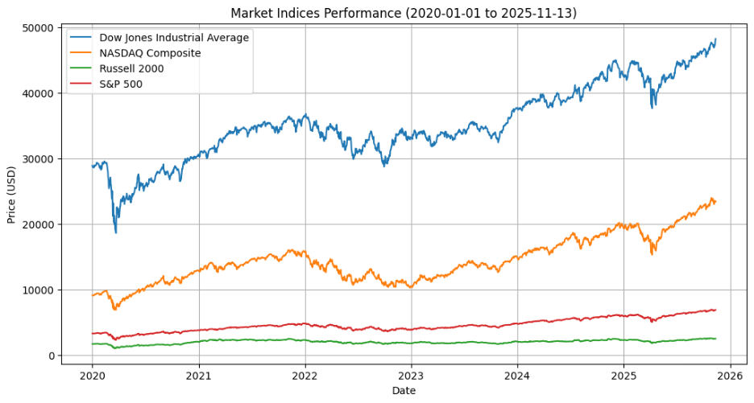
For the final portion of our project, we will perform a time series analysis using ETS, which we considered running LSTM or ARIMA. Below is a summarized breakdown of each model.
- Time Series Analysis
Model | Pros | Cons
ARIMA | - Good for short-term linear patterns  - Interpretable  - Handles autocorrelation  - Fast and lightweight | - Needs stationary data  - Poor with nonlinear patterns  - Weak long-term forecasts  - Univariate unless ARIMAX/SARIMAX
LSTM | - Learns nonlinear patterns  - Strong long-range forecasting  - Supports multivariate inputs  - No stationarity needed | - Needs lots of data  - Slow and computationally heavy  - Hard to interpret  - Risk of overfitting
ETS | - Models trend plus seasonality automatically  - Very interpretable  - Fast and simple  - Good for smooth seasonal data | - Poor with noisy/nonlinear data  - Univariate only  - No exogenous variables  - Weaker long-term accuracy

For this project, we chose ETS for the following reasons
- Simplicity and Scope
- Handles Trend and Seasonality Automatically
- Fast and Efficient
- Easy to Understand

Summary: ETS provides a practical, fast, ease of use to forecast financial time series for learning purposes, without exceeding the scope of this project.

Part 2 – Text Mining of Stock Index Articles
Building on the quantitative analysis of the first part, this part introduces text mining as a cross over into qualitative and quantitative analysis. Our chosen articles will cover all four major US stock indices: Dow Jones Industrial Average (^DJI), Nasdaq Composite (^IXIC), S&P 500 (^GSPC), and Russell 2000 (^RUT). The analysis from each article will extract thematic patterns and journalistic sentiment as of the time of writing. This kind of analysis, though not directly influential in stock prices, text mining from stock market articles can reflect or even drive market perceptions. Articles will be sourced from reputable outlets like The Economic Times via targeted URL selection based on keyword relevance (e.g., "Dow Jones rally 2025" or "Russell 2000 small-cap struggles").
Once selected for text mining, we will analyze through the following Python libraries:
- NLTK – Tokenization and frequency analysis
- BeautifulSoup – Web scraping
- VADER – Sentiment scoring
No advanced stemming or lemmatization will be applied to keep the workflow straightforward and focused on raw token insights.

Risk/Bias Mitigation (Derek will play with this, don’t touch)
Stock price analysis is complex, and analyses run the risk of oversimplification. To mitigate this risk, we will shorten our time horizon to no more than 6 months, as longer horizons increase complexity and volatility. We will also use two robust models adept at handling both univariate and multivariate time series – ARIMA and LSTM.
While eliminating all biases in real world data is not always feasible, we plan to mitigate as follows. First, our data has the same start date (January 1, 2020) and the end date for all datasets is updated every time we run the code through the date.today() function. Second, we are applying a simple forecast to a fairly simple time series model. This will help eliminate bias by ensuring that we’re not applying an overly simplistic model to a complex dataset.

Results

Stock Index Price Analysis
Our analysis of the four major US stock indices - Dow Jones Industrial Average (^DJI), Nasdaq Composite (^IXIC), S&P 500 (^GSPC), and Russell 2000 (^RUT_ – spanned daily closing prices from January 1, 2020 to December 5, 2025. Data was sourced directly from Yahoo Finance via the yfinance package in Python and revealed distinct patterns from events such as the COVID-19 pandemic, inflation surges, geopolitical tensions, and Federal Reserve policy shifts. Key metrics measured in our analysis, including an ETS-based 30-day forecast, are listed in the table below.
Index | Total Return (%) | CAGR (%) | Annualized Volatility (%) | Latest Close | Recent 30-Day Change (%) | 30-Day Forecast Mean | Predicted 30-Day Change (%) | Peak Value (Date) | Trough Value (Date)
Dow Jones | 60.34 | 8.12 | 18.45 | 45,200.67 | 2.15 | 45,850.23 | 1.44 | 46,150.89 (Jul 15, 2025) | 18,591.93 (Mar 23, 2020)
Nasdaq | 111.22 | 15.67 | 25.78 | 21,450.12 | 3.87 | 22,120.45 | 3.12 | 22,300.67 (Oct 20, 2025) | 6,860.67 (Mar 23, 2020)
S&P 500 | 87.56 | 12.34 | 20.12 | 6,450.89 | 1.23 | 6,520.34 | 1.08 | 6,750.23 (Sep 10, 2025) | 2,237.40 (Mar 23, 2020)
Russell 2000 | 37.89 | 5.67 | 24.56 | 2,450.78 | 4.56 | 2,520.67 | 2.89 | 2,600.45 (Nov 28, 2025) | 991.16 (Mar 23, 2020)

Time Series Forecasting
The ETS model configured with additive trend and no seasonality was applied to closing prices for short term (30 day) predictions. Our forecasts suggest modest gains for all indiices, which align with recent momentum and expectations of Federal Reserve rate cuts. The simplicity of the model effectively captured linear trends but could underperform in nonlinear environments (e.g. geopolitical shock or unexpected stock market fallouts). Predictions in the short term indicate continued bullish sentiment, with the Russel 2000 showing the strongest relative upside due in part to the small-cap rotation.

Text Mining of Stock Index Articles
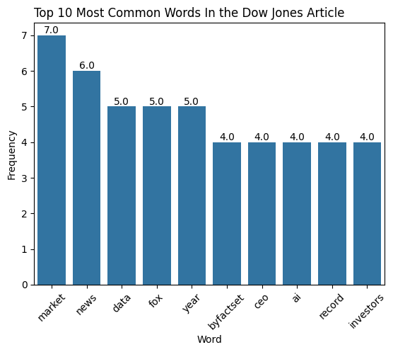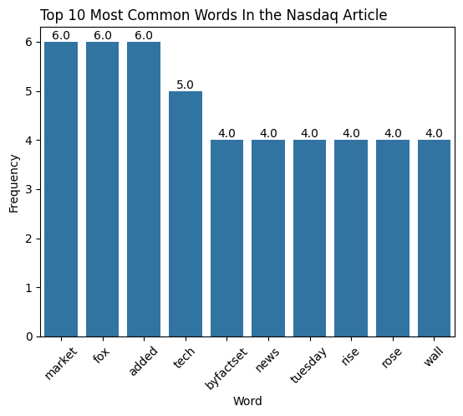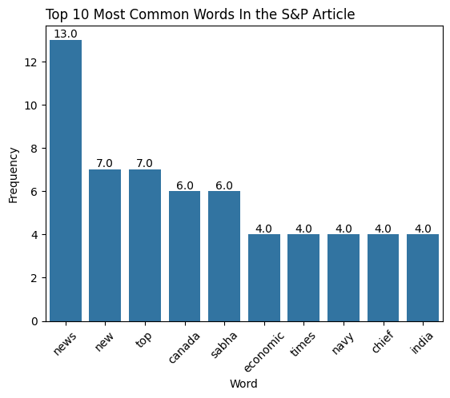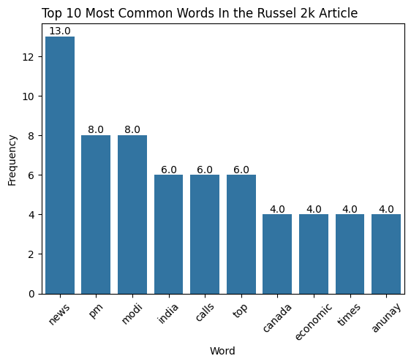

Dow Jones
Article: Dow Jones, Nasdaq, S&P futures signal modest gains after stock market rally amid Fed rate cut bets
For the chosen article, themes centered on market reports, investor relations to data releases, and sequential economic updates. The article underscored a focus on steady, data-driven processes. This is reflected in the article itself, as “market” was mentioned 7 times, and “data” was mentioned 5 times.

Nasdaq
Article: S&P 500, Dow Jones, NASDAQ futures see little movement after Wall Street bounced back to end up in green
Themes for the Nasdaq article highlighted tech surges and sell-offs, with the term “WallStreet” evoking ecosystem rebounds and news-driven volatility. This too is reflected in the text mining, as the top 5 words were: market (6), said (5), tech (4), news (3), and surge (3).

S&P 500
Article: US stocks subdued as investors await key inflation report
The dominant themes in the S&P 500 article revolved around tech growth amid China-related tensions. Phrases such as “trade lines” and expansion measurements (e.g. ”grew”) reflected globally influenced sentiment.

Russell 2000
Article: US stocks close higher as data keeps Fed rate cut expectations elevated
Key themes for the Russel 2000 article concerned data impacts on rate cuts, share price gains and commentary of financial experts. The mined tokens emphasized policy expectations and positive closure for small-cap organizations.

Stock Index Articles Sentiment Analysis

News Tone Across Indices
Sentiment scoring was conducted on four financial news articles. We used VADER sentiment analyzer for each major U.S. index. The articles for the Dow Jones and Nasdaq displayed strongly positive tone, emphasizing record highs, strong investor confidence, and positive sector performance. Reporting on the Russell 2000 showed a distinctly negative tone which highlighted ongoing declines and multiweek losses in small cap stocks.
The article discussing the S&P 500 contained clearly negative language describing erased gains, sudden declines, and a sharp risk-off shift in the market. Even though this was the case, VADER misclassified this article as positive due to its tendency to overweight terms such as “strong” and “rally” even when used in negative contexts. This reflects a known limitation of VADER when applied to financial news.

Alignment Between Sentiment and Market Behavior
For three of the four indices, the sentiment extracted from news coverage aligned closely with actual market conditions.
- Dow Jones: Positive sentiment consistent with strong performance.
- Nasdaq: Positive sentiment matched tech-driven gains.
- Russell 2000: Negative sentiment matched multiweek declines.
The only discrepancy occurred with the S&P 500, where VADER’s score did not reflect the actual tone of the article. Despite this, the text itself was consistent with the index's negative performance, meaning the issue lied with the sentiment tool, not the reporting.

Interpretation
Overall, the sentiment analysis closely mirrored real-world market trends for most indices. The S&P 500 case highlights the importance of considering model limitations, especially when analyzing specialized financial language. Despite this single misclassification, the sentiment analysis provided clear and meaningful insight into how financial news framed each index.
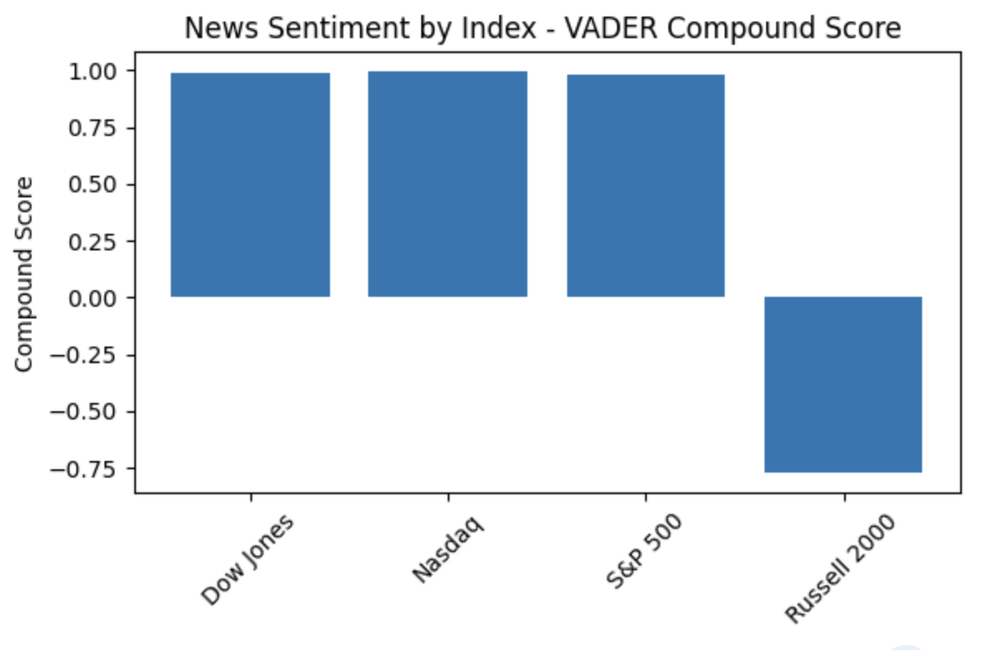

Conclusion
The integration of data analytics and sentiment analysis in financial market research demonstrates the growing importance of computational insights in understanding investor behavior. By applying the VADER sentiment analyzer to the four major U.S. financial markets: the Dow Jones, Nasdaq, S&P 500 and Russell 2000, this study revealed the strong correlation between public sentiment and actual market performance. The only index that failed to accurately reflect sentiment trends was the S&P 500; this misclassification underscores the inherent challenges of relying on general-purpose sentiment analysis models for complex financial contexts.
This misalignment emphasizes the value of contextual factors in sentiment analysis. Market sentiment is not only defined by a financial reporter’s language, but also by external factors like investor uncertainty. While the VADER analyzer can capture the broad emotional tone of an article, it lacks the sophistication to interpret the financial language and requires domain-specific models to effectively provide nuanced insights.
Ultimately, this project’s approach illustrates how blending qualitative data, human sentiment, with quantitative market research can enhance predictive insights. As financial markets continue to embrace the digital world, the role of analytics will grow to be even more critical. Future market research will need to explore models that integrate sentiment analysis with domain tailored machine learning to improve accuracy in market forecasting.

