CIRCUIT ANALYSIS LAB_5
Name: Muhammad Najeeb Subah
Reg No: 2025-CE-91
Date: 25/04/2026

Experiment # 1:
Measure Current between R1 and R2, and Voltage across R1, R2.

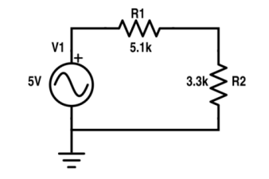

TABLE FOR READINGS:

Stimulated Values:

R₁ Voltage | R₂ Voltage | Current between R₁ & R₂
2.14V | 1.39V | 0.42mA

Experiment # 2:
Measure Current across R1, R2, R3 and Voltage between node 2 and 3.

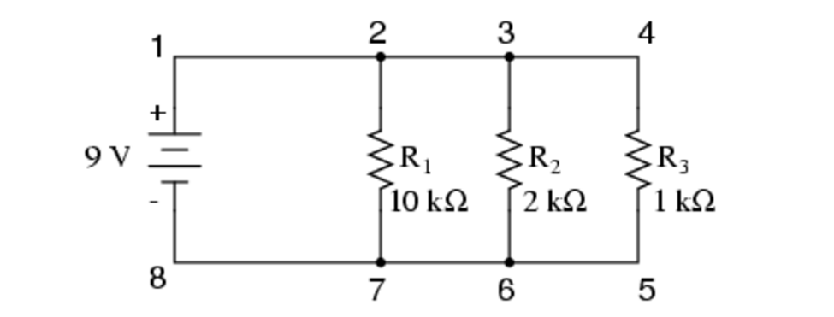

TABLE FOR READINGS:

Stimulated Values:
R₁ Current | R₂ Current | R₃ Current | Voltage between node 2 & 3
0.9mA | 4.5mA | 9mA | 0V

