CIRCUIT ANALYSIS LAB_6
Name: Muhammad Najeeb Subah
Reg No: 2025-CE-91
Date: 25/04/2026

Experiment # 1: KCL CIRCUIT:
Procedure for KCL:
1. Give the connections as per the circuit diagram.
2. Set a value in RPS.
3. Note down the corresponding readings using multimeter
4. Repeat the same for different voltages
Circuit - KCL:
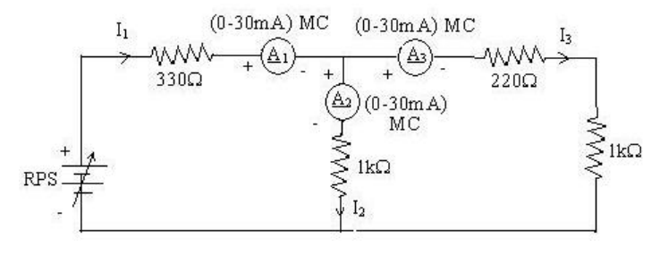
TABLE FOR READINGS:
KCL – Practical Values:
SI.No | Voltage | Current |  |  | I₁=I₂+I₃
 |  | I₁ | I₂ | I₃
 | Volts | mA | mA | mA | mA
1 | 5 | 5.68 | 3.12 | 2.56 | 5.68
2 | 15 | 17.1 | 9.37 | 7.68 | 17.1
3 | 25 | 28.4 | 15.6 | 12.8 | 28.4
Experiment # 2: KVL Circuit
Procedure for KVL:
1. Give the connections as per the circuit diagram.
2. Set a value in RPS.
3. Note all the voltage reading
4. Repeat the same for different voltages
Circuit - KVL
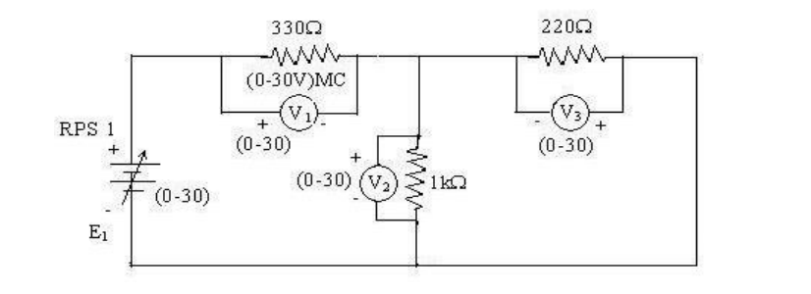
TABLE FOR READINGS:
KVL – Practical Values:
SI.No | RPS | Voltage |  |  | E₁=V₁+V₂
 | E₁ | V₁ | V₂ | V₃
 | Volts | V | V | V | V
1 | 5 | 3.23 | 1.77 | 1.77 | 5
2 | 10 | 6.47 | 3.53 | 3.53 | 10
3 | 15 | 9.7 | 5.3 | 5.3 | 15

Post Lab Q/A:
- Define Kirchhoff’s Current Law (KCL).
Kirchhoff’s Current Law states that the algebraic sum of currents at any node (junction) in an electrical circuit is zero. This means that the total current entering a node is equal to the total current leaving it. It is based on the principle of conservation of charge. Mathematically, ∑I = 0 at a node. This law is useful for analyzing current distribution in circuits.

- Define Kirchhoff’s Voltage Law (KVL).
Kirchhoff’s Voltage Law states that the algebraic sum of all voltages in any closed loop of a circuit is zero. This implies that the total voltage supplied is equal to the total voltage drop in that loop. It is based on the conservation of energy principle. Mathematically, ∑V=0 in a closed loop. It is used to calculate unknown voltages in electrical circuits.

- What are the applications of regulated power supply?
A regulated power supply is used to provide a constant output voltage despite variations in input voltage or load conditions. It is widely used in electronic devices such as computers, mobile chargers, and laboratory instruments. It ensures stable and reliable operation of sensitive electronic components. It is also used in communication systems and industrial control circuits. It helps in protecting devices from voltage fluctuations.

- What are the limitations of KCL?
Kirchhoff’s Current Law assumes that no charge is stored at the node, which may not be valid at high frequencies. In circuits with capacitors and inductors, displacement currents can affect accuracy. It may not be applicable in distributed parameter systems like transmission lines. The law also ignores electromagnetic effects in rapidly changing fields. Therefore, its application is limited in high-frequency and complex circuits.

