

SIMATS ENGINEERING

Saveetha Institute of Medical and Technical Sciences Chennai- 602105
Student Name: AL NAJEEB A Reg. No.:192424325
Course Code: DSA0423 Slot: D
Course Name: DSA0423 - Fundamentals of Data Science for NLP
Course Faculty: Dr. Senthilvadivu.S

Project Title:Design and Evaluation of Bayesian-Based Portfolio Optimization Models Using Financial Market Data
Module Photographs:
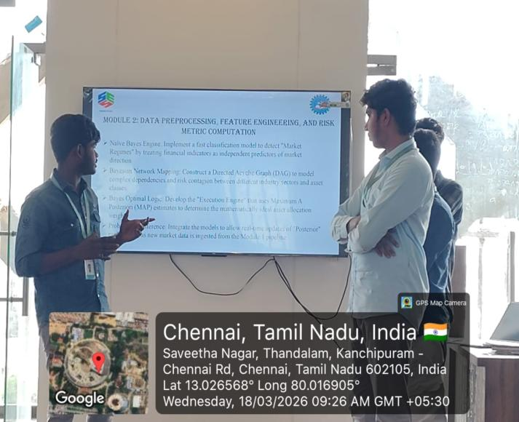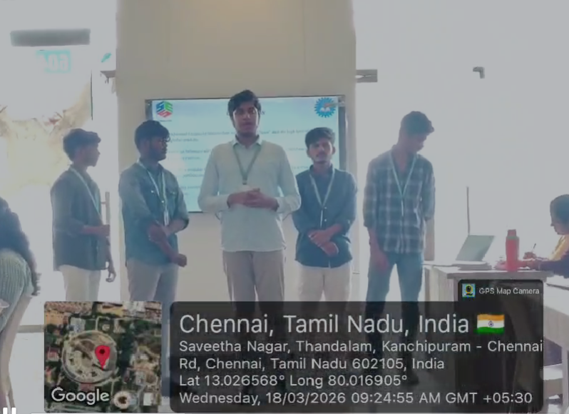
Project Description:
+The Bayesian Model Implementation (SMA50) was developed as a key analytical component of our asset management software designed to manage investments across stocks, real estate, and gold. The main objective of this project was to create a decision-support system that assists investors in making informed portfolio choices using probabilistic modeling combined with financial indicators. By integrating Bayesian inference with a trend-based approach, the system generates intelligent predictions about asset performance and market direction.The role of SMA50 in the system is primarily for basic trend identification. It helps determine whether an asset is generally moving upward or downward over a medium-term period. Instead of relying heavily on this indicator alone, the system uses it as an initial signal, which is then enhanced through Bayesian probability calculations. This ensures that decisions are not based solely on moving averages but on updated statistical reasoning derived from historical and current market data.The Bayesian component plays a central role in the model. It uses prior market behavior as initial knowledge and continuously updates predictions as new data becomes available. This dynamic updating mechanism allows the system to adapt to changing market conditions in stocks, gold prices, and real estate indices.

Student Signature Guide Signature

