CSA14 - Compiler Design | Assessment Tool 2 | Error Analysis Task
AL NAJEEB
192424325

Q1.
(a) Error Identification
- Line 4 (for(i = 0; i <= n; i++)) - loop condition should be i < n, not i <= n. As written it accesses arr[n], which is out of bounds for an n-size array.
- Line 10 (int arr[5] = {1,2,3,4,5}) - missing semicolon at the end of the statement.
- Line 12 (total = sumArray(arr);) - sumArray is defined to take two parameters (arr, n) but is called with only one argument.
- Line 14 (printf("Correct Sum\n")) - missing semicolon at the end of the statement.
- Line 17 (int c = a / b;) - b is 0, so this is a division by zero.
- Line 18-19 (int *p; *p = 20;) - pointer p is declared but never initialised, so *p = 20 writes to a random memory address.
(b) Classification of Errors
- Line 4 - Logical error (wrong loop bound).
- Line 10 - Syntax error (missing semicolon).
- Line 12 - Semantic error (argument count mismatch).
- Line 14 - Syntax error (missing semicolon).
- Line 17 - Runtime error (division by zero).
- Line 18-19 - Runtime error (uninitialised/dangling pointer dereference).
(c) Compilation Behavior
Detected at compile time: the missing semicolons (lines 10, 14) and the argument-count mismatch (line 12), since these violate syntax rules and the function's declared signature.
Detected only at runtime: the division by zero (line 17), the wild pointer write (line 18-19), and the effect of the off-by-one loop (line 4), which does not stop compilation but produces an out-of-bounds read/incorrect sum when the program runs.
A syntax error (like a missing semicolon) stops the parser from building a correct parse tree for that statement, so the compiler cannot reliably continue semantic checking beyond that point - it may misread the following lines as part of the broken statement, hiding or misreporting later semantic and logical errors until the syntax error is fixed first.
(d) Code Correction
#include <stdio.h>

int sumArray(int arr[], int n) {
int i, sum = 0;
for(i = 0; i < n; i++) {
sum = sum + arr[i];
}
return sum;
}

int main() {
int arr[5] = {1,2,3,4,5};
int total;
total = sumArray(arr, 5);
if(total == 15) {
printf("Correct Sum\n");
}
int a = 10, b = 2;
int c = a / b;
int val = 20;
int *p = &val;
*p = 20;
return 0;
}
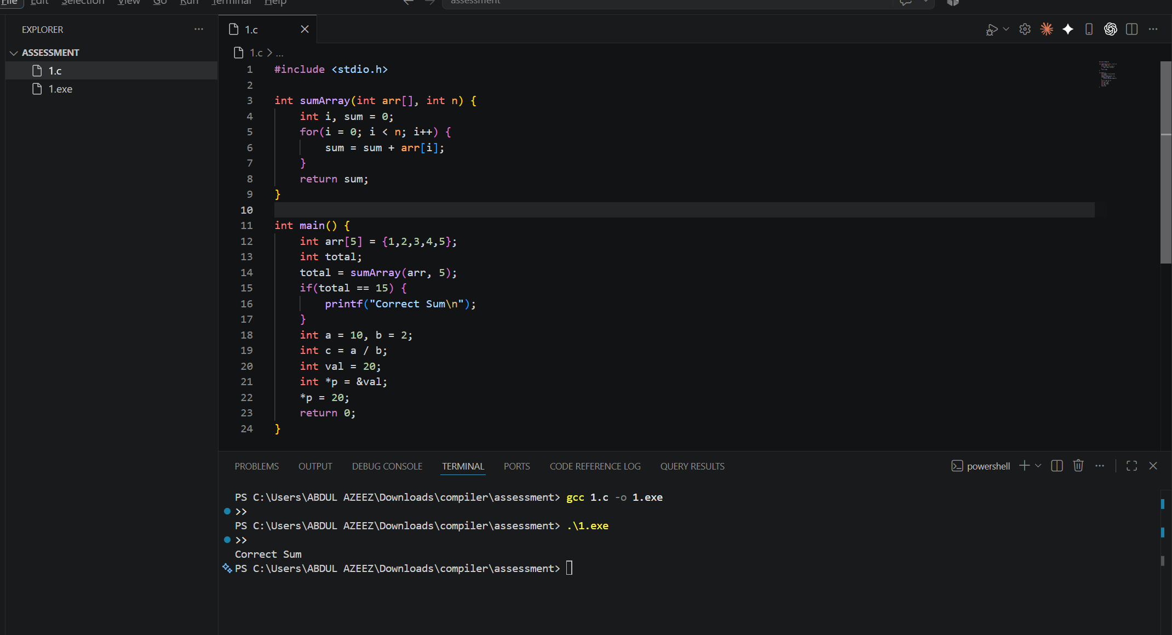
(e) Impact Analysis
- Off-by-one loop (line 4): reads arr[n], which is outside the array - this can return garbage values or crash the program, and gives a wrong sum even when it doesn't crash.
- Division by zero (line 17): integer division by zero is undefined behaviour in C and typically terminates the program with a runtime exception (SIGFPE).
- Uninitialised pointer (line 18-19): *p = 20 writes to whatever address p happens to hold, which can crash the program or silently corrupt unrelated memory, making the bug hard to trace.
In general: improper pointer usage causes undefined behaviour because the program writes/reads memory it does not own; division by zero causes an immediate runtime crash; infinite loops cause the program to hang and consume CPU indefinitely, so the system becomes unresponsive until it is forcibly terminated.
(f) Advanced Compiler Perspective
- Give error messages that name the exact problem and line, and suggest a fix (e.g. "function sumArray expects 2 arguments, 1 given") instead of a generic error.
- Enhancement 1: add static data-flow analysis to flag likely runtime issues at compile time - e.g. warn on pointers used before being assigned, and on constant/likely-zero divisors.
- Enhancement 2: add optional bounds-checked array access in debug builds so out-of-range indices are reported immediately with the offending index and array size.

Q2.
(a) Error Identification
- Line 3: 1num - identifier starts with a digit.
- Line 4: rate@ - '@' is not a valid identifier character.
- Line 5: 'abc' - character constant has more than one character.
- Line 6: 50$20 - '$' is not a valid symbol in a numeric token.
- Line 7: num#1 - '#' is not a valid identifier character.
- Line 8: %count - identifier starts with an illegal symbol '%'.
- Line 9: "Welcome to Compiler Design) - string literal is never closed with a matching quote.
- Line 10: 09 - invalid octal constant (9 is not a valid octal digit).
- Line 11: 0xZ12 - invalid hexadecimal constant ('Z' is not a hex digit).
- Line 12: 12.3.4 - malformed floating-point constant (two decimal points).
- Line 13: "Hello - string literal is never closed.
- Line 16: invalid-id - hyphen is not allowed inside an identifier.
- Line 17: 5..6 - malformed floating-point constant (two consecutive dots).
- Line 18: 10@5 - '@' is not a valid symbol inside a numeric expression/token.
- Line 19: 'xy' - character constant has more than one character.
- Line 20: 3value - identifier starts with a digit.
(b) Error Classification
- Identifier rules violated - lines 3, 4, 7, 8, 16, 20: an identifier must start with a letter or underscore and may contain only letters, digits and underscores afterward.
- Constant formation rules violated - lines 6, 10, 11, 12, 17, 18: numeric constants must follow valid decimal/octal/hex/float grammar with no illegal characters.
- String/character literal rules violated - lines 5, 9, 13, 19: a character constant must hold exactly one character, and a string literal must be closed with a matching double quote.
- All of the above are lexical errors because they are caught while the scanner is forming individual tokens, before any parsing or meaning is attached to the code.
(c) Token Correction
- 1num -> num1
- rate@ -> rate
- 'abc' -> 'a'
- 50$20 -> 5020
- num#1 -> num1
- %count -> count
- "Welcome to Compiler Design) -> "Welcome to Compiler Design"
- 09 -> 9
- 0xZ12 -> 0x112
- 12.3.4 -> 12.34
- "Hello -> "Hello"
- invalid-id -> invalid_id
- 5..6 -> 5.6
- 10@5 -> 105
- 'xy' -> 'x'
- 3value -> value3
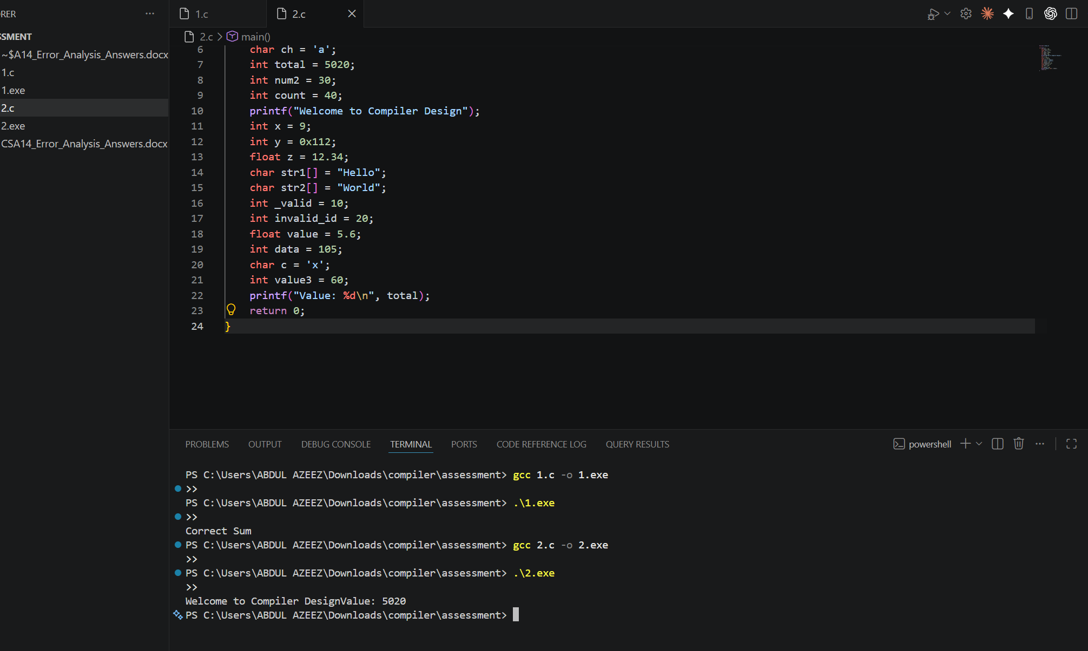
(d) Compiler Behavior Analysis
The lexical analyzer reads the source character by character and matches the longest prefix against the token patterns (DFAs) for identifiers, keywords, constants, strings and operators. When a character sequence does not match any valid pattern, it reports a lexical error at that position.
Most compilers use error recovery (panic mode): the scanner does not stop at the first bad token - it skips characters until it reaches a recognisable delimiter (whitespace, semicolon, quote) and resumes scanning, so it can report multiple lexical errors in one pass instead of stopping immediately.
(e) Advanced Thinking
DFA idea for invalid identifiers starting with a digit: from the start state S0, a transition on a letter or underscore goes to an accepting state S1 (valid identifier), which loops on letters/digits/underscores. A transition from S0 on a digit goes to a separate state (S_err) that is never an accepting identifier state - so any token beginning with a digit followed by letters is trapped and flagged as an invalid identifier rather than a number.

Q3.
(a) Identify Errors
- Line 3: return a / b - missing semicolon.
- Line 6: int #value = 20; - '#' is an illegal character in an identifier.
- Line 7: float num = 15.5 - missing semicolon.
- Line 9: result = divide(10); - divide expects 2 arguments but is called with 1.
- Line 10: if(result = 5) - uses assignment (=) instead of comparison (==), so the condition always evaluates to 5 (true) and also overwrites result.
- Line 11: printf("Result is 5\n") - missing semicolon.
- Line 15: int z = x / y; - y is 0, division by zero.
- Line 17: printf("%d\n", arr[4]); - arr has 4 elements (valid indices 0-3), so arr[4] is out of bounds.
- Line 18-19: int *ptr; *ptr = 25; - ptr is never initialised before being dereferenced.
- Line 21: total = x + y * result + 0; - the "+ 0" is a redundant, unnecessary computation.
- Line 22-24: while(x < 20) { printf(...); } - x is never updated inside the loop, so this is an infinite loop.
(b) Classify by Compiler Phase
- Lexical: line 6 (#value).
- Syntax: lines 3, 7, 11 (missing semicolons).
- Semantic: line 9 (argument count mismatch), line 10 (assignment used where a comparison was intended).
- Intermediate Code Issues: line 10 - the assignment inside the condition changes what value flows into the generated code, producing logic different from what was intended.
- Optimization Issues: line 21 - the "+ 0" is redundant and should be eliminated by the optimizer.
- Runtime Errors: line 15 (division by zero), line 17 (array index out of bounds), line 18-19 (invalid pointer access), line 22-24 (infinite loop).
(c) Compilation vs Execution
Detected at compile time: lines 3, 6, 7, 11 (lexical/syntax errors) and line 9 (argument mismatch against the function's declared signature).
Detected only during execution: line 15 (division by zero), line 17 (out-of-bounds array access), line 18-19 (invalid pointer write), and line 22-24 (the program hangs because the loop never terminates). Line 10 also only shows its true effect at runtime, since it compiles fine but behaves incorrectly.
Missing semicolons (lines 3, 7) break the parser's ability to identify where one statement ends and the next begins, so it may misinterpret following lines as part of the same broken statement - this cascades into further reported errors and can prevent the compiler from reaching later semantic checks until the syntax is fixed.
(d) Correct the Program
#include <stdio.h>

int divide(int a, int b) {
return a / b;
}

int main() {
int value = 20;
float num = 15.5;
int result;
result = divide(10, 2);
if(result == 5) {
printf("Result is 5\n");
}
int x = 10;
int y = 1;
int z = x / y;
int arr[4] = {1,2,3,4};
printf("%d\n", arr[3]);
int val = 25;
int *ptr = &val;
*ptr = 25;
int total;
total = x + y * result;
while(x < 20) {
printf("%d\n", x);
x++;
}
return 0;
}

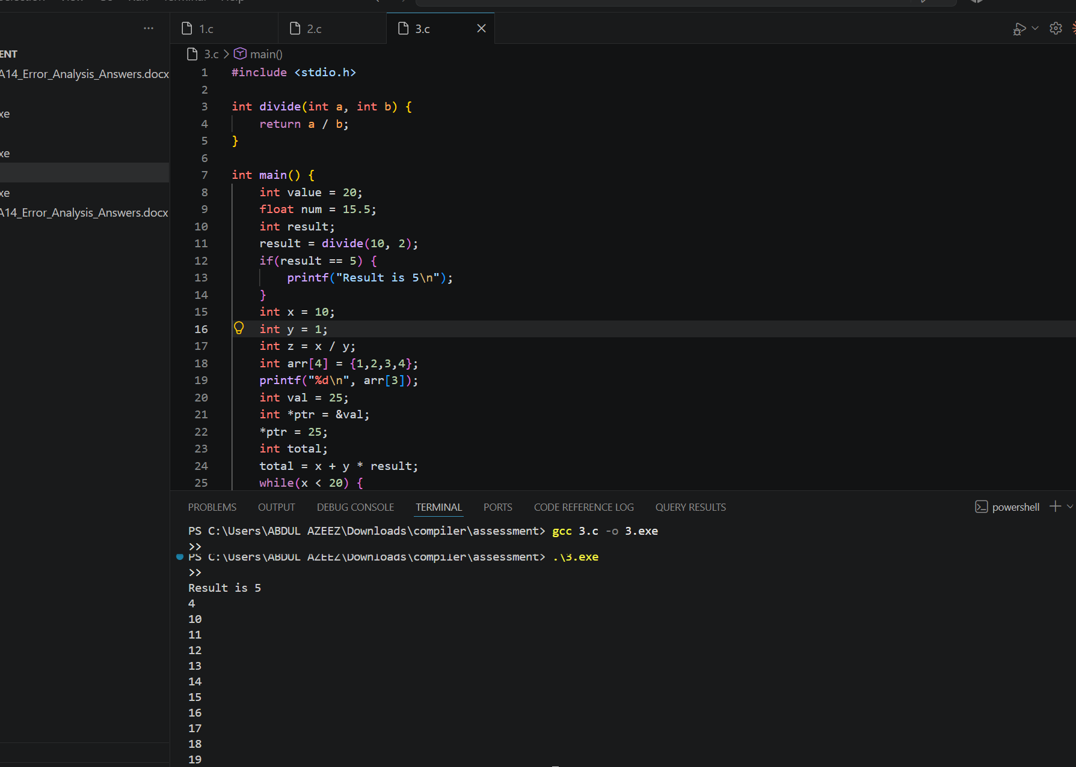
(e) Deep Analysis
- Incorrect pointer usage: writing through an uninitialised pointer (*ptr = 25) sends data to an unpredictable memory address, which can crash the program or silently overwrite unrelated variables or OS-owned memory, causing bugs that appear far from their real cause.
- Array bounds violation: arr[4] reads memory just past the end of a 4-element array. That memory may belong to another variable, so the program can return garbage values, or, if written to, corrupt adjacent memory and cause unpredictable behaviour later in execution.
- Operator precedence: an expression evaluated in the wrong order at the intermediate-code stage produces a different three-address-code sequence than intended, so the computed result differs from what the source code appears to say - this is dangerous because there is no syntax error to flag it.
(f) Advanced Task
- Improvement 1: static analysis to catch assignment used as a condition (= instead of ==) and to flag pointers dereferenced before initialisation, both at compile time.
- Improvement 2: optional runtime bounds-checking instrumentation (similar to AddressSanitizer) in debug builds, so out-of-range array access and invalid pointer writes are reported immediately with the exact location, instead of failing silently.
- Optimization phase: add constant folding and dead-code elimination passes so redundant expressions like "+ 0" or "* 1" are automatically simplified or removed.

