Project Report
NSL-KDD Intrusion Detection
Name : Najeeb Ullah
Roll no : 22f-3124

1. Executive Summary
This project implements a binary intrusion detection pipeline using the NSL-KDD dataset. It trains supervised machine-learning models (Random Forest and XGBoost) to classify network connections as normal (0) or malicious (1), evaluates baseline performance, and then simulates multiple adversarial perturbation strategies to measure model robustness under attack.

2. Repository Contents
Primary artifact:
- NSL_KDD.ipynb (Jupyter notebook)
- Supporting script (this report generator):
- generate_project_report.py

3. Dataset
Dataset source and access method:
- Downloaded via KaggleHub dataset: hassan06/nslkdd
- Files used: KDDTrain+.txt and KDDTest+.txt
Labeling:
- Binary label created from the original 'class' column: normal vs attack
Observed dataset statistics (from notebook execution output):
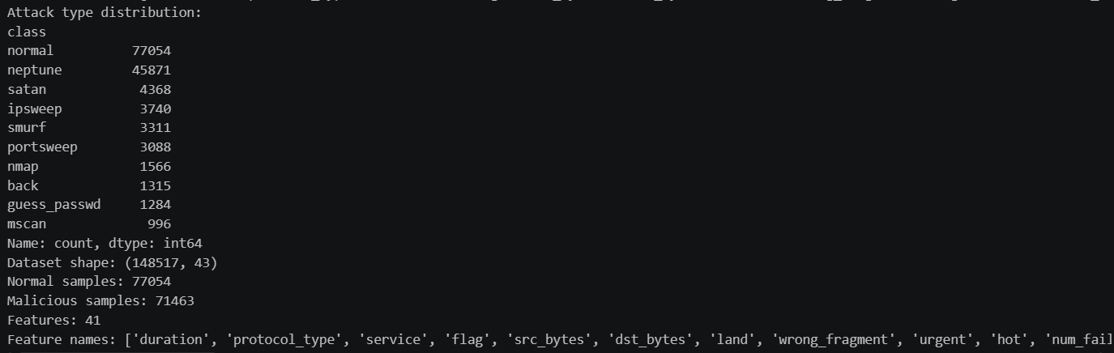

4. Data Preparation & Preprocessing
Key preprocessing steps implemented in the notebook:
- Drop the 'difficulty' column.
- Encode categorical features: protocol_type, service, flag.
- Replace ±∞ with NaN, fill NaN with 0.
- Train/test split: 70% / 30% with stratification.
- Feature scaling using StandardScaler.
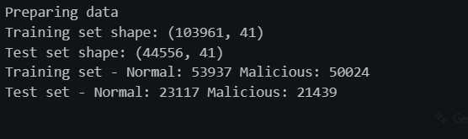

5. Models
Two classifiers are trained and evaluated:
- RandomForestClassifier (n_estimators=100, max_depth=10, random_state=42)
- XGBClassifier (n_estimators=100, max_depth=6, random_state=42)

6. Baseline Performance (Before Adversarial Attacks)

After training, both models were evaluated on the test dataset. The results indicate that both classifiers achieved strong performance in detecting network intrusions. XGBoost slightly outperformed Random Forest in terms of accuracy and training efficiency, making it the more effective model in the baseline evaluation. The preprocessing pipeline proved highly effective in separating normal traffic from attack patterns, enabling both models to learn meaningful representations from the data.
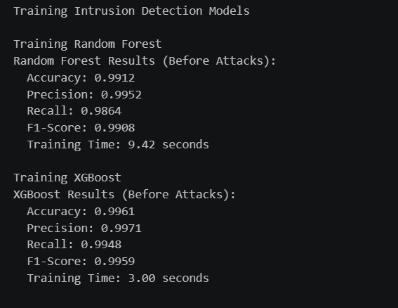
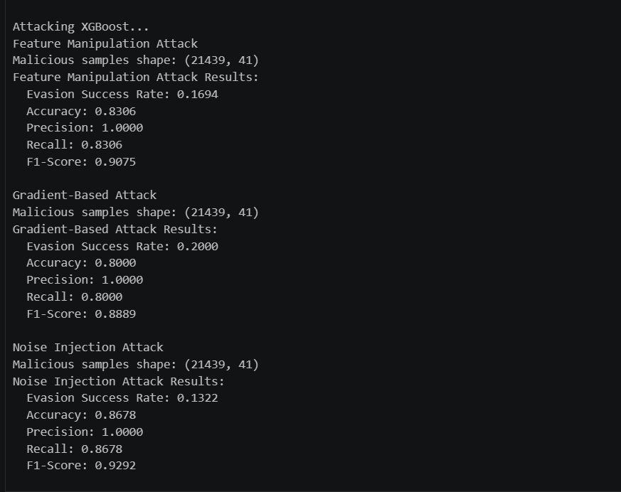

7. Adversarial Robustness Evaluation
The notebook evaluates three perturbation-based attacks applied only to malicious test samples (n=21,439), measuring the evasion success rate (fraction of malicious samples misclassified as normal) and standard classification metrics on the malicious subset.
Attack types implemented:
- Feature manipulation (Gaussian noise with perturbation_strength=0.1)
- Gradient-based perturbation (feature-importance guided, epsilon=0.1)
- Noise injection (Gaussian noise with noise_level=0.05)

8. Results Under Attack (Malicious Subset)
Model | Attack | Evasion Success | Accuracy | Precision | Recall | F1
Random Forest | Feature manipulation | 0.2576 | 0.7424 | 1.0000 | 0.7424 | 0.8521
Random Forest | Gradient-based | 0.6588 | 0.3412 | 1.0000 | 0.3412 | 0.5087
Random Forest | Noise injection | 0.2405 | 0.7595 | 1.0000 | 0.7595 | 0.8633
XGBoost | Feature manipulation | 0.1694 | 0.8306 | 1.0000 | 0.8306 | 0.9075
XGBoost | Gradient-based | 0.2000 | 0.8000 | 1.0000 | 0.8000 | 0.8889
XGBoost | Noise injection | 0.1322 | 0.8678 | 1.0000 | 0.8678 | 0.9292

9. Key Findings
Performance:
- Both models achieve very high baseline accuracy; XGBoost performs best overall.
Robustness:
- XGBoost demonstrates stronger robustness across all tested perturbation attacks (lower evasion success rates than Random Forest).
- Random Forest is particularly vulnerable to the gradient-based perturbation in this implementation (evasion success 0.6588)

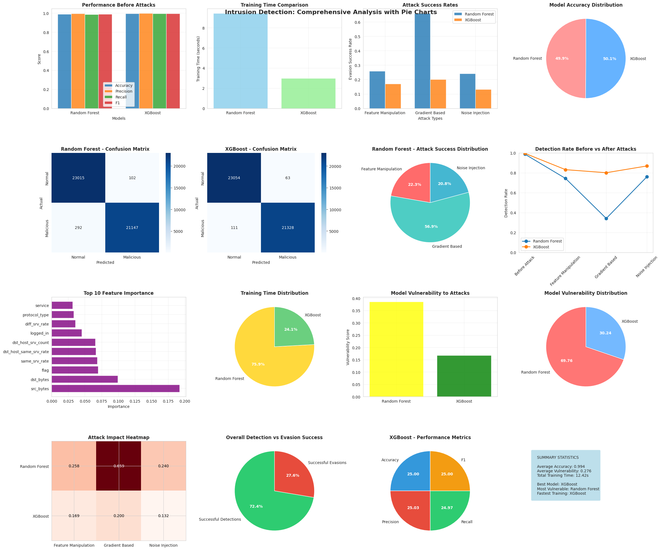

10. Reproducibility Notes
The notebook appears to have been run in a Google Colab-like environment (pip installs and KaggleHub download). To reproduce locally, ensure Python 3.10+ and install core dependencies: numpy, pandas, scikit-learn, matplotlib, seaborn, kagglehub, and xgboost.

11. Limitations & Next Steps
Limitations:
- Attack implementations are heuristic approximations (especially for non-differentiable models) and may not represent strongest possible adversaries.
- Metrics under attack are computed on the malicious-only subset; consider reporting full test-set confusion matrices post-attack as well.
Recommended next steps:
- Add cross-validation and hyperparameter tuning.
- Evaluate additional models (e.g., Logistic Regression, LightGBM).
- Consider adversarial training or defensive preprocessing.
- Export trained models and preprocessing artifacts for deployment.

Conclusion

This project successfully demonstrates the application of machine learning techniques for intrusion detection using the NSL-KDD dataset. Both Random Forest and XGBoost models achieve strong classification performance, with XGBoost showing superior accuracy and robustness. The adversarial evaluation highlights potential vulnerabilities in machine learning-based security systems and emphasizes the need for robust model design in cybersecurity applications.

Appendix A. Screenshots / Visual Evidence
The screenshots included in this report provide visual confirmation of the experimental workflow and outcomes produced by the notebook execution. They are intended to support reproducibility, demonstrate that the pipeline ran end-to-end, and highlight key results in an easily verifiable form.
In summary, the screenshots typically capture the following:
- Dataset loading and preprocessing outputs (e.g., dataset shape, class distribution, and feature list), confirming correct ingestion of NSL-KDD.
- Baseline model training results for Random Forest and XGBoost (accuracy, precision, recall, F1-score, and training time), demonstrating high initial performance.
- Adversarial-attack execution logs (feature manipulation, gradient-based, and noise-injection attacks), including evasion success rates that quantify model robustness.
- Comprehensive visualization output (multi-panel figure with performance comparisons, attack success rates, confusion matrices, and feature-importance plots) summarizing the analysis at a glance.
- Any additional figures showing model vulnerability comparisons or detection-rate degradation after perturbations.
These visuals complement the numeric tables in the main report by showing the raw outputs as produced during execution, which helps reviewers validate the results without rerunning the notebook.

