Emotion Detection System
Applied as an Emotion-Aware Shopping Customer Service Chatbot
PAI Project Report
Developed By:
Najia Khan
BSAI - 4B

1. Emotion Detection

1.1 What is Emotion Detection?
Emotion Detection is a task in Natural Language Processing (NLP) where we train a machine learning model to read text and identify the emotion behind it. Just like humans can read a sentence and feel whether someone is happy, sad, or angry, we teach the computer to do the same thing automatically.

For example:
- "I can't stop crying, everything is falling apart" → Sadness
- "I got promoted today!!" → Happiness
- "How dare they do this to me!" → Anger
- "I am so worried my package will get lost" → Worry

1.2 How Does It Work?
The system follows these steps to detect emotion from any text input:

- User types a text message
- Text is cleaned and preprocessed
- TF-IDF converts text into numbers
- Logistic Regression model predicts the emotion
- System returns the detected emotion label

1.3 Emotions the Model Can Detect
Our model is trained to detect 12 different emotions:

Emotion | Example Sentence
Anger | My order never arrived and I am so angry!
Happiness | I absolutely love my new purchase!
Sadness | I am really disappointed with this product.
Worry | I am worried my package might be lost.
Love | I love everything about this store!
Hate | This is the worst service ever!
Fun | Shopping here is always so fun!
Enthusiasm | I am so excited to try my new order!
Relief | I am so relieved my order finally arrived!
Surprise | Wow I did not expect such fast delivery!
Neutral | Where is my order?
Empty | I do not know how I feel about this.

2. Dataset

2.1 Dataset Overview
To train our Emotion Detection model, we used an Emotion Sentiment Dataset in CSV format. The original dataset contained 839,555 labeled text samples. Each row had a sentence and its corresponding emotion label.

Since the original dataset was very large, we created a balanced version to ensure fair representation of all emotions and to avoid memory issues during training.

2.2 Dataset Details
Property | Detail
Original Rows | 839,555 sentences
After Balancing | 4,800 rows (400 per emotion)
Columns | text, Emotion
Number of Emotions | 12 emotions
Format | CSV file

2.3 dataset link

https://drive.google.com/drive/folders/17ZlLd-ESoVUCPx-IWQ_uj_TD8PEWnmEy?usp=sharing

3. Data Preprocessing

Before training the model, we cleaned and prepared the text data through several preprocessing steps. Raw text contains a lot of noise that does not help in detecting emotions, so we remove it first.

Step 1: Lowercasing
All text is converted to lowercase so that words like Angry and angry are treated as the same word.

Step 2: URL and Punctuation Removal
We remove all URLs, punctuation marks, numbers and special characters since they do not carry emotional meaning.

Step 3: Tokenization
Each sentence is split into individual words called tokens. For example: "I feel happy" becomes ["I", "feel", "happy"]. This allows us to process each word separately.

Step 4: Stop Words Removal
Common words like "I", "am", "the", "is" are removed because they appear in every sentence and do not help in detecting the emotion.

Step 5: Lemmatization
Words are reduced to their base form. For example: "crying" becomes "cry", "loving" becomes "love". This ensures that different forms of the same word are treated as one word.

4. Machine Learning Model

4.1 TF-IDF Feature Extraction
After preprocessing, we use TF-IDF Term Frequency - Inverse Document Frequency to convert text into numbers because machine learning models can only work with numbers, not words.

TF-IDF gives higher scores to words that appear frequently in one sentence but rarely across the whole dataset. This helps the model focus on the most meaningful words for emotion detection.

4.2 Logistic Regression
We used Logistic Regression as our classification algorithm. Even though the name says regression, it is actually used for classification. It calculates the probability of each emotion and predicts the one with the highest probability.

We chose Logistic Regression because:
- It works very well for text classification tasks
- It is fast to train even on large datasets
- It gives probability scores for each emotion
- It is easy to understand and explain

4.3 Model Results
Metric | Value
Training Data | 3,840 rows (80%)
Testing Data | 960 rows (20%)
TF-IDF Features | 5,000 features
Model Accuracy | 90.94%

5. Application: Shopping Customer Service Chatbot

After building the Emotion Detection model, we applied it to a real-world use case: a Shopping Customer Service Chatbot. The chatbot uses the emotion detection model to understand how the customer is feeling and then gives a response that matches their emotional state.

5.1 Why Shopping Customer Service?
Customer service is one of the most important real-world applications of emotion detection. In a shopping context, customers express a wide range of emotions:
- An angry customer who did not receive their order needs an apology
- A happy customer who loves their purchase deserves appreciation
- A worried customer needs reassurance
- A relieved customer should be congratulated

By detecting these emotions automatically, the chatbot can give the right response every time without needing a human agent.

5.2 How the Chatbot Works
- Customer types a message in the chat interface
- The message is sent to the Flask backend
- The Emotion Detection model predicts the emotion
- The chatbot selects a response based on the detected emotion
- Both the response and detected emotion are shown to the customer

5.3 Interface
The chatbot has a clean and modern web interface built using Flask and HTML. It features a pink and white color theme, quick message buttons for testing, and a real-time emotion detection badge that shows the detected emotion after each message.

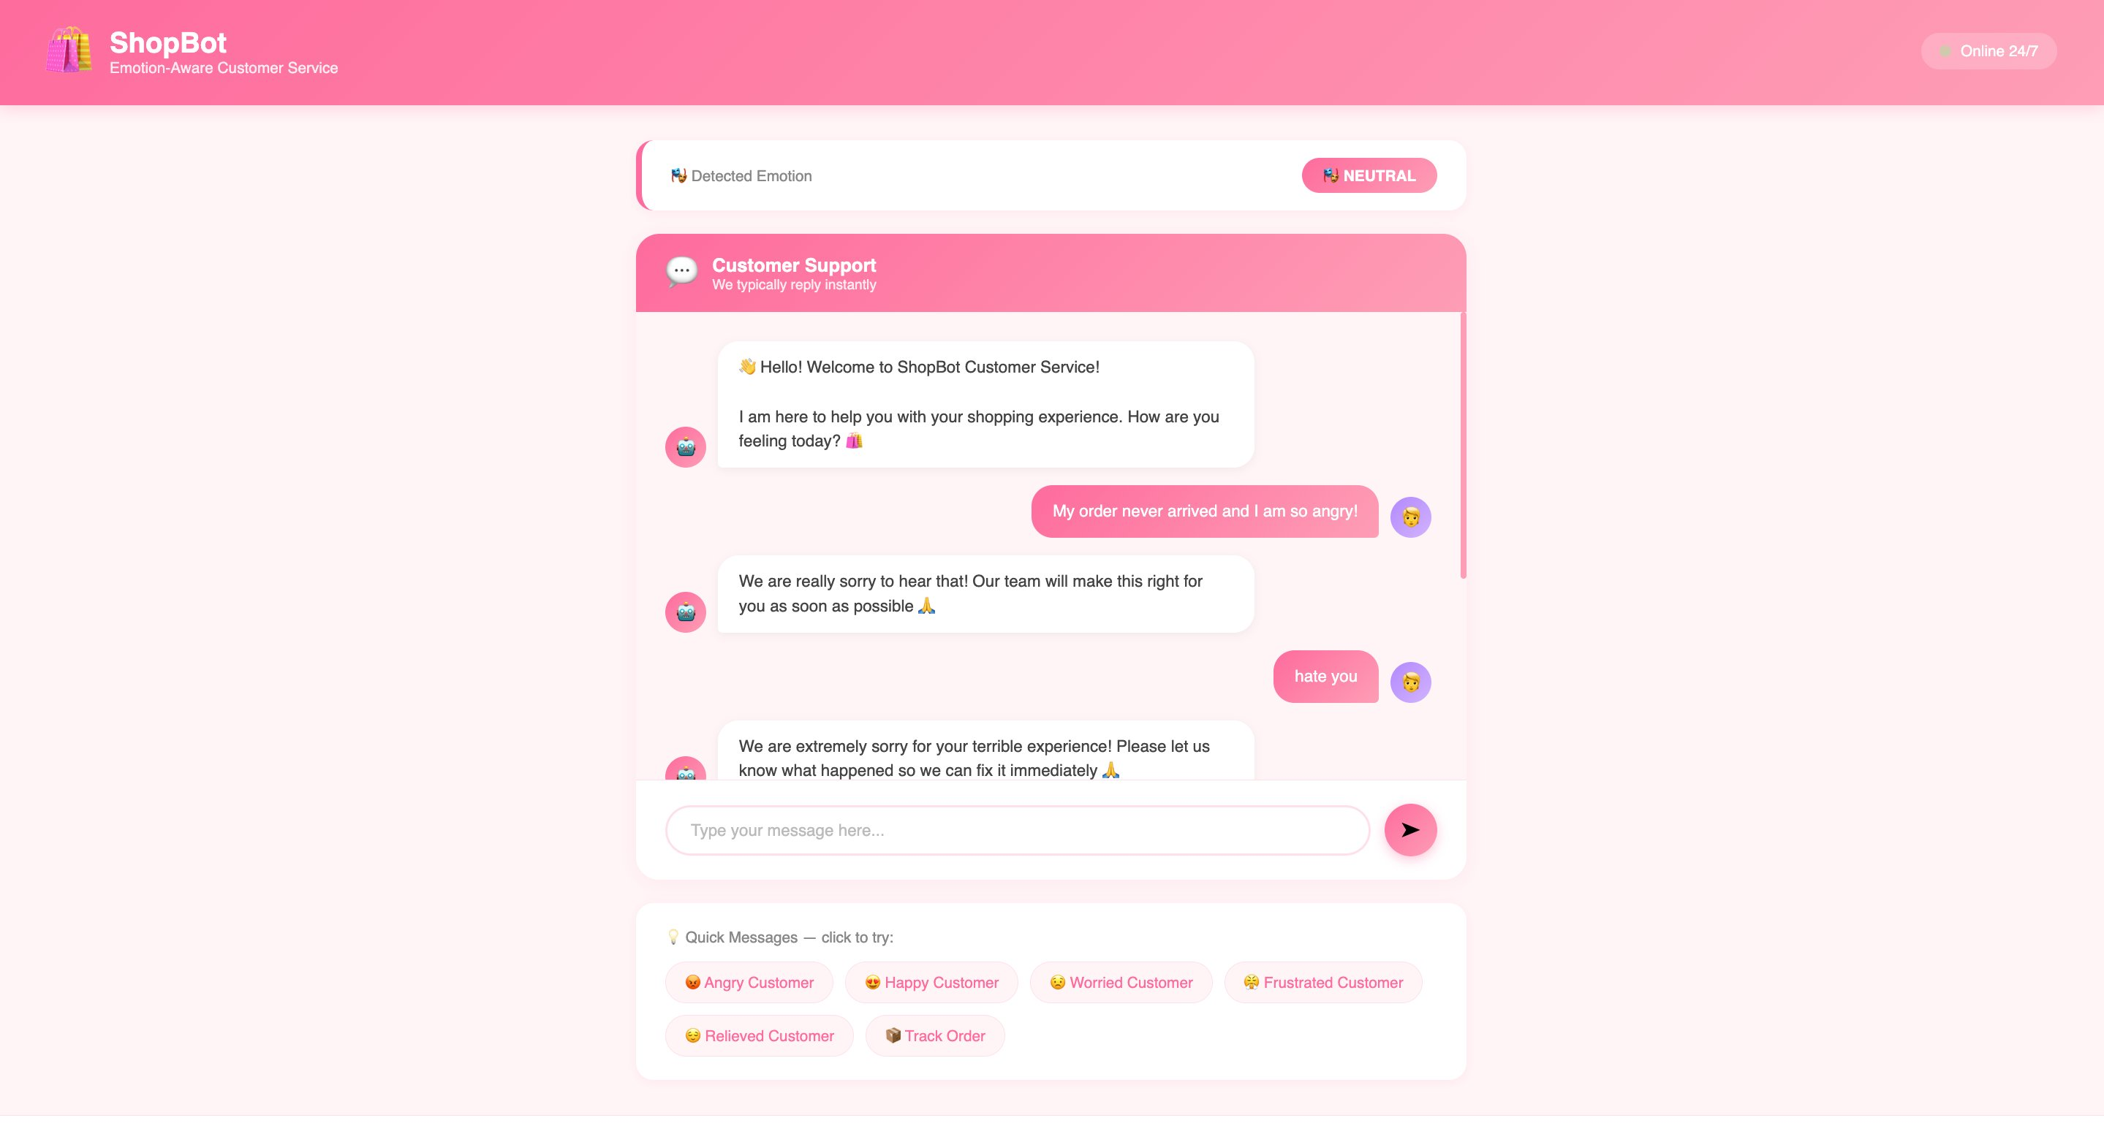

6. Technologies Used

Technology | Purpose
Python | Main programming language
NLTK | Natural Language Processing and text preprocessing
Scikit-learn | Machine learning model training and evaluation
TF-IDF Vectorizer | Converting text into numerical features
Logistic Regression | Emotion classification algorithm
Joblib | Saving and loading the trained model
Flask | Web framework for the chatbot interface
HTML & CSS | Frontend interface design
Pandas | Dataset loading and manipulation

7. Conclusion

This project successfully demonstrates an Emotion Detection system using NLP and machine learning. The Logistic Regression model achieved an accuracy of 90.94% in detecting 12 different emotions from text.

The emotion detection model was then applied to a real-world Shopping Customer Service Chatbot that gives tailored responses based on the customer's emotional state. This shows how emotion detection can be used to make AI systems more human-aware and effective in real life.

Developed By: Najia Khan
BSAI - 4B | PAI Project

