LAB-TASK-1

AI-LAB

NAME: NAJIA KHAN (123)

**Mini Project: To-Do list (Dynamic)**

1. My project is based on To-Do-List that store user daily task and help user to add, update, remove, and view tasks dynamically.
2. It will run infinite times due to while loop until the user enter done
3. Here dynamic means user can change task any time and it will be continue uploading the task until user type done
4. Here I create an empyt list where tasks willbe store tasks = [ ]
5. User will input task which will append into that empty list it will break after user types done
6. Each task will store in new line bcz of for loop
7. Then we have some functions that will make changes like user can add extra task after done function , user can update any task with the previous one, user can remove the task .
8. Loop will exit in 4th operation.

**Source code:**

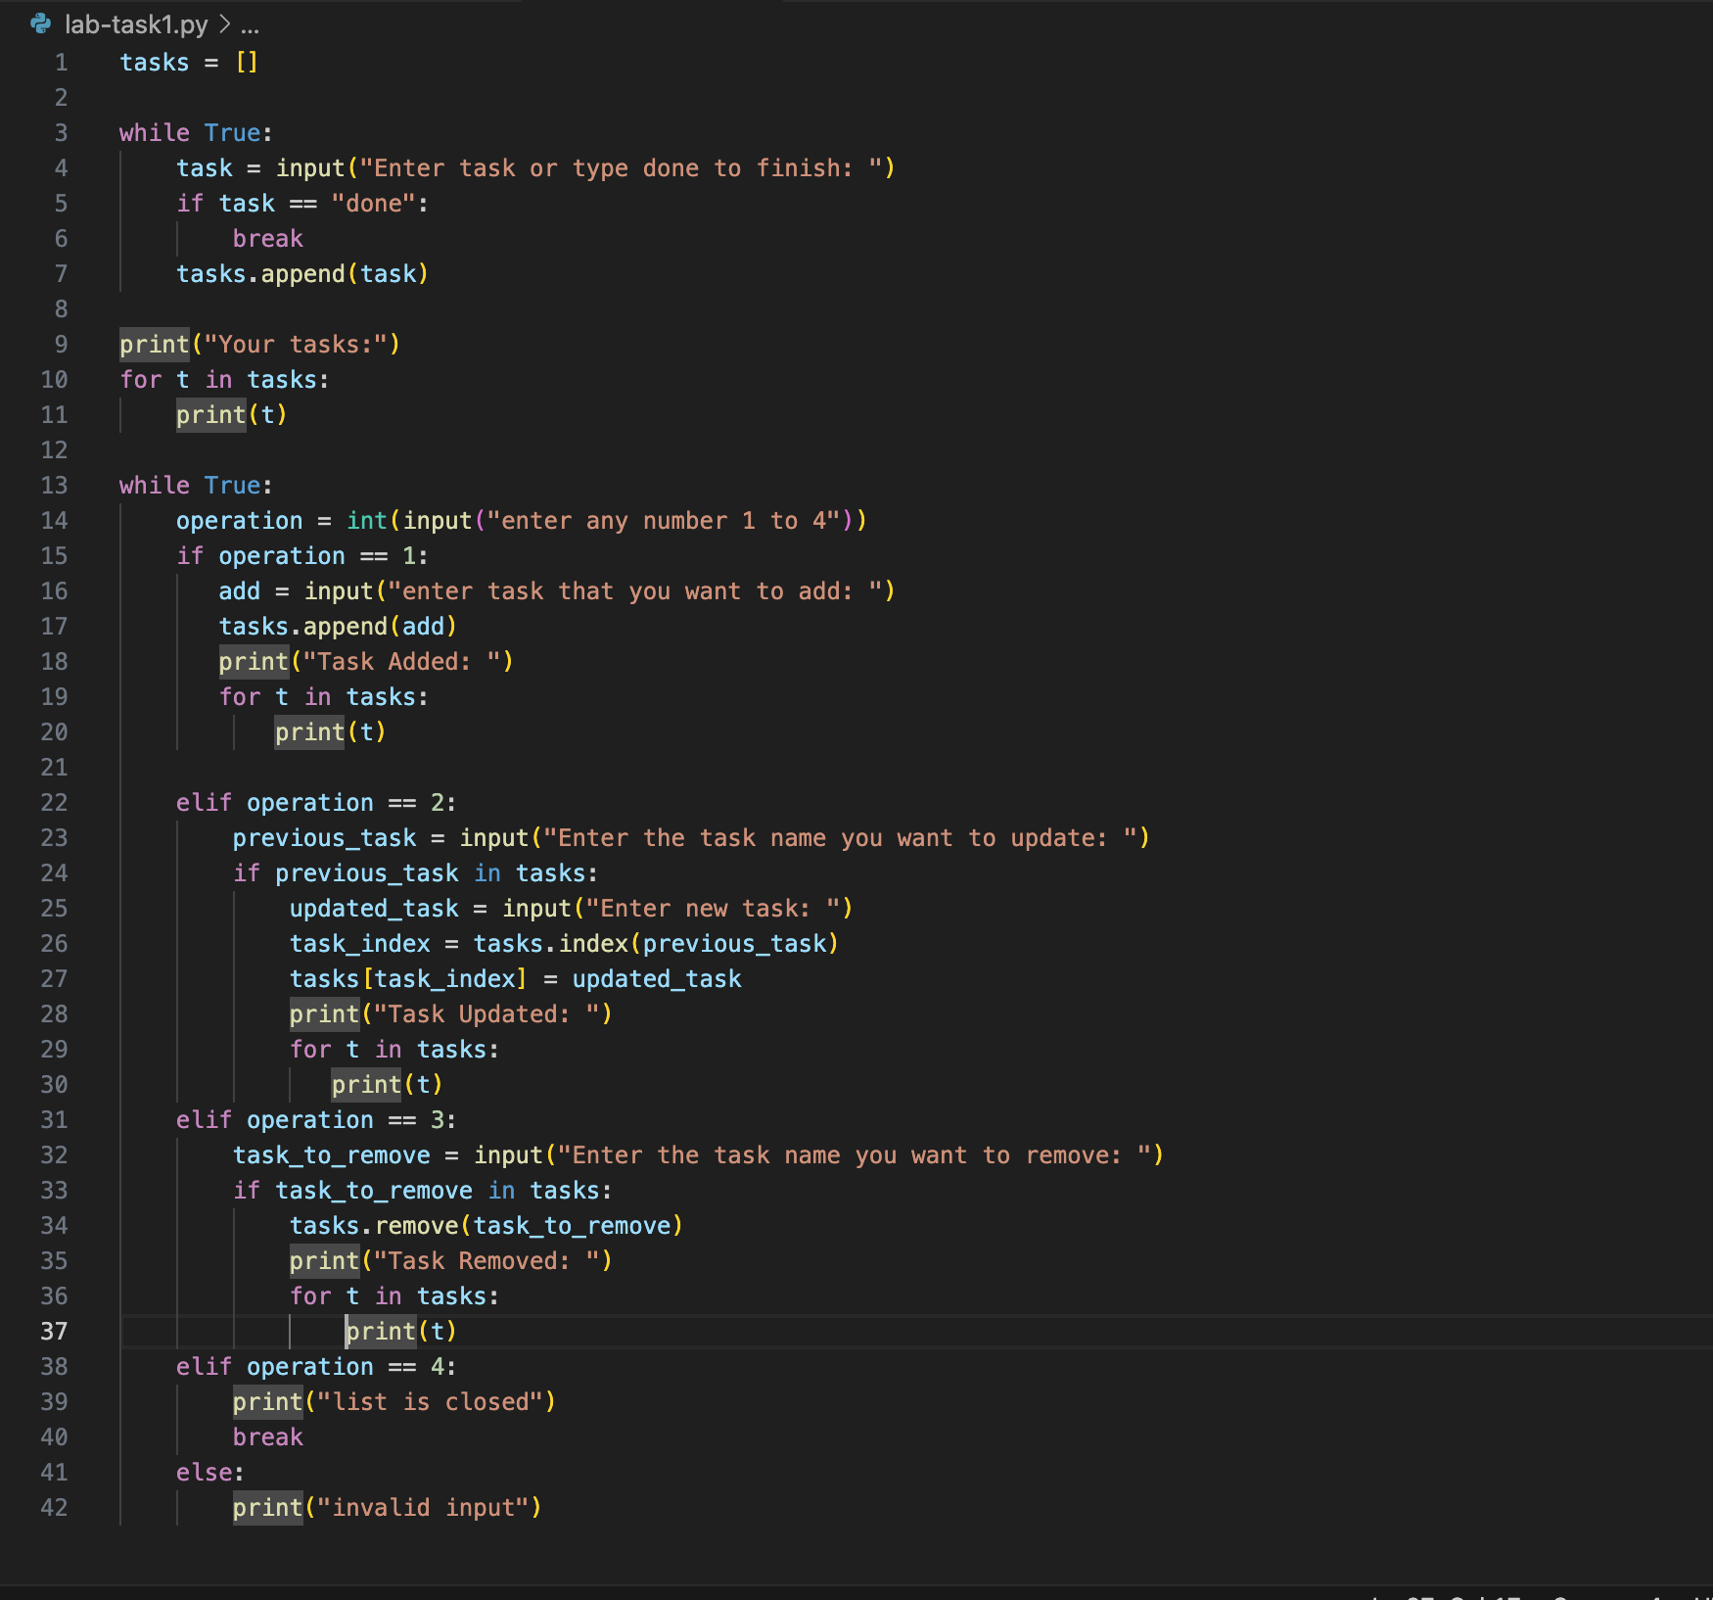

**Output:**

