Lab-task-4

Name: Najia Khan (123)

**1.Code for LUHN Algorithm**

The LUHN algorithm also known as the modulus 10 algorithm is a simple checksum formula used to validate identification numbers such as credit card numbers.This program demonstrates the LUHN algorithm in Python using an object-oriented approach with a class LUHN

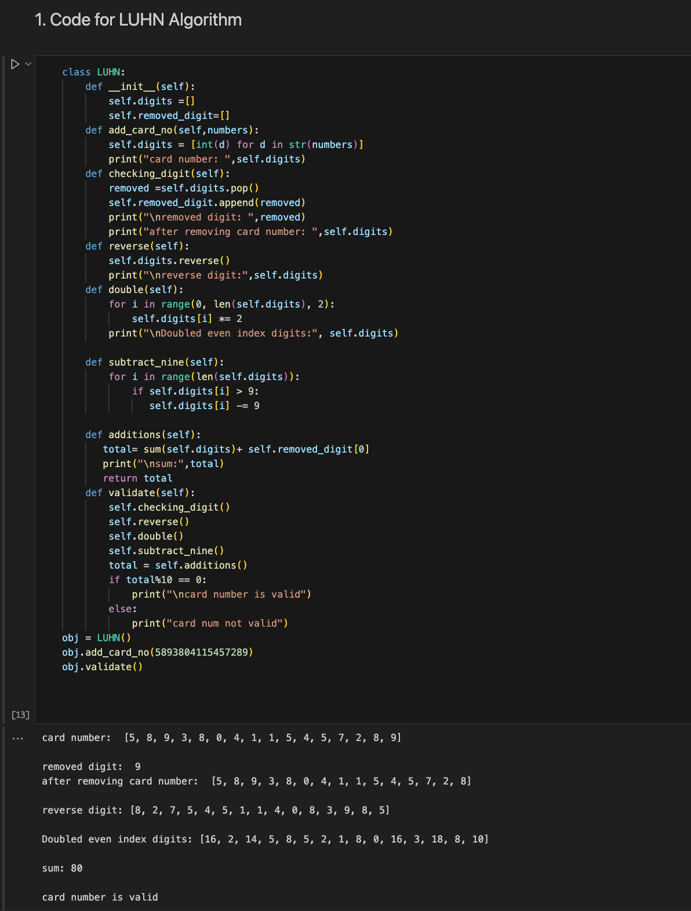

**2. Write a python program to remove punctuations from the given string?**

This program takes a sentence from the user and removes all special characters from it. It does this by checking each character of the sentence one by one and only keeping those characters that are not in the predefined list of special characters.Finally, it prints both the original sentence and the cleaned sentence without special symbols.

**3. Write a python program to sort the sentence in alphabetical order?**

**What the code does**

1. Takes a sentence from the user.
2. Splits the sentence into a list of words.
3. Uses the bubble sort algorithm to compare and swap words until they are in alphabetical order.
4. Prints the original sentence and the sorted list of words.

