Task-12
Task Title: Hotel Information QnA Bot using MiniLM and FAISS
Objective: The objective of this task is to build an AI-powered Hotel Information QnA Bot using Hugging Face MiniLM embeddings and FAISS vector search. The bot finds the most similar question from the dataset and returns the correct answer.
Dataset: We created a custom hotel QnA dataset with 20 question-answer pairs covering topics like room types, prices, amenities, booking, check-in, check-out, wifi, pool, gym, spa, location, contact, cancellation, pets, parking, airport transfer, breakfast, conference rooms and room service.
Pipeline:
First we preprocessed the dataset by cleaning the questions using lowercasing, punctuation removal and extra space removal.
Then we used Hugging Face MiniLM model (all-MiniLM-L6-v2) to convert cleaned questions into embeddings. MiniLM is a lightweight sentence transformer model that converts text into meaningful numerical vectors.
After that we stored these embeddings in a FAISS index. FAISS (Facebook AI Similarity Search) is a library that efficiently searches for the most similar vectors. We used IndexFlatL2 which finds the nearest vector using L2 distance.
When a user asks a question, we embed their query using the same MiniLM model and search the FAISS index for the most similar question. The answer corresponding to that question is then returned to the user.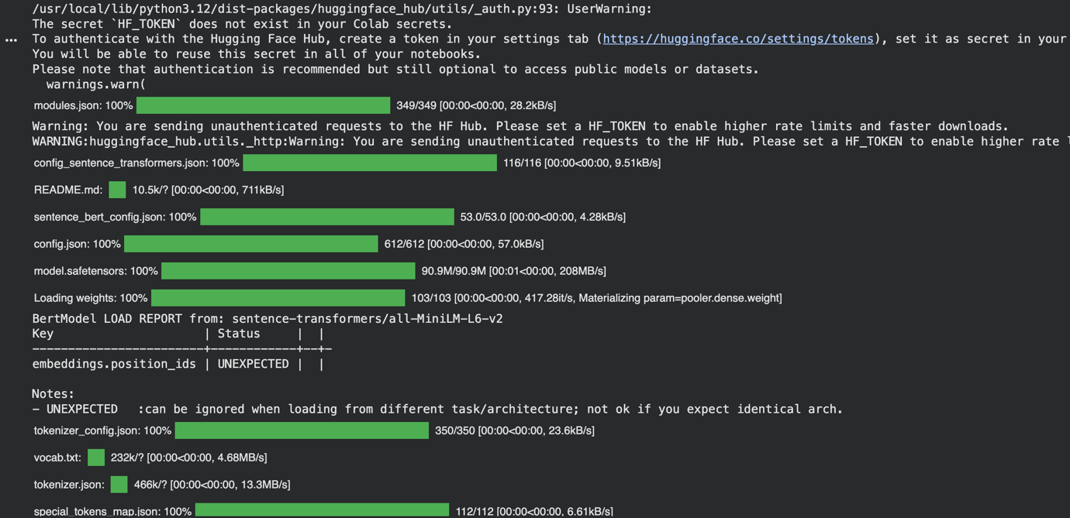
Finally we built a Flask web application with an HTML frontend where users can type their questions and get instant answers from the bot.
Technologies Used: Python, Pandas, Sentence Transformers, MiniLM, FAISS, NumPy, Flask, HTML and CSS.
Result: The bot successfully finds the most relevant answer for any hotel related query even if the user does not type the exact question. For example typing "whats your timing" correctly returns the checkout time answer.
