Lab-Task-14

Emotion Detection System
Applied as an Emotion-Aware Shopping Customer Service Chatbot
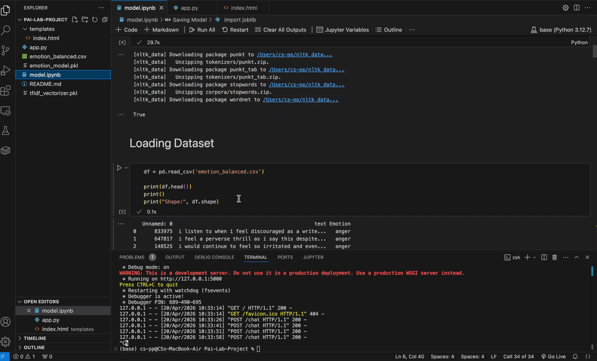
link: https://drive.google.com/file/d/17GXdOTrpwpfy1xDQI1oWhvvZcV2cKdMZ/view?usp=sharing

