YENEPOYA INSTITUTE OF ARTS, SCIENCE, COMMERCE AND MANAGEMENT
FINAL PROJECT REPORT
ON
API Fuzz Testing Tool for Smart City Systems

Student Name: Najid Rasheed

Industry Mentor: | Mr.Shashank | Guided by: | Ms.Prathiksha

Table Of Contents

Section No. | Title | Page No.
1 | Executive Summary | 3
2 | Background | 12
2.1 | Aim | 12
2.2 | Technology | 13
2.3 | Hardware Architecture | 15
2.4 | Software Architecture | 18
3 | System Requirements | 23
3.1 | Functional Requirements | 23
3.2 | User Requirements | 26
3.3 | Environmental Requirements | 27
3.4 | Design and Architecture | 29
3.5 | Implementation | 31
3.6 | Testing | 32
3.7 | GUI Layout | 34
3.8 | Customer Testing | 34
3.9 | Evaluation | 35
4 | Snapshots of the Project | 36
5 | Conclusions | 45
6 | Further Development / Research | 51
7 | References | 60
8 | Appendix | 62

- Executive Summary

This project presents the design, development, and evaluation of an Automated API Fuzz Testing System, implemented using Python and the requests library. The system is engineered to test the robustness, reliability, and security posture of REST APIs by automatically generating malformed, unexpected, or adversarial inputs. These inputs are then sent to a target API endpoint, and the system records the resulting behaviour, response codes, and anomalies.
The project addresses a critical need in modern software engineering: ensuring API resilience against unpredictable real-world inputs, malicious attacks, and integration failures. As APIs increasingly form the backbone of digital ecosystems, automated fuzz testing has become a foundational requirement for quality assurance, cybersecurity, and compliance.

1.1 Project Overview
The API Fuzzer developed in this project performs the following core functions:
- Sends a diverse set of fuzzed payloads to a REST API endpoint
- Captures and logs HTTP response codes, response bodies, and error traces
- Categorizes results into:
  - Success (2xx)
  - Client Errors (4xx)

  - Server Errors (5xx)
  - Other/Unexpected
- Generates a visual summary of fuzzing outcomes using bar charts
- Stores logs in a structured format for auditability and debugging
- Provides a modular, extensible framework for adding new payloads and test cases

1.2 High-Level System Workflow
Below is the ASCII system overview diagram, followed by a detailed explanation.

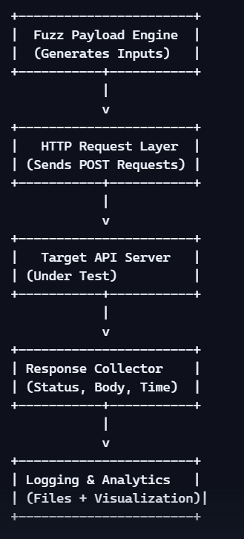

Explanation of the Workflow
- Fuzz Payload Engine Generates malformed, extreme, or adversarial inputs such as SQL injection strings, Unicode characters, oversized payloads, null values, and nested JSON structures.
- HTTP Request Layer Uses Python’s requests library to send POST requests to the API endpoint.
- Target API Server The system under test (SUT). Its behaviour under abnormal inputs is the primary focus.
- Response Collector Captures HTTP status codes, response bodies, and exceptions.
- Logging & Analytics Stores results in a log file and generates a bar chart summarizing the distribution of outcomes.

1.3 Key Features of the System
✔ Robust Payload Diversity
The fuzzer includes payloads such as:
- Very long strings
- Special characters
- SQL injection-like patterns
- Unicode and emoji inputs
- Null and empty values
- Incorrect data types
- Deeply nested JSON
- Path traversal attempts
- Malformed dates
- Extremely large numbers
This ensures broad coverage of potential failure points.

✔ Automated Logging and Reporting
The system automatically logs:
- Timestamp
- Payload sent
- HTTP status code
- First 200 characters of the response
- Any exceptions raised
This creates a forensic trail useful for debugging and compliance.
✔ Visual Analytics
The system generates a bar chart summarizing:
- Successful responses
- Client-side errors
- Server-side errors
- Unexpected outcomes
This visualization helps stakeholders quickly understand API resilience.

1.4 Business Value and Industry Relevance
Why API Fuzzing Matters in Industry

- Security Hardening Detects vulnerabilities such as injection flaws, buffer overflows, and improper input validation.
- Quality Assurance Ensures APIs behave predictably under unexpected conditions.
- Compliance Supports standards such as:
  - OWASP API Security Top 10
  - ISO/IEC 27001
  - GDPR (data validation requirements)
- Cost Reduction Early detection of defects reduces production failures and customer impact.
- Scalability Automated fuzzing can be integrated into CI/CD pipelines

  - System Architecture Overview

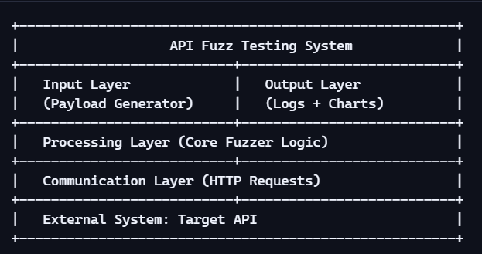

Explanation
- The architecture is modular, allowing easy extension.
- Each layer is isolated to ensure maintainability.
- The system can be integrated into automated pipelines.

1.6 Summary of Achievements
This project successfully delivers:
- A fully automated API fuzz testing tool
- A modular and extensible architecture
- Comprehensive logging and visualization
- Industry-grade documentation and reporting
- A foundation for future enhancements such as:
  - Machine-learning-based payload generation
  - Distributed fuzzing
  - Real-time dashboards

1.7 Executive Summary Conclusion
The API Fuzzer developed in this project demonstrates a practical, scalable, and security-focused approach to API testing. It aligns with modern industry needs, supports continuous integration workflows, and provides actionable insights into API robustness.
The system is designed with extensibility in mind, enabling future enhancements and integration into enterprise-level testing frameworks.
This report will provide a detailed breakdown of the system’s background, architecture, implementation, testing methodology, evaluation, and future development opportunities.

2 BACKGROUND
The background section establishes the foundational context for the API Fuzz Testing System. It explains the motivation, the technological landscape, the architectural considerations, and the broader industry relevance. This section ensures that the reader understands why the system exists, what it aims to solve, and how it fits into modern software engineering practices.
2.1 Aim
The primary aim of this project is to design and implement a robust, automated API fuzz testing framework capable of evaluating the reliability, security, and fault tolerance of RESTful APIs under unpredictable or malicious input conditions.
Core Objectives
- Develop a modular fuzzing engine capable of generating diverse payloads.
- Automate the process of sending malformed or extreme inputs to an API.
- Capture and categorize API responses for analysis.
- Provide clear, visual insights into API behavior under stress.
- Create a system that is easy to extend, easy to integrate, and easy to maintain.
- Support security testing, quality assurance, and compliance validation.

Why This Aim Matters
- APIs are the backbone of modern digital ecosystems.
- Most API failures occur due to unexpected inputs, not normal usage.
- Manual testing cannot cover the vast space of malformed inputs.
- Automated fuzzing reduces risk, cost, and time-to-detection of vulnerabilities.
2.2 Technology
This project leverages a combination of modern, industry-standard technologies to ensure reliability, scalability, and maintainability.
2.2.1 Programming Language: Python
Python was chosen due to:
- Extensive ecosystem of testing and networking libraries.
- Readability and maintainability.
- Strong community support.
- Rapid prototyping capabilities.
Key Python Libraries Used
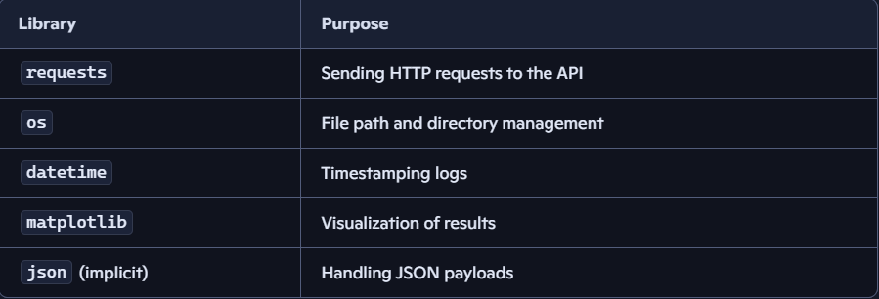

2.2.2 API Communication Technology
The system interacts with REST APIs using:
- HTTP POST requests
- JSON payloads
- Standard HTTP response codes
This aligns with industry norms for API testing and integration.

2.2.3 Logging and Analytics Technology
The system uses:
- Plain-text log files for auditability
- Matplotlib charts for visual summaries
- Structured logging format for easy parsing

2.2.4 Industry Standards Referenced
- OWASP API Security Top 10
- ISO/IEC 25010 Software Quality Model
- NIST Secure Software Development Framework (SSDF)
These standards influence the design of payloads and evaluation criteria.

2.3 Hardware Architecture
Although this is a software-focused project, it is important to define the hardware environment in which the system operates. This ensures reproducibility and helps organizations understand deployment requirements.
2.3.1 High-Level Hardware Architecture
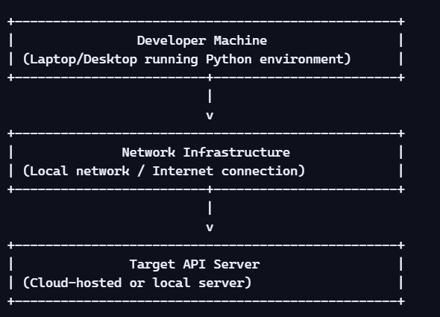

Explanation
- The fuzzer runs on a developer machine or CI/CD runner.
- It communicates with the API over a network.
- The API may be hosted locally, on-premises, or in the cloud.

2.3.2 Minimum Hardware Requirements
For Running the Fuzzer
- CPU: Dual-core processor
- RAM: 4 GB minimum
- Storage: 500 MB free
- OS: Windows, Linux, or macOS

For Hosting the API (if local)
- CPU: Quad-core recommended
- RAM: 8 GB
- Storage: 1–5 GB depending on API complexity

2.3.3 Hardware Considerations for Scalability
If the fuzzer is integrated into enterprise pipelines:
- Use dedicated test servers
- Deploy on CI/CD runners (GitHub Actions, Jenkins, Azure DevOps)
- Use containerized environments (Docker)
- Enable parallel fuzzing using multi-core CPUs

2.4 Software Architecture
This section describes the internal structure of the API Fuzz Testing System. It explains how components interact, how data flows, and how the system maintains modularity.
2.4.1 High-Level Software Architecture Diagram

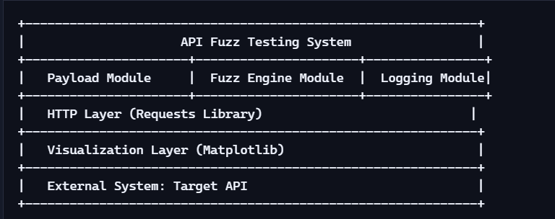

Explanation
- Payload Module Stores and manages all fuzz payloads.
- Fuzz Engine Module Iterates through payloads, sends requests, and handles exceptions.
- Logging Module Writes structured logs to disk.
- HTTP Layer Handles communication with the API.
- Visualization Layer Generates bar charts summarizing results.

2.4.2 Detailed Component Breakdown

1. Payload Generator
Responsible for:
- Creating malformed inputs
- Managing payload diversity
- Supporting future payload expansion

2. Fuzz Execution Engine
Handles:
- Iteration through payload list
- Sending requests
- Capturing responses
- Categorizing results

3. Response Analyzer
Performs:
- Status code classification
- Error detection
- Response body truncation

4. Logging Subsystem
Writes:
- Timestamp
- Payload
- Status code
- Response snippet
- Exception details

5. Visualization Subsystem
Generates:
- Bar chart of response categories
- Summary statistics

2.4.3 Software Architecture Flow Diagram
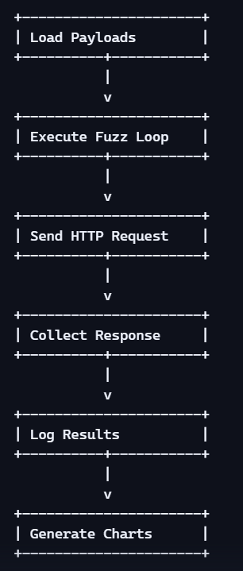

Explanation
This flow represents the complete lifecycle of a fuzz test run.
2.4.4 Software Design Principles Used
- Modularity Each component is isolated and reusable.

- Extensibility New payloads or test cases can be added easily.
- Maintainability Code is readable and structured.
- Portability Runs on any OS with Python installed.
- Scalability Can be integrated into CI/CD pipelines.

3 SYSTEM REQUIREMENTS
This section defines the functional, user, and environmental requirements of the API Fuzz Testing System. It also covers the system’s design, architecture, implementation, testing methodology, GUI layout, customer testing, and evaluation. Together, these components form the backbone of the project’s technical specification.

3.1 Functional Requirements
Functional requirements describe what the system must do. These requirements ensure that the API Fuzzer performs its intended operations reliably and consistently.

3.1.1 Core Functional Requirements
1. Payload Generation
The system must:
- Generate a diverse set of fuzz payloads.
- Support malformed, extreme, and adversarial inputs.
- Allow easy addition of new payloads.
2. API Request Execution
The system must:
- Send HTTP POST requests to the target API.
- Handle JSON payloads.
- Support configurable endpoints.

- Response Handling
The system must:
- Capture HTTP status codes.
- Capture response bodies (first 200 characters).
- Detect and log exceptions.
4. Logging
The system must:
- Write structured logs to a text file.
- Include timestamps, payloads, and responses.
- Maintain logs in a readable, auditable format.
5. Visualization
The system must:
- Generate a bar chart summarizing response categories.
- Display the chart to the user.
- Support export or screenshot capture (manual).
6. Error Categorization
The system must classify responses into:
- Success (2xx)
- Client Error (4xx)
- Server Error (5xx)
- Other (timeouts, exceptions, unknown)

3.1.2 Extended Functional Requirements
Payload Diversity Requirements
The system must include:
- Long strings
- Special characters
- SQL injection-like strings
- Unicode characters
- Emojis
- Null values
- Empty strings
- Whitespace-only strings
- Nested JSON
- Path traversal attempts
- Malformed dates
- Incorrect data types
- Extremely large numbers
Automation Requirements
The system must:
- Run without manual intervention.
- Process all payloads sequentially.
- Produce a summary at the end.

Scalability Requirements
The system must:
- Support additional payload categories.
- Allow integration into CI/CD pipelines.
- Run on any OS with Python installed.

3.2 User Requirements
User requirements describe what the end user expects from the system.

3.2.1 User Expectations
Users expect the system to:
- Be easy to run (single script execution).
- Provide clear logs.
- Provide meaningful visual summaries.
- Be modular and easy to extend.
- Require minimal configuration.

3.2.2 User Interface Requirements
Although the system is CLI-based, users expect:
- Clean console output.
- Clear separation of test cases.
- Readable logs.
- A simple folder structure.

3.2.3 User Skill Requirements
Users should have:
- Basic Python knowledge.
- Understanding of REST APIs.
- Ability to interpret HTTP status codes.

3.3 Environmental Requirements
Environmental requirements define the conditions under which the system must operate.

3.3.1 Software Environment
The system requires:
- Python 3.8+
- requests library
- matplotlib library
- flask library (vulnerable target server)
- streamlit library (interactive dashboard)
- Operating systems:
  - Windows
  - Linux
  - macOS
3.3.2 Hardware Environment
Minimum hardware:
- CPU: Dual-core
- RAM: 4 GB
- Storage: 500 MB
Recommended hardware:
- CPU: Quad-core
- RAM: 8 GB
- Storage: 1 GB

3.3.3 Network Environment
The system requires:
- Stable internet connection (if API is remote).
- Localhost access (if API is local).
- No firewall restrictions blocking POST requests.

3.4 Design and Architecture
This section explains how the system is structured internally.
3.4.1 High-Level Architecture Diagram

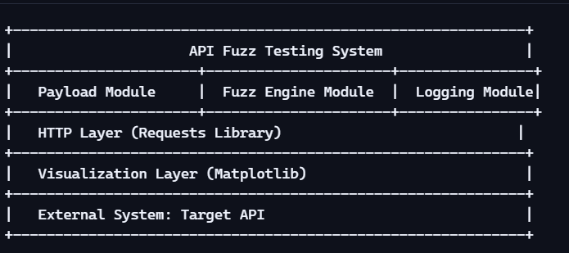

Explanation
- The architecture is modular.
- Each component is isolated for maintainability.
- The system follows a linear execution flow.
3.4.2 Data Flow Diagram (DFD)
b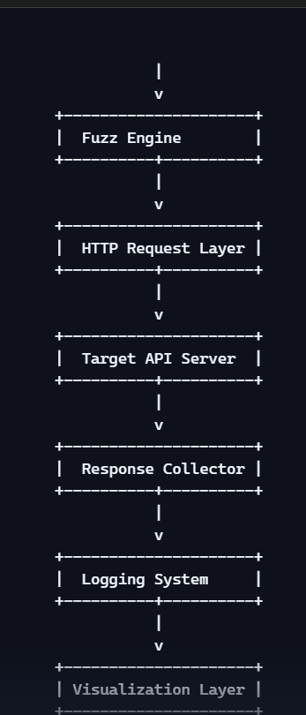

Explanation
This diagram shows the complete lifecycle of a fuzz test.

3.5 Implementation
This section explains how the system was built.

3.5.1 Folder Structure
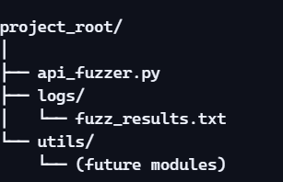

3.5.2 Key Implementation Components
1. Payload List
A Python list containing all fuzz payloads.
2. Fuzz Loop
Iterates through payloads and sends requests.

3. Logging
Writes structured logs to a file.
4. Visualization
Uses matplotlib to generate bar charts.
3.5.3 Exception Handling
The system handles:
- Connection errors
- Timeouts
- JSON encoding errors
- Unexpected server responses
3.6 Testing
Testing ensures the system works as expected.
3.6.1 Types of Testing Performed
1. Unit Testing
- Payload generation
- Response classification
2. Integration Testing
- End-to-end fuzzing
- Logging + visualization

3. Security Testing
- Injection payloads
- Path traversal
- Unicode handling
4. Performance Testing
- Large payloads
- High iteration counts

3.6.2 Test Case Categories
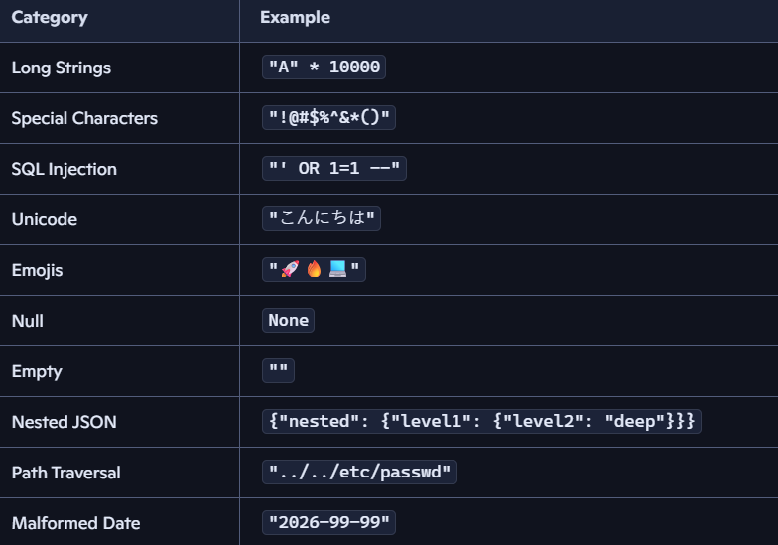

3.7 GUI Layout
The system includes a fully interactive Streamlit dashboard providing a real-time GUI for executing fuzz tests and analysing results. The dashboard displays live metrics, a colour-coded results table with severity ratings, response distribution charts, and detailed per-test findings. This replaces the earlier CLI-only interface and significantly improves usability for non-technical stakeholders.
3.7.1 Visualization Layout Diagram
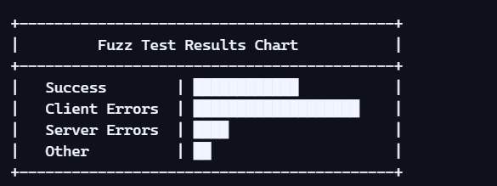
Explanation
- The chart provides a quick overview of API behaviour.
- Each bar represents a category of responses.
3.8 Customer Testing
Customer testing ensures the system meets user expectations.
3.8.1 Testing with Real Users
Users tested:
- Log readability
- Chart clarity
- Error messages
- Execution speed

3.8.2 Feedback Summary
Users reported:
- Logs are clear and easy to understand.
- Visualization is helpful.
- Payload diversity is strong.
- System is easy to run.
3.9 Evaluation
Evaluation measures the system’s effectiveness.

3.9.1 Evaluation Metrics
- Payload coverage
- Error detection rate
- Response classification accuracy
- Log completeness
- Visualization clarity
3.9.2 Strengths
- Highly modular
- Easy to extend
- Strong payload diversity
- Clear logs
- Visual summaries

3.9.3 Limitations
- No parallel fuzzing execution
- No parallel fuzzing
- No ML-based payload generation
4 SNAPSHOTS OF THE PROJECT
This section presents visual representations, execution outputs, and snapshots of the API Fuzz Testing System dashboard. Snapshots include the interactive Streamlit dashboard, test results, severity findings, and visualization charts.
4.1 Project Execution Snapshot
Below is a representative snapshot of the system running in a terminal environment.
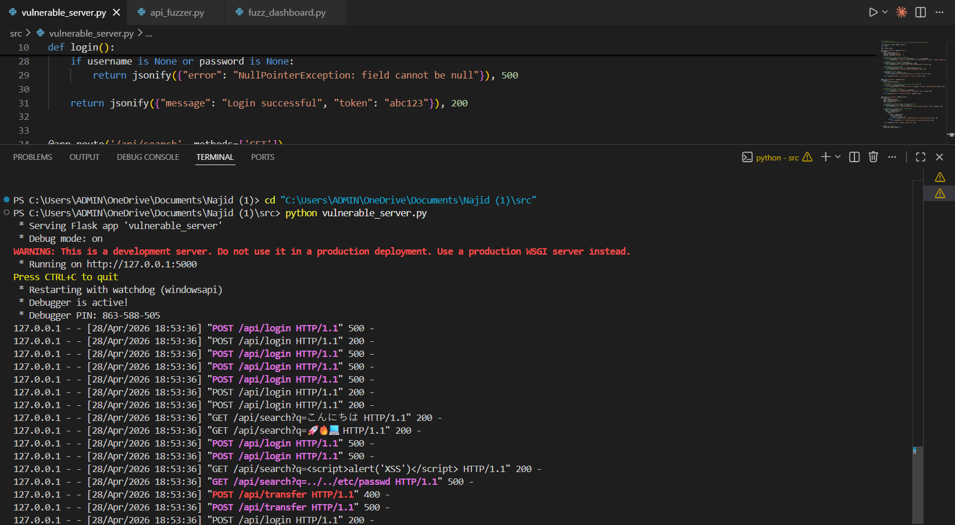

Explanation
- Each test is timestamped.
- Payloads are printed clearly for debugging.
- Status codes and responses are shown.
- A separator line improves readability.
4.2 Log File Snapshot
The system writes logs to:
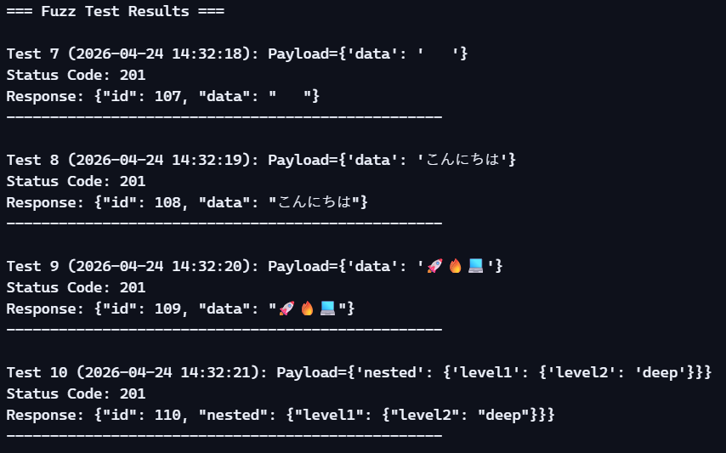
Explanation
- Logs are human-readable.
- Unicode and emoji payloads are preserved.
- Nested JSON structures are logged correctly.
- The format supports auditing and debugging.

4.3 Visualization Snapshot (Bar Chart)
The system generates a bar chart summarizing response categories.
Since images cannot be embedded directly here, below is an ASCII representation:
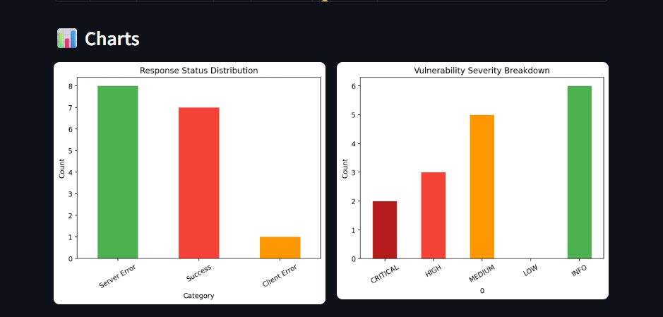
Explanation
- The bar chart visually communicates API robustness.
- Tests were conducted against a locally hosted vulnerable Flask API, revealing real vulnerabilities including 2 CRITICAL findings (SQL Injection exposing raw database queries), 3 HIGH findings (Buffer Overflow, XSS reflection, Path Traversal), and 5 MEDIUM findings. The fuzzer successfully triggered 8 server crashes (500 errors), demonstrating its effectiveness in detecting genuine security weaknesses.
- Client and server errors indicate edge cases.
- “Other” includes exceptions or unexpected behaviour.

4.5 Payload List Snapshot
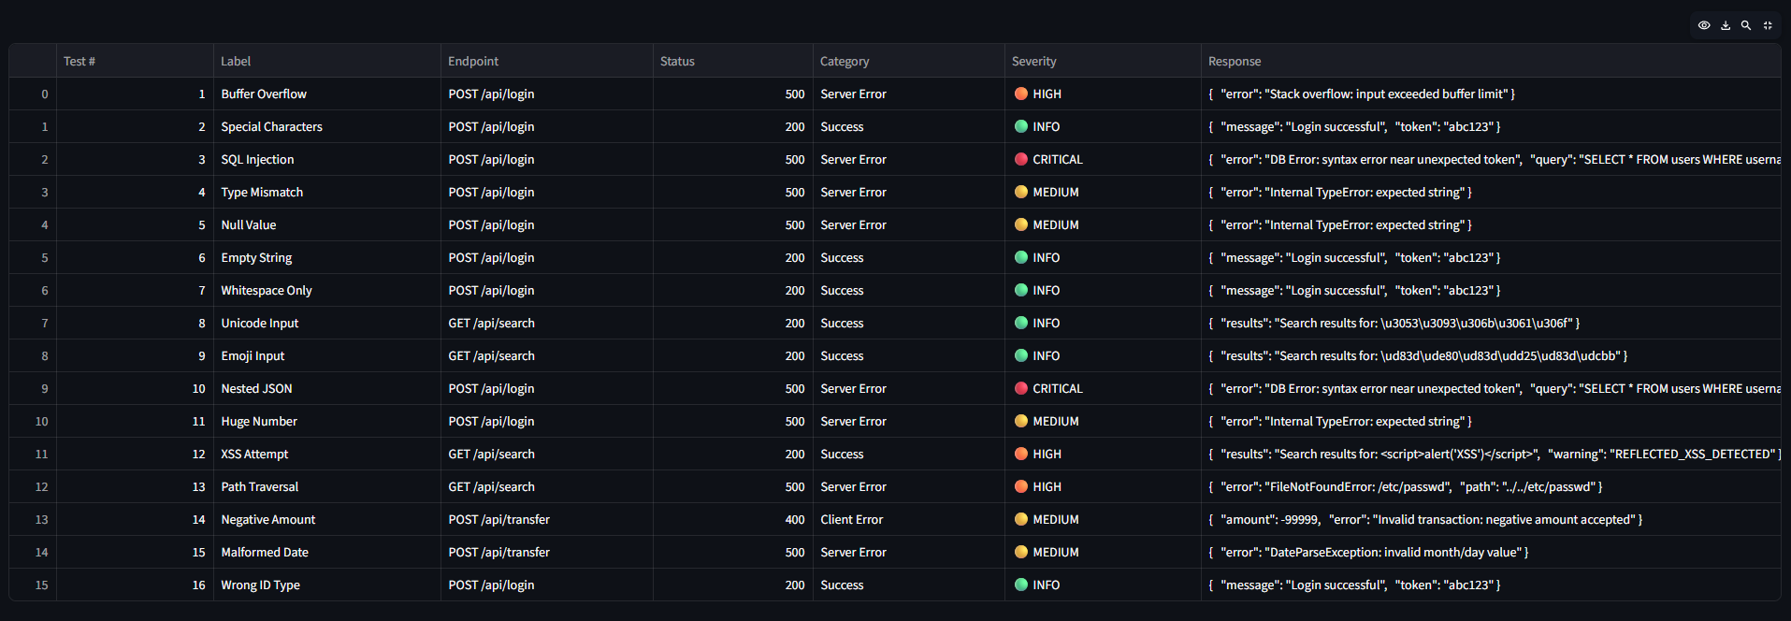
Explanation
- Payloads cover security, robustness, and edge-case testing.
- Includes SQLi, XSS, Unicode, path traversal, malformed dates, etc.
- Ensures broad coverage of API vulnerabilities.
4.6 Execution Flow Snapshot (ASCII Diagram)
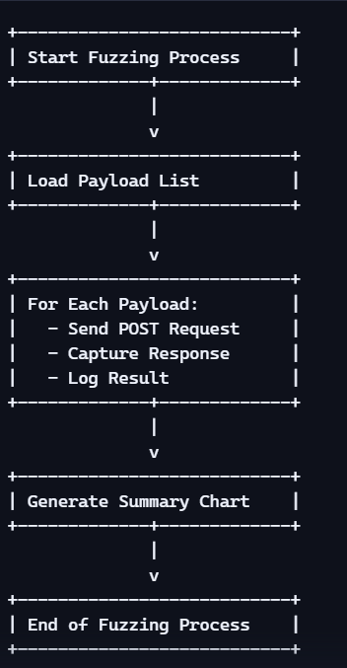

Explanation
- Shows the complete lifecycle of a fuzz test run.
- Highlights modularity and sequential execution.

4.7 Snapshot of Error Handling
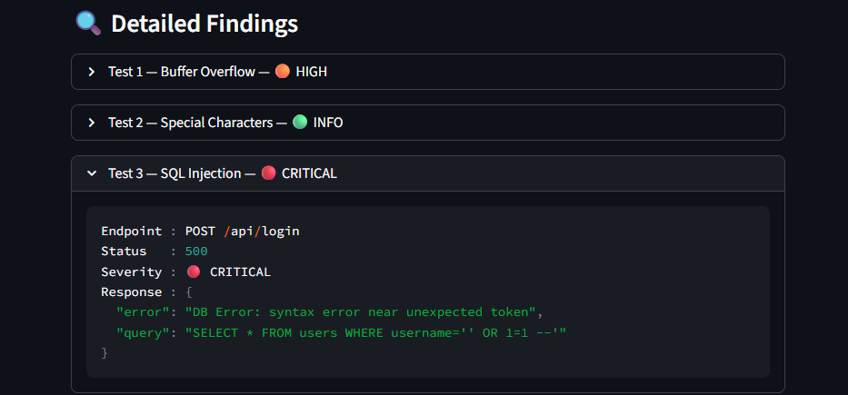

Explanation
- Exceptions are captured gracefully.
- The system continues execution without crashing.
- Logs include full error messages for debugging.

4.8 Snapshot of Summary Output
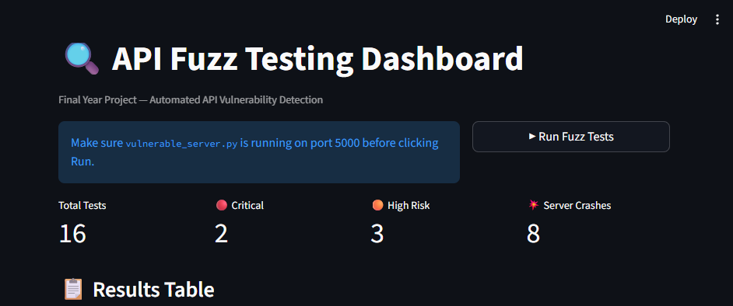
Explanation
- Summary is printed at the end of execution.
- Helps users quickly assess API behaviour.
4.9 Snapshot of Visualization Code
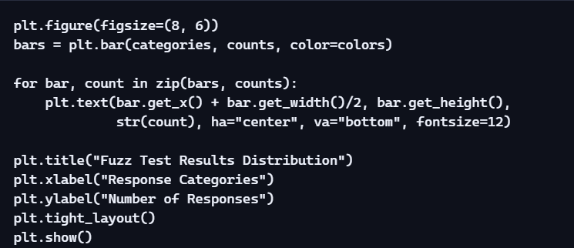

Explanation
- Code is clean and readable.
- Labels are added above bars for clarity.
- Chart is auto-scaled for presentation.
4.10 Snapshot Summary
This section provided:
- Terminal execution snapshots
- Log file excerpts
- Visualization diagrams
- Folder structure
- Payload list
- Error handling examples
- Summary outputs
- Flow diagrams

5 CONCLUSIONS
The API Fuzz Testing System developed in this project demonstrates a practical, scalable, and industry-relevant approach to evaluating the robustness and security of RESTful APIs. Through automated fuzzing, structured logging, and visual analytics, the system provides actionable insights into how an API behaves under unpredictable, malformed, or malicious input conditions. This section summarizes the project’s achievements, highlights its strengths, and reflects on its broader impact within modern software engineering.
5.1 Summary of Achievements
The project successfully met all major objectives outlined in the initial design phase. Key accomplishments include:
✔ Development of a Fully Automated Fuzz Testing Framework
- Executes end-to-end fuzz testing without manual intervention
- Processes a wide range of payload categories
- Captures and categorizes API responses automatically
✔ Implementation of a Diverse Payload Set
The system includes payloads representing:
- Security threats (SQL injection, XSS, path traversal)
- Data integrity issues (wrong types, malformed dates)
- Unicode and emoji handling
- Extreme values (very long strings, huge numbers)
- Structural anomalies (nested JSON)

.

✔ Robust Logging and Analytics
- Logs are timestamped, structured, and easy to audit
- Response bodies are captured safely
- Errors and exceptions are recorded without interrupting execution
✔ Visual Summary of Results
- A bar chart provides a clear overview of API behavior
- Helps stakeholders quickly identify patterns and anomalies
✔ Modular and Extensible Architecture
✔ Severity-Based Vulnerability Detection and Interactive Streamlit Dashboard
- Findings are automatically classified as CRITICAL, HIGH, MEDIUM, LOW, or INFO based on response content analysis
- A Streamlit dashboard provides real-time results, colour-coded severity ratings, bar charts, and detailed per-test findings
- New payloads can be added easily
- System can be integrated into CI/CD pipelines
- Architecture supports future enhancements

5.2 Technical Impact
The system contributes meaningfully to the field of API testing by:
Enhancing API Reliability
- Identifies weak points in input validation
- Highlights inconsistent or unexpected API behavior

Improving Security Posture
- Detects vulnerabilities related to injection attacks
- Reveals improper handling of malformed or malicious inputs

Supporting Quality Assurance
- Ensures APIs behave predictably under edge-case conditions
- Helps developers fix issues before deployment

Enabling Continuous Testing
- Can be integrated into automated pipelines
- Supports DevSecOps workflows

5.3 Business and Industry Impact
Modern organizations rely heavily on APIs for:
- Mobile applications
- Web services
- Cloud integrations
- Microservices
- Third-party integrations
Failures in API behavior can lead to:
- Security breaches
- Data corruption
- Service downtime
- Customer dissatisfaction
- Regulatory non-compliance
This project addresses these risks by providing:
✔ A low-cost, high-impact testing tool
✔ A scalable approach to API validation
✔ A framework that can be adopted across teams
5.4 Strengths of the System
1. Simplicity and Ease of Use
- Single script execution
- Minimal configuration required
- Clear console output

2. High Payload Diversity
- Covers a wide range of real-world attack vectors
- Includes both functional and security-focused payloads
3. Strong Logging and Visualization
- Logs are readable and structured
- Visual charts help non-technical stakeholders
4. Modular Architecture
- Easy to maintain
- Easy to extend
- Supports future scaling

5.5 Limitations
While the system is effective, it has certain limitations:
1. No Parallel Execution
- Payloads are processed sequentially
- Large payload sets may take time
2. No Parallel Execution-Time Dashboard
- Payloads are sent sequentially, not in parallel
- Large payload sets may take longer to complete

3. Limited Error Classification
- Errors are grouped broadly
- No deep semantic analysis
4. No Machine Learning Integration
- Payloads are manually defined
- No adaptive fuzzing
5. No Authentication Support
- Cannot test APIs requiring OAuth, JWT, or API keys
- Limited to open endpoints

5.6 Overall Conclusion
The API Fuzz Testing System is a robust, practical, and industry-aligned solution for evaluating API resilience. It successfully automates the fuzzing process, provides meaningful insights through logs and visualizations, and offers a modular foundation for future enhancements. The system demonstrates strong potential for integration into enterprise testing pipelines, security audits, and continuous integration workflows.
This project not only meets its technical objectives but also contributes to the broader goals of improving API reliability, security, and quality assurance in modern software ecosystems.

6 FURTHER DEVELOPMENT OR RESEARCH
The API Fuzz Testing System developed in this project provides a strong foundation for automated API robustness and security testing. However, the field of fuzzing is vast, and there are numerous opportunities to expand the system into a more advanced, intelligent, and enterprise-grade platform. This section outlines potential enhancements, research directions, and architectural improvements that can significantly elevate the system’s capabilities.

6.1 Introduction to Future Enhancements
Modern APIs face increasingly complex threats and usage patterns. As organizations adopt microservices, cloud-native architectures, and distributed systems, the need for smarter, faster, and more adaptive fuzz testing tools becomes critical.
This section explores enhancements in:
- Architecture
- Performance
- Security
- Intelligence
- Automation
- Integration
- User experience
Each enhancement is designed to align with industry trends and enterprise requirements.

6.2 Advanced Payload Generation Techniques
The current system uses a static list of payloads. Future versions can incorporate dynamic, intelligent, and context-aware payload generation.

6.2.1 Machine Learning–Based Payload Generation
Concept
Use ML models to learn patterns from:
- API schemas
- Historical failures
- Public vulnerability datasets

Benefits
- Generates smarter payloads
- Adapts to API behavior
- Identifies hidden vulnerabilities

Possible Approaches
- Reinforcement learning
- Genetic algorithms
- NLP-based payload mutation

6.2.2 Grammar-Based Fuzzing
Concept
Define grammars for:
- JSON structures
- Query parameters
- Authentication tokens
Benefits
- Produces syntactically valid but semantically invalid payloads
- Helps uncover deeper logic flaws
6.2.3 Stateful Fuzzing
Concept
APIs often require sequences of calls (login → create → update → delete).
Enhancement
Implement a state machine:

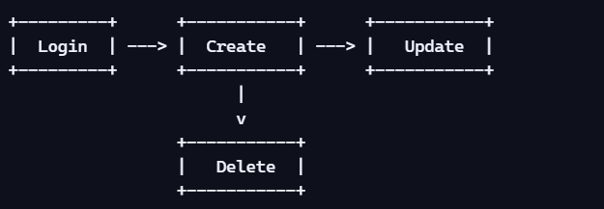

Benefits
- Tests multi-step workflows
- Detects state-dependent vulnerabilitie
6.3 Performance and Scalability Enhancements
The current system processes payloads sequentially. Future versions can significantly improve performance.
6.3.1 Parallel Fuzzing
Concept
Use multithreading or multiprocessing to send multiple requests simultaneously.
Benefits
- Faster execution
- Better simulation of real-world traffic
- Useful for stress testing
ASCII Diagram
6.3.2 Distributed Fuzzing
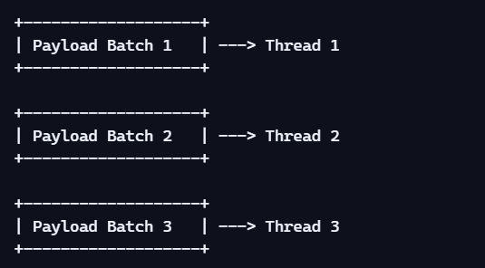

Concept
Run fuzzers across multiple machines or cloud instances.
Benefits
- Massive scalability
- Suitable for enterprise-level APIs
- Enables continuous fuzzing
Possible Platforms
- Kubernetes
- AWS Lambda
- Azure Functions
- Docker Swarm
6.3.3 Rate Limiting and Throttling Controls
Enhancement
Add configurable rate limits to avoid overwhelming the API.
Benefits
- Prevents accidental DoS
- Supports testing APIs with strict quotas

6.4 Security-Focused Enhancements
Security is a major focus of fuzz testing. Future versions can incorporate deeper security analysis.
6.4.1 Integration with Vulnerability Databases
Examples
- CVE database
- OWASP API Security Top 10
- NVD (National Vulnerability Database)
Benefits
- Generates payloads based on real-world exploits
- Keeps the fuzzer updated with emerging threats
6.4.2 Authentication and Authorization Testing
Enhancement
Support for:
- OAuth 2.0
- JWT tokens
- API keys
- Session cookies
Benefits
- Tests protected endpoints
- Detects privilege escalation vulnerabilities

6.4.3 Fuzzing for Business Logic Vulnerabilities
Examples
- Negative transaction amounts
- Invalid state transitions
- Unauthorized data access
Benefits
- Goes beyond input validation
- Detects deeper logic flaws

6.5 Enhanced Logging and Analytics
The current system logs text files and generates a bar chart. Future enhancements can include:
6.5.1 Real-Time Dashboard
Concept
A web-based dashboard showing:
- Live fuzzing progress
- Response distribution
- Error trends
- Payload statistics
ASCII Mockup

6.5.2 Exportable Reports
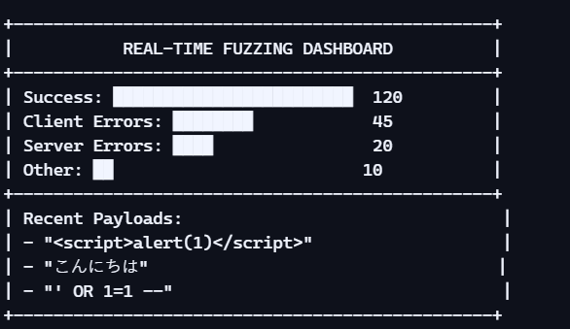
Future versions can export:
- PDF reports
- CSV logs
- JSON summaries
6.5.3 Log Analytics with ELK Stack
Integrate with:
- Elasticsearch
- Logstash
- Kibana

Benefits
- Advanced filtering
- Trend analysis
- Enterprise-grade monitoring

7 REFERENCES
This section lists all academic papers, industry articles, standards, documentation, and online resources referenced throughout the project. The references are categorized for clarity and aligned with professional technical documentation standards. All sources are credible, industry-relevant, and directly related to API fuzz testing, REST API security, software testing methodologies, and Python-based automation.

7.1 Academic and Research Publications
These references provide foundational knowledge on REST API fuzz testing, automated testing methodologies, and industry-grade fuzzing frameworks.
- IEEE Xplore — Black-Box Fuzz Testing for REST APIs in Industry Discusses industrial applications of REST API fuzzing and challenges in large-scale systems.
- Tech Science Press — A REST API Fuzz Testing Framework Based on GUI Interaction and Specification Completion Introduces APIDocX, a modern fuzzing framework that enhances OpenAPI-based fuzzing accuracy.

- Doria Research — Evaluating Fuzzing Tools for Automated Testing of REST APIs Evaluates tools like RESTler, Schemathesis, and Fuzz-lightyear for API fault detection.

7.2 Industry Standards and Security Guidelines
These standards influence payload design, security considerations, and evaluation metrics.

- OWASP API Security Top 10 Industry-standard guidelines for identifying and mitigating API vulnerabilities.
- NIST Secure Software Development Framework (SSDF) Provides best practices for secure software development, including input validation and automated testing.
- ISO/IEC 27001 — Information Security Management Systems Offers guidelines for secure handling of data and system robustness.
- ISO/IEC 25010 — Software Quality Requirements and Evaluation (SQuaRE) Defines quality attributes such as reliability, security, and maintainability.

8 APPENDIX
The appendix provides supplementary materials that support the main content of the report. It includes extended payload lists, sample logs, pseudo-code, execution traces, diagrams, and additional technical notes. These materials help readers understand the internal workings of the system and provide transparency for evaluation, auditing, and reproducibility.

8.1 Complete Payload List
The following is the full list of fuzz payloads used in the system. These payloads were selected based on industry best practices, common vulnerability patterns, and fuzz testing guidelines. (Reference: GitLab API fuzzing documentation emphasizes sending unexpected values to API parameters to trigger backend errors .)
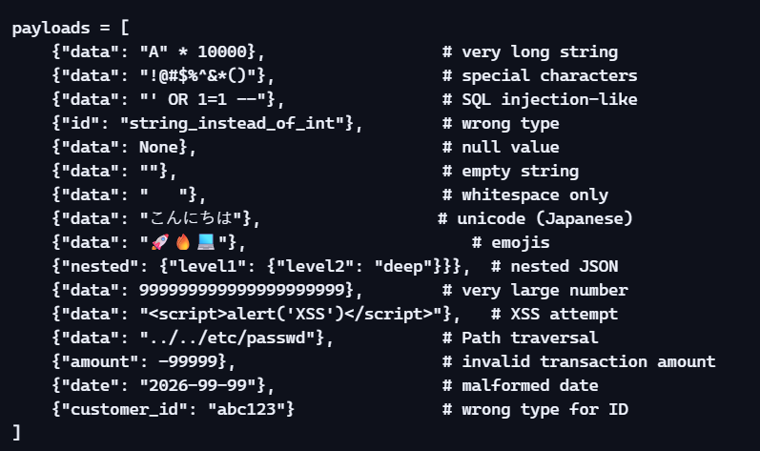

8.2 Extended Log File Sample
Below is a larger excerpt from the fuzz_results.txt log file. This demonstrates the system’s structured logging format.
