YENEPOYA INSTITUTE OF ARTS, SCIENCE, COMMERCE AND MANAGEMENT
HIGH - LEVEL DESIGN
ON
API Fuzz Testing Tool for Smart City Systems

Student Name: Najid Rasheed

Industry Mentor: | Mr.Shashank | Guided by: | Ms.Prathiksha

Table Of Contents

- Introduction. ……………………………………………………………………………….. 3
  - Scope of the document. ……………………………………………………………… 3
  - Intended Audience. …………………………………………………………………… 3-4
  - System Overview. …………………………………………………………………….. 4

- System Design. …………………………………………………………………………….. 5
  - Application Design. …………………………………………………………………… 5
  - Process Flow. …………………………………………………………………………. 5-6
  - Information Flow. ……………………………………………………………………… 6
  - Components Design…………………………………………………………………… 6
  - Key Design Consideration……………………………………………………………. 7
  - API Catalogue…………………………………………………………………………. 7

- Data Design. ………………………………………………………………………………. 8
  - Data Model. ……………………………………………………………………………8
  - Data Access Mechanism. …………………………………………………………8-9
  - Data Retention Policies. ……………………………………………………………… 9
  - Data Migration. ………………………………………………………………………… 10

- Interfaces. …………………………………………………………………………………… 11-14

- State and Session Management. …………………………………………………………. 15-16

- Caching. ……………………………………………………………………………………… 17

- Non-functional Requirements. ……………………………………………………………... 18
  - Security Aspects. ………………………………………………………………………... 18
  - Performance Aspects. ………………………………………………………………….. 19
- References. …………………………………………………………………………………… 20

- INTRODUCTION

  - Scope of the Document

This High-Level Design (HLD) document provides an architectural overview of the Smart City API Fuzzer project. It explains the system’s objectives, design philosophy, and how different components interact at a conceptual level. Unlike the LLD, which focuses on implementation details, the HLD emphasizes why the system is structured the way it is and how it achieves resilience, extensibility, and clarity in fuzz testing.

  - Intended Audience

- Project Evaluators / Professors → To assess the design quality and robustness of the fuzzer.

- Interviewers / Recruiters → To evaluate technical documentation and professional presentation skills.

- Developers / Contributors → To understand the system architecture before diving into code.

- Security Analysts → To see how fuzz testing can be applied to Smart City/Retail APIs.

  - System Overview

The Smart City API Fuzzer is designed to test API endpoints against malformed, edge-case, and potentially malicious inputs. Its primary goals are:

- Resilience Testing → Ensure APIs don’t crash under unexpected inputs.
- Validation Testing → Identify whether APIs properly reject invalid data.
- Logging & Reporting → Maintain detailed logs (fuzz_results.txt) and generate visual summaries (bar chart).
- Extensibility → Allow future integration with real Smart City/Retail APIs beyond the demo endpoint.

- SYSTEM DESIGN

  - Application Design

The Smart City API Fuzzer is designed as a modular Python application:

- Payload Generator → Defines diverse test cases (long strings, SQL-like, XSS, invalid dates, etc.).
- Request Handler → Sends payloads to the API using requests.post().
- Response Classifier → Categorizes results into Success, Client Error, Server Error, Other.
- Logger → Records detailed results in logs/fuzz_results.txt.
- Visualizer → Generates a bar chart summarizing outcomes.

  - Process Flow

      - Initialize → Clear/create log file and counters.
      - Iterate Payloads → Loop through each fuzz input.
      - Send Request → API call via requests.
      - Classify Response → Based on status code.
      - Log Results → Append details to log file.

      - Summarize → Print/write final counts.
      - Visualize → Generate bar chart of results.

  - Information Flow

- Input → Hardcoded payloads in Python dictionaries.

- Processing → Serialized into JSON, sent to API, response classified.

- Output →
- Console output (live monitoring).
- Log file (fuzz_results.txt).
- Visualization (bar chart).

  - Components Design

      - Payloads Module → Defines test cases.
      - Fuzzer Core (fuzz_api) → Executes fuzzing loop.
      - Logger → Writes results to file.
      - Visualizer → Uses matplotlib to generate charts.

  - Key Design Consideration

      - Resilience → Script continues even if one test fails.
      - Transparency → Logs include payload, timestamp, status code, response snippet.
      - Extensibility → Easy to add new payloads or integrate real APIs.
      - Professionalism → Visualization and structured logs improve presentation.

  - API Catalogue

      - Demo API: https://jsonplaceholder.typicode.com/posts

      - Behavior: Accepts arbitrary JSON, returns payload with auto-generated id.

      - Limitation: No input validation, so all fuzz tests succeed.

      - Future Scope: Replace with real Smart City/Retail APIs for meaningful validation.

- DATA DESIGN

  - Data Model

- Payloads:
- Represented as Python dictionaries.
- Each dictionary simulates a fuzz input (e.g., long strings, SQL-like, XSS, invalid dates).
- No external schema or database — purely in-memory test cases.

- Responses:
- Captured as JSON objects returned by the API.
- Classified into categories: Success, Client Error, Server Error, Other.

- Logs:
- Stored as plain text in logs/fuzz_results.txt.
- Each entry includes: timestamp, payload, status code, response snippet.

  - Data Access Mechanism

- Input Access:
- Payloads are hardcoded in the script.

- Accessed sequentially in a loop.

- Output Access:
- Logs are written using Python’s file I/O (open() with append mode).
- Results can be viewed in console (real-time) or in the log file (post-execution).

- Visualization Access:
- Summary dictionary (summary) is passed into visualize_results().
- matplotlib generates a bar chart for quick analysis.

  - Data Retention Policies

- Logs:
- Each run overwrites the previous fuzz_results.txt (fresh start).
- Ensures clarity and avoids mixing results from different runs.
- Visualization:
- Chart is generated live but not stored by default.
- Can be extended to save PNGs in logs/ for documentation.

  - Data Migration

- Current State:
- No database, no migration needed.
- Data is ephemeral (payloads in memory, logs in text file).

- Future Scope:
- Migrate logs to structured storage (CSV, SQLite, or cloud DB).
- Enable long-term tracking of fuzz test results across multiple runs.
- Support dashboards for Smart City/Retail API resilience monitoring.

- INTERFACES

  - API Interface

      - Endpoint: https://jsonplaceholder.typicode.com/posts

      - Protocol: HTTP/HTTPS

      - Method: POST

      - Payload Format: JSON

      - Response Format: JSON (echoed payload + auto-generated id)

      - Behavior: Accepts arbitrary data without validation, always returns 201 Created.

  - Logging Interface

- File Path: logs/fuzz_results.txt

- Format: Plain text entries with:
  - Timestamp
  - Payload sent
  - Status code
  - Response snippet
- Access: Readable via console output during execution or by opening the log file afterward.

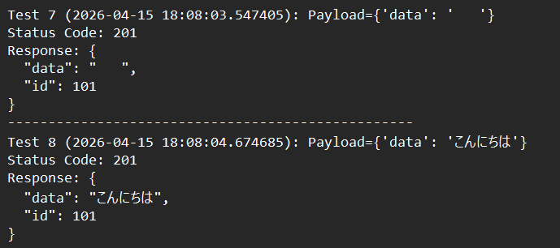

  - Visualization Interface

      - Library: matplotlib
      - Input: Summary dictionary (success, client_error, server_error, other)
      - Output: Bar chart showing distribution of results.

      - Usage: Provides a quick, visual overview of fuzz test outcomes for reporting.

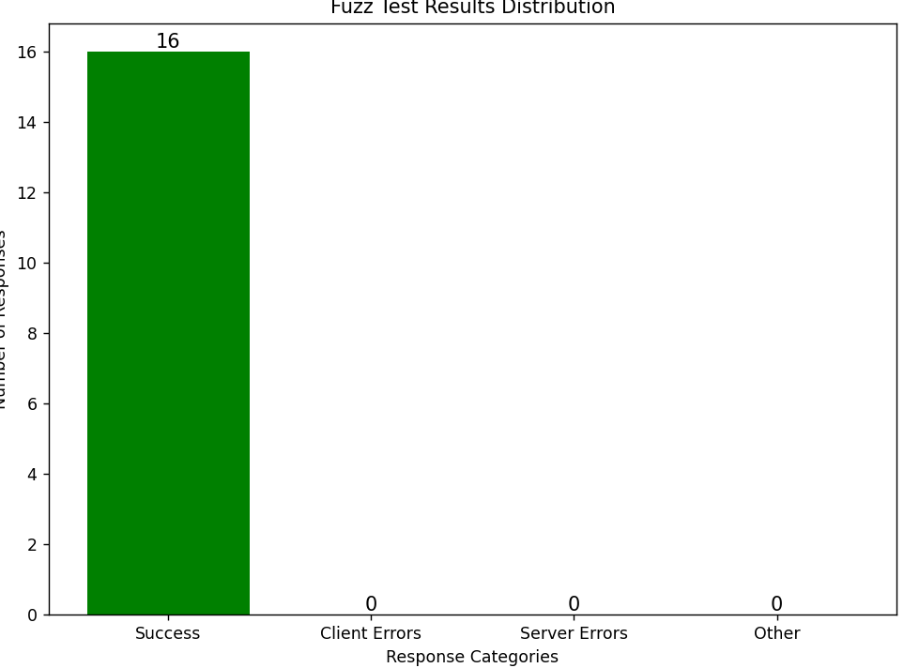

  - User Interface

- Execution: Run via command line (PowerShell/VS Code terminal).
- Interaction:

  - Console prints live results.
  - Log file stores detailed records.
  - Chart pops up at the end for visualization.

- Design Choice: Minimal UI, focused on clarity and professional presentation.

- STATE AND SESSIONS MANAGEMENT

  - State Management

- Summary Counters:
- Maintained in a dictionary (success, client_error, server_error, other).
- Updated dynamically after each test case.
- Provides a snapshot of system state at any point in execution.

- Log File State:
- fuzz_results.txt acts as a persistent record of each run.
- Each test appends results sequentially, preserving chronological order.
- At the end, a summary block reflects the final state of all counters.

- Visualization State:
- The summary dictionary is passed into the visualization function.
- Produces a bar chart representing the final state distribution.

  - Session Management

- Current Design:
- Stateless across runs.
- Each execution starts fresh, overwriting the previous log file.
- No session persistence beyond the single run.

- Rationale:
- Fuzz testing is typically batch-oriented.
- Each run is independent, ensuring clarity and avoiding confusion with mixed results.

  - Future Scope

- Session Persistence:
- Store results in a database (SQLite, PostgreSQL, or cloud storage).
- Allow comparison across multiple runs.
- Enable dashboards for long-term monitoring of API resilience.

- State Recovery:
- Resume fuzzing from the last payload if interrupted.

- CACHING

  - Current Design

No Caching Implemented:
- The fuzzer sends each payload directly to the API.
- Responses are logged immediately without reuse.
- Since the demo API (jsonplaceholder.typicode.com/posts) always accepts inputs and returns a fresh 201 Created, caching provides no benefit in the current setup.

  - Rationale

- Fuzz Testing Nature:
- Each payload is unique and intentionally malformed.
- Reusing cached responses would defeat the purpose of testing API resilience.

- Demo API Behavior:
- Always returns success regardless of input.
- Caching would only repeat identical results, adding no analytical value.

- NON-FUNCTIONAL REQUIREMENTS

  - Security Aspects

- Safe Payload Handling:
- Payloads are generated and sent only to the demo API (jsonplaceholder.typicode.com).
- No sensitive or real user data is involved.
- Ensures ethical testing without impacting production systems.

- Isolation:
- Fuzzer runs locally on your machine.
- No external dependencies beyond the demo API and Python libraries.

- Future Scope:
- When integrated with real Smart City/Retail APIs, security considerations will include:
  - Authentication (API keys, OAuth).
  - Rate limiting to avoid denial-of-service.
  - Sanitization of logs to prevent leaking sensitive data.

  - Performance Aspects

- Efficiency:
- Payloads are processed sequentially in a loop.
- Lightweight design ensures minimal CPU/memory usage.
- Suitable for small to medium test suites.

- Scalability:
- Current design handles ~tens of payloads easily.
- Can be extended to hundreds/thousands with minor optimizations (parallel requests, async I/O).

- Resilience:
- Errors are caught via try/except, preventing crashes.
- Script continues execution even if one payload fails.

- Future Scope:
- Add concurrency (e.g., asyncio or threading) for large-scale fuzzing.
- Benchmark response times to measure API performance under stress.
- Integrate caching or structured storage for faster reporting.

- REFERENCES

1. Systematic Review of ML-Based Fuzzing
- Title: A systematic review of fuzzing based on machine learning techniques
- Authors: Yan Wang, Peng Jia, Luping Liu, Cheng Huang, Zhonglin Liu
- Published: PLOS One, August 18, 2020
- DOI Link: https://doi.org/10.1371/journal.pone.0237749
- Highlights: Reviews how machine learning improves fuzzing efficiency, input mutation, and vulnerability discovery.

2. Comprehensive Review of Learning-Based Fuzz Testing
- Title: A Comprehensive Review of Learning-based Fuzz Testing Techniques
- Source: IEEE Xplore
- Link: IEEE Xplore Article (requires institutional access)
- Highlights: Explains inefficiencies in traditional fuzzing, how learning-based approaches improve code coverage, and future directions.

