YENEPOYA INSTITUTE OF ARTS, SCIENCE, COMMERCE AND MANAGEMENT
LOW-LEVEL DESIGN
ON
API Fuzz Testing Tool for Smart City Systems

Student Name: Najid Rasheed

Industry Mentor: | Mr.Shashank | Guided by: | Ms.Prathiksha

Table Of Contents

- File Structure. ……………………………………………………….. 3

- Module Details. …………………………………………………….. 4
  - Imports. ………………………………………………………. 4
  - Functions. ……………………………………………………. 4-6
  - Main Execution Block. ………………………………….. 6

- Data Flow. ………………………………………………………………. 7
  - File Input. ……………………………………………………… 7
  - Parsing and Tokenization. …………………………….. 7
  - Summarization Engine. …………………………………. 8
  - Output Generation. ………………………………………. 8-9

- Example Input. ……………………………………………………….. 10-11

- Example Output. …………………………………………………….. 12-13

- Technology Stack. …………………………………………………….. 14-16

- Error Handling. …………………………………………………………. 17-18
- Future Enhancements. ………………………………………………. 19-20

- FILE STRUCTURE

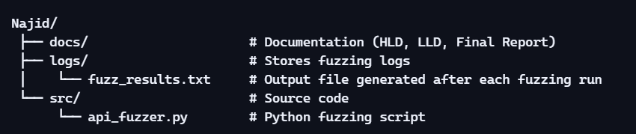

- docs/ → Reserved for design documents (HLD, LLD, Final Report).

- logs/ → Contains fuzz_results.txt, which records payloads, status codes, and responses for each fuzz test.

- src/ → Houses the main fuzzing script (api_fuzzer.py).

- MODULE DETAILS

  - Import

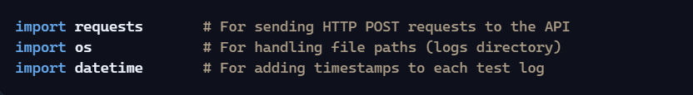

      - requests → Core library to interact with the demo API.

      - os → Ensures cross-platform safe path handling for logs/fuzz_results.txt.

      - datetime → Provides precise timestamps for each fuzz test entry.

  - Functions

- fuzz_api()
- Purpose: Main function that executes fuzz testing.
- Steps:

      - Initialize summary counters → Tracks Success, Client Errors, Server Errors, Other.
      - Clear/Create log file → Writes a header before each run.
      - Iterate through payloads → Sends each payload via requests.post().
      - Classify response → Based on status code (2xx, 4xx, 5xx, Other).
      - Log results → Payload, timestamp, status code, response snippet.
      - Handle exceptions → Logs any runtime errors (e.g., network issues).
      - Write summary → Appends classification totals at the end of the log file.

- Helper Logic Inside fuzz_api()
      - Payload loop → Iterates through all defined test cases.
      - Classification block → Categorizes status codes into success/error groups.
      - Logging block → Appends results to logs/fuzz_results.txt.

      - Exception handling → Ensures script doesn’t crash if one test fails.

  - Main Execution Block

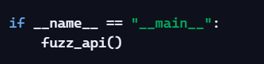

      - Ensures the script runs only when executed directly.

      - Calls fuzz_api() to start fuzz testing.

      - Prevents accidental execution when imported as a module.

- DATA FLOW

  - File Input

- Source of payloads: Hardcoded inside api_fuzzer.py as Python dictionaries.

- No external file input is required.

- Each payload represents a “bad” or edge-case input (e.g., long strings, special characters, nested JSON, invalid dates).

  - Parsing and Tokenization

      - Payloads are directly serialized into JSON by the requests library.

      - No manual parsing/tokenization is needed — requests.post(API_URL, json=payload) handles conversion.

      - Ensures consistent formatting when sending data to the API.

  - Summarization Engine

- After each test, the script classifies the response based on status code ranges:
      - 2xx → Success
      - 4xx → Client Error
      - 5xx → Server Error
      - Other → Unexpected/exception

- Counters are updated for each category.

- At the end of execution, a summary block is appended to logs/fuzz_results.txt:

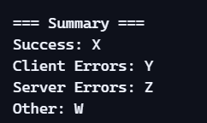

  - Output Generation

- Console Output:
- Prints each test with timestamp, payload, status code, and truncated response.
- Helps monitor fuzzing progress live.

- Log File Output (logs/fuzz_results.txt):
- Stores detailed results for every test case.
- Includes payload, timestamp, status code, and response snippet.
- Ends with a summary section for quick analysis.

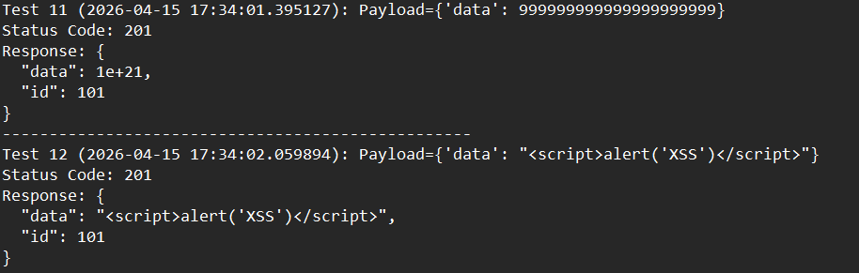

- EXAMPLE INPUT

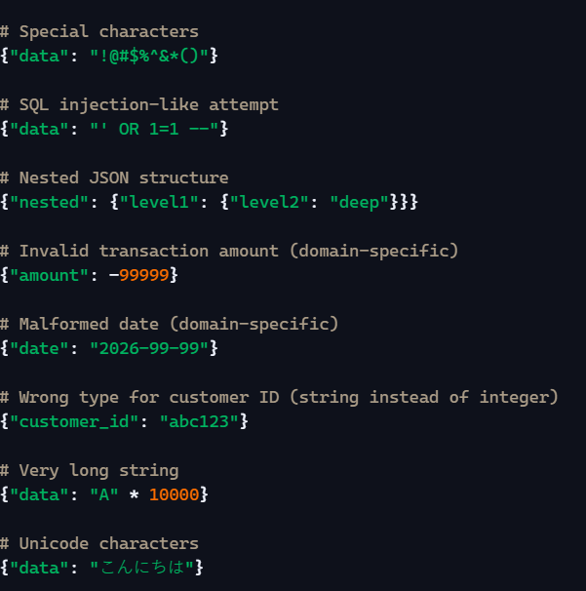

      - These inputs represent edge cases and malicious patterns.

      - They test whether the API validates, rejects, or blindly accepts malformed data.

      - Covering multiple categories (special chars, SQL-like, nested JSON, domain errors, XSS, path traversal) shows breadth in fuzz testing.

- EXAMPLE OUTPUT

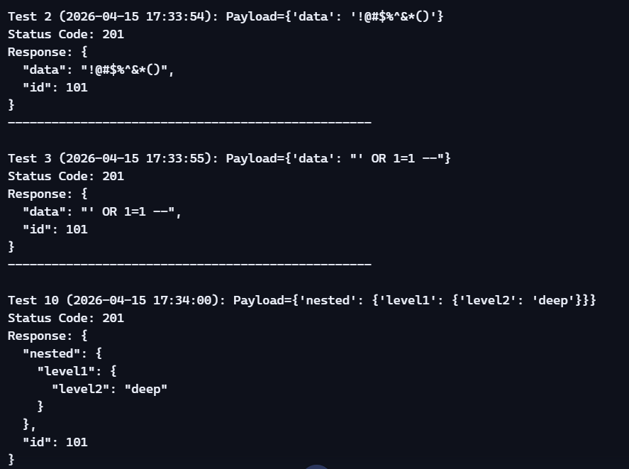

- Status Code 201 → The API accepted each payload and simulated creating a resource.

- Response body → Echoed back the payload, sometimes with an auto-generated id.

- Summary section → Confirms all 16 tests were successful, with no client or server errors.

- This output demonstrates that the demo API is resilient (no crashes) but lacks input validation (accepts malformed or malicious data without rejection).

- TECHNOLOGY STACK

  - Programming Language

- Python 3.x
    - Chosen for its simplicity, readability, and strong ecosystem of libraries for HTTP requests and automation.

    - Widely used in security testing and pentesting scripts.

  - Libraries

- requests
- Handles HTTP communication with the demo API.
- Simplifies sending JSON payloads via requests.post().

- os
- Manages file paths for cross-platform compatibility.
- Ensures logs are written to logs/fuzz_results.txt.

- datetime
- Provides timestamps for each fuzz test entry.
- Useful for tracking when each payload was executed.

  - Environment

- Operating System: Windows 10
- IDE/Editor: Visual Studio Code (VS Code)
- Execution: PowerShell or terminal within VS Code

- File Structure:
- src/api_fuzzer.py → main script
- logs/fuzz_results.txt → output log file
- docs/ → documentation folder (HLD, LLD, Final Report)

  - Demo API Endpoints

      - Endpoint Used: https://jsonplaceholder.typicode.com/posts

      - Purpose: Acts as a mock API for testing.

      - Behavior: Accepts arbitrary JSON payloads and returns them with an auto-generated id.

      - Limitation: Does not reject malformed inputs, making it ideal for demonstrating fuzz testing but not for real security validation.

- ERROR HANDLING

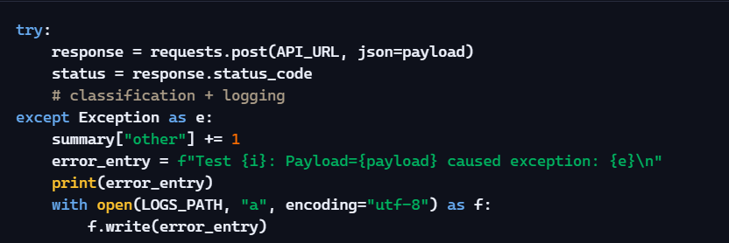

- Basic try/except block around each API request:
      - Prevents the script from crashing if a request fails.
      - Logs the payload and exception message into logs/fuzz_results.txt.
      - Increments the Other counter in the summary when exceptions occur.

- Status Code Classification:
      - Success → 2xx
      - Client Error → 4xx
      - Server Error → 5xx

      - Other → Exceptions or unexpected codes
- Resilience:

      - Even if one test fails, the script continues with the rest.
      - Final summary reflects accurate counts of successes, errors, and exceptions.

- FUTURE ENHANCEMENTS

  - Advanced Error Handling

      - Timeouts: Add request timeouts to prevent the script from hanging if the API doesn’t respond.

      - Retry Mechanism: Implement automatic retries for failed requests before logging them as errors.

      - Detailed Error Classification: Differentiate between network errors, serialization errors, and API-level errors.

      - Separate Error Log File: Maintain a dedicated error_log.txt for exceptions.

  - Automated Reporting

      - Create Markdown/HTML reports summarizing payloads, responses, and classifications.

      - Helps in presenting results to professors or interviewers.

  - Real API Integration

- Replace demo endpoint with actual Smart City/Retail APIs (with proper permissions).
- Test resilience of production-like systems against fuzzed inputs.

