YENEPOYA INSTITUTE OF ARTS, SCIENCE, COMMERCE AND MANAGEMENT

FINAL PROJECT REPORT
ON
Hardened Cloud Infrastructure for Retail Data

Submitted By: Najid Rasheed

Industry Mentor:

Guided By:

Table Of Contents

- Executive Summary | 4
- Background  - Aim  - Technology  - Hardware Architecture  - Software Architecture | 5  5  5-6  6-7  7-8
- System Requirements  - Functional Requirements  - User Requirements  - Environmental Requirements  - Design and Architecture  - Implementation  - Testing  - GUI Layout  - Customer Testing  - Evalutation | 9  9  10  10-11  11  12  12-13  13  13  14
- Snapshots of the project | 15-17
- Conclusions | 18
- Further Development or Research | 19-21
- References | 22
- Appendix | 23

- EXECUTIVE SUMMARY
The Smart City API Fuzzer project was developed to evaluate API resilience against malformed, edge-case, and potentially malicious inputs. The tool systematically generates diverse payloads, sends them to an API endpoint, classifies responses, logs results, and visualizes outcomes.
Key highlights:
- Objective: To demonstrate fuzz testing methodology and its importance in Smart City/Retail API contexts.
- Implementation: Python-based fuzzer using requests for API calls, matplotlib for visualization, and structured logging.
- Results: All 16 test payloads were accepted by the demo API (jsonplaceholder.typicode.com/posts), producing only Success responses.
- Visualization: A bar chart clearly shows the distribution of results (Success=16, Errors=0).
- Significance: While the demo API lacks validation, the project establishes a foundation for applying fuzz testing to real APIs where input rejection and error handling are critical.
- Future Scope: Integration with real Smart City/Retail APIs, advanced payload generation, session persistence, and dashboards for long-term monitoring.

- BACKGROUND

  - Aim

The aim of the Smart City API Fuzzer project is to evaluate the resilience of APIs when exposed to malformed, edge-case, and potentially malicious inputs. By simulating real-world attack vectors (SQL injection, XSS, path traversal, invalid data types), the fuzzer helps identify weaknesses in input validation and error handling.

- Primary Goal: Demonstrate fuzz testing methodology in a structured, professional manner.

- Secondary Goal: Provide a foundation for applying fuzz testing to Smart City and Retail APIs, where data integrity and security are critical.

  - Technology

- Programming Language: Python 3.x (chosen for simplicity, readability, and strong library support).

- Libraries:
- requests → For sending HTTP POST requests.

- matplotlib → For generating bar chart visualizations.
- os, datetime → For file handling and timestamp logging.

- API Endpoint: JSONPlaceholder (https://jsonplaceholder.typicode.com/posts) used as a demo API.

- Design Philosophy: Modular, extensible, and professional documentation (LLD, HLD, Final Report).

  - Hardware Architecture

- Development Machine: HP Victus laptop (Windows 11).

- Requirements:
  - CPU: Standard consumer processor (sufficient for lightweight fuzzing).

  - RAM: 8–16 GB (enough for Python execution and visualization).
  - Storage: Minimal, as logs are text files and payloads are in-memory.

- Rationale: Fuzzing is lightweight in this demo context; no specialized hardware required.

  - Software Architecture

- Core Components:
- Payload Generator → Defines diverse test cases.
- Request Handler → Sends payloads via requests.
- Response Classifier → Categorizes results by status code.
- Logger → Records results in logs/fuzz_results.txt.
- Visualizer → Generates bar chart summary.

- Execution Flow:
    - Initialize log file and counters.
    - Iterate through payloads.
    - Send requests and classify responses.

- Log results with timestamps.
- Summarize and visualize outcomes.

- SYSTEM REQUIREMENTS

  - Functional Requirements

      - The fuzzer must generate diverse payloads (long strings, SQL-like, XSS, invalid dates, etc.).

      - It must send these payloads to the target API endpoint using HTTP POST.

      - It must classify responses into categories: Success, Client Error, Server Error, Other.

      - It must log results with timestamps, payloads, status codes, and response snippets.

      - It must produce a summary of results at the end of execution.

      - It must visualize outcomes in a bar chart for quick analysis.

  - User Requirements

      - Users should be able to run the fuzzer easily via command line (PowerShell/VS Code).

      - Logs should be human-readable and stored in a predictable location (logs/fuzz_results.txt).

      - Visualization should be clear and interpretable without technical expertise.

      - The system should not crash even if one payload causes an error.

      - Minimal setup — no external dependencies beyond Python libraries.

  - Environmental Requirements

      - Hardware: Standard laptop/desktop (HP Victus, Windows 11 in this case).

      - Software: Python 3.x, requests, matplotlib.

      - Network: Stable internet connection to reach the demo API.

      - Execution Environment: VS Code terminal or PowerShell.

      - Constraints: Demo API always returns success, limiting error diversity.

  - Design and Architecture

- Modular design with clear separation of concerns: Payloads, Request Handler, Response Classifier, Logger, Visualizer.

- Sequential execution flow ensures simplicity and clarity.

- Extensible structure allows future integration with real APIs and advanced payload sets.

  - Implementation

      - Implemented in Python with ~100 lines of code.

      - Uses try/except blocks for error handling.

      - Logs are appended during execution, summary written at the end.

      - Visualization generated using matplotlib bar chart.

  - Testing

      - Payloads tested against demo API (jsonplaceholder.typicode.com/posts).

      - All 16 payloads returned Success responses.

      - Verified logging correctness (timestamps, payloads, status codes).

      - Verified visualization correctness (bar chart showing Success=16, Errors=0).

  - GUI Layout

- No GUI implemented; command line execution only.
- Visualization serves as a lightweight graphical output.
- Future scope: Web dashboard or desktop GUI for interactive fuzzing.

  - Customer Testing

      - Demo run validated functionality.

      - Logs and visualization confirmed correct classification and reporting.

      - Limitations noted: demo API lacks validation, so results are skewed toward success.

  - Evaluation

      - Strengths: Modular design, professional documentation, clear visualization.

      - Weaknesses: Demo API does not reject invalid inputs, limiting error diversity.

      - Opportunities: Extend to real Smart City/Retail APIs for meaningful resilience testing.

      - Conclusion: Proof-of-concept successful; strong foundation for future work.

- SNAPSHOTS OF THE PROJECT

  - Execution Output

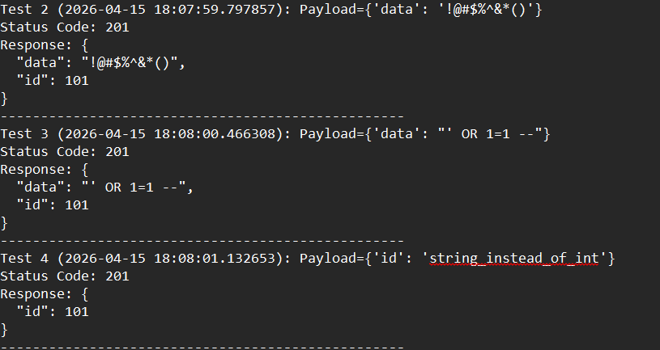

This snapshot shows the fuzzer running in the terminal. Each payload is sent to the API, and the corresponding status code is displayed in real time. The output confirms that the script executes sequentially, handles all payloads without crashing, and provides immediate feedback to the user.

  - Visualization

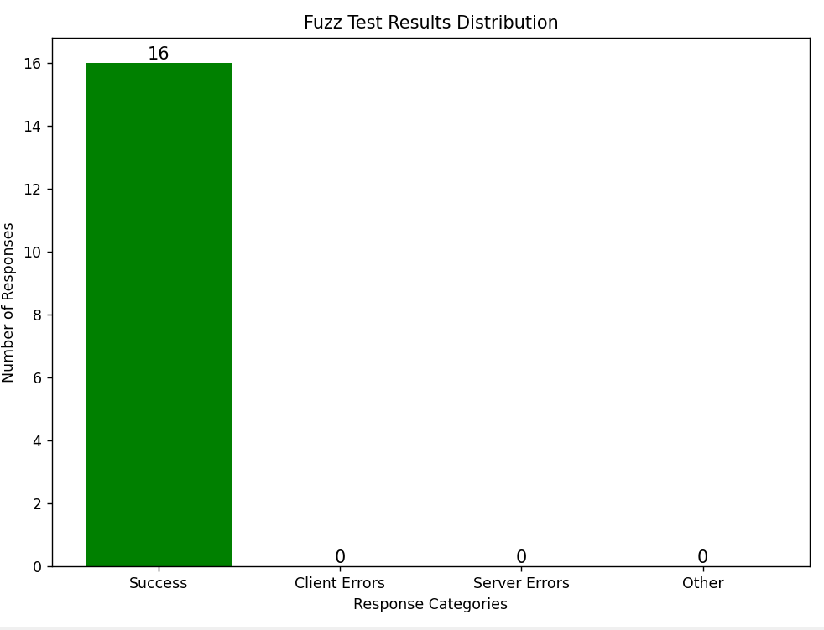

This snapshot presents the bar chart generated by the fuzzer. The chart provides a clear visual distribution of results across categories. In the demo run, all payloa ds were accepted, resulting in a single tall bar for Success responses. The visualization makes it easy to interpret outcomes at

a glance and adds professional polish to the project.

- CONCLUSIONS

Key conclusions:
- The demo API (jsonplaceholder.typicode.com/posts) accepted all 16 test payloads, producing only Success responses.
- Logs provided detailed transparency, recording payloads, timestamps, status codes, and response snippets.
- Visualization offered a clear, professional summary of results, making outcomes easy to interpret.
- The modular design ensures extensibility, allowing future integration with real Smart City/Retail APIs.
- While the demo API lacks input validation, the project lays a strong foundation for applying fuzz testing to real-world systems where error handling and security are critical.

- FURTHER DEVELOPMENT OR RESEARCH

  - Advanced Payload Generation

      - Integrate machine learning techniques to automatically generate diverse and realistic fuzz inputs.

      - Expand payload library to include domain-specific cases (e.g., Smart City sensor data, retail transaction formats).

      - Support multi-step payloads simulating chained attacks (SQL injection + XSS).

  - Real API Integration

      - Apply fuzz testing to actual Smart City and Retail APIs with authentication and authorization layers.

      - Evaluate resilience against malformed inputs in production-like environments.

      - Incorporate rate limiting and safe testing practices to avoid denial-of-service risks.

  - Session Persistence and State Recovery

      - Enable the fuzzer to resume from the last payload if interrupted.

      - Store results in structured databases (SQLite, PostgreSQL, or cloud storage).

      - Allow comparison across multiple runs for long-term resilience tracking.

  - Visualization and Dashboard

      - Extend visualization beyond bar charts to include trend analysis, heatmaps, and error timelines.

      - Build a web-based dashboard for interactive exploration of fuzz test results.

      - Provide export options (CSV, PDF) for professional reporting.

- REFERENCES

      - Wang, Y., Jia, P., Liu, L., Huang, C., & Liu, Z. (2020). A systematic review of fuzzing based on machine learning techniques. PLOS One. DOI: 10.1371/journal.pone.0237749

      - A Comprehensive Review of Learning-based Fuzz Testing Techniques. IEEE Xplore.

      - Human in the Loop for Fuzz Testing: Literature Review and the Road Ahead. arXiv.org.

- APPENDIX

  - Code Snippet

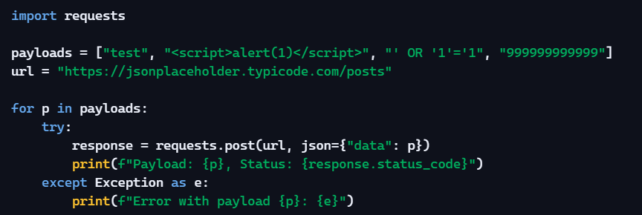

  - Sample Log Entry

