Brief Written Explanation of the System

What My System Does
My system uses multiple agents with different roles such as RAG over a local dataset that I made as well as function-calling tools that have access not to only my local data but also external data using API. The main purpose of the system would be to use this RAG to provide relevant recommendations using our local data for systems engineering decision rather than generic responses only.

How My Components Work Together
My workflow starts with two agents that focus on data retrieval. Agent 1A retrieves data locally from my custom made dataset named “course_resources.csv” using the search tool from lab 7 that I made. Agent 1B retrieves supporting data from external places using OpenAlex API. Finally, their output will be merges into a single JSON and will be passed to the next agents.
The third agent will act as an analyst and will get the data passed to it by the two first agents and create a clear and concise interpretation of it. Then finally a fourth agent will rewrite the analysis that the third agent made into a more readable format for the stakeholders with implementation steps as well as caution notes. This separation of the roles improves clarity allowing each prompt for each agent to be responsible for specific details.

Design Choices and Challenges
One challenge I encountered was making a robust tool-calling chain when the local model services were not available. To fix this, I added a deterministic Python fallback for the agents. This kept the workflow reproducible and easier to debug.

Links:
- Multi-agent orchestration script: https://github.com/Najiullah7/SYSEN_HW2/blob/main/homework2_ai_agent_system.py
- RAG implementation: https://github.com/Najiullah7/SYSEN_HW2/blob/main/homework2_ai_agent_system.py
- Function calling / tool definitions: https://github.com/Najiullah7/SYSEN_HW2/blob/main/homework2_ai_agent_system.py
- Support file: https://github.com/Najiullah7/SYSEN_HW2/blob/main/functions.py

Screenshots
System Asks the User a question:
Output Agent 1A (Local RAG Retrieval):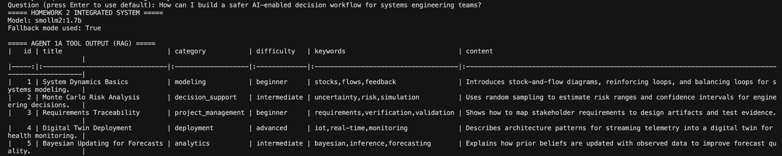
Output Agent 1B (External API Retrieval)
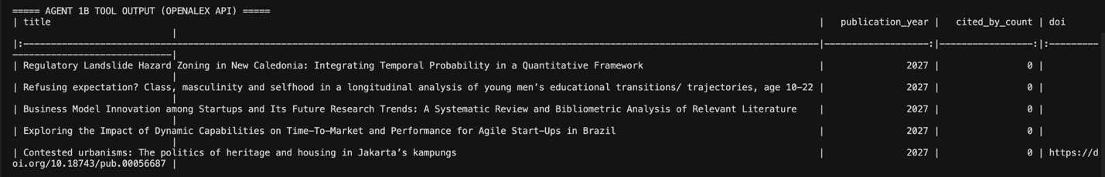
Output Agent 2 (Analysis):
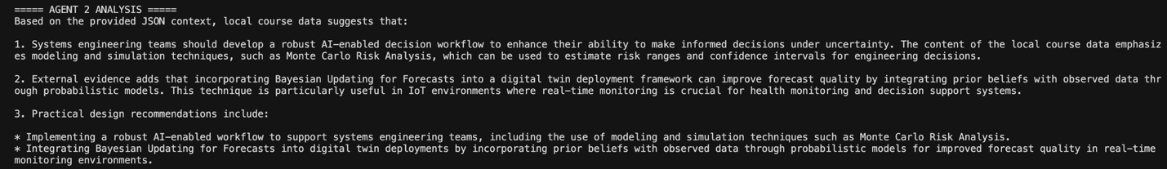
Output Agent 3 (Final Report):
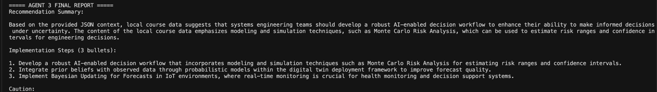

Documentation

System Architecture
1. Agent 1A (RAG Retriever): uses function calling to run `search_course_resources()`
2. Agent 1B (Evidence Retriever): uses function calling to run `fetch_openalex_evidence()`
3. Agent 2 (Analyst): combines local and external context into a grounded interpretation
4. Agent 3 (Reporter): converts analysis into a stakeholder-facing report

Data flow
1. User question -> Agent 1A + Agent 1B (tools)
2. Tool outputs -> merged JSON context
3. JSON context -> Agent 2 analysis
4. Analysis -> Agent 3 final report

RAG Data Source
Primary local data source:
- File: `course_resources.csv`
- Records: 10 course-themed entries
- Purpose: provide grounded context relevant to systems engineering and AI workflows

Data columns:
Column Name | Type | Description
id | integer | Unique row identifier
title | string | Resource title
category | string | Thematic category (e.g., modeling, analytics)
difficulty | string | Relative difficulty level
keywords | string | Comma-separated keywords used for matching
content | string | Short content summary used in retrieval context

Tool Functions
Tool Name | Purpose | Parameters | Returns
search_course_resources | Local CSV retrieval for RAG grounding | query (str), top_n (int), optional document (str) | List of matched resource dictionaries
fetch_openalex_evidence | External evidence lookup via OpenAlex API | topic (str), per_page (int) | List of recent works (title/year/citations/doi)

Technical Details
- Main script: `homework2_ai_agent_system.py`
- Runtime helper: `functions.py`
- LLM endpoint: Ollama local API (`http://localhost:11434/api/chat`)
- External API endpoint: OpenAlex Works API (`https://api.openalex.org/works`)
- Python packages: `requests`, `pandas`

4.5 Usage Instructions
1. Install dependencies:
- `pip install requests pandas`
2. Ensure Ollama is running locally (if using live agent generations):
- Example: `ollama serve`
3. Ensure model is available:
- `ollama pull smollm2:1.7b`
4. Run from repository root:
- `python3 ‘homework2_ai_agent_system.py`
5. Ask your question when prompted.
6. Verify outputs:
- Agent 1A prints local RAG retrieval table
- Agent 1B prints OpenAlex API retrieval table
- Agent 2 prints analysis
- Agent 3 prints final report

