By :-Najm Adin Hussain

--ETL

In transform: -

- Remove Blank Rows

- replace

“TotalCharges” “Null” with “0”

“has Partner” “Yes/No” with “1/0”

“has Dependents” “Yes/No” with “1/0”

“PhoneService” “Yes/No” with “1/0”

“Churn” “Yes/No” with “1/0”

“InternetService” “Digital Subscriber Line” with “DSL”

- Change data type

“SeniorCitizen” to “True/False”

“has Partner” to “True/False”

“has Dependents” to “True/False”

“PhoneService” to “True/False”

“Churn” to “True/False”

“MonthlyCharges” to “Fixed decimal Number”

“TotalCharges” to “Fixed decimal Number”

**Now the data is cleaned**

**The data model and measuers** 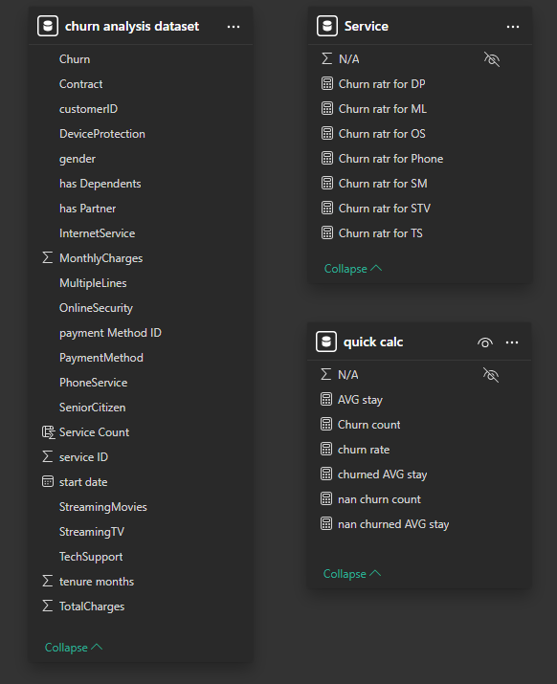

**Visualize**