**LAPORAN PRAKTIKUM 3  
ACTIVITY DAN INTENT**

**NPM : 22.12.2688**

**Nama : Najmah Nur Wafiyah**

Bahan : Modul Praktikum 3 – Acitivity dan Intent

Alat : Android Studio

**Desain Halaman Login**

Source code layout :

<?xml version="1.0" encoding="utf-8"?>  
<LinearLayout xmlns:android="http://schemas.android.com/apk/res/android"  
 xmlns:app="http://schemas.android.com/apk/res-auto"  
 xmlns:tools="http://schemas.android.com/tools"  
 android:layout_width="match_parent"  
 android:layout_height="match_parent"  
 tools:context=".LoginActivity"  
 android:orientation="vertical"  
 android:background="#FE7E07"  
 >  
  
  
 <ImageView  
 android:id="@+id/imageView2"  
 android:layout_width="125dp"  
 android:layout_height="150dp"  
 app:srcCompat="@drawable/read"  
 android:layout_gravity="center"  
 android:layout_marginTop="80dp"/>  
  
 <TextView  
 android:id="@+id/textView6"  
 android:layout_width="match_parent"  
 android:layout_height="wrap_content"  
 android:text="Login"  
 android:textAlignment="center"  
 android:textColor="@color/white"  
 android:textSize="29sp"  
 android:textStyle="bold"  
 />  
  
 <EditText  
 android:id="@+id/editTextUsername"  
 android:layout_width="match_parent"  
 android:layout_height="50dp"  
 android:ems="10"  
 android:inputType="text"  
 android:text="Username"  
 android:textColor="@color/white"  
 android:backgroundTint="@color/white"  
 android:textSize="17sp"  
 android:layout_marginTop="50dp"  
 android:layout_marginLeft="50dp"  
 android:layout_marginRight="50dp"  
 />  
  
 <EditText  
 android:id="@+id/editTextPassword"  
 android:layout_width="match_parent"  
 android:layout_height="50dp"  
 android:layout_marginLeft="50dp"  
 android:layout_marginTop="40dp"  
 android:layout_marginRight="50dp"  
 android:backgroundTint="@color/white"  
 android:ems="10"  
 android:inputType="textPassword"  
 android:text="Password"  
 android:textColor="@color/white"  
 android:textSize="16sp" />  
  
 <Button  
 android:id="@+id/buttonLogin"  
 android:layout_width="150dp"  
 android:layout_height="wrap_content"  
 android:text="Login"  
 android:backgroundTint="@color/white"  
 android:textColor="#FE7E07"  
 android:textSize="19dp"  
 android:textStyle="bold"  
 android:layout_gravity="center"  
 android:layout_marginTop="32dp"  
 />  
  
 <TextView  
 android:id="@+id/textView7"  
 android:layout_width="match_parent"  
 android:layout_height="wrap_content"  
 android:text="Don't have an account? Register here"  
 android:textSize="17dp"  
 android:textStyle="bold"  
 android:textAlignment="center"  
 android:textColor="@color/white"  
 android:layout_marginTop="10dp"  
 />  
  
  
</LinearLayout>

Design UI :

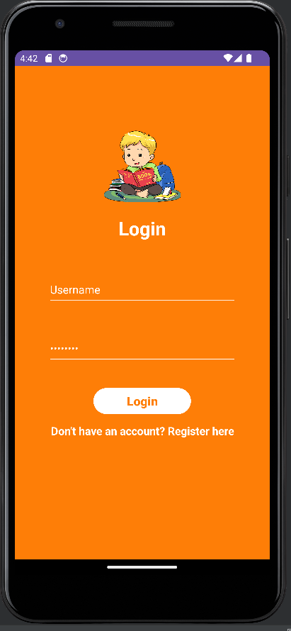

**Desain Halaman About Us:**

Source code layout :

Design UI :

**EXPLICIT INTENT**

1. Menampilkan Activity Home (home page) dari Activity Login
2. Menampilkan Activity About dari Activity Home

**IMPLICIT INTENT**

1. Dial Number
2. Web Browser
3. Google Maps