

|  |
| --- |
| Business Template  **Subject areas** |
| **Logo / Image** |

Contents

1 Business Description 3

1.1 Business background 3

1.2 Problems. Current Situation 3

1.3 The benefits of implementing a database. Project Vision 3

2 Model description 3

2.1 Definitions & Acronyms 3

2.2 Logical Scheme 3

2.3 Objects 3

# 

# Business Description

## Business background

## Problems. Current Situation

## the Benefits of implementing a database. Project Vision

# Model description

## Definitions & Acronyms

1. **Climber**
   * Description: Stores information about climbers.
   * Fields:
     + id (Primary Key, Integer)
     + first_name (String)
     + last_name (String)
     + address (String)
     + email (String)
2. **Country**
   * Description: Stores information about countries where mountains are located.
   * Fields:
     + id (Primary Key, Integer)
     + country_name (String)
3. **Mountain**
   * Description: Stores information about mountains.
   * Fields:
     + id (Primary Key, Integer)
     + mountain_name (String)
     + mountain_heigh (Float)
     + country (String, ManyToOne relationship with Country table)
4. **Climb**
   * Description: Records details of each climb, including start and end dates.
   * Fields:
     + id (Primary Key, Integer)
     + mountain_id (Foreign Key referencing Mountain, ManyToOne relationship with Mountain table)
     + start_date (Date)
     + end_date (Date)
5. **ClimberClimb**
   * Description: Facilitates the many-to-many relationship between climbers and climbs.
   * Fields:
     + id (Primary Key, Integer)
     + climber_id (Foreign Key referencing Climber, ManyToMany relationship with Climber table)
     + climb_id (Foreign Key referencing Climb, ManyToMany relationship with Climb table)
6. **Area**
   * Description: Defines geographical areas where mountains are located.
   * Fields:
     + id (Primary Key, Integer)
     + area_name (String)
7. **MountainArea** 
   * Description: Facilitates the many-to-many relationship between mountains and areas.
   * Fields:
     + Id (Primary Key, Integer)
     + Mountain_id (Foreign Key referencing Mountain, ManyToMany relationship with Mountain table)
     + Area_id (Foreign Key referencing Area, ManyToMany relationship with Area table)
8. **ClimberEmergencyContact**
   * Description: Stores emergency contact information for climbers.
   * Fields:
     + id (Primary Key, Integer)
     + climber_id (Foreign Key referencing Climber, OneToMany relationship with Climber table)
     + contact_name (String)
     + contact_phone (String)
9. **ClimbingGear**
   * Description: Contains information about climbing gear.
   * Fields:
     + id (Primary Key, Integer)
     + gear_name (String)
     + description (String)
     + climber_id (Foreign Key referencing Climber, ManyToOne relationship with Climber table)
10. **ClimbingGearUsage**
    * Description: Records the usage of climbing gear in specific climbs.
    * Fields:
      + id (Primary Key, Integer)
      + climb_id (Foreign Key referencing Climb, ManyToOne relationship with Climb table)
      + gear_id (Foreign Key referencing ClimbingGear, OneToOne relationship with Gear table)
      + quantity (Integer)

## Logical Scheme

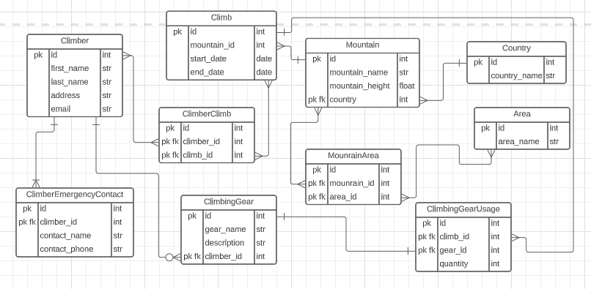

## Objects

**Climber Table Description**

Stores information about climbers, including their names, addresses, and contact details.

|  |  |  |
| --- | --- | --- |
| Table Name | Field Name | Data Type |
|  | id, pk | Int |
|  | first_name | Str |
| Climber | last_name | Str |
|  | Address | Str |
|  | Email | Str |

**Example with date**

|  |  |  |  |  |
| --- | --- | --- | --- | --- |
| **Id** | **First_name** | **Last_name** | **address** | **email** |
| 1 | John | Smith | 123 Main St, Anytown, USA | [john.smith@email.com](mailto:john.smith@email.com) |
| 2 | Sarah | Johnson | 456 Elm St, Othertown, US | [sarah.johnson@email.com](mailto:sarah.johnson@email.com) |
| 3 | David | Lee | 789 Oak St, Anycity, USA | [david.lee@email.com](mailto:david.lee@email.com) |

**Country Table Description**

Stores information about countries where mountains are situated.

|  |  |  |
| --- | --- | --- |
| Table Name | Field Name | Data Type |
| Country | id, pk | Int |
|  | country_name | Str |

**Example with date**

|  |  |
| --- | --- |
| **id** | **country_name** |
| 701 | Nepal |
| 702 | Tanzania |
| 703 | United States |

**Mountain Table Description**

Contains details about mountains, such as their names, heights, and countries where they are located.

|  |  |  |
| --- | --- | --- |
| Table Name | Field Name | Data Type |
|  | id, pk | Int |
| Mountain | mountain_name | Str |
|  | mountain_height | Str |
|  | country_id, pk fk | Int |

**Example with date**

|  |  |  |  |
| --- | --- | --- | --- |
| **id** | **mountain_name** | **mountain_height** | **country_id** |
| 101 | Everest | 8848.86 | 701 |
| 102 | Kilimanjaro | 5895.03 | 702 |
| 103 | Denali | 6190.5 | 703 |

**Climb Table Description**

Records the details of each climb, including the mountain climbed, start and dates.

|  |  |  |
| --- | --- | --- |
| Table Name | Field Name | Data Type |
|  | id, pk | Int |
| Climb | mountain_id, pk fk | Int |
|  | start_date | Date |
|  | end_date | Date |

The “Mountain” table is related to the “Climb” table with a many-to-one relationship, indicating that multiple climbs can take place on a single mountain.

**Example with date**

|  |  |  |  |
| --- | --- | --- | --- |
| **id** | **mountain_id** | **start_date** | **end_date** |
| 201 | 101 | 10.05.2023 | 20.05.2023 |
| 202 | 102 | 15.06.2023 | 25.06.2023 |
| 203 | 101 | 08.07.2023 | 18.07.2023 |

**ClimberClimb Table Description**

Serves as a junction table to facilitate the many-to-many relationship between climbers and climbs.

|  |  |  |
| --- | --- | --- |
| Table Name | Field Name | Data Type |
|  | id, pk | Int |
| ClimberClimb | climber_id, pk fk | Int |
|  | climb_id, pk fk | Int |

The “Climber” table is related to the “Climb” table through the “ClimberClimb” many-to-many relationship table, which enables multiple climbers to participate in multiople climbs.

**Example with date**

|  |  |  |
| --- | --- | --- |
| **id** | **climber_id** | **climb_id** |
| 301 | 1 | 201 |
| 302 | 2 | 201 |
| 303 | 1 | 202 |
| 304 | 3 | 203 |

**Area Table Description**

Defines geographical areas where mountains are located.

|  |  |  |
| --- | --- | --- |
| Table Name | Field Name | Data Type |
| Area | id, pk | Int |
|  | area_name | Str |

**Example with date**

|  |  |
| --- | --- |
| **id** | **area_name** |
| 501 | Himalayas |
| 502 | African Rift |
| 503 | Alaskan Range |

**MounrainArea Table Description**

Acts as a junction table to establish the many-to-many relationship between mountains and areas.

|  |  |  |
| --- | --- | --- |
| Table Name | Field Name | Data Type |
|  | id, pk | Int |
| MountainArea | mountain_id, pk fk | Int |
|  | area_id, pk fk | Int |

The “Mountain” table is related to the “Area” table through the “MountainArea” many-to-many relationship table, allowing mountains to belong to multiple areas.

**Example with date**

|  |  |  |
| --- | --- | --- |
| **id** | **mountain_id** | **area_id** |
| 801 | 101 | 501 |
| 802 | 102 | 502 |
| 803 | 103 | 503 |

**ClimberEmergencyContact Table Description**

Stores emergency contact information for climbers.

|  |  |  |
| --- | --- | --- |
| Table Name | Field Name | Data Type |
|  | id, pk | Int |
| ClimberEmergencyContact | climber_id, pk fk | Int |
|  | contact_name | Str |
|  | contact_phone | Str |

**Example with date**

|  |  |  |  |
| --- | --- | --- | --- |
| **Id** | **climber_id** | **contact_name** | **contact_phone** |
| 901 | 1 | Mary Smith | 1234567890 |
| 902 | 2 | Mark Johnson | 9876543210 |
| 903 | 3 | Emily Lee | 5555555555 |

**ClimbingGear Table Description**

Contains information about climbing gear, including gear name and description.

|  |  |  |
| --- | --- | --- |
| Table Name | Field Name | Data Type |
|  | id, pk | Int |
| ClimbingGear | gear_name | Str |
|  | Description | Str |
|  | climber_id, pk fk | Int |

The “ClimbingGear” table has a many-to-one relationship with the “Climber” table, indicating that a climber can own multiple pieces of climbing gear.

**Example with date**

|  |  |  |  |
| --- | --- | --- | --- |
| **id** | **gear_name** | **description** | **climber_id** |
| 601 | Ice Axe | For ice climbing | 1 |
| 602 | Harness | Climbing safety harness | 2 |
| 603 | Crampons | For icy terrain | 3 |

**ClimbingGearUsage Table Description**

Records the usage of climbing gear during climbs.

|  |  |  |
| --- | --- | --- |
| Table Name | Field Name | Data Type |
|  | id, pk | int |
| ClimbingGearUsage | climb_id, pk fk | int |
|  | gear_id, pk fk | int |
|  | Quantity | int |

The “ClimbingGearUsage” table establishes a many-to-one relationship between a climb and the climbing gear used during that climb.

**Example with date**

|  |  |  |  |
| --- | --- | --- | --- |
| **id** | **climb_id** | **gear_id** | **quantity** |
| 701 | 201 | 601 | 2 |
| 702 | 202 | 602 | 1 |
| 703 | 202 | 603 | 1 |