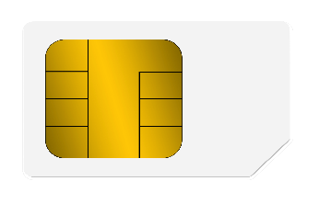

SBI Debit card

Simply CLICK

NAJREEN

4321 0123 4567 8901 VISA