Project plan

# 1 Overview/ Introduction

## 1.1 Name

AI based gym trainer (Human pose detection, tracking, scoring) system.

## 1.2 Context

Fitness exercises are very beneficial to personal health and fitness. However, they can also be ineffective and potentially dangerous if performed incorrectly. They can cause severe injuries to the muscles and ligaments. Exercise mistakes are made when the user does not make the pose correctly. This could be due to a lack of formal training. In addition, gyms may not have a sufficient number of personal trainers to satisfy the demand because of their high cost.

The process is based on a camera with artificial intelligence that will capture the position of different parts of the body while performing an exercise at the gym. Thus, the system will return a score that indicates how well the movement was performed.

## 1.3 Goals

The goal is to develop a human pose detection & tracking system based on AI as effective as a human trainer . The aim is to make profit, and help gymers to perfect their training, while the gym owner will have lower cost to pay for personal trainers each month. In fact, each machine will have it’s own personal trainer that will be available at any time so like this we can satisfy any density of gymers at the same time. We seek to aid people in performing the correct posture for exercises, so they don’t damage themselves at the gym, by building a software application that detects and scores the exercise pose made by the user and finally send a feedback. This application will use the latest advances in pose estimation and machine learning (neural network).

## 1.4 Time estimation

8 months

## 1.5 Cost estimation

cost of camera : ~ € 400 ? GPU ?

## 1.6 Members

Arthur Zucker, Abdallah Daboul, Younes Belkada, Najwa Moursli, Jérôme Bonacchi, Nguyen Van Nam

## 

## 1.7 List of deliverable

AI-based gym trainer system :

* detecting and tracking system : designing a Human Motion detection software architecture according customer requirements based on mechanisms which match depth informations with colors and takes into account both spatial and temporal informations collected by a depth camera. Subsequently, this system will be trained and tested on our database which will lead us to select an appropriate AI deep learning framework and pretrain networks for detection & tracking. Then, this network must be validated by training it on our dataset.
* scoring system : finding the most appropriate scoring system which has to be simple, efficient and the least skewed possible thanks to the coding of a scoring system algorithm tested and validated on simulation environments at first.
* feedback system : This evaluation system is built on our scoring system in order to give the best recommendations to the learners with the intent to enhance their moves.
* cross-platform (electron) app : developing an application using internet on an electronic support such as Smartphones or Laptops and web technologies for the purpose of operating on various Operating systems.

## 1.8 List of reference materials

* software frameworks: TensorFlow, Torch
* ANN: Keras
* Programming language: Python
* Tools: OpenPose (2D), Google’s GPU, depth cameras, RGB cameras
* Ressources: dataset provided by Chainos, several scientific articles describing human pose detection & tracking, online datasets
* Work Environments: Google Drive and Google Collaboratory, GitHub

## 1.9 List of definitions

* GPU: A graphics processing unit is a specializedelectronic circuit designed to rapidly manipulate and alter memory to accelerate the creation of images in a frame buffer intended for output to a display device. GPUs are used in embedded systems, mobile phones, personal computers, workstations, and game consoles.
* cross-platform app: based on cross-platforms softwares which are computer softwares implemented on multiple computing platforms.
* OS: Operating system is a system software that manages computer hardwares, software resources and provides common services for computer programs.
* AI: Artificial Intelligence is the study of “intelligent agents”. This is a system’s ability to correctly interpret external data, to learn from such data, and to use those learnings to achieve specific goals and tasks through flexible adaptation.
* ANN/ SNN: Artificial Neural Network or Simulated Neural Network is an interconnected network of natural or artificial neurons that uses a mathematical or computational model for information processing based a connectionistic approach to computation.
* Machine learning: is the scientific study of [algorithms](https://en.wikipedia.org/wiki/Algorithm) andstatistical models that [computer systems](https://en.wikipedia.org/wiki/Computer_systems) use to perform a specific task without using explicit instructions, relying on patterns and inference instead. It is seen as a subset of artificial intelligence. Machine learning algorithms build amathematical model based on sample data, known as “training data”, in order to make predictions or decisions without being explicitly programmed to perform the task.
* Deep learning: a class of machine learning algorithms that uses multiple layers to progressively extract higher level features from the raw input. For example, in image processing, lower layers may identify edges, while higher layers may identify the concepts relevant to a human such as digits or letters or faces.

# 2 Description of the organisation

## 2.1 Organization chart

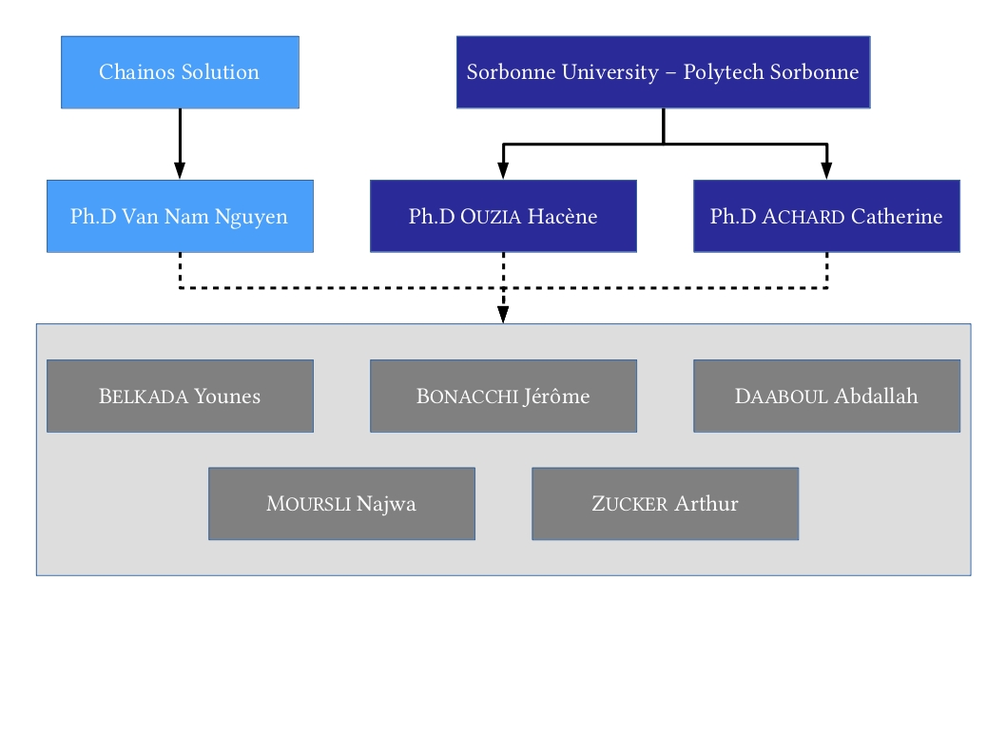

## 2.2 Responsibility assignment

Fixed meeting between students each tuesday from 8:00 AM -> 12.30 PM

Skype meeting with our tutor and Chainos representer Mr. Nam each 2 weeks.

Meeting with our academic tutor M. Achard one time in a 3 week maximum delay.

# 3 Management and technical processes

resource histogram

# 4 Work to be done

wbs tree diagram:

<https://www.smartsheet.com/free-work-breakdown-structure-templates>

# 5 Schedule (Macro planning/Gantt), milestones

Gantt: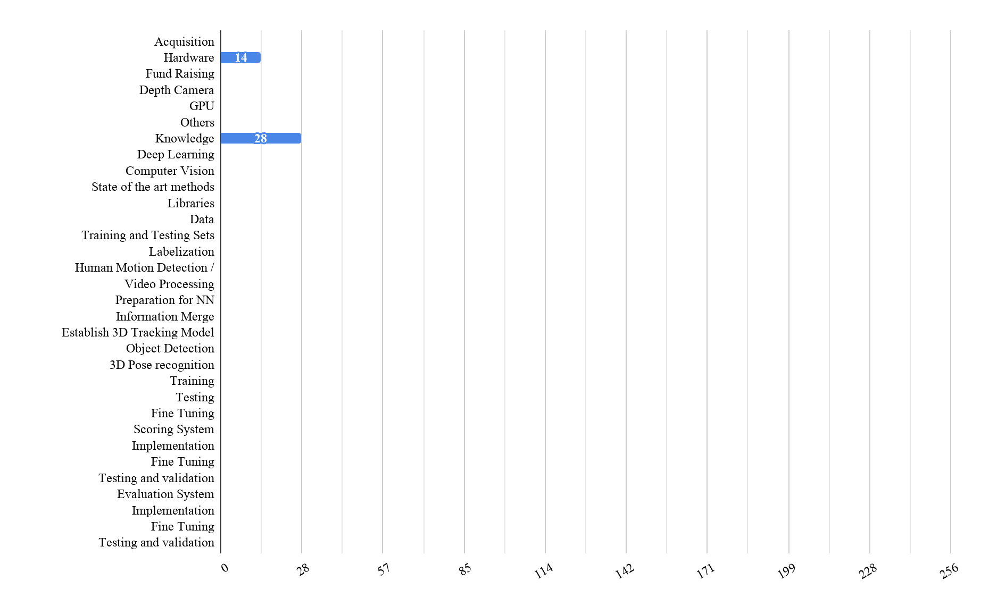

# 6 Budget information

camera ? → $200 for one depth camera (see link above)

~$2/GPU/hour (google HBM2/GDDR5 memory)