# Environment strategy

# 

|  |  |
| --- | --- |
| **Environment** | **Description** |
| **Feature Development Environments** | Individual Dev sandboxes or scratch orgs. If multiple developers work in the same environment, they should align between themselves to avoid conflicts and overwritten code. |
| **DevInt** | Dev sandbox used for validations and checking that all features being implemented do not have conflict among themselves. |
| **Testing** | Partial sandbox to retain data even after being refreshed. User for QAs and testers to validate if features are working properly. |
| **Staging** | Full sandbox where features approved by QAs and testers are deployed. This environment will contain at all times features that are ready to go to Production. It will also be used for training and UAT. |
| **Production** | This is the live environment. |
| **Hotfix** | Dev Pro sandbox. Will always be a copy of Production and will be used for fixing and testing of critical bugs n Production. |

**Scratch Orgs/Individual Sandboxes**

There is one scratch org/sandbox assigned to every developer. If multiple developers work in the same environment, they should align between themselves to avoid conflicts and overwritten code.

It is strongly recommended to keep a local copy of the ongoing development on VSCode as well as the Feature branch associated update in a regular basic (ideally several times a day) to avoid losing any ongoing work.

Every time there is a successful merge request on the “main” branch from any individual sandbox, the latest code is automatically deployed into all individual sandboxes.

Squad Tester supports Squad Developers in this environment to perform feature testing before merge.

**DevInt (Development/Deployment Checks)**

Dev sandbox used for developments integrations to perform validations and checking that all features being implemented do not have conflict among themselves.

Code gets deploy into this environment automatically every time a merge request has been approved on “main” branch.

This environment is not mean to be used by Developers or QA.

**Testing (SIT and regression testing)**

Partial sandbox to retain data even after being refreshed. User for QAs and testers to validate if features are working properly.

Code is deployed after every successful deployment in DevInt to allow testers to work on it as soon as it is ready.

Full run of local test at 00:00 CET.

*\*\*There is a possibility to just once a day so QA may not be confused with the features available on the environment and its instability.*

**Staging**

Full sandbox where features approved by QAs and testers are deployed. This environment will contain at all times features that are ready to go to Production. It will also be used for training and UAT.

Deployment into this environment happen on demand, when QA confirm that all the relevant Test cases have been passed and the code could be deployed to production (if required).

**Production**

Deployment on demand when release has been approved to Go Live.

**Hotfix**

Copy of Production and will be used for fixing and testing of critical bugs in Production.

Fixes on this environment will be back promote into the “main” branch to ensure consistency of the code.

|  |  |
| --- | --- |
| **Branch** | **Description** |
| **main** | Default branch. Protected. Every developer should always checkout from the most updated version of this branch in order to create their feature branches before starting a new development. When a development is finished and have passed proper quality gates, it will be merged into this branch and automatically deployed to DevInt. Content of this branch will also be deployed automatically to Testing after successful deployment to DevInt. |
| **feature/** | Branches created by developers out of main for developments. Individual sandboxes or scratch orgs are used to work on these branches. |
| **bugfix/** | Branches created by developers out of main for bug fixes. Individual sandboxes or scratch orgs are used to work on these branches. |
| **hotfix/** | Branches created by developers out of latest release branch for critical bugs in production. Hotfix is used to work on these branches. When ready, they will be merged to the latest release branch and, as soon as possible, same change will be added as well as a bugfix. |
| **release/** | Protected. Branches created out of main, at a particular point in time, where all features until then have been properly tested, approved, and are considered ready to Production. When a release is considered ready, latest major release version branch will be deployed in production. Next major release version branches will be deployed only to Staging until release is considered ready again.  If a feature already merged in main is not tested and approved, features added later, even if tested and approved, will not be deployed to next environments until all previous features are tested and approved as well. This restriction is to avoid dependencies on untested features and maintain robustness, however it is subjected to exceptions. |

# Branching strategy

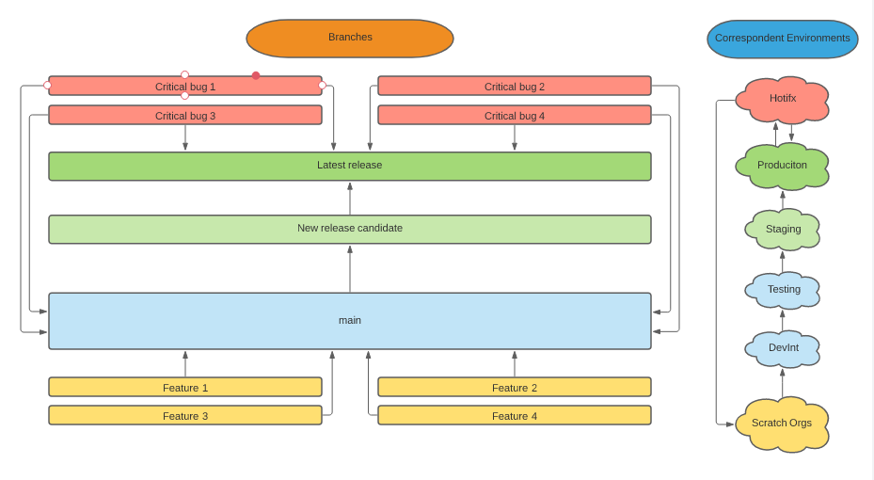

*How should developers use branches and source control?*

*Feature development:*

1. Every time a new feature development is going to start, developers should create a **feature branch from main.**
   1. Make sure you create your feature branch named after your US out of latest version of main.
   2. Make sure you push your development into the feature branch frequently (ideally few times per day).
   3. Make sure you keep a local copy (VSCode) and the feature branch update to avoid losing work when automatic back promotion happens on individual sandboxes.
2. Feature branches must have a sort life time (no more than few days) to avoid conflicts when merging the code into main branch.
   1. If this is not possible you should at least rebase your feature branch every few days to avoid having conflicts with other developments already merged into main.
3. When your feature (US) is ready and tested by the Squad Tester in your individual sandbox or scratch org, it is time to merge it to “main” branch.
   1. Please review the developing [guides](https://github.com/Nakama-Partnering-Services/guides) to ensure that the right formatting, code coverage, etc., has been taken into account to ensure your merge request is compliance and can be merge into main.
   2. Make sure you include all the relevant manual steps associated to your US on the deployment runbook.
   3. Remember, we enforce rebase in this project, you must rebase your local repository before your final commit and merge request creation.

*Bugfix development:*

1. Bugfix branches should be created for US of bugfix type. These US are common few days before a release to production, when UAT and final E2E testing is happening in Staging. After feature freeze, a new “release candidate” branch is created and only bug fixes are allowed. These ones should be created from and merged to this new “release candidate” branch.
2. Bugfix get promoted across environments in the same way that Features. DevInt -> Testing -> Staging

*Hotfix development:*

1. Hotfix branches should be created from the “latest release” branch, which contains production code.
2. Hotfix will only be used when critical/urgent bugs have been identified in production and require an immediate fix.
3. Code from Hotfix branch is deployed into Hotfix environment for QA testing and then promoted directly to production.
4. Hotfix branch is merge back into main to ensure code consistency on the next releases.