How the levels of
Tomb Raider: The Angel of Darkness are made
A simple guide to the game files, to how they are linked together
and to how TRAODLE turns them into Maya scenes
TRAODLE project (Level Exporter) / TRAODLI (Level Importer)
October 2026

Contents
1. What this document is for
2. The level in short
3. "Hashes": names turned into numbers
4. RMX: rooms and nodes
5. ZONE: geometry, objects, materials and textures
6. The objects of the level
7. CLN: collisions
8. Characters and animations
9. The level logic: triggers, messages, events and scripts
10. Effects (emitters)
11. Cutscenes
12. What TRAODLE produces in Maya
13. What is needed to go back (TRAODLI)
14. Glossary

1. What this document is for
This document explains, with no programming knowledge required, how the level files of Tomb Raider: The Angel of Darkness (2003) are organized. It summarizes the decoding work done with TRAODLE, the program that opens the game files and turns them into Maya scenes, and it is the starting point for TRAODLI, the program that will go the other way: from Maya scenes to game files.
The information comes from three sources: the analysis of all the level files, the original source code of the developers' tools (the WorldEdit editor, the animation editor, the converters) and the log files written in 2003 by the WorldEdit exporter, which contain the original names of rooms, objects and events.
The full technical details (the position of every field in the files) are in the *_Struct.h files of the TRAODLE project.

2. The level in short
A game level (for example PARIS1B, Carvier's apartment) is a single file with the .GMX extension, sometimes compressed (.GMX.CLZ). The GMX is an archive, like a ZIP without compression: it contains all the files the level needs, each one identified not by its name but by its "hash" (see chapter 3). The files are aligned to 2048-byte blocks, the size of a PlayStation 2 DVD sector.
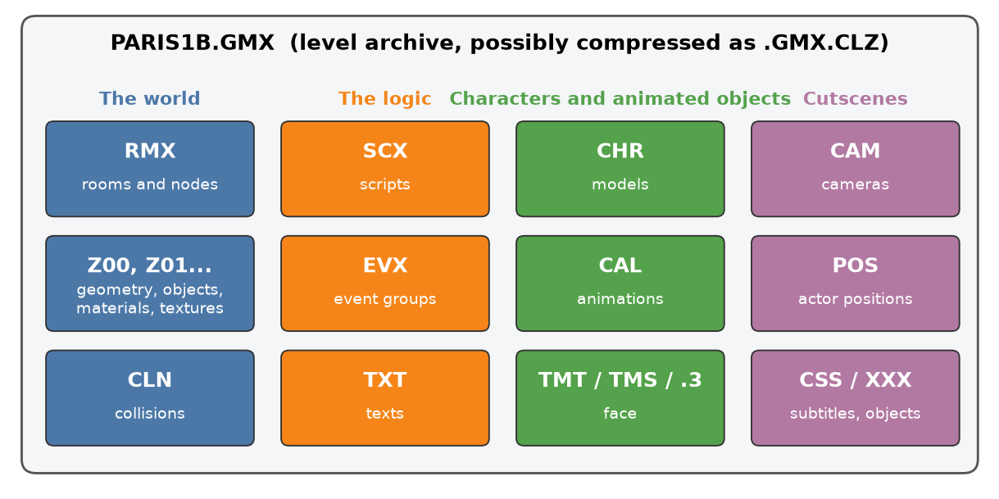
Figure 1 - The file types contained in a level, grouped by purpose
File | What it contains | How many (in 57 levels)
RMX | The rooms of the level and all the "nodes" inside them: lights, objects, triggers, navigation points... | 57
Z00, Z01, ... (ZONE) | The visible geometry: rooms, objects, materials and textures. A large level is split into several zones | 97
CLN | Collisions: the surfaces you walk on and bump into | 57
SCX | Scripts: small programs that control characters and situations | 51
EVX | Event groups: sequences of messages sent when something happens | 57
CHR | The models of the characters (skeleton, meshes, textures) and of the animated objects | 901
CAL | The animations of characters and objects | 955
TMT, TMS, .3 | Facial expressions and their animations (dialogues and cutscenes) | 129 + 76
CAM, POS, CSS, XXX | Cutscenes: cameras, actor and object positions, subtitles | 56 / 56 / 22 / 56
TXT | The game texts (dialogues, items) in the various languages | 60
Table 1 - The files of a level
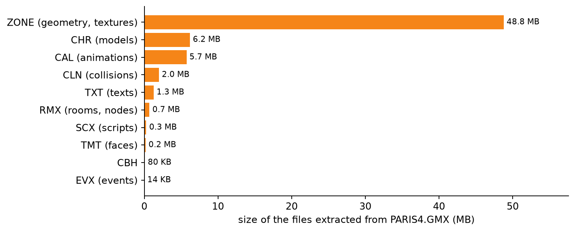
Figure 2 - How much each file type weighs in a large level (PARIS4)
As the chart shows, almost all the space is taken by graphics (ZONE) and characters (CHR and CAL). The information about the structure of the level (RMX), the logic (SCX, EVX) and the collisions (CLN) is much smaller.
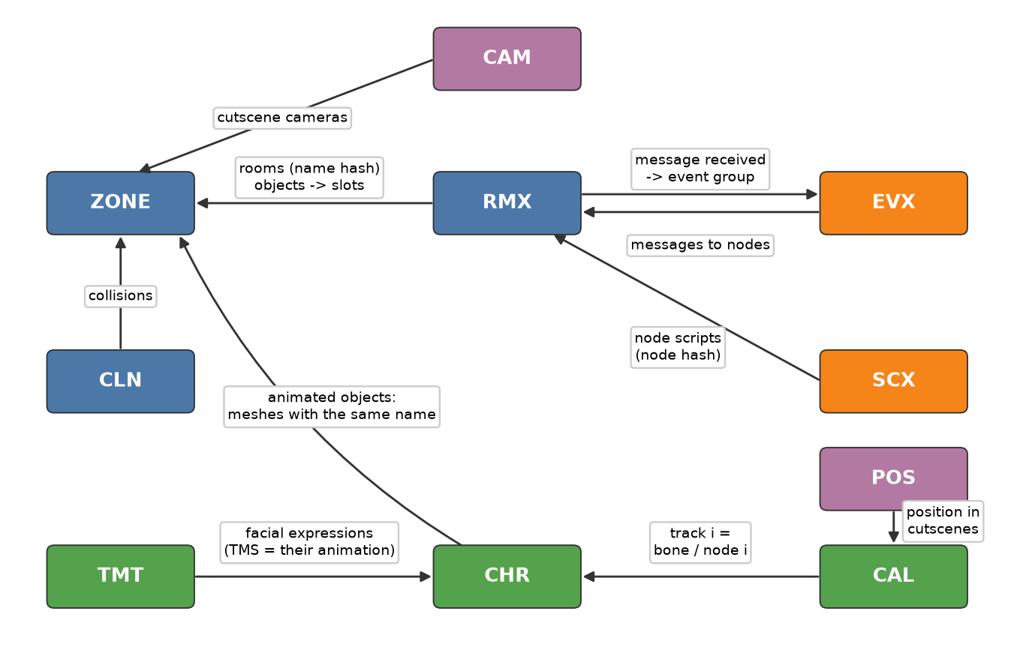
Figure 3 - How the files are linked together

3. "Hashes": names turned into numbers
In the editor everything has a name: the room "carviers__room2", the light "herod__lite_65", the event group "give_diary". To save memory the game does not store the names: it turns them into a 32-bit number with a fixed formula (the GetHashValue function) and stores only that number, called a hash. The same name always gives the same number, but you cannot get the name back from the number.
Original name | Rule | Hash stored in the file
carviers__room2 (room) | name as written | 0xB0F6CE00
carviers__objectorigin (object) | name as written | 0x089111E8
give_diary (event group) | name in UPPER CASE | 0xE320770C
DWR (drawer mesh) | name in UPPER CASE | 0x0002AB64
Fog Fade (effect template) | name in UPPER CASE | 0xAE7F819F
Table 2 - Hash examples
This is why TRAODLE contains a dictionary of about 30,000 original names taken from the 2003 logs: when the hash of a name in the dictionary matches the one in the file, the Maya scenes show the real name instead of the number. The dictionary covers almost all the rooms, nodes and meshes of the levels; the missing names stay as numbers.

4. RMX: rooms and nodes
The level is split into rooms. A room is not just a room in the everyday sense: it is a portion of the world (a corridor, a square, a stretch of rooftops) with its own volume (bounding box). The RMX file describes all the rooms and, for each of them, the list of its "nodes": everything placed in the world that is not plain geometry.
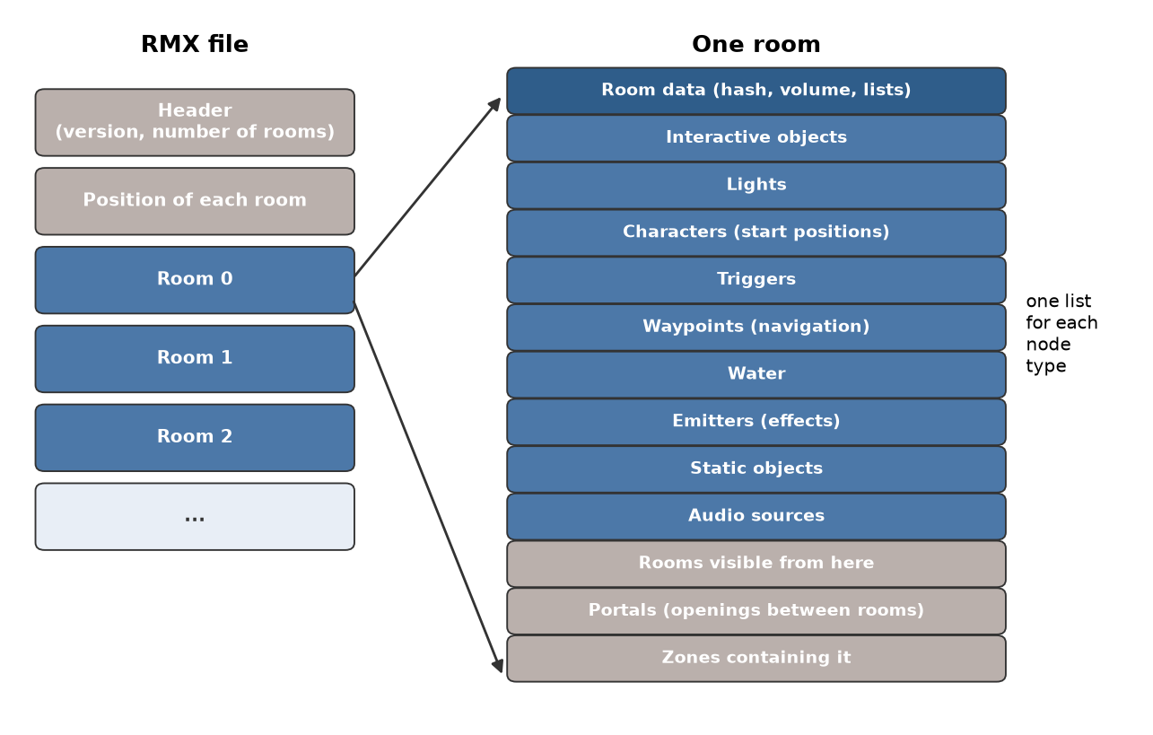
Figure 4 - Layout of the RMX file and of a room
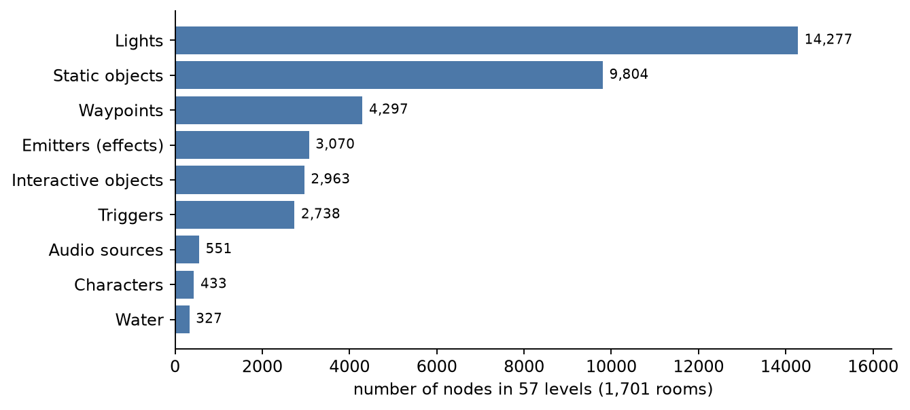
Figure 5 - How many nodes of each type there are in all the levels
Node type | What it is for | How it appears in Maya (TRAODLE)
Light | Static light with inner and outer radius | Point light with two spheres for the radii
Static object | Places a ZONE object (furniture, decorations) | Locator; the object with its geometry is in the zone scene
Interactive object | Doors, drawers, levers, pickups | Object placed in the zone scene (Interactive layer)
Trigger | Volume that makes something happen when Lara (or something else) enters it | Green box with the actions as attributes
Waypoint | Navigation points of the enemies, linked together | Locators and curves for the links
Character | Start position of Lara, enemies and other characters | Locator with a pawn
Water | Water volume | Water plane
Emitter | Effect: fog, fire, rain, smoke, volumetric lights | Box, line or point with the effect type
Audio source | Ambient sound | Locator
Portal | Opening between two rooms: used to know what is visible | Rectangle
Table 3 - The nodes of the rooms
Each room also has a "visibility mask": the list of the rooms that can be seen from it. The game draws only those, to run faster. Coordinates are in game units, the vertical axis is Z and angles are in degrees.
Some rooms have "alternative versions" (flip rooms): for example in PARIS3 rooms 66-72 have two versions each (74-80 and 81-87), which the game swaps with a message when something changes in the level. TRAODLE marks them with the flipRooms and isFlipRoom attributes. A second mask tells which distant background objects (Fakes) can be seen from each room.

5. ZONE: geometry, objects, materials and textures
The ZONE file (extension .Z00, .Z01...) contains everything you see: the room surfaces, the object meshes, the materials and the textures. A large level has several zones; the game loads the right zone as Lara moves around. The same room or object can appear in more than one zone.
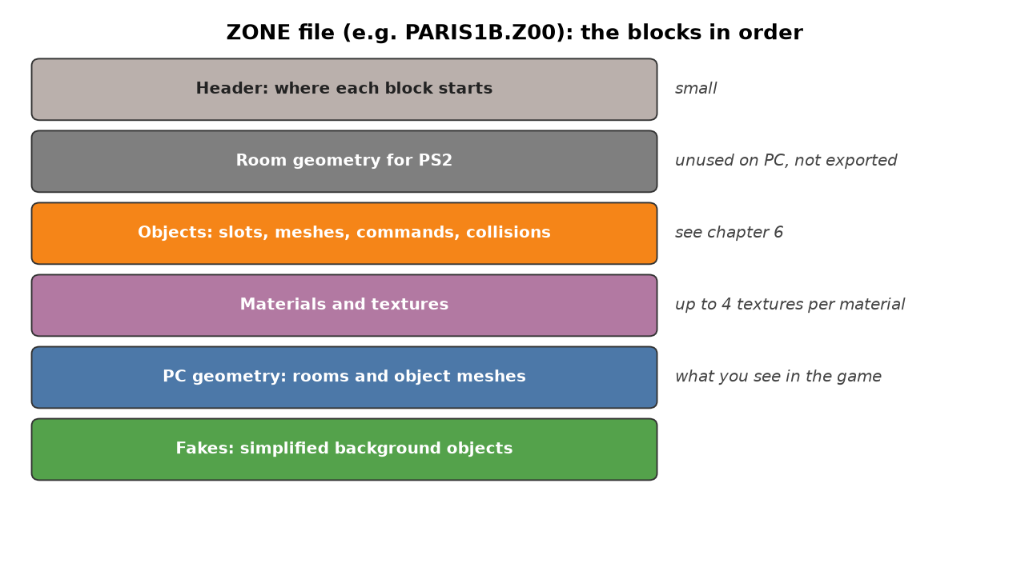
Figure 6 - The blocks of a ZONE file
The PC version of the game draws only the "PC" geometry. The PS2 blocks are still in the file but are not used: TRAODLE decodes them but does not export them.
The room geometry is split into "elements": pieces of mesh with a single material. The vertices have a position, a normal, two sets of UV coordinates (texture and "shadow map", the precomputed lighting), a color and tangents. The triangles are stored as "strips" (triangle strips), a compact form where each new vertex makes a triangle with the two previous ones.
Each material combines up to four textures: color (diffuse), shadow map, bump/reflections and "fur" (tufts of grass). The textures are compressed in the DXT1, DXT3 or DXT5 formats, or uncompressed.
The material type is a number (TextureMode) whose bits tell which textures to use. The PC game reads it differently for rooms and for characters (verified in the TRAOD_P4.exe executable): the same value does not always give the same effect.
Value | Rooms and objects (ZONE) | Characters (CHR)
0x04 / 0x08 / 0x0C | Color / Bump / Color + bump | same
bit 0x10 | Shadow map (precomputed lighting) | not used
bit 0x20 | ignored | Specular (0x2C is the most common character type)
bit 0x40 | Environment reflection (env map) | Environment reflection
0x84 / 0x8C / 0x9C | Fur / Metal / Glass | same
0x80 / 0x88 / 0x90 | unknown | Iridescence / Hair / Skin
0x94 | Self-illuminated | Color + bump, self-illuminated
0x98 | Snow | -
Table 4 - Material types in the PC game
The two lowest bits of the type and the field believed to mean "double sided" together form the blend mode: opaque, transparent, additive, cut-out (alpha test), subtractive or opaque visible from both sides. Every mode except plain opaque draws the faces from both sides.

6. The objects of the level
The ZONE objects are organized in "slots". A slot is a compound object: one or more meshes arranged in a small hierarchy, described by a list of commands (open a node, move and rotate it, add a mesh, close the node). Slot numbering is shared by all the zones of the level.
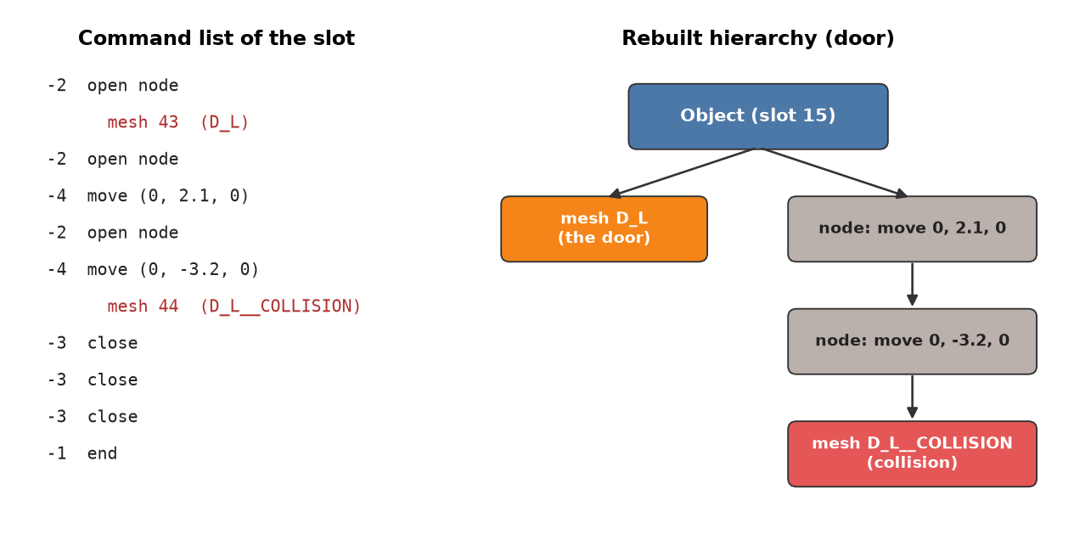
Figure 7 - Example: the slot of the PARIS1B door and the hierarchy it produces
What places the slot | Which objects | In Maya (layer)
RMX "static object" node | Furniture, decorations, fixed parts | <LEVEL>_Z00_Objects
RMX "interactive object" node | Doors, drawers, levers, pickups | <LEVEL>_Z00_Interactive
ZONE fake | Distant, simplified backgrounds | <LEVEL>_Z00_Fakes
Nothing (created by scripts) | Objects with no known position | <LEVEL>_Z00_Items (laid out on a grid)
Table 5 - How objects are placed
Interactive objects also have a "class" (Object Template), for example "Lara Drawer" or "HEALTH_Medipak", which defines their behavior. The ones that move (doors, drawers, machinery, fish) have a special CHR file (starting with the word NODE) and a CAL file with the animations: the CHR contains no geometry, only the "nodes" (the moving parts, with their pivot point); the geometry is the ZONE one with the same name.
Many meshes have an associated collision mesh (for example "D_L" and "D_L__COLLISION"): when the door opens, its collision moves too.

7. CLN: collisions
The solid surfaces of the world are not the visible geometry but a simplified version made of triangles. The CLN file organizes them in an "octree", a structure that splits space into smaller and smaller cubes to quickly find the triangles close to Lara.
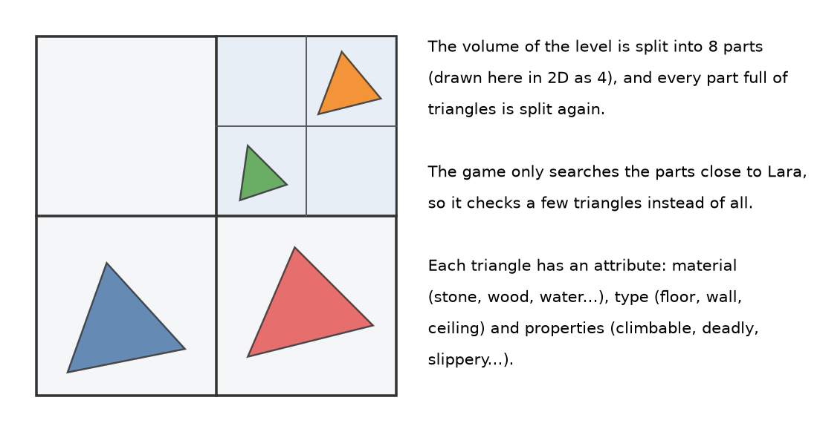
Figure 8 - The idea of the octree and of the collision attributes
Part of the attribute | Examples
Material (60 types) | stone, marble, gravel, sand, mud, grass, carpet, wood, metal, rock, water, snow, glass, ice
Surface type | wall, floor, ceiling
Properties | deadly, harmful, climbable, monkey swing, permeable to shots or sight, wall climb, stairs, slide, no slide, no grab
Table 6 - What the attribute of a collision triangle says
The material decides the sound of the footsteps and the footprints; the properties decide what Lara can do on that surface.

8. Characters and animations
A character (CHR file) has a skeleton of bones and some meshes: a main mesh deformed by two bones per vertex (the skin) and rigid meshes attached to one bone (for example the head). It also contains materials and textures.
The animations (CAL files) contain one track for each bone: position, rotation and scale for every frame, at 30 frames per second. To take little space every track is split into compressed blocks of three types.
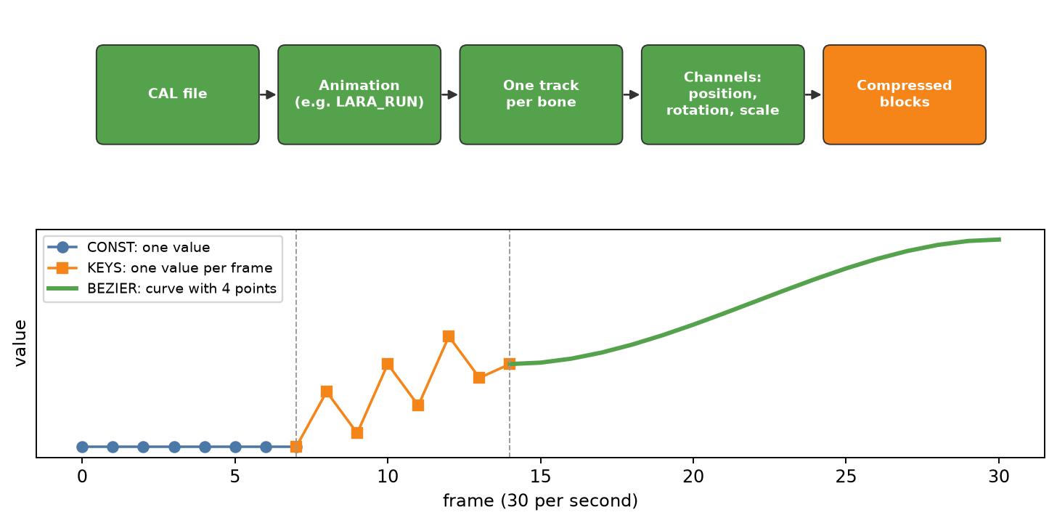
Figure 9 - From the CAL file to the curves: the three types of compressed block
File | Content
LARA.CAL | Lara's gameplay animations, shared by all her outfits (LARAD, LARAC1, ...)
LARA_DLG.CAL + LARA.3 | Dialogue animations and the facial expressions that start during the lines
LARA_<cutscene>.CAL/.TMT/.TMS | Lara's animation, face and facial animation in a cutscene
TMT | The 7 face expressions (blend shapes), applied to the head mesh
TMS / .3 | How the expression weights change over time
Table 7 - The character files
Animations also contain events tied to frames: sounds (including footsteps, which change with the surface type), overlaid animations (for example a nod during a dialogue), facial expressions, objects that appear and disappear (the pistol moving from the holster to the hand) and effects attached to bones (a weapon's muzzle flash). TRAODLE writes them in a text file for each CAL (<CAL>_EVENTS.txt) and, to see them in Maya, as animated attributes of an <animation>_EVENTS node. The rules for moving from one animation to another are in <CAL>_TRANSITIONS.txt.

9. The level logic: triggers, messages, events and scripts
Everything that "happens" in the level goes through messages (178 types, such as NM_OPEN, NM_ACTIVATE, NM_GIVEITEM). A message is sent to a node, identified by its hash, with an optional parameter.
- Triggers: when they activate, triggers send a list of messages (their "actions");
- Nodes: every node has a small table that says: "when I receive this message, start this event group";
- Events: the EVX file contains the event groups: lists of messages sent one after the other;
- Scripts: the SCX file contains programs written in the Small language (the ancestor of Pawn) that control characters and situations, and that in turn receive and send messages.
Each trigger has flags that say who can activate it and how. They were worked out from the game code (a PS2 development executable with debug information):
Flag | Meaning
PLAYER | Lara enters the volume
CHARACTERS | An (enabled) character enters the volume
CAMERA | The camera enters the volume
ACTUATOR | A specific object touches the volume (e.g. a pushed crate)
ACTION | The action button is also needed (the icon appears)
FACING | Lara must face the right direction
TRACKED | Fires only on entry; on exit it sends an exit message
ONESHOT | Works only once, then switches off
REPEAT | After the action it can fire again while staying inside
BOUND / BONE | The volume follows an object (or a bone of an animated object)
Table 8 - Trigger flags
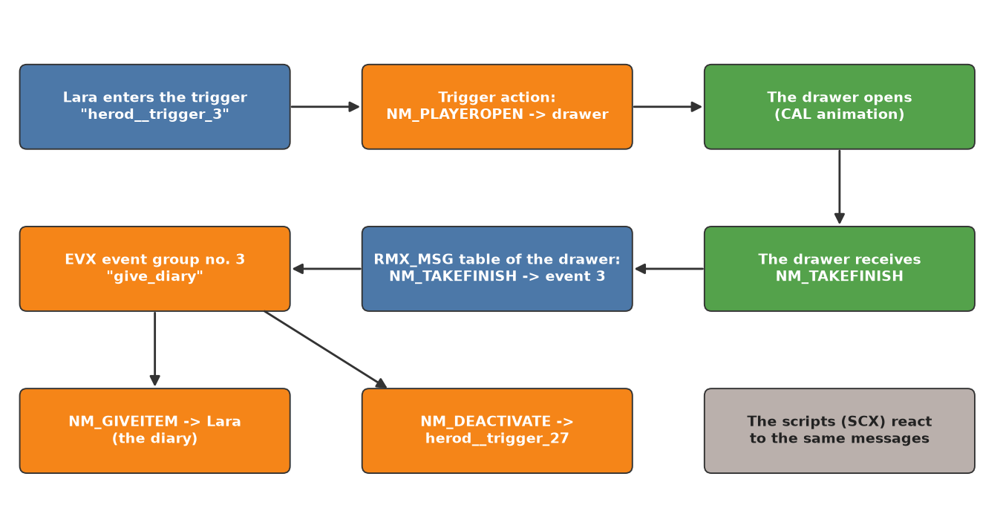
Figure 10 - A real example from PARIS1B: opening the drawer and finding the diary
TRAODLE writes this logic to readable text files in the Scripts folder: <LEVEL>_EVENTS.txt (the event groups and what starts them), <LEVEL>_TRIGGERS.txt (the triggers and their actions) and, for each script, the disassembled code and an approximate reconstruction of the source.

10. Effects (emitters)
Emitters are the nodes that produce visual effects. Each one uses one of the 155 effect "templates" defined in the editor (effects.fsc file) and has a shape: a box (the effect fills a volume, like fog), a line (like a laser beam or water dripping along an edge) or a point (like a flame). It also has a color and two numeric parameters whose meaning depends on the template.
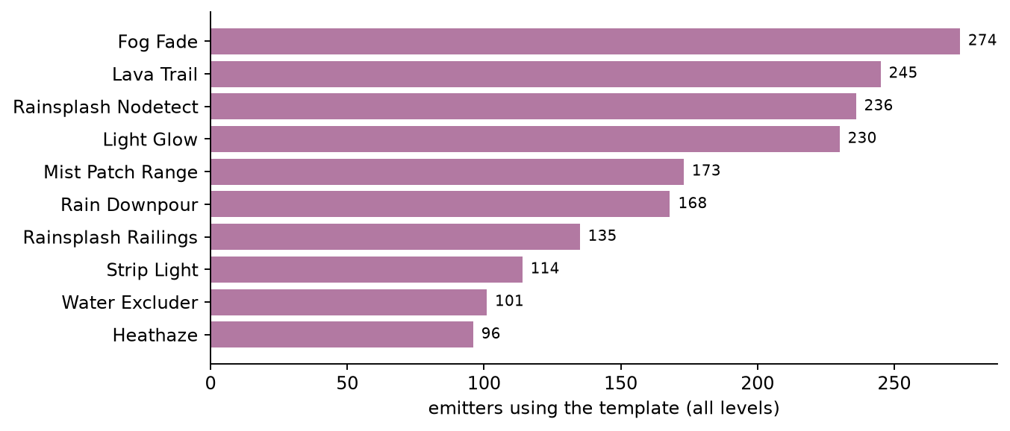
Figure 11 - The most used effect templates
Shape | How many | Examples
Box | 1570 | Fog Fade, Rain Downpour, Mist Patch, Lava Trail
Line | 986 | Strip Light, Laser Line, Drip Line, Generic Lightbeam
Point | 512 | Light Glow, Flame Torch, Smoke, Candle Glow
Table 9 - The three emitter shapes

11. Cutscenes
There are two kinds of cutscenes: the CS_* levels (full cutscenes) and the IG_* (in-game) cutscenes, contained inside normal levels. All of them run at 30 frames per second, with frame 0 at the start of the cutscene.
File | Content
CAM | Cameras: position, look-at point, roll and field of view for every frame, with the cuts
POS | For each actor, the world position of the pelvis (HIP) in every frame
<actor>_<cutscene>.CAL | The animation of each actor
<actor>_<cutscene>.TMT/.TMS | The face and its animation
CSS | Subtitles: start frame, duration and text code
XXX | For each animated object of the cutscene, its world position and visibility in every frame
Table 10 - The cutscene files

12. What TRAODLE produces in Maya
Next to the GMX, TRAODLE creates a folder named after the level with a Maya scene (and an FBX) for each part of the level. The scenes use the same units and the same vertical axis (Z) as the game.
Folder | What it contains
Rooms | Rooms and nodes: lights, water, portals, waypoints, characters, emitters, triggers, static objects
Zones | One scene per zone: room geometry, objects with their hierarchy, materials and textures
Collisions | Collisions, with a different texture for each surface type
Characters | Characters and animated objects
Animations | One scene per animation (using the character as a reference), an FBX with all the animations, events and transitions as text, one assembled scene per cutscene
Cameras | Cutscene cameras, in-game cameras (fixed and on rails) and script camera sequences
Scripts | Scripts (.amx, .asm, .p) and the text files of events and triggers
Subtitles | Cutscene subtitles
Table 11 - The folders created by TRAODLE
The information that has no direct equivalent in Maya is stored as custom attributes of the nodes (Extra Attributes), for example the room number, the visible rooms, the object slot, the class (objectTemplate), the effect type or the actions of a trigger. The decoded node fields are added too: room reverb and Fakes visibility, object flags and database key, character flags and weight, water and audio parameters, object mesh flags.
For now FBX writing is disabled (a switch in TRAODLE's code): the reference scenes are the MA files.

13. What is needed to go back (TRAODLI)
To rebuild the game files starting from Maya, TRAODLI has to walk the path backwards: read the scene, recognize things from names, layers and attributes, and write the files in the original format. Some things must be recomputed (triangle strips, the collision octree, hashes from names), others are not yet in the exported scenes and will have to be added to TRAODLE or taken from the original files.
What | Status
Collisions (CLN) | TRAODLI already rebuilds them, octree included
Room geometry (ZONE) | Partly: TRAODLI writes the rooms, to be aligned with the names TRAODLE uses today
Objects and slots (ZONE) | To be completed: hierarchy, object collisions, mesh information
PS2 geometry (ZONE) | Not needed: the PC version does not use it
Rooms and nodes (RMX) | To do: many minor fields are not in the scenes yet
Characters, animations, scripts, events | To do
Scripts (SCX) | To do: TRAODLI will recompile them from the decompiled .p files with a new Small compiler
Table 12 - Status of the reverse path
The plan: first the updated structures and the GMX writer, verified by writing an original level back byte for byte; then one format at a time, each checked with the full round trip (export with TRAODLE, import with TRAODLI, comparison with the original file); finally the script compiler.

14. Glossary
Term | Meaning
Hash | Number derived from a name with a fixed formula; the game stores it instead of the name
Node | Anything placed in the world: light, trigger, object, waypoint...
Room | Portion of the world with its nodes and its list of visible rooms
Zone | Part of the level loaded into memory together (ZONE file)
Slot | Object made of several meshes with a small hierarchy, in the ZONE
Fake | Simplified background object
Trigger | Volume that sends messages when it is activated
Message (NM_...) | Command sent to a node, for example NM_OPEN
Event group | List of messages sent in sequence (EVX file)
Emitter | Node that produces a visual effect (fog, fire, rain...)
Octree | Division of space into nested cubes to quickly find nearby triangles
Triangle strip | Compact way to store triangles: each vertex makes a triangle with the two previous ones
Blend shape | Variant of the shape of a mesh (a facial expression) that can be mixed with the others
Frame | A single image of an animation; the game uses 30 per second

