**NetCDF4Excel – User documentation –**

**3.0 Version**

**Content :**

1. Getting started 3

Setup 3

Facultative : How to add permanently the add-in in Excel? 3

2. Display conventions 3

Which rules are used to display the header of a NetCDF file in the Excel Workbook ? 3

What are the conventions for the NetCDF variables content display in Excel ? 5

How are processed character variables? 8

3. Opening/Saving a file 9

How to open entirely a NetCDF file ? 9

How to save the modification of a NetCDF file loaded entirely in Excel ? 9

How to save the modification of a NetCDF file partially loaded in Excel ? 9

How « Create New File » and « Add/Update Variables into an Existing File » use information stored in the NC_INFO header sheet ? 9

How to open partially a (big) NetCDF file   ? 11

Read only : How to only display a variable header ? 11

4. Conditionnal filter 11

What is the principle of the filter ? 11

How to use the filter function? 12

Size of the filtered dimension (number of indexes matching all the conditions will be displayed in the header sheet. 14

5. Edit, modify a file 15

Is it possible to manually modify data in the NC_INFO header sheet ? 15

Is it possible to shorten an existing NetCDF file? 15

How to create a new NetCDF file without opening an existing NetCDF file? 16

How to add a new dimension in data? 16

How to add a new variable? 16

Is it possible to delete variables or dimensions ? 16

# Getting started

## Setup

Run the installer **NetCDF4Excel_3_0_setup.exe.** You need the administration rights on your account.

A link to the Excel file NetCDF4Excel.xlsm is created on desktop. 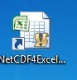. If you open this workbook, you can see in the Excel Add-ins menu that a NetCDF menu has been added. This new menu contains NetCDF4Excel functionalities.

In case of problem of problem (program not found), please close and restart Excel.

## Facultative : How to add permanently the add-in in Excel?

It is possible to display permanently the add-in NetCDF4Excel every time you run Excel, without always opening the link on desktop of the **NetCDF4Excel_2007.xlsm**.

1. Open the link of the file **NetCDF4Excel_2007.xlsm**

2. Save the file in **«C:\Users\ *UserName*\AppData\Roaming\Microsoft\AddIns»**, in selecting a **.xlam** extension.

3. Click on **File>Options**, and then click the **Add-Ins** category

4. In the Manage box, click COM **Add-ins**, and then click **Go.** The COM Add-Ins dialog box appears.

5. In the Add-Ins available box, select **NetCDF add-in for Excel**.

6. **NetCDF** menu will permanently appear in the **Add-ins** menu in Excel.

# Display conventions

## Which rules are used to display the header of a NetCDF file in the Excel Workbook ?

The header of a NetCDF file is displayed in a dedicated sheet which, by convention, is named **NC_INFO** and is the first displayed sheet. It contains dimensions of the file, list of variables and their dimensions.

**NcFileName:** Name of the NetCDF file displayed in Excel.

**NcFileType :** Not used

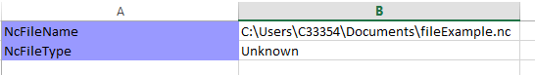

**Global Attributes (facultative data) :** list of global attributes of the file 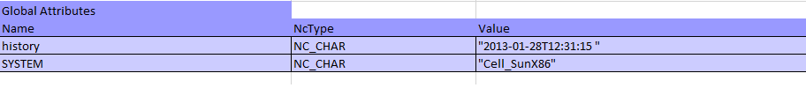

**Dimensions/Name:** full name of the dimension as it is used in the NetCDF file.

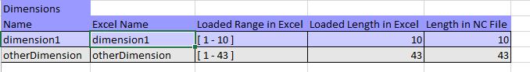

**Dimensions/Excel Name:** if the name of the dimension outsizes a defined length (28 characters), a truncated « Excel name » is built from the full name. This Excel name will be used to name the Excel sheet referring to this dimension.

**Dimensions/Loaded Range in Excel:** it is the minimum index (base 1) and the maximum index of the values range loaded in the Excel name for this dimension. It will be used for all variables depending on this dimensions:

* If the file is opened with « Open Entire File » : the range loaded is [ 1 – size of dimension ]
* If the file has been opened with « Open File Subset»: value range is specified by user.

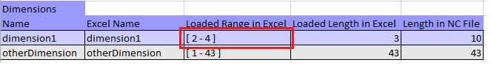

* If the file is opened with « Filter File »: there is potentially no continuous range loaded, the mention “filtered” is displayed.

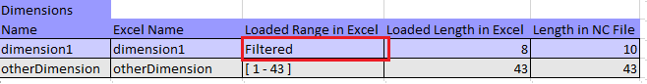

* If the file has been opened with  « Extract header »: mention « Not loaded » is displayed.

**Dimensions/Loaded Length in Excel:** Number of values loaded for the dimension. It corresponds to the difference: «*maximum index– minimum index +1* » displayed in the « Loaded Range » cell. When the dimension is filtered, the displayed value « *loaded length* » is the number of index in the dimension matching the filter.

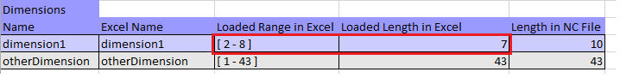

**Length in NC file:** Value of the dimension in the NC file (if no filter used or if the dimension is not partially loaded, the length in NC file is of course the same as the loaded length in Excel).

**Variables/Name:** the name of the variables in the NetCDF file

**Variables/Excel Name:** if the NetCDF name of the variable outsizes a limit (28 characters), an « *Excel name* » is truncated and built with the index of the variable. This name will be used in the spread sheet storing the variable values.

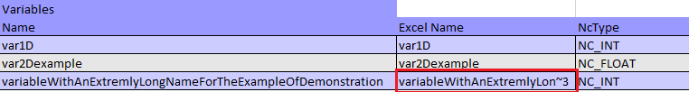

Variable dimensions, type, and facultative attributes are also displayed in the header sheet.

**NB: Modifying manually the values in the NC_INFO header sheet is not recommended (except for 0D variables stored in this sheet). NetCDF4Excel is designed to modify manually the data values in the data sheets. Modifying colors or policies has no influence on the program running.**

## What are the conventions for the NetCDF variables content display in Excel ?

* The **NC_INFO** sheet contains the header, but also the 0D variables or the 1D characters variables value.

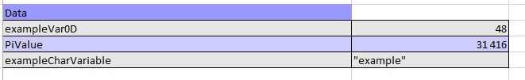

* **2D and 3D variables** have specific sheet for each variable. Sheet name is variable name, shortened if it outsizes the Excel limit for sheet names.

For numeric variables with at least 3 dimensions or for character variables with at least 4 dimensions, dimensions are concatenated to display the variable as 2D variables. Variable dimension indexes are displayed in the sheet.

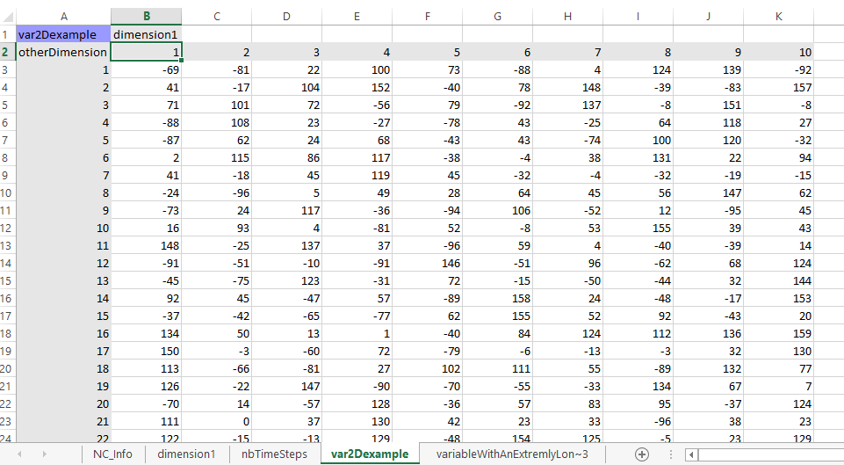*2D variable example*

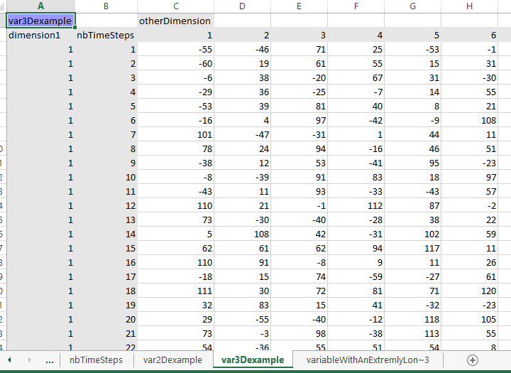

*3D variable example*

* **1D numeric variables or 2D string variables** sharing a dimension are grouped in the same sheet.

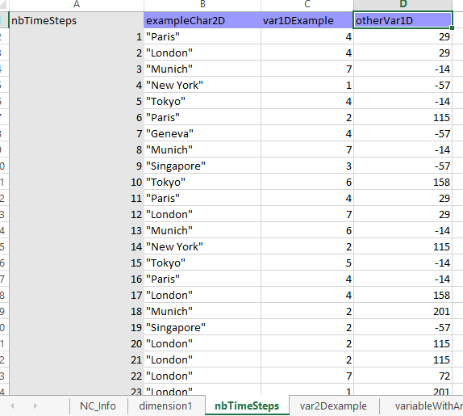

*In the example, the variables displayed in this sheet share the dimension “nbTimeSteps”.*

For character variables see alsoHow are processed character variables?

**Sheet names** correspond to the **Excel Name** of the variables or dimensions displayed in the NC_INFO header sheet. It can be shorten when the name is too long.

## How are processed character variables?

Principle: a NC_CHAR variable with N dimensions in NetCDF is displayed in Excel as a string table with N-1 dimensions and the last dimension of the variable is considered as the length of the strings.

* NC_CHAR type 0D or 1D variables are displayed in NC_INFO header sheet, in the data section.
* NC_CHAR type 2D variables are displayed as 1D numeric variables. They are displayed in the sheet named with their first dimension, with other 2D character variables using this dimension or with 1D numeric variables using this dimension.
* NC_CHAR type 3D variables are displayed in the same way as 2D numeric variables, with their own sheet.

# Opening/Saving a file

## How to open entirely a NetCDF file ?

Click on **Open > Open Entire File,** and choose the address of the file you want to open.

It will display the content of the NetCDF file in a new Excel WorkBook, following the data presentation rules described in What are the conventions for the NetCDF files display in Excel ?

## How to save the modification of a NetCDF file loaded entirely in Excel ?

Click on **Save > Create a New File,** and select the address where you want to save your file.

If you click on **Save > Add/update variables into existing file,** modifications will be saved in the file loaded initially.

## How to save the modification of a NetCDF file partially loaded in Excel ?

Click on **Add/Update variables into an existing file. ,** your modifications will be saved in the initially loaded file.

Updated NetCDF file will contain:

* **Variables read in NetCDF and loaded in Excel.** The variables value may have been modified by the user in Excel. If only a range of the dimensions of the variables have been loaded, only this range can be modified: the not loaded part remains unchanged in the NetCDF file (variables are not shortened in the NetCDF file).
* **New variables** added by the user in Excel (cf How to add a new variable ? ). They can use dimensions already existing in NetCDF file or added by user in Excel. NB: if new variables uses dimensions partially loaded in Excel, default values will be used outside the loaded range in Excel.
* **NetCDF variables already existing and not loaded in Excel**

**NB :** in case of using **Create a New file**, program create a file only containing Excel workbook content (loaded or added variables, and data corresponding to the loaded part of the dimensions ). If you save in the previously existing NetCDF file, data not loaded in Excel will be lost.

## How « Create New File » and « Add/Update Variables into an Existing File » use information stored in the NC_INFO header sheet ?

Depending on the function used, NC_INFO will not be used in the same way.

|  |
| --- |
| **NcFileName** ( displays the adress of the NetCDF file opened in **NcFileName ):**   * **Create New File**: address displayed will be ignored, a message box asks the user the emplacement of the saved file. * **Add /update into Existing File** : no address is asked, information are automatically saved at the displayed address. |
| **Dimensions / Loaded Range in Excel :**   * **Create New File** : value displayed is ignored when saving (but coherence tests are done) * **Add /update into Existing File** : saved data will correspond to the displayed range. If the dimension has been filtered, an error is prompted. |
| **Dimensions / Loaded Length in Excel :**   * **Create New File** : the value displayed will be the length of the dimension in the new file. * **Add /update into Existing File** : this value is only used for coherence test |
| **Dimensions / Length in NC File :**   * **Create New File** : this value will not be used when saving * **Add /update into Existing File** : the value in the NetCDF file is not modified and will correspond to this value. |
| **Variables:**   * **Create New File** : All variables displayed in Excel are stored in the new NetCDF file * **Add /update into Existing File** :   + Variable present in Excel and not in NetCDF : added in NetCDF file   + Variable present in Excel and in NetCDF: variable values are updated in NetCDF with Excel values. Dimensions must be identical.   + Not present in Excel and present in NetCDF : variable is kept unchanged in NetCDF |
|  |

## How to open partially a (big) NetCDF file   ?

Click on **Open>Open file subset,** and select the address of the NetCDF file.

Select then:

- the list of variables you want to load in Excel

- if you want to load partially some dimensions, click on **Truncate Dimension**

and fill in the form with the indexes of the range you want to load: for example 3-28

**NB : the convention of the indexes starts at 1 and ends at N with N the dimension size**

**NB :** truncating a dimension is processed in the same way for all variables using this dimension

## Read only : How to only display a variable header ?

Click on **Open > extract header.**

Only the header will be loaded in Excel (dimensions values and list of variables description).

# Conditionnal filter

## What is the principle of the filter ?

Filter concerns a given dimension. All variables using this dimension will be filtered in the same way. For the moment, only one dimension can be filtered in an opened NetCDF file.

Conditions values of the filter are defined with 1D numeric variables using the dimension or 2D character variables. The criteria is value equality. For the moment no other criteria is possible.

If several variables are used, all the conditions must match.

For example, for 1D variable « year » of dimension « nbTimeSteps » and a 2D character variable « Semester » of dimension « nbTimeSteps » x 2 (2 is the size of the strings).

|  |  |  |
| --- | --- | --- |
| **Index** | **Year** | **Semester** |
| 1 | 2015 | S1 |
| 2 | 2015 | S2 |
| 3 | 2016 | S1 |
| 4 | 2016 | S2 |

***nbTimeSteps dimension = 4***

If we use the 2 conditions « year = 2015 » et « semestre = S2 », the filter will only match the second index.

|  |  |
| --- | --- |
| **Indice** | **Action** |
| 1 | Ignore |
| 2 | Load |
| 3 | Ignore |
| 4 | Ignore |

For all the variables depending on this dimension, only the values corresponding to the second index of this dimension will be loaded.

## How to use the filter function?

Click on **Open > Filter File,** and select the file you want to open.

In the opened message box, select the dimension you want to filter.

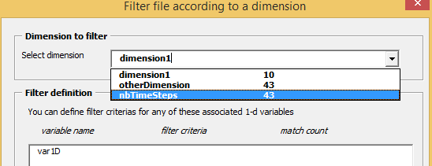

After selecting a dimension, a list of variables which can be used to define conditional values is displayed. For the moment, only one value condition can be used for each variable.

Once a condition is added, the number of values matching is displayed only for this condition (not for the intersection of all the added conditions).

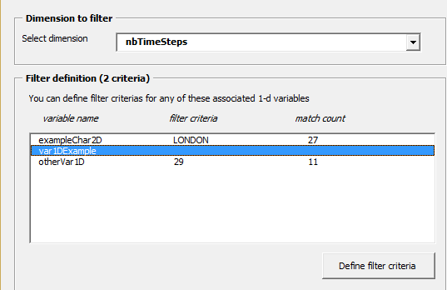

The final filter is the intersection of all the conditions. If no index in the dimension matches all the conditions, a message is prompted to warn the user.

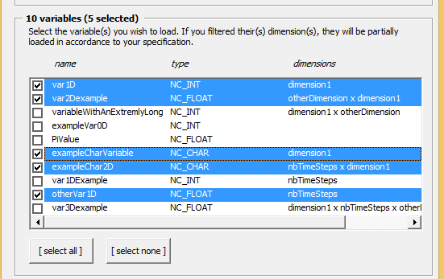

Then, select in the message box the variables you want to load in Excel.

The variables loaded in the Excel are independent of the variables used to build the filter

* It is possible to build variables not linked to the filtered dimension
* It is possible to not load variables linked to the filtered dimension, even those used to build the filter

# Size of the filtered dimension (number of indexes matching all the conditions will be displayed in the header sheet.

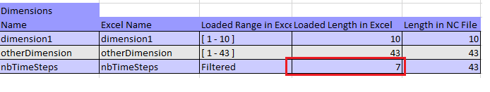

**NB :** Once a NetCDF file is loaded in Excel with a filter, you cannot save your modifications in the initial NetCDF file (the function Add/update variables in existing file is not available). You can save your Excel file in a new NetCDF file (Create a new file function), but the filtered dimension will be shortened.

# Edit, modify a file

## Is it possible to manually modify data in the NC_INFO header sheet ?

*Of course, if you don’t want to save your modification in a Netcdf file*, you can modify the Excel file as you want. Your modifications will not modify the NetCDF file.

*If you save in a NetCDF file* using « **Create New File** » or «**Add/Update Variables into an Existing File***»* functions, value displayed in Excel will be stored in NetCDF. You must consequently be cautious with your modifications.

**You can:**

* Modify the value of any variable
* Add new dimensions (using the Add new dimension function): if you save, it will be added in the NetCDF file.
* Add new variables (using the Add new dimension function): if you save, it will be added in the NetCDF file.
* Modify the format of any cell (color, police …), sheets order, size of cells, … , as long as you do not modify content of the cells.

**You should not (unless you are sure of what you do):**

* Add manually variables or dimensions: the risk, if you do not respect expected data display conventions, is to have an error when saving your modifications in a NetCDF file.
* Modify the loaded range in the header
* Generally speaking modify values in the NC_INFO header sheet

**You CAN NOT :**

* Modify a dimension length: Instead, you’d better create a new variable or a new dimension.
* Change the type, the name, the list of dimension of a variable : Instead, you’d better delete the variable (with the delete function) and create a new one
* Modify the header structure

## Is it possible to shorten an existing NetCDF file?

Yes, by using the function **Open > Open File Subset** (cf How to open a file subset) , and then saving the workbook with **Create a New File.**

It enables you :

* To create a new NetCDF file with only a part of the variables of the initial NetCDF file.
* And/or to create a file with shorter dimensions.

## How to create a new NetCDF file without opening an existing NetCDF file?

Click on **Add/delete > New Empty File** in the menu.

A new Excel Workbook is created, with a NC_INFO (header sheet) containing no variables no dimensions.

Then you will have to fill the WorkBook with new dimensions and new variables (cf Adding a new dimension et Adding a new variable )

## How to add a new dimension in data?

Click on **Add/delete > Add new dimension.**  Fill the fields with the name and the value of dimension. The new dimension is displayed in the header sheet (highlighted in yellow).

This functionality can be used with a new file created by the user, or with an existing NetCDF file opened by the user.

## How to add a new variable?

Click on **Add/delete > Add new variable.** Fill the form with the **name** of the variable, and select its **type** (INT, FLOAT…)

Select then for each **dimension** of the variable, the name of the dimension. For string vectors, a special field must be filled, giving the length of each string (the convention is that is the last dimension of the NetCDF variable). Only existing dimensions can be selected: otherwise you will have to create missing dimensions before creating the variable (cf *Insertion d’une nouvelle dimension*).

After validating, the Workbook display the added variable in the header sheet (yellow highlighted). In the sheet containing the data of the variable, the cells expecting data values of the created variable are also yellow highlighted: **user will have to fill them with values manually.**

This functionality can be used with a new file created by the user, or with an existing NetCDF file opened by the user.

## Is it possible to delete variables or dimensions ?

You cannot delete dimensions or variables (or shorten dimensions) of an existing NetCDF file, unless you erase it.

You can nevertheless delete a dimension in the Excel workbook with the function **Add/delete >**  **Delete Selected Dimension** (if the dimension is not used by variables displayed in the workbook) or delete a variable with the function **Add/delete > Delete Selected Variable** .

* If you save your Workbook in a new NetCDF file with **Create a New File )** , the deleted dimensions or variables won’t be written in the NetCDF file.
* If you save your modifications in an existing NetCDF file **Add/Update variables into an existing file**:
  + If these variables or dimensions did not exist before in the NetCDF file (they had been added in the Excel workbook by the user) they won’t be written in the NetCDF file.
  + If these variables or dimensions did exist previously in the NetCDF file, they won’t be modified or deleted in the NetCDF file.