Database, User, Table & Records Operations, Other Keywords,
Aggregate Functions

1. Create a user with only database create access rights.

-> Createuser anju ;
-> Alter Role anju createdb;
-> Alter Role anju -d;



2. Create a user with superuser access rights.

-> Createuser anju;
-> Alter Role anju Superuser;



3. Create a user with database creation, superuser and role creation access rights.

-> Createuser anju -d -s -R;



4. Drop any one of the users which you have created.

-> Drop user anju ;



5. Alter any one user’s password with your desired password.

-> Alter user anju with password ‘anju’;

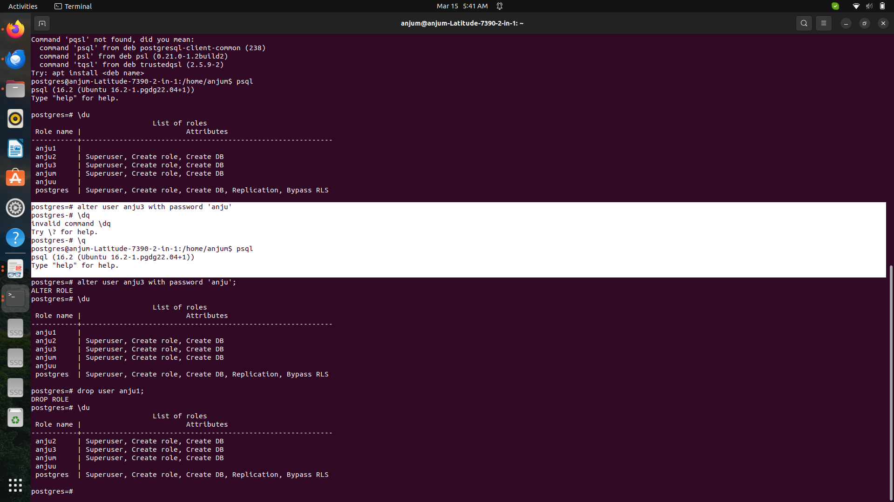

6. Create a database.

-> Create database test;

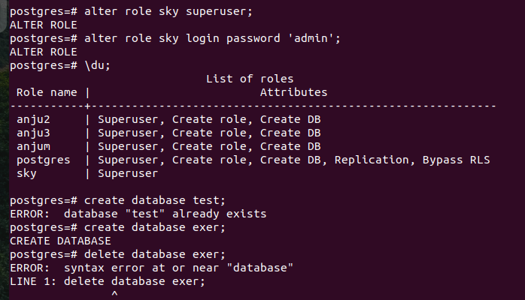
7. Delete a database which is created.

-> Delete database test;

All the below operations are to be performed in the terminal prompt of
PosgreSQL and pgAdmin.

8. Create a database and add a table employee with specified fields.
◦ Employee ID
◦ Name
◦ Email
◦ Phone no
◦ Designation
◦ Department
◦ Birth Date
◦ Join Date

-> Create table Employee(emp_id primary key int, name varchar, email varchar,phone no int,Designation varchar,Department varchar,birthdate int, joindate int);

9. Modify the table and add two fields as following.
◦ Level
◦ Qualification
◦ Join Date

->Alter table Employee
Add column level varchar(50),
Add column Qualification varchar(100);
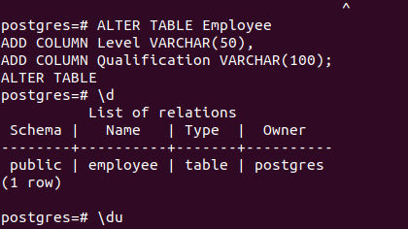

10. Modify a table and Delete a column from the table.

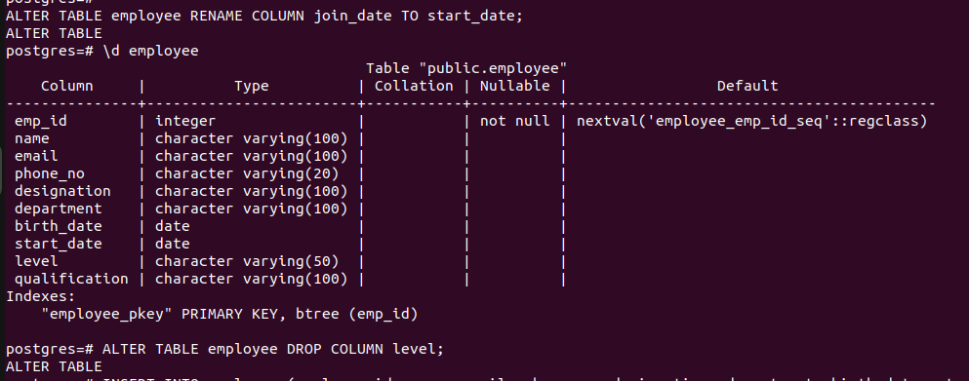
-> Alter table Employee rename column join_date to start_date;
-> Alter table Employee Drop column level;
11. Insert 10 records with unique employee ids in the employee table.

-> Insert into Employee(name,email,phone_no,designation,department,birthdarte,startdate)
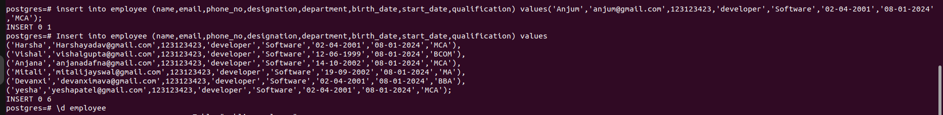
values (‘Disha’,’disha@gmail.com’,9021-292-238,’Developer’,’Software’,’2-04-2001’,’MCA’);
12. Update all the records together. Update only one field.

-> Update Employee set designation=’Junior’ where id=4;

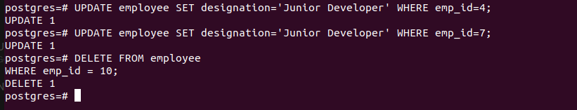

13. Delete a single record from a table.

-> Delete from Employee where emp_id=10;

14. Delete all the records from a table using Delete.

-> Delete from Employee;

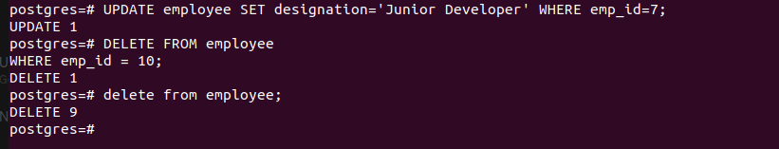

15. Delete all the records from a table without using Delete.

-> Truncate table Employee;
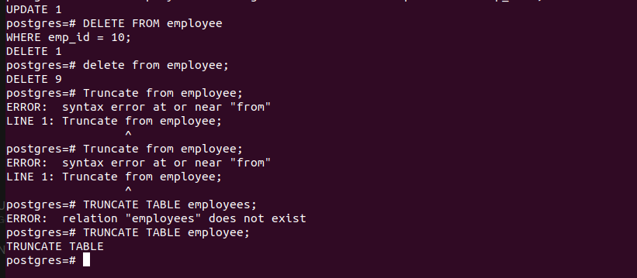
NOTE: Below operations to be done from pgAdmin GUI.

16. Create a table using the Create script in pgAdmin.
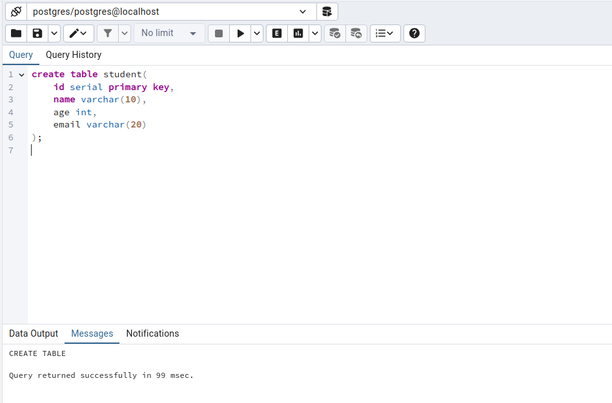

17. Insert 10 records using the Insert script in pgAdmin.

-> Insert into Student(name,age,email) values(‘Mitali’,23,’mitali@gmail.com);

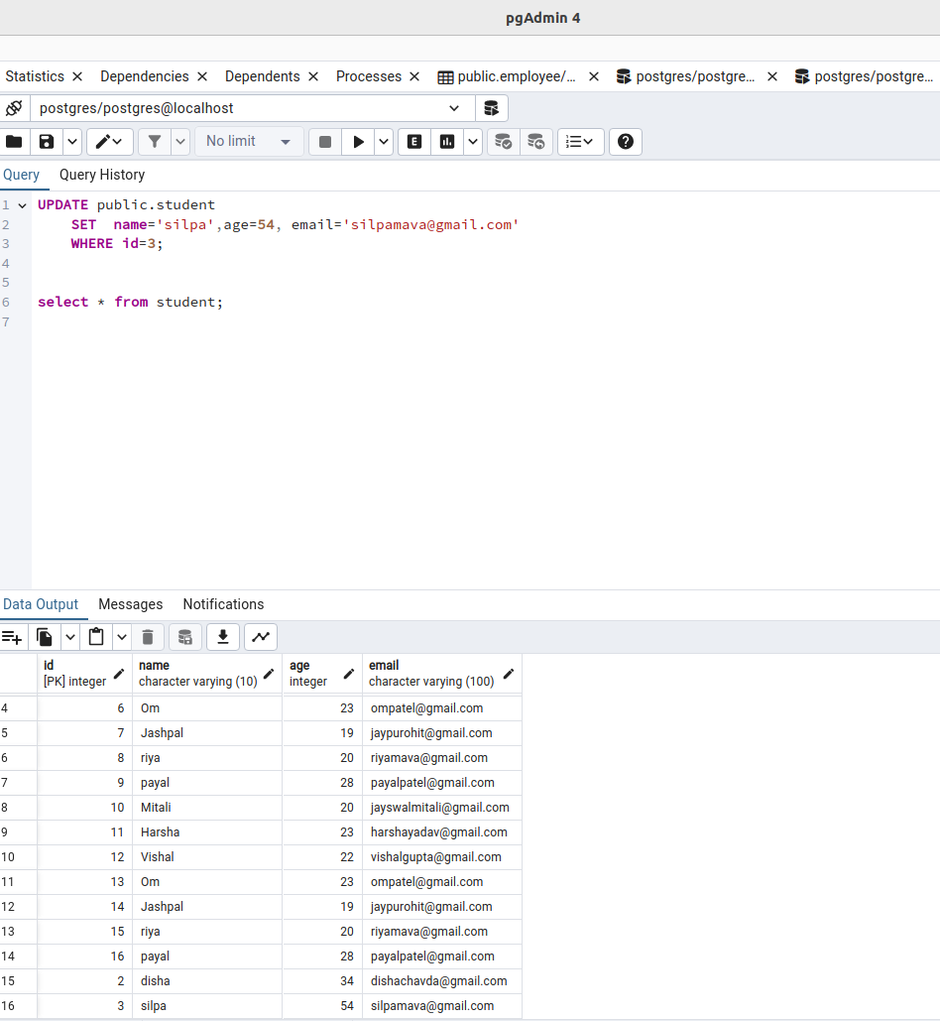

18. Update a record using the Update script in pgAdmin.

19. Delete a record using the Delete script in pgAdmin.

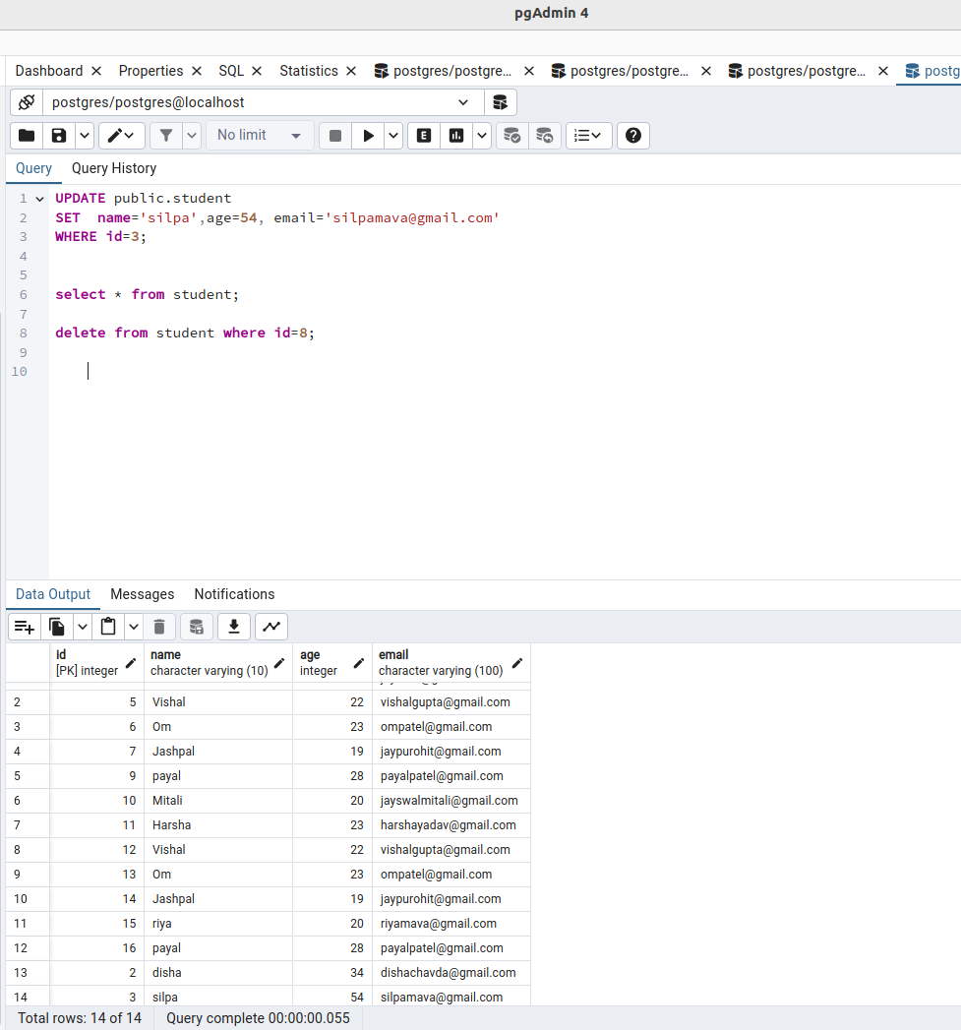

20. Create a table from the Pgadmin.

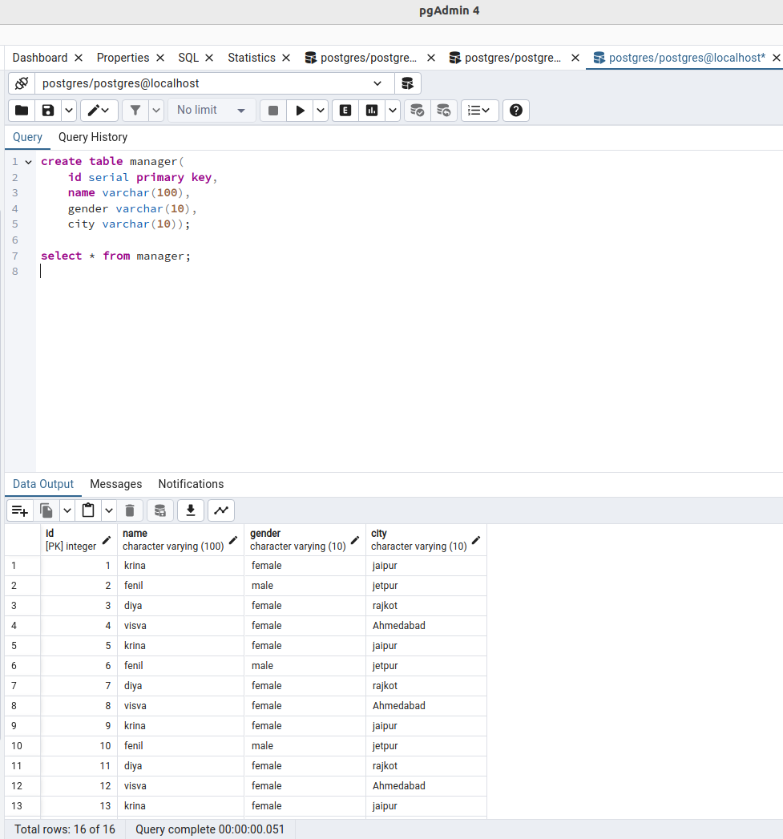

21. Update a table and add a column from pgAdmin.

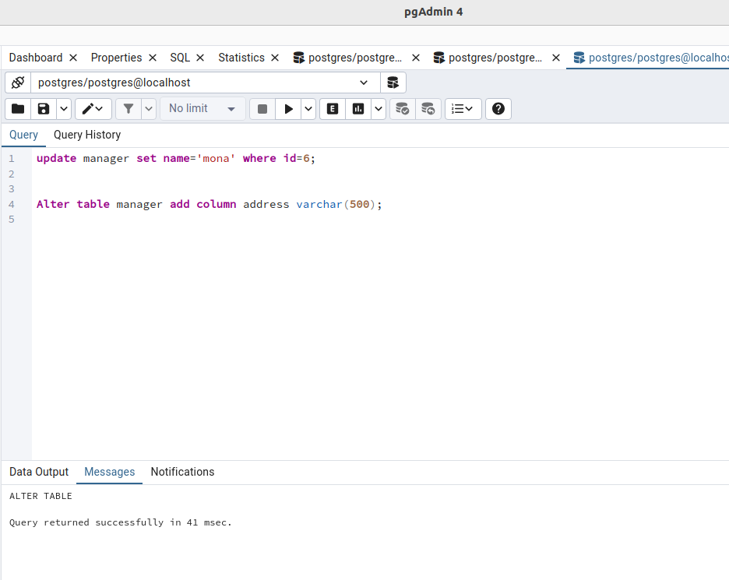

22. Remove a column from a table from pgAdmin.

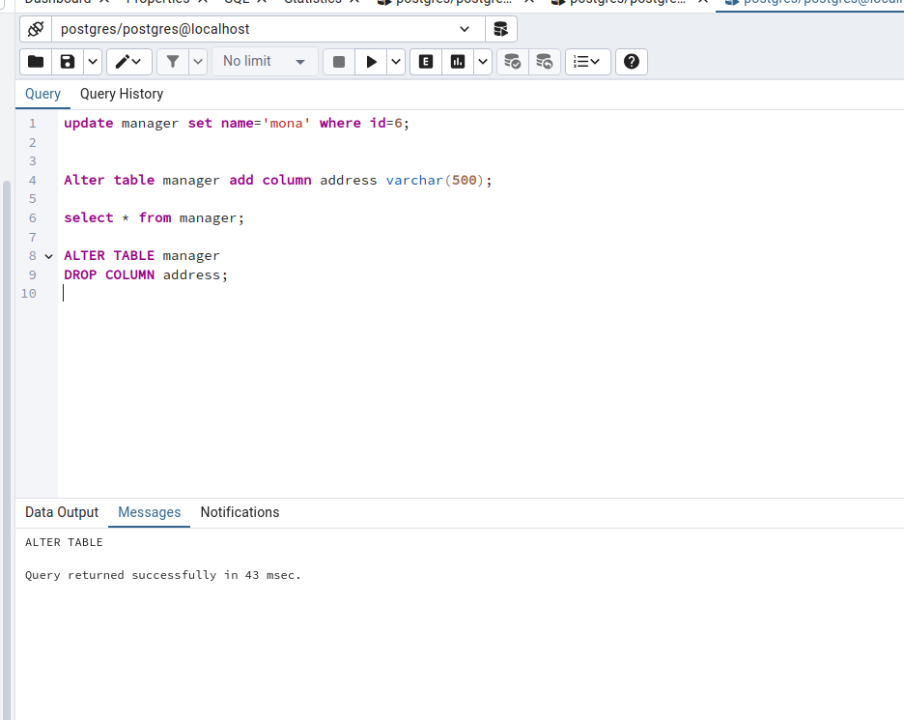

23. Update record from the Pgadmin.

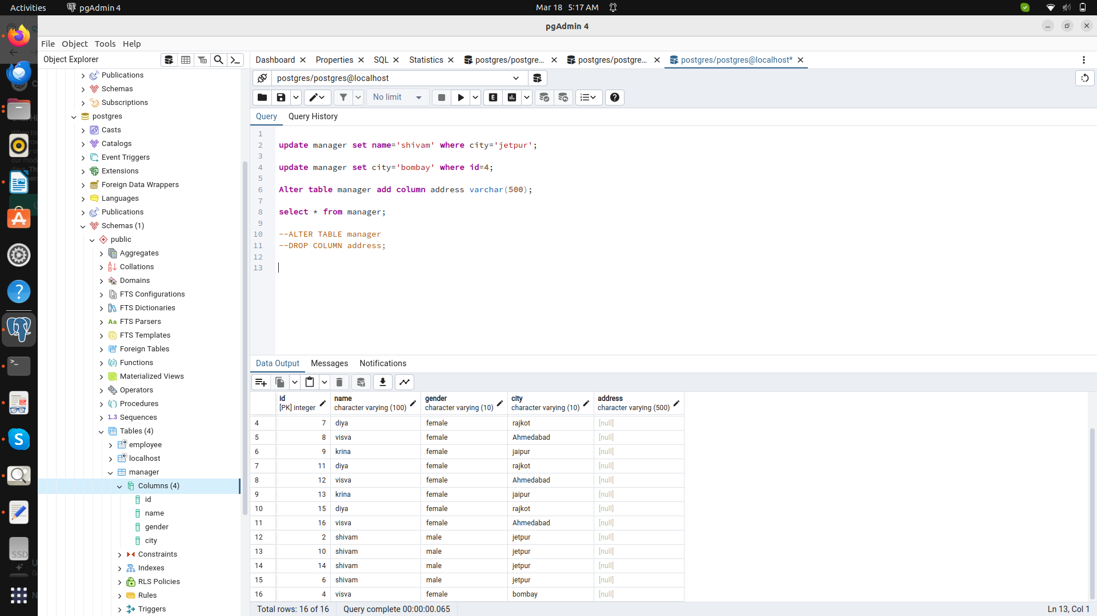
24. View all the records of a table.

25.Write a select query with multiple conditions using ‘AND’ and ‘OR’.

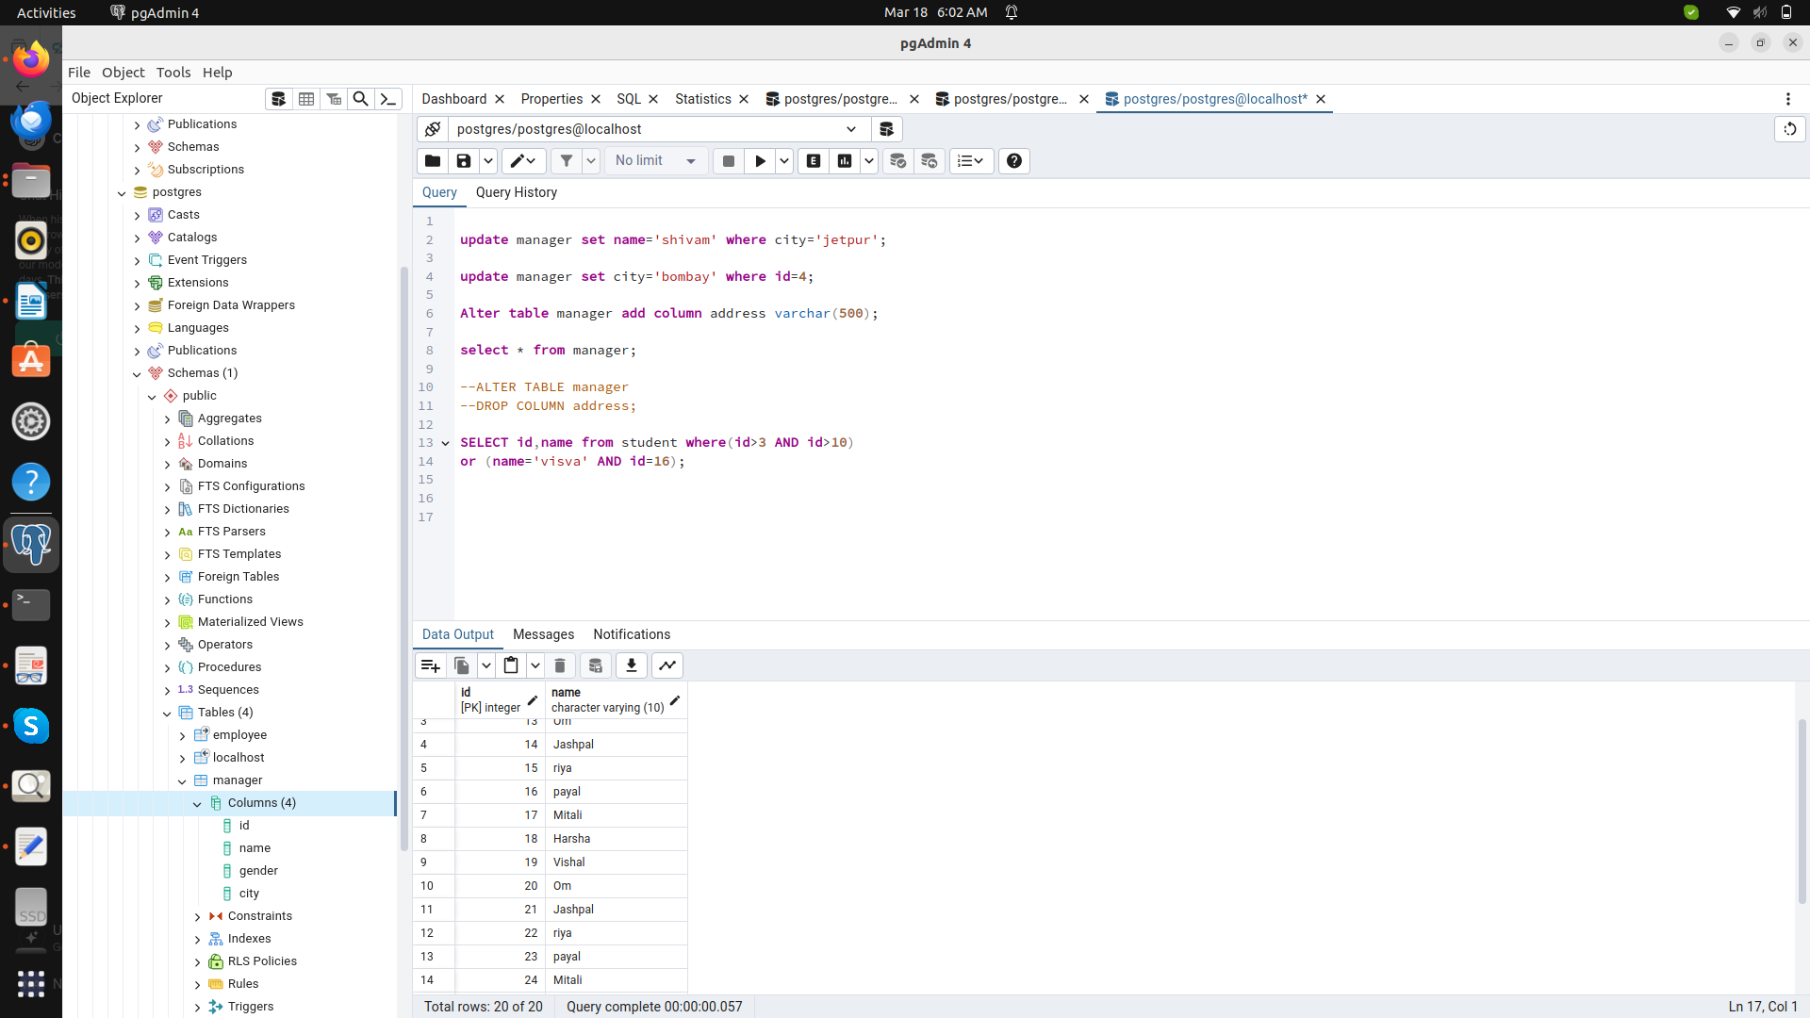

26.Create a table employee where it contains id, name, city. Find the city which ends with ‘abad’. Enter 30 records scattered in different cities like Hyderabad,
Ahmedabad, Mumbai, Delhi, Chennai, Kochin, Kolkatta, Pune, Bangalore.
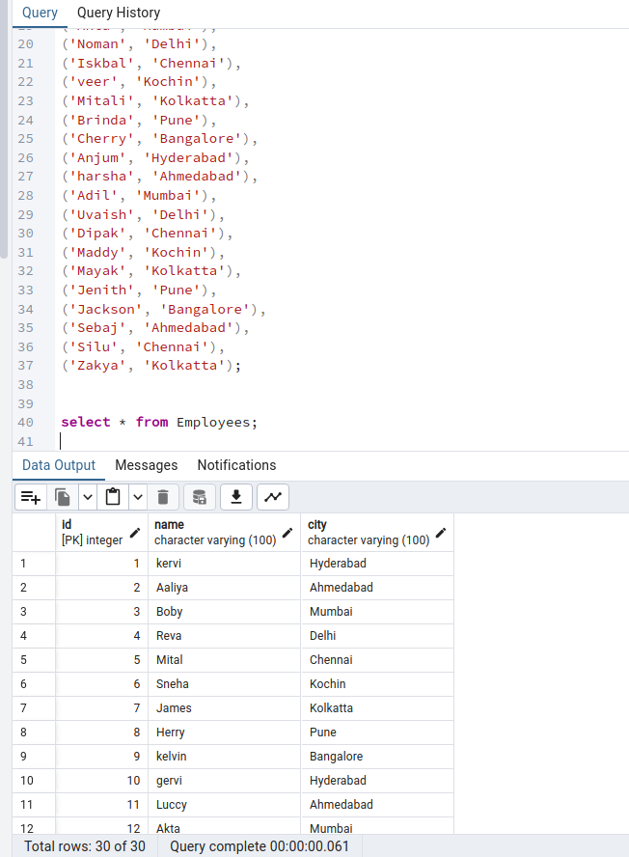

27.Search records where the city contains the string ‘under’.

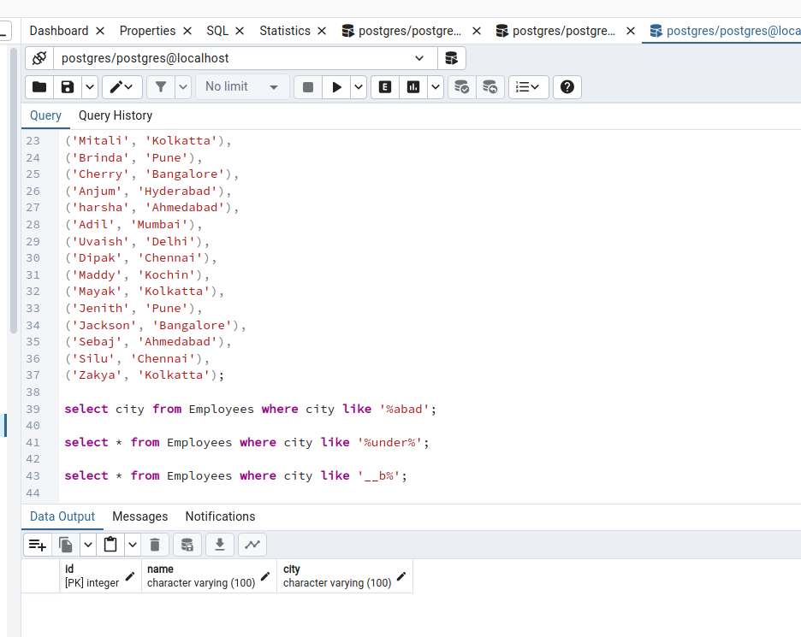

28.Search records where the third last character of the city is ‘b’.

29.Search the records where first characterof the city is ‘A’.

->select * from Employee where city like ‘%A’;
30.Search the records where second Charator of the city is ‘o’.

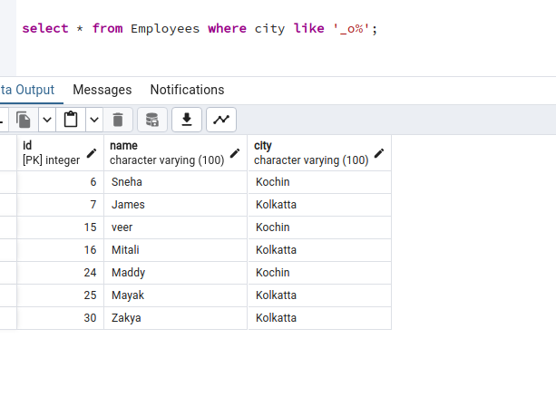
-> select * from Employee where city like ‘_o%’;

31.Search first 10 records.

-> select * from Employee limit 10;

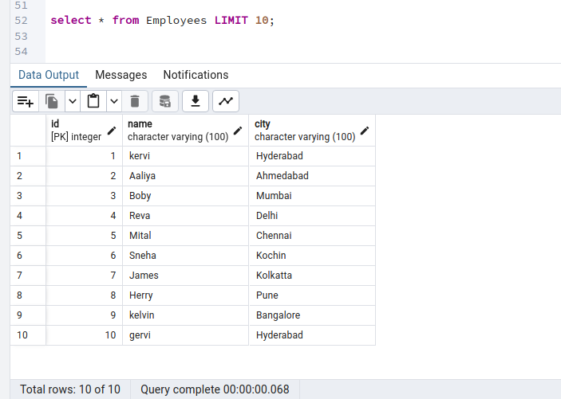

32.Search first 5 records where city is Mumbai

-> select * from Employee where city=’Mumbai’ limit 5;

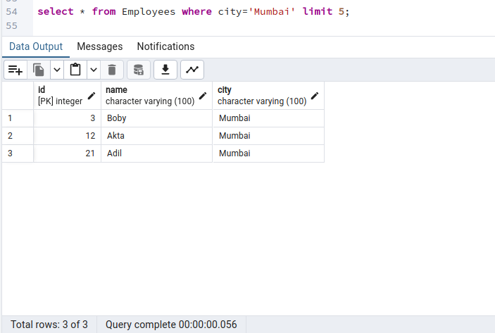

33.Search first 5 records where city is Mumbai or Bangalore. Search the next 5
records skipping the first 5 records where city is Mumbai or Bangalore.

-> select * Employee where city in (‘Mumbai’,’Banglore’) order by id limit 5;

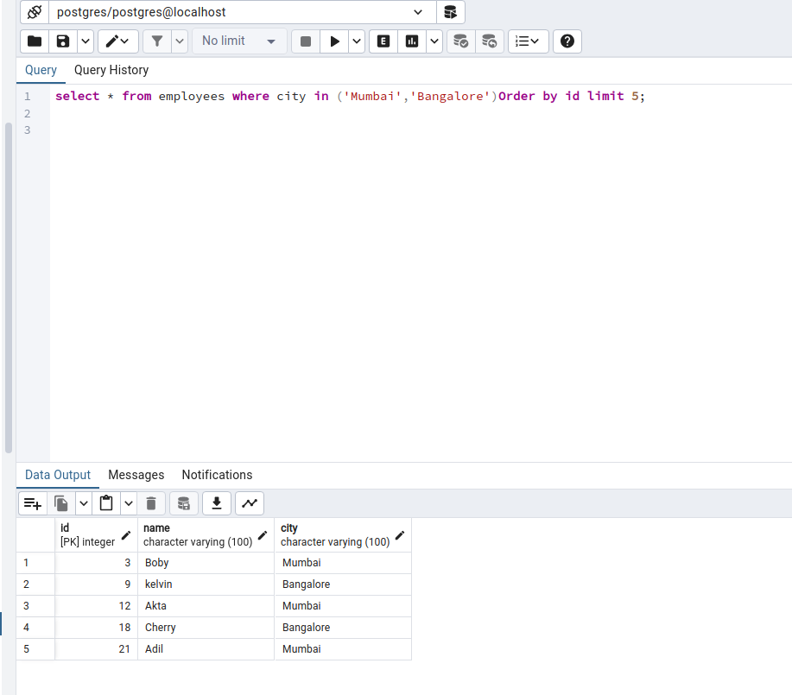

34. Sort the records where city is Mumbai or Bangalore by City Name.

-> select * from Employee where city in (‘Mumbai’,’Bangalore’) order by city;

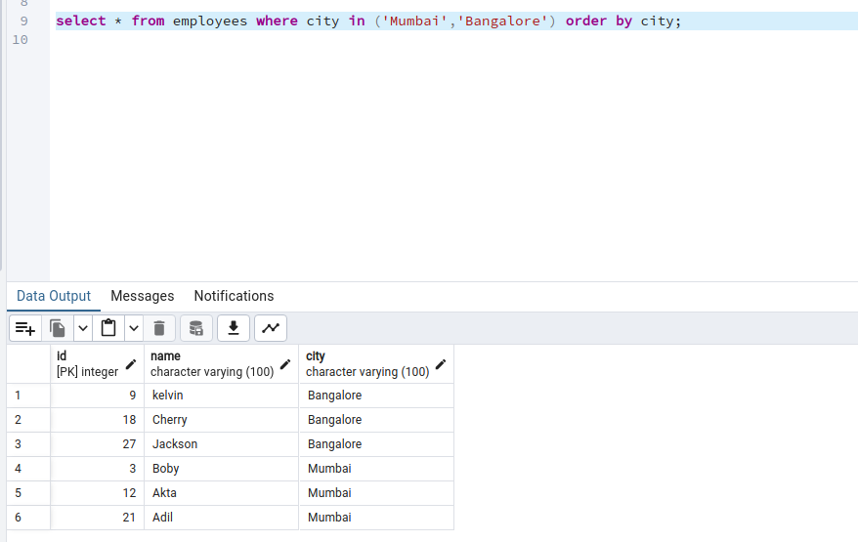

35. Sort all the records of the table by ID in descending order.

-> select * from Employees order by Id DESC;

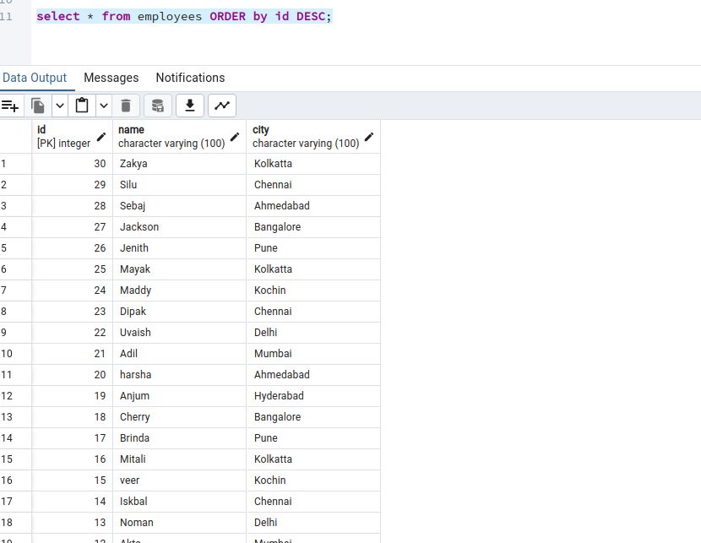

36. Insert few records where the city is not entered. Search all the records where the city field is blank.
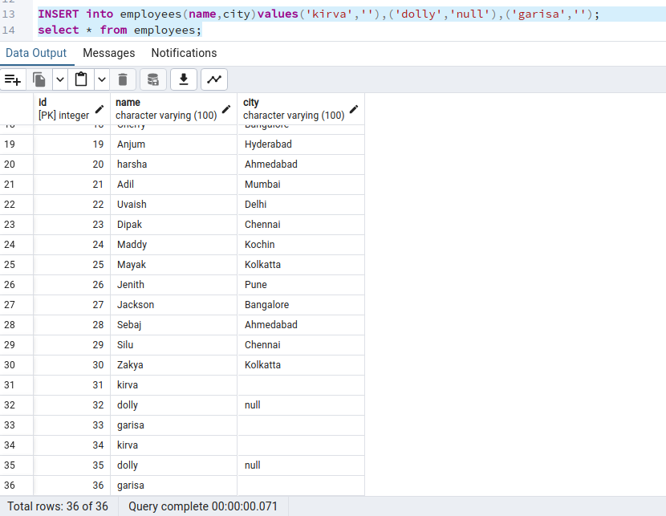
-> Select * from employees where city=’ ‘;
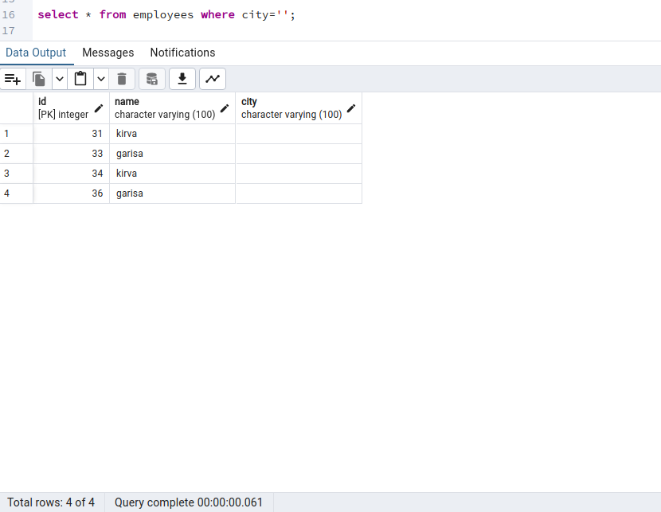

37. Enter few duplicate records where name is duplicate. Select unique records from a table.

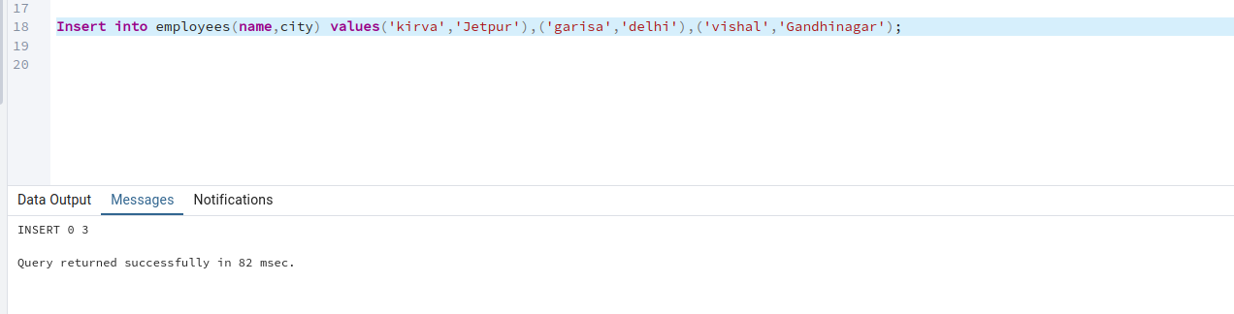
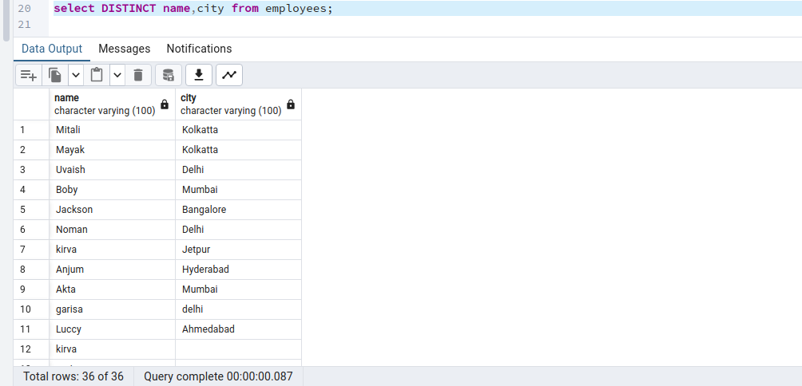

38. Enter a column amount in the table. Get a total of the complete amount.

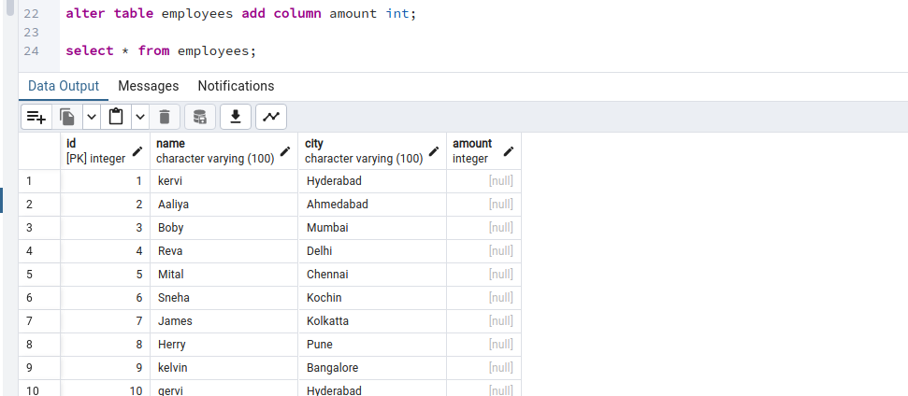
39. Get total of amount by city.

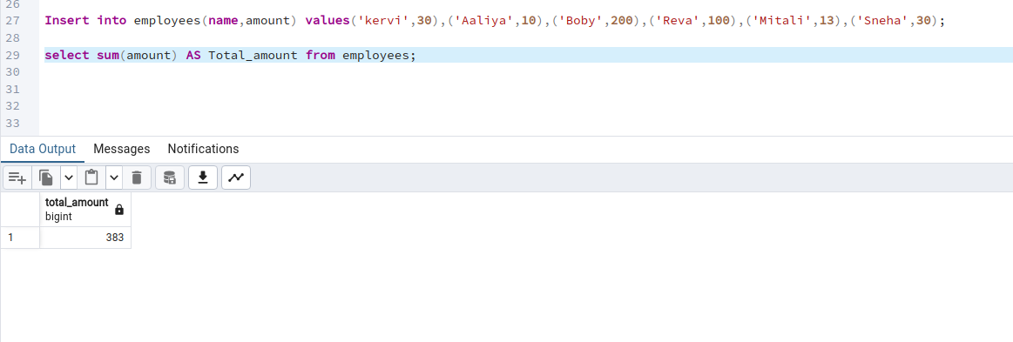
-> select city, sum(amount) as total_amount from employees group by city;

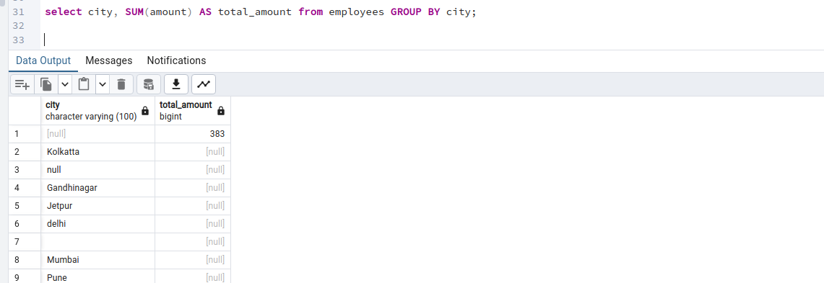

40. Get avg of amount by city.

-> select city, avg (amount) as total_amount from employees group by city;

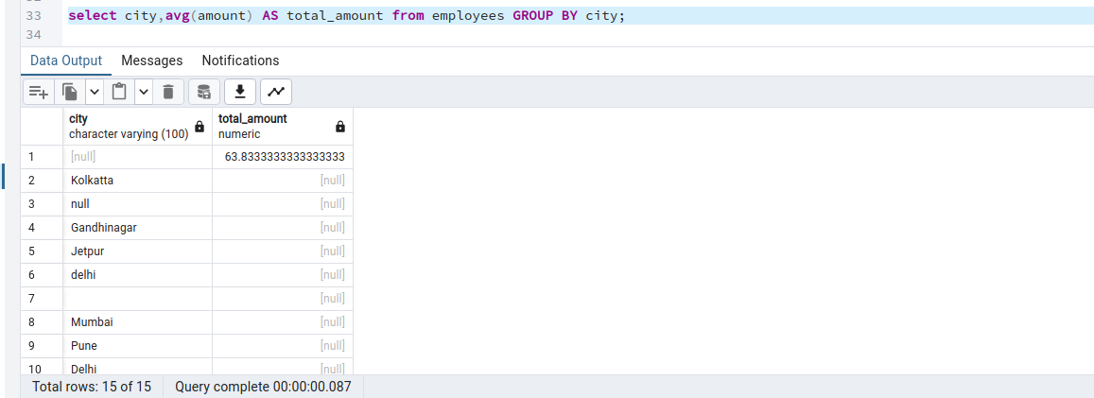
41. Get maximum amount from all records

-> select max(amount) as max_amount from employees;

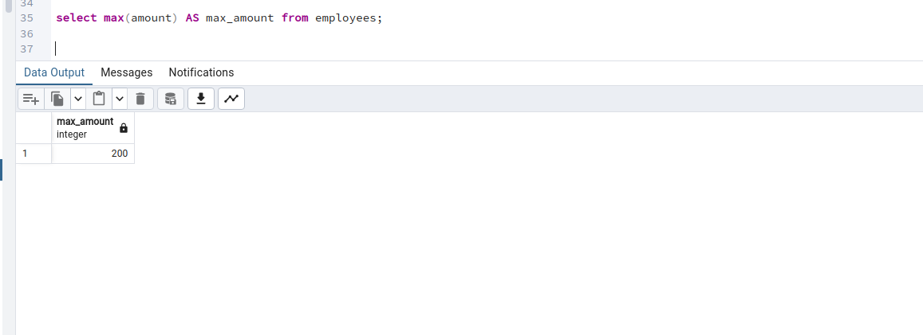

42. Get minimum amount from all records.

-> select min(amount) as min_amount from employees ;
