CC 207 — APPLICATION DEVELOPMENT
AND EMERGING TECHNOLOGIES
PROJECT PROPOSAL
(MIDTERM PROJECT)
RELIEF DONATION PICK-UP
AND DELIVERY SYSTEM
A Web-Based Platform for Donation Collection and Delivery Tracking

Group Number | Group 7
Section | C
Members
Date Submitted | [Enter submission date]
Instructor | JOYCE C. LIMUA
SDG Addressed | SDG 3: Good Health and Well-Being
Project Area | Lambunao, Iloilo

1. SDG Impact Proposal

1.1 Problem Statement
In Lambunao, Iloilo, donation collection and delivery may depend on manual messages, phone calls, and informal coordination. This can make it difficult for charity organizations to organize requests, confirm pick-up schedules, find exact donor locations, and keep donors informed about the progress of a donation. Donation, collection, and delivery details may also be spread across different communication channels, making records harder to monitor.
These coordination problems matter when relief goods are intended for people who need assistance. Delays or unclear delivery arrangements can make it harder for donations to reach the intended recipients in an organized way. A centralized system can help charity administrators and personnel coordinate each request from submission through delivery confirmation.

1.2 Target Users / Beneficiaries
The direct users are donors who submit relief donations, pick-up and delivery personnel who collect and transport donations, and charity administrators who review requests, assign personnel, manage records, and prepare reports. The indirect beneficiaries are the individuals or households receiving relief goods. In the initial version, beneficiaries do not need a separate system account; their destination details are included in the donation request and managed by authorized charity personnel.

1.3 SDG Addressed
The project addresses United Nations Sustainable Development Goal 3 (SDG 3): Good Health and Well-Being. The system is not a medical service and does not directly provide healthcare. Its contribution is indirect: it supports the organized collection and delivery of relief donations that may include essential supplies for people affected by difficult circumstances.
Relevant connection: SDG Target 3.d focuses on strengthening capacity for early warning, risk reduction, and management of health risks. The system's practical link to SDG 3 is supportive rather than direct; it can help improve the coordination and traceability of relief supplies, while the project does not claim to measure health outcomes or emergency-response capacity on its own.

1.4 How the System Contributes to the SDG
The system centralizes donation details, donor pick-up locations, preferred schedules, beneficiary destinations, personnel assignments, notifications, and delivery status. These features can reduce avoidable coordination problems and make it easier for charity staff to see which requests are pending, collected, or delivered. Clearer records can also help administrators identify requests that need follow-up.
The project can measure its operational contribution using indicators such as the number of donation requests recorded, the percentage of accepted requests marked delivered/completed, the average time from request submission to pick-up, and the number of requests with complete pick-up and delivery details. These indicators measure system use and process performance; they do not by themselves prove an improvement in health outcomes.

2. System Design Models

2.1 Data Flow Diagram (DFD)
Context Diagram
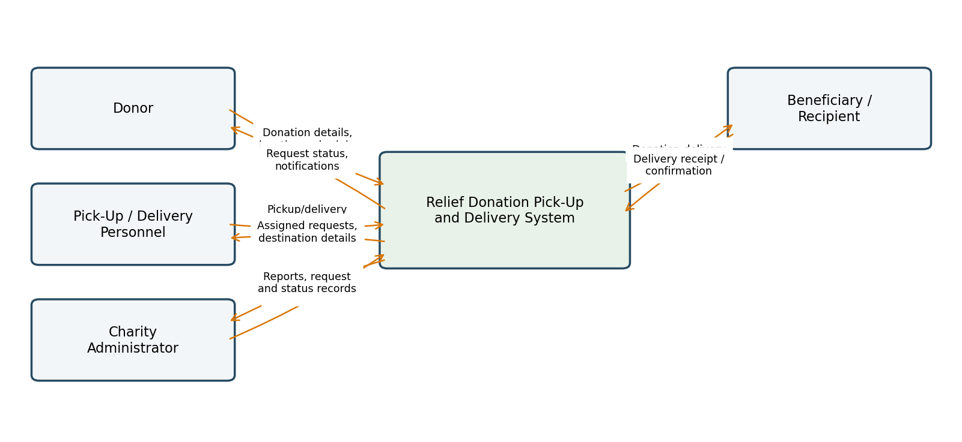
Level 1 DFD
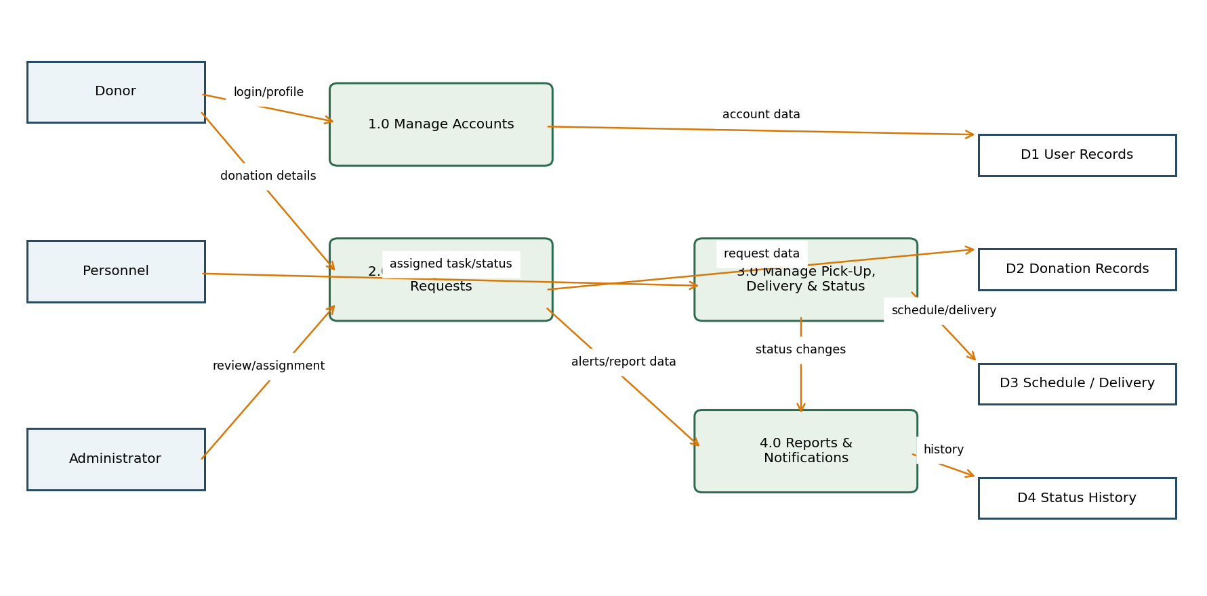
.

2.2 Entity-Relationship Diagram (ERD)
The following is a proposed initial data model based on the project workflow. It includes account, donor, personnel, donation, beneficiary, location, schedule, delivery, status-history, and notification records. Confirm final relationships and normalization with the selected database before implementation.
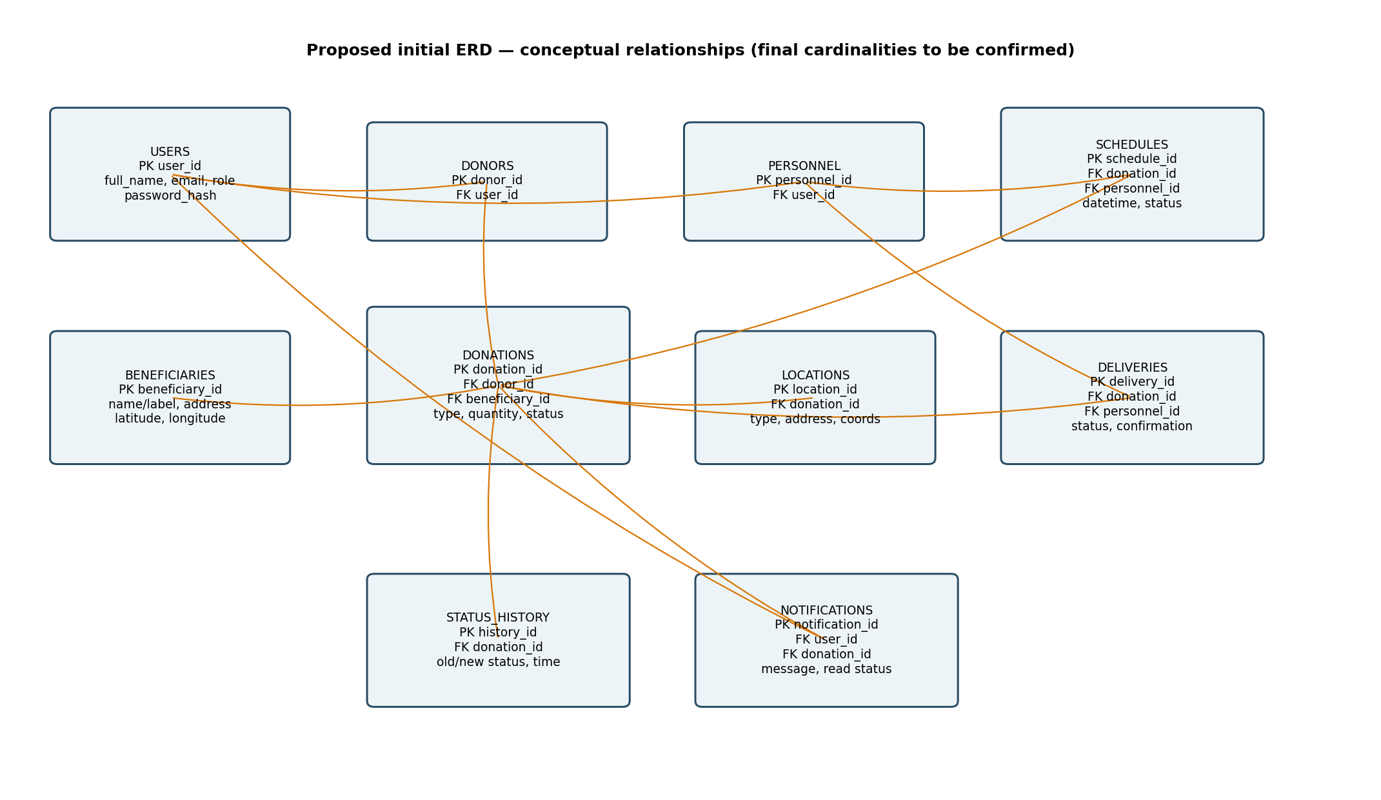
Figure 3. Proposed ERD overview. PK = primary key; FK = foreign key.

Entity Summary Table
Entity Name | Key Attributes (PK / FK) | Related To (relationship)
users | PK user_id; full_name, email, phone, password_hash, role | Donors, personnel, notifications, status history
donors | PK donor_id; FK user_id | Users; one donor may submit many donations
pickup_personnel | PK personnel_id; FK user_id; availability_status | Users; assigned schedules and deliveries
beneficiaries | PK beneficiary_id; name/label, contact, address, coordinates | One beneficiary/destination may be linked to donation requests
donations | PK donation_id; FK donor_id, beneficiary_id; donation_type, quantity, status | Donor, beneficiary, locations, schedules, deliveries, history
locations | PK location_id; FK donation_id; location_type, address, latitude, longitude | Donation; records pick-up and delivery locations
pickup_schedules | PK schedule_id; FK donation_id, assigned_personnel_id; preferred_datetime, status | Donation and assigned personnel
deliveries | PK delivery_id; FK donation_id, personnel_id; status, delivered_at, confirmation | Donation and personnel
status_history | PK history_id; FK donation_id, updated_by_user_id; old_status, new_status, changed_at | Donation and user who changed the status
notifications | PK notification_id; FK user_id, optional donation_id; message, is_read | User and related donation request

3. Architecture Report

3.1 Recommended Architecture
A three-tier client-server web architecture is recommended. The presentation layer would provide browser-based pages for donors, personnel, and administrators; the application layer would process authentication, donation requests, scheduling, assignments, status updates, and notifications; and the data layer would store accounts, donation records, locations, schedules, deliveries, and status history. This separation makes the system easier to maintain and allows individual layers to be improved as usage grows.
The source documents do not specify a finalized programming language, framework, database, or hosting provider. The following options are therefore recommendations for discussion, not confirmed implementation choices.

3.2 Options Considered
Criterion | Option Considered | Why Chosen / Rejected
Deployment model | Client-server, three-tier web application | Recommended because donors and staff can use a browser without installing a separate desktop application, while application logic and data storage remain organized in separate layers.
Backend language/framework | PHP with Laravel, or another course-approved web framework | Laravel is one possible option for routing, authentication, validation, and role-based access. The team should choose based on course requirements and member familiarity.
Database system | MySQL or MariaDB | A relational database fits connected records such as users, donations, schedules, deliveries, and status history. Foreign keys can help maintain record consistency.
Hosting/infrastructure | Local development first; deploy to a suitable web host when ready | Local development supports testing with low initial cost. A hosted deployment can provide online access, but must be selected based on budget, security, and availability needs.

3.3 Scalability Justification
The first version is intended for Lambunao, Iloilo, and is expected to support a local group of donors, charity administrators, and pick-up/delivery personnel. The exact number of users and records has not yet been established, so load testing should be used to determine practical capacity. A relational database, indexed search fields, and separate application modules can support gradual growth in donation requests and status-history records.
If usage grows, the team can consider upgrading hosting resources, adding database indexes, optimizing map and image handling, introducing scheduled background tasks for notifications, and separating frequently used services. Access to exact donor and beneficiary locations should remain restricted to authorized users. Expansion beyond Lambunao should be considered only after operational needs, staffing, and hosting capacity are reviewed.

4. Proof-of-Concept Scaffold
This section is prepared according to the template. Actual prototype screenshots, a repository URL, and evidence of a working database connection were not included in the provided project document, so the placeholders below must be completed after the prototype is implemented.

4.1 System Prototype (UI Mockups)
Screen / Mockup | Purpose | Database tables expected to be used
Screen 1 — Login / Registration | Users sign in or create an account. Access should depend on the assigned role. | users
Screen 2 — Donor Dashboard | Donors view their requests, statuses, and option to submit a new donation. | donations, status_history, notifications
Screen 3 — Donation Request Form | Donor enters donation type, quantity, description, optional photo, pick-up location, preferred schedule, and beneficiary destination. | donations, beneficiaries, locations, pickup_schedules

Insert actual screenshots or clearly labeled mockups for the three screens above before submission.

4.2 Repository Link
[Paste the project repository URL here. Do not submit this placeholder as a real link.]

4.3 Setup Checklist
- ☐ Database schema script included in repository and matches the submitted ERD.
- ☐ Application successfully connects to the database.
- ☐ “Hello World” or a basic database query runs without error.
- ☐ Prototype screens match the running scaffold.
- ☐ README file includes setup and run instructions.
- ☐ Repository is accessible to the instructor (public or shared access granted).

4.4 Known Limitations / Next Steps
- Confirm group number, section, member names, and submission date.
- Confirm the final technology stack with the instructor and project team.
- Review and finalize DFD and ERD notation, cardinalities, and database normalization.
- Build and capture the login, dashboard, and donation request screens.
- Implement and test authentication, role-based access, donation submission, mapping, scheduling, assignment, status tracking, and notifications.
- Test delivery confirmation and privacy controls before pilot use.
- Define measurable baseline and target values for the operational indicators.

Project Workflow Reference
The system follows the workflow described in the supplied project document:
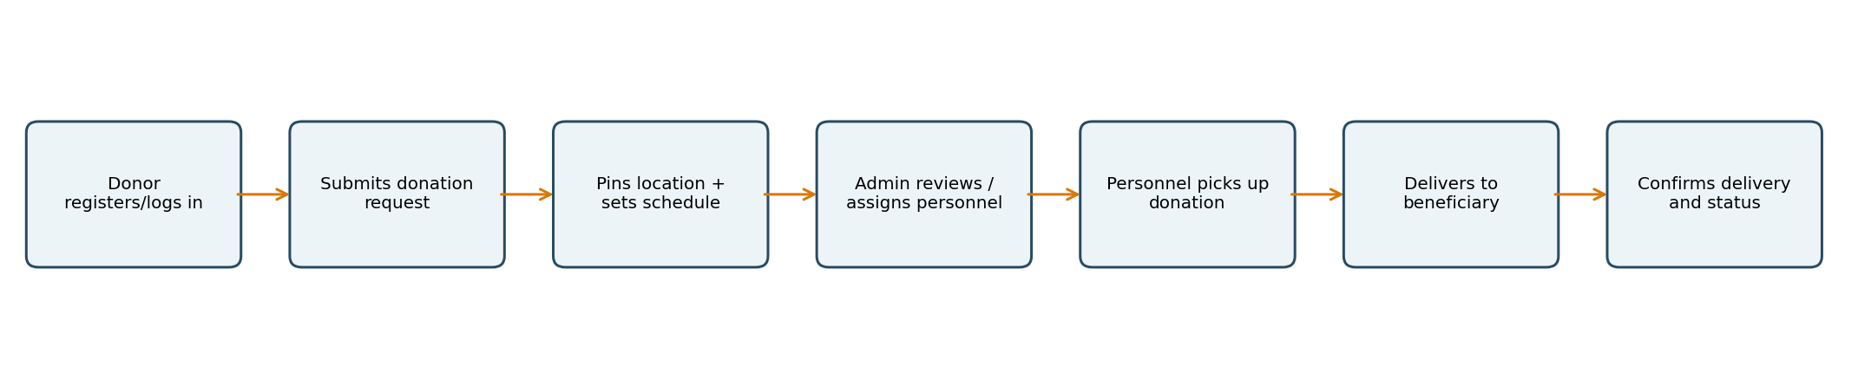
Figure 4. End-to-end relief donation workflow.
- Register or Log In: The donor creates an account or signs in.
- Submit Donation Request: The donor enters donation type, quantity, description, and a photo when available.
- Set Pick-Up Location and Schedule: The donor pins the pick-up location and provides a preferred date and time.
- Provide Beneficiary Destination: The donor supplies beneficiary/recipient details and the delivery destination.
- Review and Accept: The charity administrator or authorized personnel reviews and accepts or assigns the request.
- Pick Up Donation: Assigned personnel collect the donation and update the request to Picked Up.
- Deliver to Beneficiary: Personnel transport the donation and update the status to Out for Delivery when appropriate.
- Confirm Delivery: Personnel record confirmation and mark the request Delivered or Completed.
- Notify and Track: The system records status history and shows the latest status to authorized users.

Suggested Status Lifecycle
Pending → Accepted / Assigned → Picked Up → Out for Delivery → Delivered / Completed
The source document also suggests Cancelled or Unable to Deliver as possible exception statuses, subject to the charity's operating rules.

Scope and Limitations Summary

Included in the Initial Scope
- Registration/login and role-based access for donors, personnel, and administrators.
- Donation request details and optional photo upload.
- Map-based donor pick-up location and beneficiary delivery destination.
- Preferred pick-up scheduling, request review, and personnel assignment.
- Pick-up/delivery status updates, notifications, delivery confirmation, and centralized records.
- Administrative monitoring and basic reporting.

Limitations
- Initial coverage is limited to Lambunao, Iloilo.
- Internet access and the availability of the selected map service are required for online/map functions.
- Online payments and financial transactions are not included.
- Actual collection and delivery depend on personnel, transport, schedules, and charity operating procedures.
- The system records delivery confirmation but does not independently verify the physical contents or condition of every donation.
- Beneficiaries do not need a separate account in the initial version.

