ALJUN C. CURSIGA  Full-Stack Web Developer  BS Computer Science | Web Development, Mobile Development, and Applied Machine Learning  Santo Tomas, Davao del Norte | 09654617308  aljun.dev@gmail.com | github.com/Nakauli | linkedin.com/in/aljun-cursiga-275b40280 | 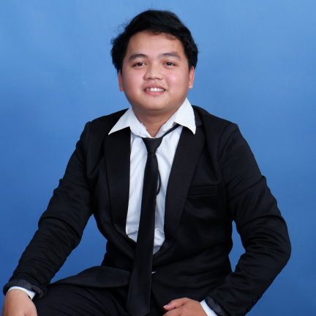
PERSONAL INFORMATION
Address: Purok 11, New Katipunan, Santo Tomas, Davao del Norte | Nationality: Filipino
Contact Number: 09654617308 | Languages: English, Cebuano, Filipino
Email: aljun.dev@gmail.com | Portfolio: github.com/Nakauli
TECHNICAL SKILLS
Languages & Development Areas  - Java - object-oriented programming, logic building, and software engineering fundamentals  - HTML5 / CSS3 / JavaScript - responsive, client-facing web interfaces  - Front-end and back-end development - full-stack project planning, account flows, and data handling  - Mobile development - mobile-first screens, user flows, and app feature planning  - Machine learning - Random Forest model workflow and data-driven recommendation logic | Tools & Platforms  - Git & GitHub - project portfolio, version tracking, and code organization  - VS Code - web development and project implementation  - Microsoft Office / Google Workspace - documentation, reports, and presentations  - Canva and video editing - visual communication and project support materials  - Spreadsheet-based data analysis and structured information handling
Core Competencies  - Full-stack web application development  - Responsive website design and client-ready presentation  - Requirements gathering and stakeholder communication  - Software design, documentation, testing, and revision  - Machine learning project development and model explanation | Soft Skills  - Clear communication with classmates, clients, and project stakeholders  - Analytical and structured problem-solving  - Team-oriented, teachable, and dependable under deadlines  - Detail-conscious, adaptable, and committed to continuous learning  - Confident in presenting project purpose, workflow, and technical decisions
PROJECTS & SOFTWARE EXPERIENCE
Aurium Yearbook Publication Website | 2025 - Present
Full-Stack Web Development | School Publication Website
- Developed and maintained a live publication website that organizes school yearbook content into a clean, accessible, and professional web presence.
- Handled layout decisions, stakeholder revisions, content organization, and responsive presentation for students and publication users.

PROJECTS & SOFTWARE EXPERIENCE
Hontoria Printing Website | 2025
Full-Stack Web Development | Local Business Website
- Built a client-ready website for a printing service, presenting business information, services, and contact pathways in a direct and user-friendly structure.
- Focused on mobile-friendly navigation, service clarity, and practical layout decisions that support customer inquiries.
COPS Interpol Website | Ongoing
Full-Stack Web Development | Organization Website
- Currently developing an organization website with emphasis on page structure, information flow, online visibility, and stakeholder-centered revisions.
- Applies full-stack thinking by planning how user-facing pages, content, and future data-driven features can work together coherently.
BuhayLink - Job Posting and Application Mobile App | 2026
Full-Stack Mobile Development | Employment Platform Concept
- Designed a mobile app where users can create accounts, post job opportunities, browse openings, and apply for available work.
- Demonstrates understanding of user roles, authentication flow, job listing data, application workflows, and mobile-first usability.
Crop Random Forest Model | 2026
Machine Learning Project | Crop Recommendation Model
- Built a machine learning project using a Random Forest model to recommend suitable crops based on soil-related inputs and agricultural conditions.
- Strengthened practical knowledge in data preparation, model training, prediction logic, and explaining results to non-technical users.
EDUCATIONAL BACKGROUND
Bachelor of Science in Computer Science | 2023 - Present
University of Mindanao Tagum College | 3rd Year Standing | Expected Graduation: 2027
Relevant coursework: Software Engineering, Web Development, Mobile Application Development, Data Structures and Algorithms, Database Concepts, Systems Analysis and Design, Java Programming, and Data Analysis.
PROFESSIONAL HIGHLIGHTS
Portfolio-driven developer: Built live websites and app-based systems that can be discussed, demonstrated, and improved. | Client-aware builder: Translates user needs into clear interfaces, organized content, and practical feature flows.
Full-stack orientation: Understands both the visible user experience and the back-end logic needed to support it. | Technical communicator: Can explain project purpose, workflow, limitations, and improvement plans in a clear interview setting.

