Validation Report
corr (Version 0.0.1)
Ryo Nakaya
04DEC2025
General Information
Corr package provides macros for computing association measures between continuous, nominal, and ordinal variables. Supports Pearson and Spearman correlations, Cramer's V, Somers' D, and eta coefficients. Outputs both long-format association tables and wide matrix-style datasets for further analysis. Includes a heatmap macro to visualize the strength and type of associations in a single plot.
Validation Environment
OS: WIN
SAS: 9.04.01M7P080520
Required Packages: -
Execution Datetime: 04DEC2025:20:25:24
Authors
Ryo Nakaya (nakaya.ryou@gmail.com)
Requirements
- %association_matrix :
To generate association matrix dataset (long, wide). Association matrix consists of correlation coefficients for continuous/ordinal x continuous/ordinal, Cramer's V for nominal x nominal, Somer's D for nominal x ordinal, Eta coefficients for nominal x continuous.
- %heatmap :
To generate heatmap based on association matrix dataset created by %association_matrix within heatmap macro.
- %scatter_matrix :
To generate scatter matrix plot (Kernel, Bar, Scatter, Mosaic, Cross Table, Box)
Validation Records

Test Description | Result | Comments
(%association_matrix)[test01] Compare expected and test datasets of association matrix | PASS | MP_ASSERTDATASET: proc compare base=expected compare=test
(%heatmap)[test01] Creating a heatmap with test data | CHECK | MP_ASSERTGRAPH: An output graph to be visually reviewed. See appendix.
(%scatter_matrix)[test01] Creating a scatter_matrix plot with test data | CHECK | MP_ASSERTGRAPH: An output graph to be visually reviewed. See appendix.

Additional comments
NA
References
https://github.com/Nakaya-Ryo/corr

Appendix

Previous | Current
 | 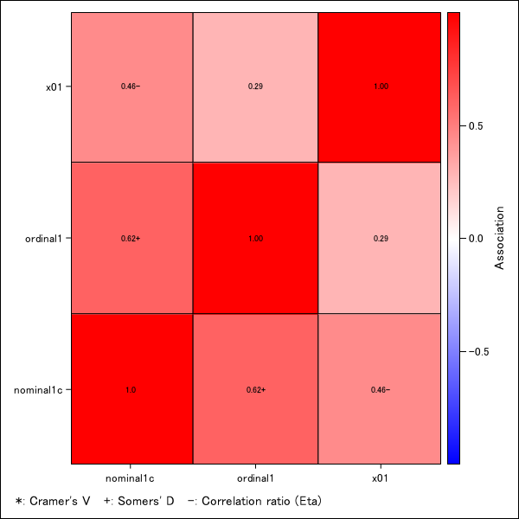 (%heatmap) [test01]
 | 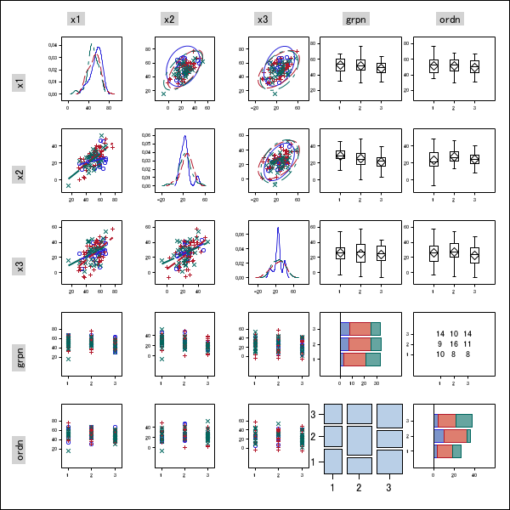 (%scatter_matrix) [test01]

