GitHub Instructions

[Yrityksen nimi] |[Yrityksen osoite]

Aleksi Nissinen

2016

Contents

GitHub Desktop 3

Making a commit 7

Making a pull request 8

# GitHub Desktop

The easiest way to use GitHub is **GitHub Desktop**. You can download the software from [here](https://desktop.github.com/). You can create a free GitHub account [here](https://github.com/join).

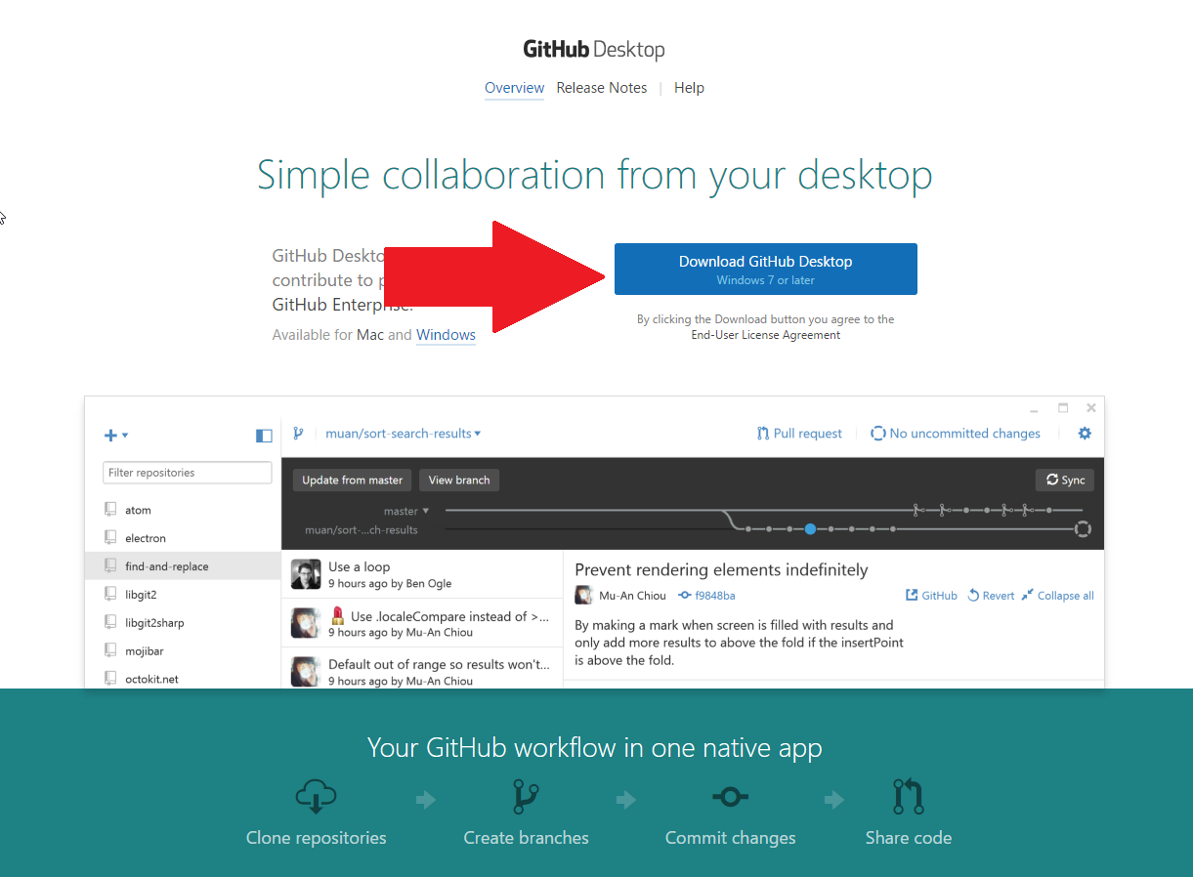

Run the software after the installation has finished. First log in with your GitHub account.

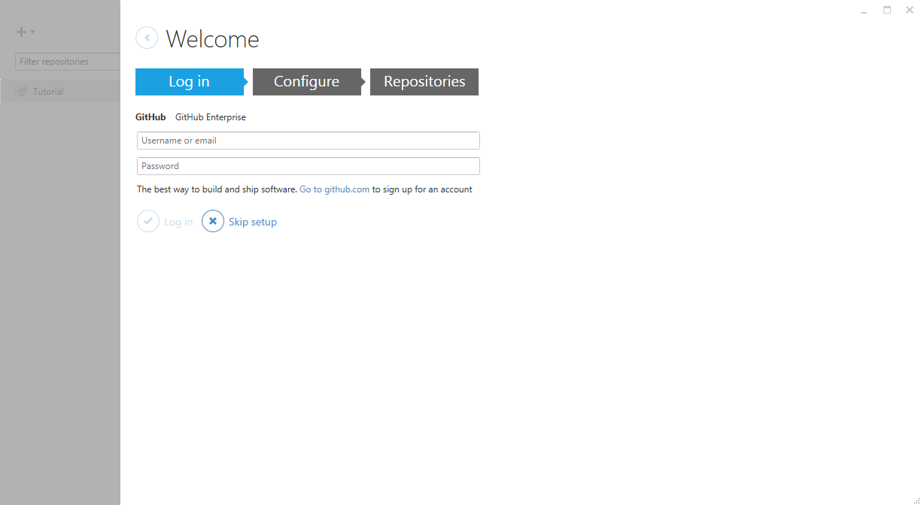

After logging in proceed to **Configure**. There you can set a **public name and email** that will be shown to others when you make a commit.

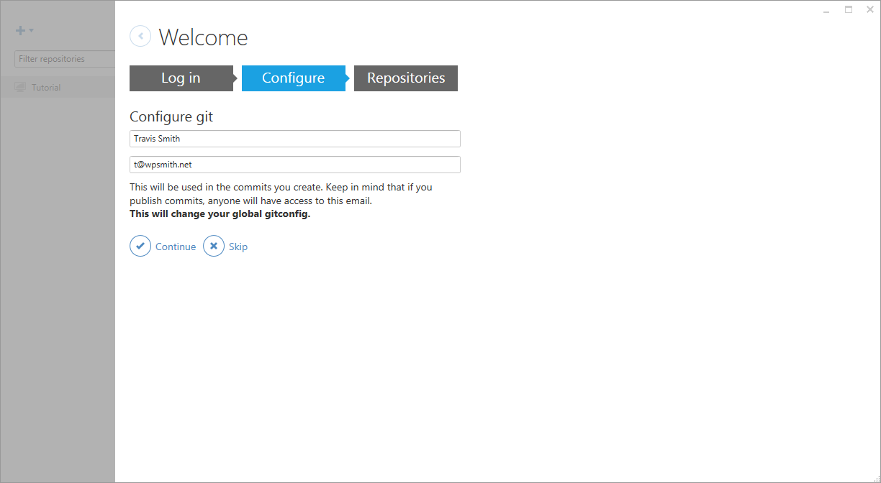

The **Repositories** part will scan your computer to see if you already have any GitHub repositories on your computer. Unless you already have the **TridentUE4Project2016** repository on your computer, you can skip this part.

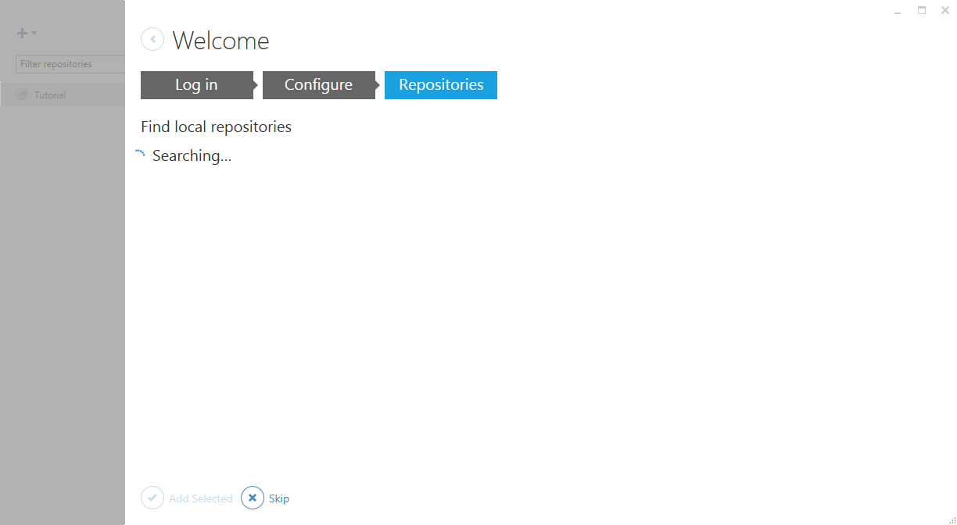

Next you will be brought to the tutorial screen. Find the **+** sign in the top left corner of the window.

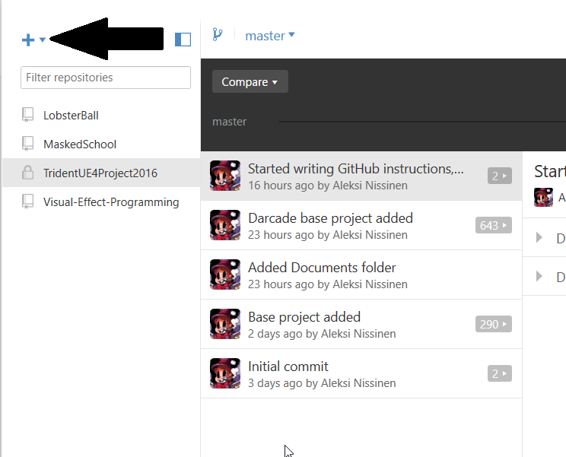

Click it and the **Clone tab** that opens to see all repositories linked to your GitHub account. You should see the **TridentUE4Project2016-** repository. Choose it and click **Clone repository**.

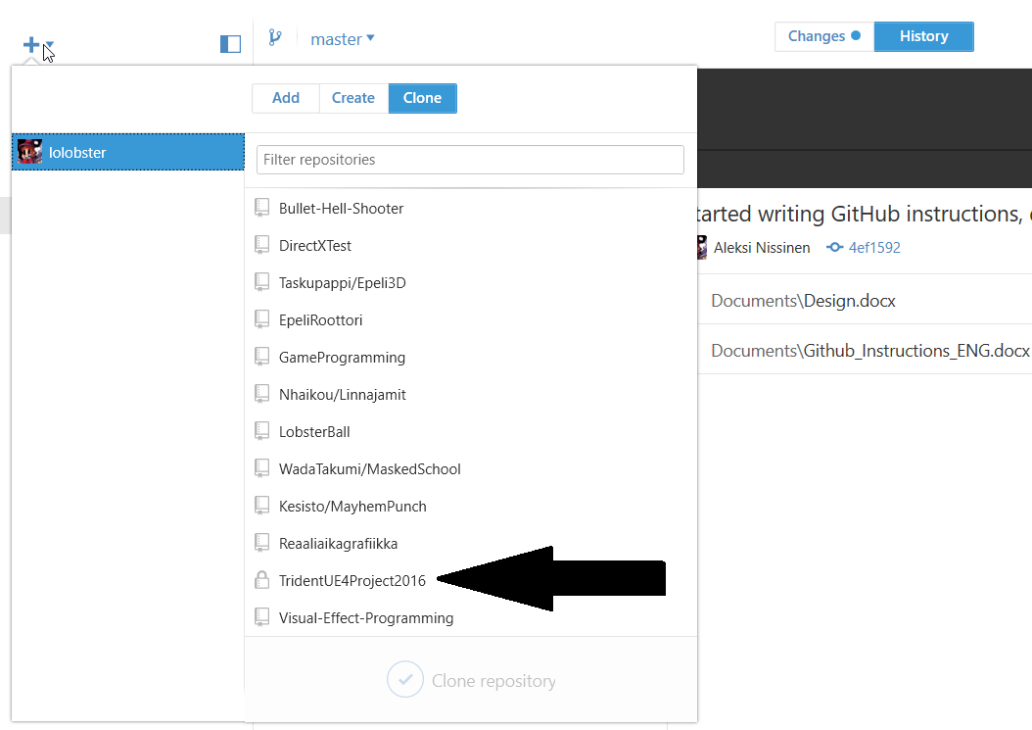

This will download the current version of the project to your computer. All changes made in this repository folder will show up on the **Changes tab** of the Desktop software and can be sent to the server.

After the cloning has finished, make sure to activate your own **branch**. If your developing **Player**, activate **Player branch**, **Enemy** for **Enemy** developers and so forth. Always make sure that you have the correct branch active when making changes. This will help us avoid conflicts and errors.

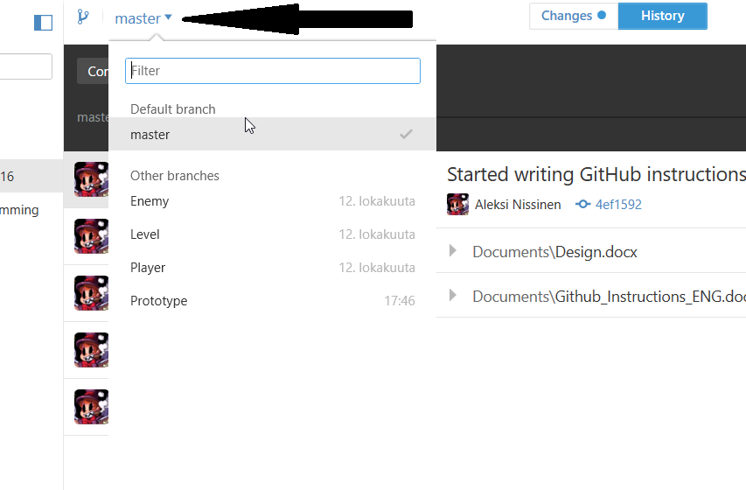

# Making a commit

If you have made changes to the project and the project still works, you can create a commit and send the changes to the server. To do this, open GitHub for Desktop. In there, find the **Changes** tab. Make sure you have the correct **branch** (1) active (Enemy if you’re developing the enemies, Player for player changes etc.) and all the changes and changed files are correct (2) and then write a name for the commit (3). If your changes require more information, add them to the Description (4). Press the Commit button (5).

1. Active branch. Make sure this is always correct before making a commit.

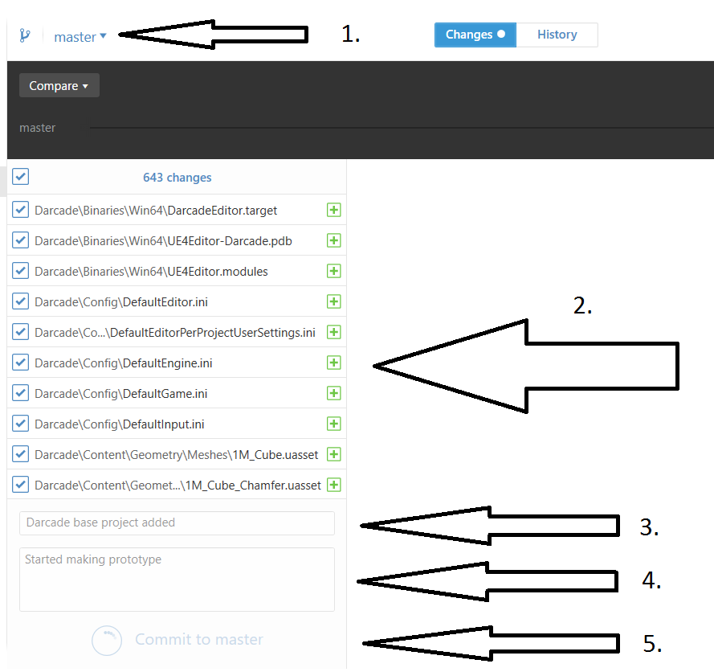

1. Changes made inside the project folder
2. Commit name (what you changed)
3. Description (more detailed info on changes)
4. Press to create a commit

Go back to the **History** page. There you will see a **Sync** button. By pressing it you can send your commit to the server. Also, if someone else has made changes and sent a commit to the server, you can download it by pressing **Sync**. **Make sure you are committing to your own branch.** Skip this step if you want to make a **pull request** (next page).

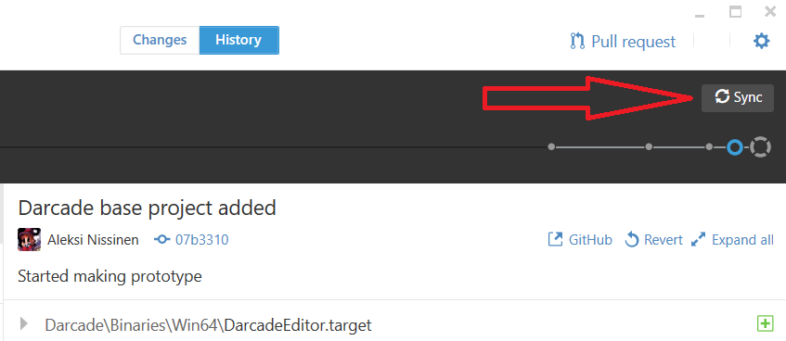

Send the changes to the server or download existing changes from the server. Skip this part if you want to make a **pull request** instead.

# Making a pull request

When you have completed a task in your own branch (for example enemy is moving, player attacks work…), you can make a request for the branch to be added to **master** branch. You can do this by first making a commit like normal but instead of syncing, you create a **pull request**.

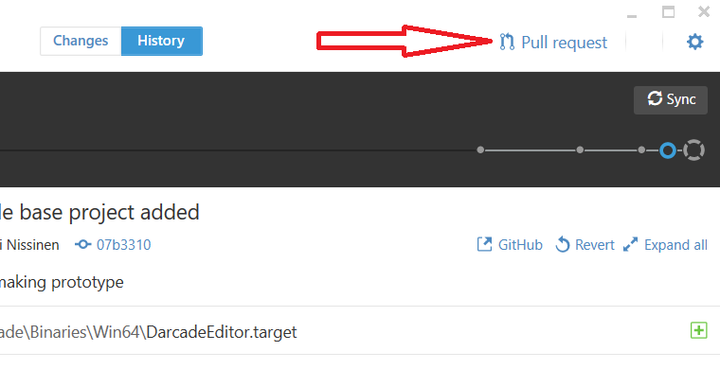

Making a **pull request** is very similar to making a **commit**: you give the request a name explaining what has been changed in the branch, and some extra information if necessary. Remember to also check that the branch is correct.

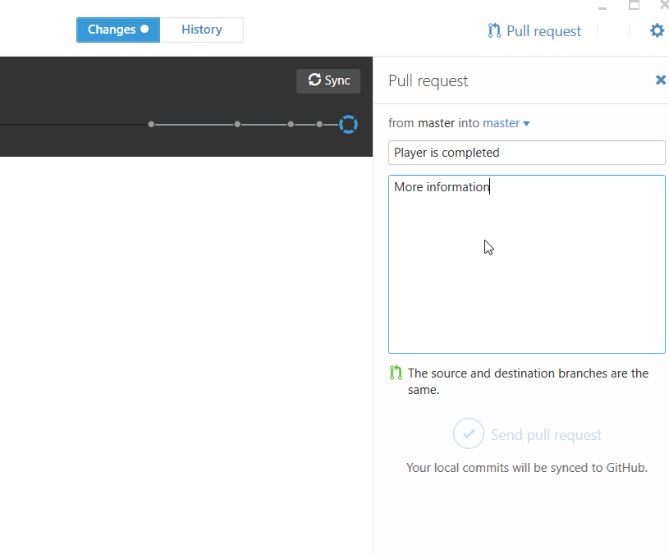

After this, press the **Send pull request** button and the request will be sent to the **repository administrator (Aleksi, GitHub nickname: lolobster)**, and they will check the request and accept it if there are no conflicts or errors. Tell **Aleksi** when you make a **pull request.**