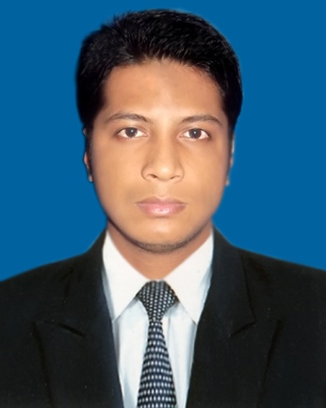Md. Nazmul Hoq

88/89/A, Sonalibagh, Moghbazar-Wireless, Dhaka-1217

Phone: 01811-840084

Email- mdnazmul786@yahoo.com

Objective

To obtain an opportunity to work as an engineer and secure position that will enable me to use my organization skills as well as my ability to work well with people. I am quick learner. I want to work in suitable environment that would challenge my technical skills and give me direction**.**

Academic Qualification

* **Bachelor of Computer Science & Engineering(CSE):**

Institution: Stamford University Bangladesh

Subject: Computer Science & Engineering (CSE)

Result: 3.50

Passing Year: 2015

Duration: 4 years

* **Higher Secondary Certificate (HSC):**

Institution: Hazigonj Model College

Result: GPA 3.50

Group: Science

Passing year: 2009

Board: Comilla

* **Secondary School Certificate (SSC):**

Institution: Balshid Hazi Akub Ali High School

Result: GPA 3.13

Group: Science

Passing year: 2007

Board: Comilla

Key Skills

* Programming Language: C, C++, Java(J2SE), IDE(neatbeans), Oracle 10g database.
* Web Development with PHP with MySQL and CodeIgniter Framework.
* Web Design HTML,HTML5,CSS,Bootstrap and JQuery,Ajax(javascript).
* Proficiency in all areas of Microsoft Office, including Access, Excel, Word and PowerPoint
* Excellent communication skills, both written and verbal

|  |
| --- |
| Training Summary |
| |  |  |  |  |  |  | | --- | --- | --- | --- | --- | --- | | **Training Title** | **Topic** | **Institute** | **Location** | **Year** | **Duration** | |  |  |  |  |  |  | | PHP CodeIgniter Framework | HTML5, CSS, PHP, CodeIgniter Framework, and JQuery | Talha Training Bangladesh | 162/2 Lake-Circus Kolabagan, Dhaka | 2015 | 4 Month | | Skill for Employment Investment Program | Web App Development-PHP | BITM | BDBL Bhabon Kawranbazar, Dhaka | 2015 | 3 Month | |

## Work Experience

Junior Web Developer (18 Octobor 2015)

Boo2 Bangla Ltd, Banosree Branch  
Zakir mansion, Road 4 Plot 14  
Banosree B Block, Dhaka-1219  
[info@boo2.com.bd](mailto:info@boo2.com.bd)

## Extracurricular Activities

* Volunteering
* Student council.
* Sports

Hobbies & Interests

I love to play cricket .This is my only hobbies & interest. I earned lot of award in my past and present life. Bangladesh cricket player Mohammad Ashraful is my inspiration.

Personal Information

* **Father's Name :** Md. Azharul Hoq
* **Mother's Name :** Jahura Khatun
* **Permanent Address :** Vill: Balshid, P.O: Balshid, P.S: Shahrasti

District: Chandpur.

* **Date of Birth :** December 29, 1992
* **Religion :** Muslim
* **Nationality :** Bangladeshi (By birth)
* **Sex :** Male
* **Blood Group : A**(+ve)

References

**Md. Shafiul Alam Md. Manzurul Islam**

Co-Founder and Chief Executive Acting Chairman,

Officer(CEO) at TahlaTraining . Department of CSE,

E-mail: topu1826@gmail.com Stamford University Bangladesh.

Phone: 01712-742217 Phone: 01713-494664

**IMG_20150308_223232.jpg Signature**