Requirement Specification

Introduction

Definition:

The Software Requirements Specification (SRS) will provide a detailed description of requirements for the Hostel Management System (HMS).

**Purpose:**

The requirement specification will be helpful in the proper understanding of what is expected from the system (functionalities of the system).

The clients will be able to use the requirement specification document to see if the analyst will be building the system that will fully provide their needs.

**Scope of the Project:**

Hostel booking system is designed basically for hostels in schools, universities.

Their will be a predefined conditions for the reservation to the hostel rooms.

The landlord will check the forms filled by the students and the he allocates them the hostel room.

**Overview of Project:**

Hostel booking system is a web application which aims at improving the acquisition or booking of the hostels via online.

Currently, there is no system that students use to book for the hostels and this creates a lot of disorganization since students report to the university without knowing the hostels they can go to.

**2. Overall Description:**

2.1 **System Requirement:**

The system has three users;

Landlord

Student

Admin

The landlord can allocate(verify) the rooms booked by the students, add rooms, view the room details.

The student can select among the different hostels and he or she books a room there.

The admin can add the landlords, courses, view the room details.

**User Requirements Definition**

The user requirement for this system is to make the system fast, flexible, less prone to error, reduce expenses and save the time.

Less human error

High security extent

Data consistency

Easy to handle

Easy data updating

Easy record keeping

Backup data can be easily generated.

**4. System Requirement Specification**

**4.1 Functional System Requirement**

This section gives the different functional requirements that are applicable to the hostel booking system.

**The student:**

Shall register so as to create an account and then shall be able to login so as to access the system.

Shall be able to book for a room in one of the hostels available after filling the form.

**The landlord:**

shall be able to log into the system and change password if he wants.

Shall be able to add new rooms on the system so that they can be seen by the students.

Shall be able to manage rooms so as to view the room details on the system.

**The admin:**

shall be able to log into the system and can also update his profile.

Shall be able to add new landlords on the system and also manage landlords that are using the system.

Shall be able to add new courses on the system and also manage courses.

Shall be able to manage rooms on the system.

**4.2 Non-Functional System Requirements:**

**4.2.1 Performance Requirements**

1. The database shall be able to accommodate around thousand records to store.

2. The software shall support use of multiple users at a time.

**4.2.2 Security requirements:**

1.The system will not allow the student to submit the form before filling all fields required.

2. The system will require any one logging in to have a password before logging in.

**LEVEL ZERO DATA FLOW DIAGRAM**

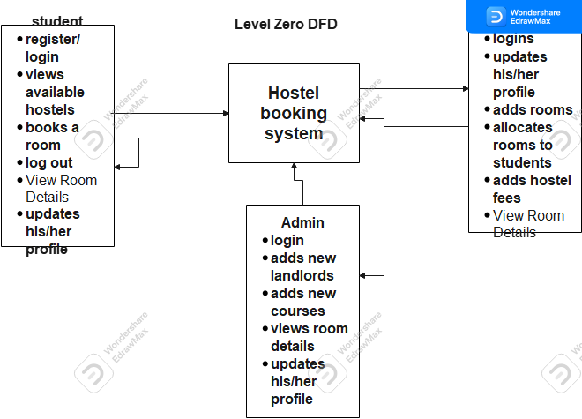

LEVEL ONE DATA FLOW DIAGRAM FOR HOSTEL BOOKING SYSTEM

