**THE SYSTEM ARCHITECTURE OF STUDENT HOSTEL BOOKING SYSTEM**

**FLOW CHART**

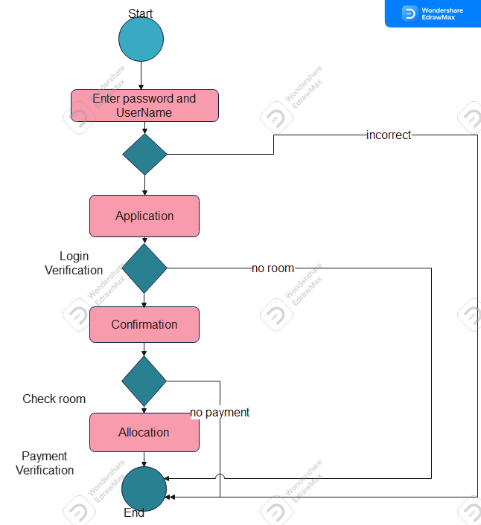

ER DIAGRAM

