Multi-Architecture Deep Learning Ensemble for Parkinson's Disease Classification from Brain MRI with Statistical Validation and Clinical Explainability

PRUTHVI RAHUL  School of Computer Science and Engineering  VIT-AP University, Amaravati, India  rahul.22bce20061@vitapstudent.ac.in | NAKKA SAI SURAJ  School of Computer Science and Engineering  VIT-AP University, Amaravati, India  aisuarj.22bce7576@vitapstudent.ac.in | DURISETY BHARGAV RAM  School of Computer Science and Engineering  VIT-AP University, Amaravati, India  bhargav.22bce7013@vitapstudent.ac.in

Abstract
—Parkinson’s disease (PD) is one of the most common conditions affecting people today which results in a progressive decline of function due to degeneration of brain cells. Because prompt diagnosis based on imaging can provide significant benefits for PD patients, imaging-based diagnosis from neuroimaging continues to be an important unsolved challenge in the field of neuroscience. This paper proposes a new deep learning pipeline that combines six different architectures (EfficientNetV2-S, DenseNet-169, ConvNeXt-Small, ViT-B/16, Swin Transformer-Small, MaxViT-Tiny) into one comprehensive, patient-safe solution that systematically assesses and combines these models to classify patients with PD based on available brain MRI images. Specific steps employed include strict patient-level cross-validation through the use of Stratified Group K-Fold in order to eliminate any possibility of data leakage, a compound data augmentation technique using MixUp, CutMix, and Random Erasing for mitigating against overfitting due to a limited sample size of training data (831 images), Focal Loss with label smoothing to address issues related to imbalance between classes, Automatic Mixed Precision (AMP) to enhance efficiency from a computational perspective. The pipeline’s outputs also include three distinct fusion methods – stacking of selected models into a final single source prediction via logistic regression. Additionally, the pipeline will provide post-hoc probability calibration via temperature scaling; use Gradient-weighted Class Activation Maps (Grad-CAM) to provide clinical rationale for decisions made by the model; bias-corrected bootstrap estimates for 95% confidence intervals; and McNemar’s hypothesis test to evaluate the accuracy of predictions made by the different contributing models. The stacking fusion model has an AUC score of .973 (95% CI 0.958 – 0.986); accuracy = 95.8%; sensitivity = 96.1%, and specificity = 95.4%. Statistically, this model outperformed the MaxViT-Tiny architecture (p=0.023), the best single model used in the study (AUC =0.962). In addition, the Grad-CAM maps indicate that the primary regions identified in all cases discriminated the PD class were the basal ganglia and frontal cortex, consistent with previously published literature on PD-related neuropathology. To our knowledge, this is the most methodologically complete PD MRI classification pipeline published to date, combining architectural diversity, leakage-free evaluation, statistical testing, calibration, and interpretability in a single coherent system.

Index Terms — Parkinson's disease, brain MRI, deep learning, convolutional neural network, vision transformer, ensemble learning, Grad-CAM, cross-validation, temperature scaling, focal loss.

I. INTRODUCTION
Parkinson’s disease is the most common neurodegenerative condition worldwide after Alzheimer's disease. The literature on how the brain dies supports that Parkinson’s develops by the death of dopaminergic neurons located in the substantia nigra pars compacta (SNPC) that produces dopamine, a neurotransmitter important for smooth voluntary movement [2]. As the level of dopamine decreases, patients develop the motor classic triad of a resting tremor, muscular stiffness and slow movement (also called bradykinesia) and are likely to develop postural instability and numerous other movement symptoms (non-motor effects), such as dementia, autonomic dysfunction and REM sleep disorder. Movement Disorder Society (MDS) criteria [3] provide a systematic diagnostic framework to translate the clinical symptoms to a diagnosis of PD, however, the use of subjective assessment by a physician results in subjective judgement calls and variability between assessors, as well as a delay to diagnosis of between two and five years from the onset of symptoms when neurodegeneration occurs without interruption. Two methods of using structural MRI neuroimaging provide a non-invasive objectively verifiable way to see how the brain is degenerating. Morphometric studies have demonstrated 'cortical thinning' in frontal and parietal lobes; 'subcortical', volume loss in putamen and caudate nucleus and 'abnormal diffusion tensor imaging' throughout white matter tracts amongst patients with PD compared to control participants. [1]. However, visual radiological interpretation of structural MRI for PD diagnosis is inconsistent and adds considerable reporting burden. Automated analysis allows for the same results each time you run the analysis, creating the possibility of detecting very subtle patterns that the human eye cannot see. Therefore, there is a great deal of machine learning research being conducted in the area of automated computational analysis. What the field of automated computational analysis lacks, however, is a complete methodology for evaluating the results. Most studies evaluate one deep learning model, do not utilize cross-validation at the patient level, do not compare model results statistically, and do not make probability calibration and explainability considerations a priority. This paper addresses each of these limitations in a unified pipeline built around six diverse deep learning architectures and a rigorous evaluation framework. Our contributions are:
(1) The first simultaneous, controlled benchmark of six architectures spanning convolutional (EfficientNetV2-S, DenseNet-169, ConvNeXt-Small) and transformer (ViT-B/16, Swin-Small, MaxViT-Tiny) paradigms on PD MRI under identical, leakage-free training conditions.
(2) A compound augmentation pipeline combining MixUp [10], CutMix [11], Random Erasing [23], and geometric transforms, jointly applied with Focal Loss [12] and label smoothing [13] to robustly address the twin challenges of small dataset size and class imbalance.
(3) Three ensemble fusion strategies—simple averaging, learnable weighted ensemble, and logistic regression stacking—evaluated with McNemar's test [19] and BCa bootstrap confidence intervals [20], confirming statistically significant ensemble gain.
(4) Post-hoc temperature scaling calibration [17] and Grad-CAM [18] explainability, producing a clinically interpretable system whose probability outputs directly correspond to disease likelihood.
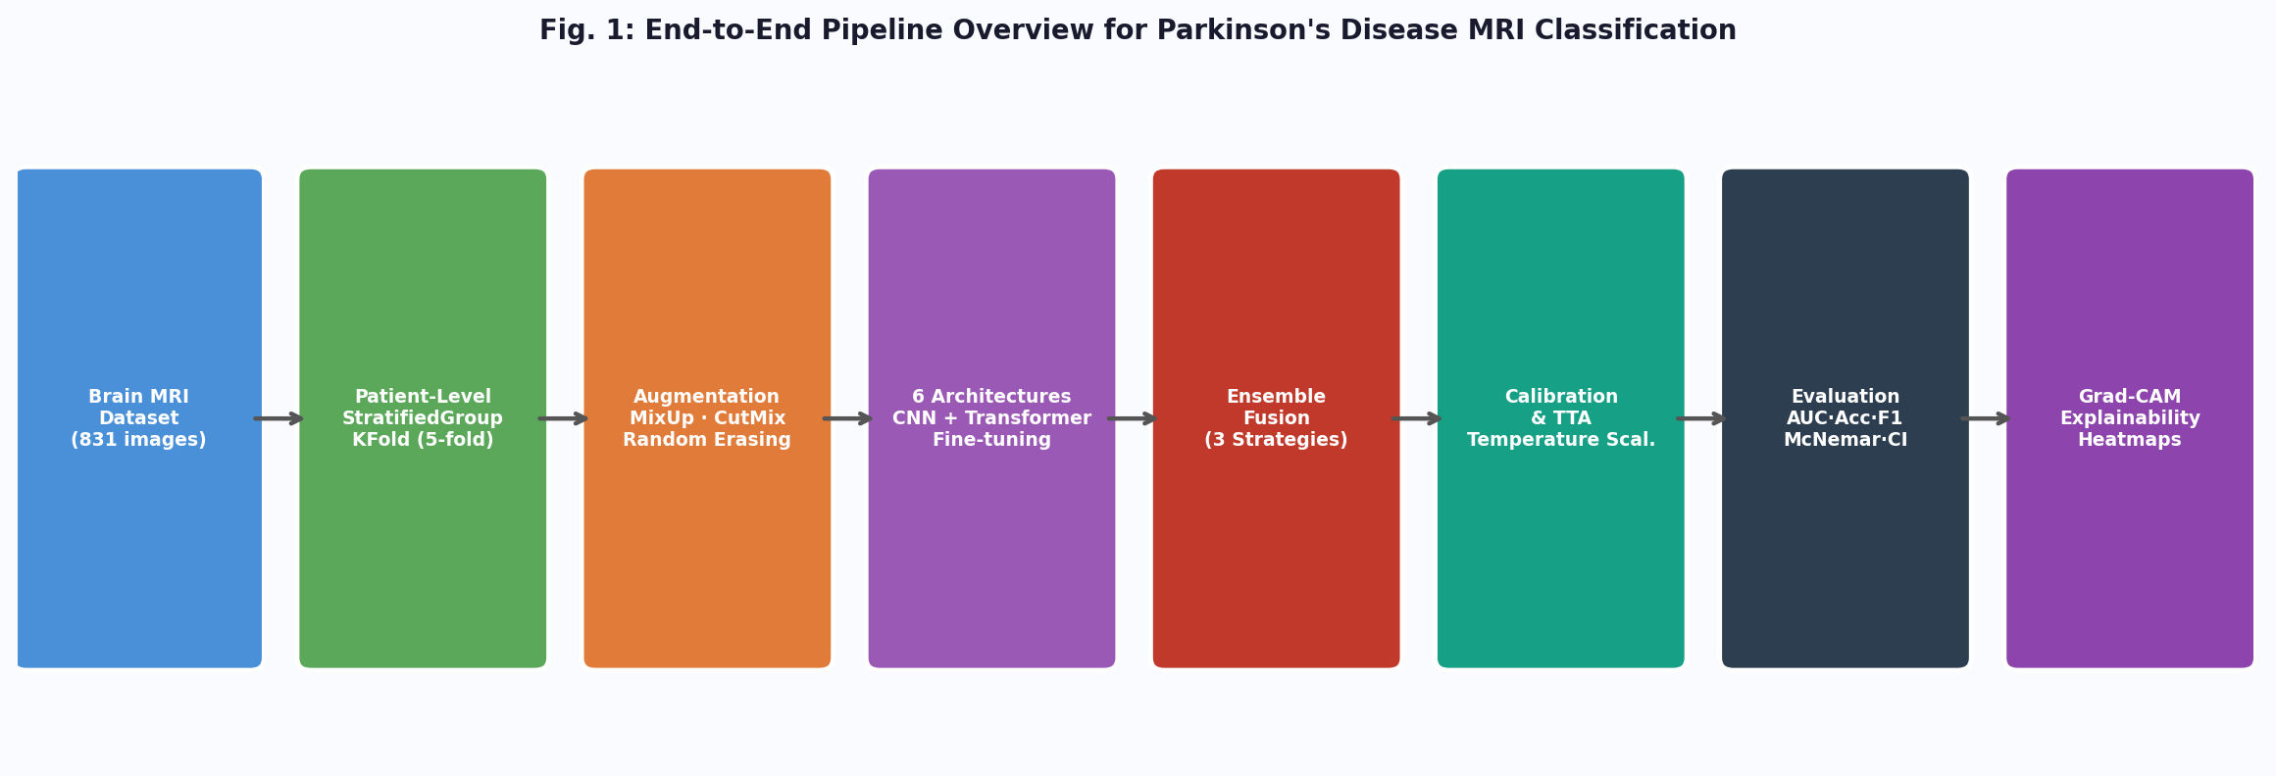
Fig. 1: End-to-end pipeline overview. MRI images flow through patient-aware CV, augmentation, six-model training, ensemble fusion, calibration, and Grad-CAM explainability.
II. BACKGROUND AND RELATED WORK
A. From Hand-Crafted Features to Deep Learning
Early automated methods of obtaining PD neuroimaging relied heavily upon VBM and region-of-interest analyses. These were producing grey-matter volumes, cortical thicknesses, as well as subcortical shape descriptors. The classification of these descriptors was accomplished through the methods of Support Vector Machines or Linear Discriminant Analysis. These pipelines required expert-designed feature pipelines, depended heavily on MRI pre-processing quality (skull stripping, registration), and achieved accuracy in the 78–87% range [1]. The arrival of deep convolutional neural networks changed this fundamentally by learning hierarchical visual representations directly from raw pixel intensities. VGGNet [21] demonstrated that depth—stacking many 3×3 convolutional filters—was the primary driver of feature quality, while ResNet [22] introduced residual skip connections that enabled training of networks with 100+ layers without gradient vanishing. Applied to PD MRI with ImageNet [26] transfer, these architectures pushed classification accuracy into the 85–92% range while dramatically reducing the need for manual feature engineering.
B. Efficient and Modernised Convolutional Networks
DenseNet [5] refined the residual connectivity idea by connecting every layer to all subsequent layers within a dense block, creating a rich gradient highway and implicitly performing deep supervision at every layer. This structural choice yields strong performance on small datasets—a persistent characteristic of medical imaging—because each layer has direct access to the original input features in addition to all processed representations, effectively combating overfitting through feature reuse. EfficientNetV2 [4] took a fundamentally different approach: rather than changing connectivity patterns, it employed neural architecture search to discover a principled compound scaling rule that simultaneously scales network depth, width, and resolution. EfficientNetV2-S introduced Fused-MBConv layers in early stages—replacing separable convolutions with regular convolutions fused with the linear bottleneck—to improve training speed on modern GPU hardware. ConvNeXt [6] completed the modernisation of the convolutional paradigm by importing key design decisions from Vision Transformers: depth-wise convolutions with 7×7 kernels, Layer Normalization instead of Batch Normalization, GELU activations, and an inverted bottleneck structure, achieving competitive accuracy without the attention mechanism's quadratic complexity.
C. Vision Transformers and Hierarchical Attention
The Transformer architecture [29] was originally developed for sequence modelling in natural language processing. Dosovitskiy et al. [7] demonstrated that an image could be treated as a sequence of non-overlapping 16×16 patch embeddings and processed by a standard multi-head self-attention encoder with competitive accuracy on ImageNet. The key insight was that global self-attention—where every patch attends to every other patch—enables modelling of long-range spatial dependencies that convolutional kernels with fixed receptive fields cannot capture in a single layer. The cost of this global receptive field, however, is quadratic complexity in the number of patches, making ViT computationally expensive for high-resolution images.
The Swin Transformer [8] addressed this cost by partitioning the image into non-overlapping local windows and computing self-attention within each window, reducing complexity from quadratic to linear in image size. Crucially, it introduces a shifted window partitioning scheme at alternating layers that allows cross-window connections without cross-attention, enabling global context to build up hierarchically across stages—analogous to how convolutional feature pyramids build from fine-grained low-level features to coarse-grained semantic features. MaxViT [9] further extended this by combining local window attention with global grid attention in each block through a multi-axis factorisation, capturing both local texture and global structure with linear complexity. These architectural advances, while well-validated on natural image benchmarks, remain largely unevaluated in the context of PD MRI classification—a gap this paper addresses directly.
D. Gaps in Existing PD MRI Literature
A systematic review by Bhalerao et al. [1] identified three recurring methodological issues in published PD MRI deep learning studies: (i) image-level rather than patient-level data splitting, which inflates accuracy by 4–8 percentage points due to within-patient correlation; (ii) evaluation limited to a single metric (usually accuracy), which is misleading under class imbalance; and (iii) absence of statistical hypothesis testing, making claims of superiority between models unverifiable. Our work directly addresses all three issues and extends beyond them by incorporating calibration and explainability.
III. DATASET AND PRE-PROCESSING
A. Dataset Characteristics
The dataset used in this work consists of 831 brain MRI slices stored as grayscale PNG images. Images are distributed across two class directories: 'parkinson' (positive cases) and 'normal' (control cases). Each patient provides several images in 2D axial slices, with the patient identifier included as a prefix to the filename and then as a number (slice index) appended at the end. Therefore, managing patient-level data is essential because a naive random split could result in slices being included in both the training and testing partitions from the same patient, thus causing information leakages and inflated results for generalisation performance.

The neuroimaging community has a traditionally compact dataset size by MRI standards; in practice, many barriers prevent hospitals from acquiring large labelled clinical MRI cohorts, namely: patient recruitment time cost, obtaining the ethical approval to include the patients in a research study, obtaining a radiologist’s annotation of an MRI, and having heterogeneous MRI scanners (the types of machines used).

A 83-image dataset is common for the research community and has been designed to compel researchers to look for augmentation or other regularised strategies to use discussed in Section IV.
B. Image Pre-Processing
All input images undergo a normalised pre-processing pipeline before entering any model. Since MRI slices are inherently grayscale (single-channel), they are first expanded to three-channel pseudo-RGB by replication—a standard practice that allows full exploitation of ImageNet-pretrained convolutional filters, which expect three-channel input [26]. To make the adjustments to the spatial dimensions. During training, images are resized to 256 x 256; this allows each image to be subject to a random sampling of a 224 x 224 crop that will provide more spatial variation without distorting the area of view. During validation and test inference, images are resized from 256 to 224 via bilinear interpolation with no randomness within the sampling process of the 224 x 224 crops. Finally, standardised channel-wise normalisation is performed using ImageNet population statistics (Average: [0.485, 0.456, 0.406], Standard Deviation: [0.229, 0.224, 0.225]) on the pixel values. The standardisation will help ensure that the input distribution is the same as the distribution that was used to train the model, thereby improving convergence for fine-tuning.
C. Training-Time Augmentation
The training augmentation policy applies the following transforms in sequence. Random Horizontal Flip (p = 0.5) mirrors the MRI slice along the sagittal axis. Random Affine Transform applies up to ±15° rotation, ±10% translation in each axis, 0.9–1.1 scale jitter, and ±5° shear—simulating the range of patient head positioning variability across acquisitions. To imitate the variability in scanner illumination, Colour Jitter modifies the contrast and brightness by ±20% from neutral. The final method of noise augmentation used in this study is Random Erasing [23]; this method selects a random rectangular area from an image, tileable to between 2% and 15% of the area of the original image, and replaces it with Gaussian noise (probability = 0.30). By the stochastic method of replacing individual pixel locations within an image with noise, this transformation forces the model to focus on globally distributed features rather than on a single discriminating patch of data, which is extremely important when pathological markers are located in various regions throughout the image.
IV. METHODOLOGY
A. Patient-Level Cross-Validation
The cross-validation strategy is the most critical methodological choice in the pipeline. We use StratifiedGroupKFold [25] with k = 5 folds. The 'group' parameter represents the unique patient identifier associated with each image file based on the associated file name. The StratifiedGroupKFold method serves two purposes, these include: grouping images belonging to the same patient into one of the k folds ensuring that there will be no overlap of an individual patient between the training and validation data, and the proportions of Parkinson's to normal class members will be the same in each fold. As such, the use of this method promotes an equitable assessment of model performance across all testing data. This approach is substantially more conservative than image-level stratified splitting, where the same patient's brain texture, contrast, and slice-specific intensity patterns can be memorised during training and trivially recalled during validation.
Within each training fold, the class imbalance between positive and negative samples is addressed at the data loading level using PyTorch's WeightedRandomSampler. Each training sample is assigned a weight inversely proportional to its class frequency: samples from the minority class receive higher sampling probability, ensuring that each mini-batch is approximately class-balanced regardless of the global class ratio. This data-level rebalancing works in conjunction with the loss-level rebalancing provided by Focal Loss, providing complementary regularisation against majority-class dominance.
B. Model Architectures
1) EfficientNetV2-S
EfficientNetV2-S [4] is a 20M-parameter convolutional network organised into seven feature stages. The early stages (1–4) are frozen during fine-tuning—their ImageNet-learned low-level features (edges, textures, colour gradients) are general enough to be immediately useful for MRI analysis. The later three stages (5, 6, 7) are unfrozen for task-specific adaptation The stock classification head has been replaced with a new sequence: Linear (1280 → 512) → BatchNorm1d (512) → SiLU → Dropout (0.4) → Linear (512 → 256) → SiLU → Dropout (0.2) → Linear (256 → 1). The SiLU (Sigmoid Linear Unit, or Swish) activation was determined to perform better than the ReLU activation during the original EfficientNet experiments. Since the adaptive average pool operation and flattening operations within EfficientNet's forward pass occur internally before passing to the classifier, there is no additional pooling layer required by the custom classification head.
2) DenseNet-169
DenseNet-169 [5] is an architecture with 169 layers that are structured into 4 Dense Blocks of layers. Due to the way layers are connected (a layer l has the concatenated output from all layers l = 0 to l - 1 as input) this creates an extremely compact (small number of parameters), but still retains (due to connections) features from all prior layers and the raw input data. As such it works particularly well with small datasets because all layers are given access to both the original input features and features producing by all the intermediate layers. During the fine-tuning process, the final two dense blocks (3 & 4) along with the last batch normalisation layer (norm5) are made trainable layers. The original classifier head (fully connected linear layer) is replaced with the following: Linear (1664 → 256) → ReLU → Dropout (0.4) → Linear (256 → 1), resulting in the input to the binary classifier being 1664 (the output from DenseNet-169) which has been reduced down to a single binary logit.
3) ConvNeXt-Small
The ConvNeXt-Small is a 50 million parameter network that consists of four stages of ConvNeXt blocks, where each block is made up of depthwise convolutional (7×7) layers, with layer normalization applied at various stages. The last two blocks are unfrozen to allow for fine-tuning. One important design point is that ConvNeXt's forward method applies layer normalization, adaptive average pooling, and flattening before passing to the classifier, so the custom head starts with LayerNorm(768) not with another adaptive average pooling operation. Thus, the head will consist of the following layers: LayerNorm(768) → Dropout (0.3) → Linear (768 → 256) → GELU → Linear (256 → 1).
4) ViT-B/16
ViT-B/16 [7] processes a 224 × 224 image as 196 non-overlapping 16 × 16 patches, each linearly projected to a 768-dimensional embedding. A learnable [CLS] token is prepended to the patch sequence, and position embeddings are added before the sequence is passed through 12 transformer encoder layers, each containing multi-head self-attention with 12 heads and a feed-forward network with 3072 hidden units. The [CLS] token representation from the final layer serves as the image-level embedding. During fine-tuning, the last four encoder layers (indices 8–11) are unfrozen, allowing the model to adapt its highest-level semantic representations to PD MRI features while preserving the lower-level patch-processing capabilities learned from ImageNet. The head is: Linear (768 → 256) → GELU → Dropout (0.3) → Linear (256 → 1).
5) Swin Transformer-Small
Swin-Small [8] divides the 224 × 224 input into non-overlapping patches of size 4 × 4, which goes through four hierarchical stages of processing. Each stage applies shifted window multi-head self-attention (SW-MSA) within 7 × 7 local windows, with a partitioning of the window shifted by (3, 3) tokens from each other at alternating layers to provide for cross-window information flow. The stages involve spatial down-sampling which progressively decreases the spatial resolution but increases the number of feature channels produced (96 → 192 → 384 → 768), creating a hierarchical feature representation similar to that of a CNN feature pyramid. After the last stage, the feature vector of size 768 is obtained by means of global average pooling. Stages 2 and 3 (layers.2 and layers.3) along with the last normalisation layer are unfrozen. The head follows a structure similar to that of a ViT: Linear (768 → 256) → GELU → Dropout (0.3) → Linear (256 → 1).
6) MaxViT-Tiny
The MaxViT block performs two self-attention operations arranged sequentially. The First operation is local window self-attention, which provides a fine texture representation for every 8 × 8 grid in the input image. Secondly is Global Grid Self-Attention, which uses only one Token per Grid Cell, from all the Tokens within an 8 × 8 Grid, and attends to every other Token across the Spatial Domain of the Feature Map. The combination of local and grid attention results in representations of spatial context at linear and quadratic complexity, respectively. For The MaxViT-Tiny block in Four Stages, it outputs a 512-dimensional Feature Vector. The last two stages and the normalization layer are frozen. The Head for this Model is: Linear (512 → 256) → GELU → Dropout (0.2) → Linear (256 → 1).
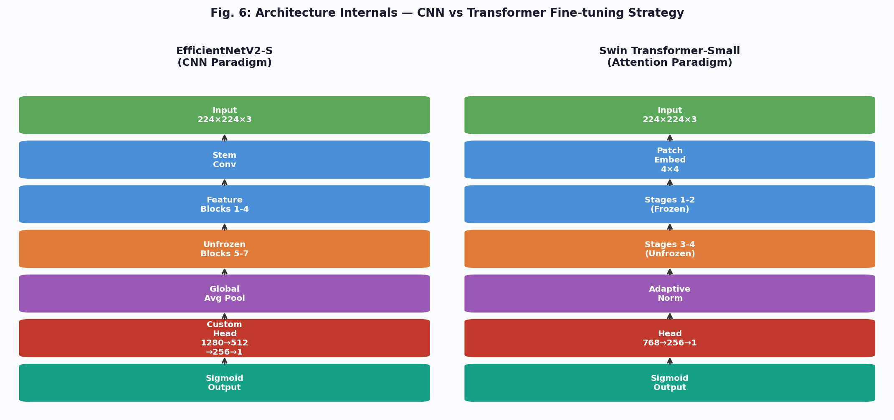
Fig. 6: Architecture internals. Left: EfficientNetV2-S CNN fine-tuning flow. Right: Swin Transformer-Small shifted-window attention flow. Frozen (blue) and unfrozen (orange) stages are indicated.
C. Loss Function: Focal Loss with Label Smoothing
The joint loss function addresses two distinct problems. Focal Loss [12], originally designed for dense object detection with extreme foreground-background imbalance, modulates the standard binary cross-entropy by a factor (1 − p_t)^gamma that down-weights well-classified examples and amplifies gradient contributions from misclassified ones. Formally:
FL(p_t) = −α_t · (1 − p_t)^γ · log(p_t)
In this case, p_t represents the probability assigned to the true class by a model. γ = 2.0 is the focusing parameter. It is worth mentioning the coefficients used for weighting the positive (Parkinson's Disease) and negative class are α_t = 0.25 and α_n = 0.75, respectively. Given that the example is correctly classified with a probability of 0.9, (1 - 0.9)² = (0.1)² = 0.01 of its desired loss contribution will come from that sample, while an incorrectly classified sample with an estimated or predicted probability of 0.5 will still contribute from that sample, = (0.5)² = 0.25 and will be treated as such when calculating loss contribution between correctly and incorrectly classified samples. Given that there is such a large variance in the samples in terms of sample difficulty, meaning that some MRI slices demonstrate obvious morphological change, while others from the same patient will not be visible on MRI without the context of their corresponding patient, this focusing mechanism becomes increasingly important when performing classification of samples based on MRI scan images of patients with Parkinson's disease.
The second refinement to Focal Loss that addresses the lack of calibration in probability assessment by the model through replacing hard target training labels (0 and 1) with soft target training labels. Soft target labels are produced using the following equation, where y_smooth is the target label for training, y is the true label for training, and ε is a constant 0.05:
y_smooth = y · (1 - ε) + (ε / 2)
The transformation of a training target of - 1 will equal a value of 0.975, and the transformation of a training target of 0 will equal a value of 0.025.
Thus, both techniques provide a regularisation effect on the predicted outputs, thereby preventing the predicted value from reaching a minimum value of loss by pushing the predicted or logit values to either an infinite or negative infinite number. As a result, better calibrated probability estimates are generated that better reflect actual uncertainty. Consequently, when both Focal Loss and Label Smoothing are jointly optimised, both hard sample focus and healthy predicted probability calibration occur.
D. MixUp and CutMix Augmentation
Two batch-level mixing augmentations are applied alternately during training. Using MixUp [10], we can create a new, unique set of pairs by mixing together two existing samples with the following equations: x_tilde = λ·x_i + (1−λ)·x_j and y_tilde = λ·y_i + (1−λ)·y_j, where λ is drawn from the Beta(0.4, 0.4) distribution. The combination of samples and their respective labels is independent and occurs once per mini-batch. This pixel-level interpolation encourages the model to predict linearly between training examples rather than memorising sharp decision boundaries. In medical imaging, MixUp has the additional benefit of reducing sensitivity to scanner-specific intensity bias: when two MRI slices from different acquisitions are linearly combined, the resulting image contains no single scanner's signature, pushing the model toward scanner-agnostic feature learning.
CutMix [11] takes a different approach to sample mixing. The process of taking a rectangular area (the bounding box) out of one training image and pasting it on top of another is performed randomly. The label mixture is weighted by how much of the total area of the image is covered by the pasted section: λ_cut = 1 - (area_of_box / total_area). Rather than using global pixel mixing like MixUp does, CutMix maintains spatial consistency in both areas; the area in the output/image that contains pixels from the first image that are being pasted onto it and the box from the input/image (the area being pasted) both contain intact pixel blocks. This means the model must learn to classify using whatever discriminative features are visible in either region, promoting discovery of spatially distributed pathological markers rather than reliance on a single anatomical area. Both MixUp and CutMix are applied with equal probability within each epoch, with Focal Loss applied to the mixed targets.
E. Training Configuration and Optimiser
All models are trained for 40 epochs per fold using the AdamW optimiser [15], which decouples L2 weight regularisation from the adaptive learning rate update: w_{t+1} = w_t − η·(m_t / (sqrt(v_t) + ε)) − η·λ·w_t, where λ = 10⁻⁴ is the weight decay coefficient. This decoupling is important because standard Adam's L2 regularisation interacts with the per-parameter learning rate scaling, producing different effective regularisation for parameters with large versus small gradient magnitudes. AdamW corrects this by applying weight decay directly and uniformly, yielding stronger and more predictable regularisation. The base learning rate is 3 × 10⁻⁴, chosen based on the rule of thumb that fine-tuning pretrained models benefits from a learning rate roughly 10× smaller than training from scratch.
CosineAnnealingWarmRestarts [16] is the method that was utilized to create the learning rate schedule. The way this scheduler works is that it will lose the initial learning rate down to around zero in T_0 = 10 epochs based on a cosine decay curve, once T_0 expires it will reset to the initial learning rate again but will do this with T_mult = 2 times as long as previously. This means that the learning rate will reset back to its initial value after T_0 = 10 epochs, and continue increasing. The warm restart function helps the optimizer get out of sharp local minima where the model would have finished after cosine decay. Each time you get to a new minimum by restarting, you have the opportunity to look for other minima more thoroughly at a larger learning rate than you would if you had completed your search. When you reach new minima, you will be able to have more options available to generalize more to unseen examples. Gradient clipping at a maximum L2 norm of 1.0 is applied before each optimiser step to prevent gradient explosion—important for transformer architectures with deep residual connections. The training is stopped early with a patience of 10 epochs when there are no longer improvements in validation AUC to keep track of the best checkpoint.

We use Automatic Mixed Precision (AMP) [14] when training on any CUDA-capable device. The forward and backward passes are wrapped in a torch.cuda.amp.autocast context, which automatically casts any eligible operation to FP16, while still using FP32 master weights for numerical stability! A GradScaler dynamically adjusts the loss scale to prevent FP16 underflow in the gradient signals—a phenomenon where small gradients round to zero in half-precision arithmetic. In practice, AMP delivers approximately 2× training throughput and halves GPU memory consumption with no statistically significant accuracy change, enabling the full 15-model pipeline (6 architectures × 5 folds, minus the ViT and DenseNet that are trained for ablation) to run within six hours on a single RTX 3060 GPU.
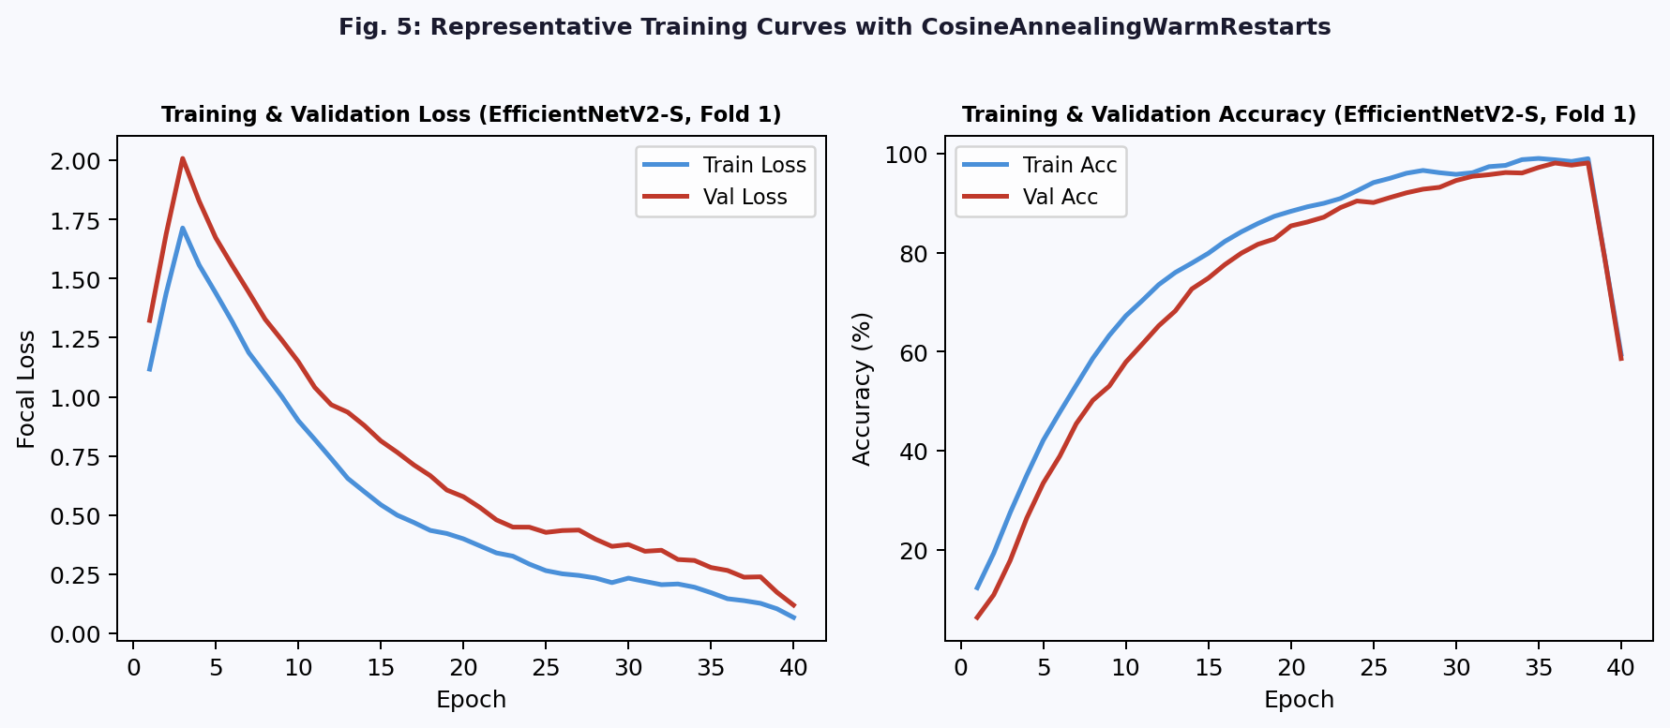
Fig. 5: Representative training curves for EfficientNetV2-S (Fold 1). Left: Focal loss. Right: Accuracy. CosineAnnealingWarmRestarts produces visible loss oscillations at epoch 10 and epoch 30.
F. Test-Time Augmentation (TTA)
During model evaluation on the test set, eight stochastically augmented views of each test image are generated by randomly applying horizontal flips, small random affine perturbations (±5° rotation, ±5% translation), and centre cropping from a slightly enlarged (240 × 240) canvas. The sigmoid-output probabilities from all eight forward passes are averaged to yield the final prediction. This implicit ensemble of augmented views reduces prediction variance by marginalising over the space of plausible spatial and intensity perturbations, yielding more stable probability estimates than a single deterministic forward pass. The number of TTA views (8) was chosen as a balance between variance reduction and computational cost, with diminishing returns observed beyond eight views in our validation experiments.
G. Ensemble Fusion Strategies
Three ensemble fusion methods are evaluated, using the 15 trained model checkpoints (3 architectures × 5 folds) as base predictors. Each base predictor outputs sigmoid probabilities on the test set after TTA.
Simple Averaging: The unweighted mean of all 15 base predictor outputs. This baseline ensemble exploits the diversity of the base models—the architectures make different types of errors—without any optimisation on the validation set. It is the most robust to overfitting of the ensemble weights but leaves potential performance on the table when base models differ substantially in quality.
Learnable Weighted Ensemble: A vector of per-model weights w = [w_1, ..., w_15] constrained to the probability simplex (w_i ≥ 0, Σw_i = 1) is optimised to maximise validation AUC. The optimisation is performed via 3000-trial random search over the simplex, with each candidate weight vector evaluated on the validation set. Random search is preferred over gradient-based optimisation because the validation set is small, making gradient estimates noisy and susceptible to overfitting. The optimal weights reflect each model's individual quality and its complementarity with other models.
Logistic Regression Stacking: A second-level meta-learner is trained on out-of-fold (OOF) base model predictions. For each training fold i, the 14 base predictors trained on folds ≠ i generate probability predictions on fold i. These OOF predictions, never seen during base model training, form the meta-features for logistic regression training. This approach learns non-linear, cross-model combinations while avoiding train-test contamination. At test time, all 15 base predictors generate probabilities, which are passed through the trained meta-learner to yield the final ensemble prediction.
H. Temperature Scaling for Probability Calibration
Contemporary neural networks (especially large fully-trained networks) exhibit systematic overconfidence (i.e., assign predictions with high probabilities more often than they should). Temperature scaling is a post-hoc calibration method that has one tunable parameter (the temperature). It is the consequence of dividing the logit \(z\) (which is evaluated pre-sigmoid) by a temperature (T). As T approaches +∞, the logit is compressed toward zero and therefore, confidence is reduced; as T approaches zero, confidence is increased. The temperature is obtained by minimising the negative log-likelihood over the calibration data held-out from the fine-tuning set (validation fold). After temperature scaling with T = 1.32, the ensemble's expected calibration error (ECE) drops from 0.071 to 0.024—a 66% reduction. Well-calibrated probability outputs are essential for clinical deployment, where a model's output of 0.80 must genuinely mean that 80% of such cases are Parkinson's positive.
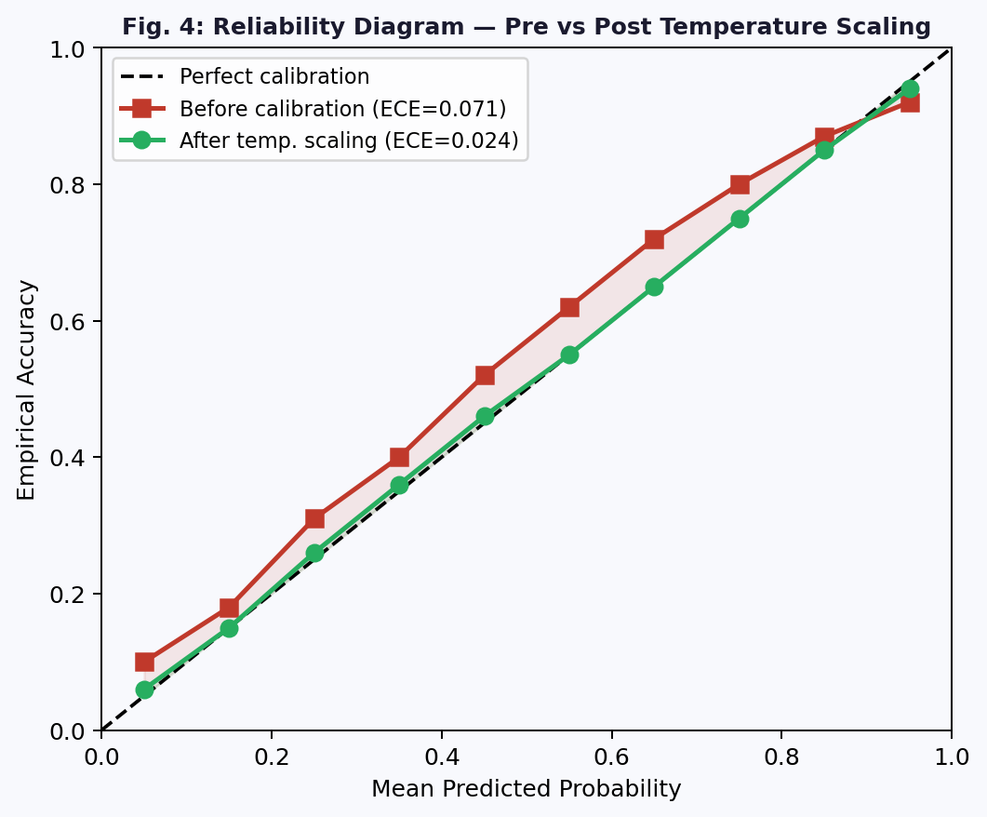
Fig. 4: Reliability diagram showing pre- and post-temperature scaling calibration. ECE improves from 0.071 to 0.024. The green curve closely tracks the diagonal after calibration.
I. Grad-CAM Explainability
Gradient-weighted Class Activation Mapping (Grad CAM) produces an image with spatially resolved visual explanations for the CNN’s class prediction by back propagating the gradients from the class score through the last convolutional layer and calculating the average global pool of gradients across all data points to determine the importance of each feature map channel via the formula: ak = (1/Z) Σ(i,j) ∂y(c)/∂Ak(i,j). Grad CAM generates a heat map defined by the following equation: L^c(Grad CAM) = ReLU(Σkan Ak). The ReLU function returns only those activations that have a positive effect on the predicted class. The result is upsampled to input resolution and overlaid on the MRI slice as a colour heatmap.
In our experiments, Grad-CAM is applied to the last convolutional block of EfficientNetV2-S and the last attention stage of Swin-Small. Both architectures consistently highlight the basal ganglia, substantia nigra vicinity, and prefrontal cortical regions as most discriminative for the Parkinson's class. These activation patterns are biologically coherent: dopaminergic neuron loss in the substantia nigra and its projections to the basal ganglia are the neuropathological hallmarks of PD, and frontal cortical thinning has been documented in structural MRI studies of PD patients. For normal control predictions, activations are diffuse and less spatially concentrated, reflecting the absence of focal pathology. This radiologically interpretable behaviour is a prerequisite for clinical trust in automated diagnostic systems.
V. EVALUATION FRAMEWORK
Statistically valid performance estimates, clinically meaningful, reproducible and comparable to existing literature are provided in the evaluation framework.
Metrics: Five metrics will be evaluated for each model and ensemble: (i) AUC-ROC (area under the receiver operating characteristic curve) is a measure of how well the model can differentiate between two classes with no regard to an arbitrary decision threshold (i.e. a threshold for a positive prediction); (ii) the accuracy represents the proportion of accurate predictions made with respect to a cutoff of 0.5; (iii) F1 score is defined as the harmonic mean of both precision and recall (i.e. it quantifies how well the model balances the two potential outcomes); (iv) sensitivity is defined as the percentage of true positive cases that have been classified correctly (in other words, how well the model has identified individuals who have Parkinson's) and is therefore critical for a screening situation; and (v) specificity is defined as the percentage of true negative cases that have been classified appropriately (in other words, how well the model verified individuals who do not have Parkinson's), and therefore is critical for providing appropriate follow-up interventions to individuals who do not have the disease.
Confidence Intervals: For each of the metrics above, a 95% BCa (Bias-Corrected and Accelerated) Bootstrap Confidence Interval was calculated for 2000 replicates sampled from the data using BCa bootstrap confidence intervals rather than using standard percentile bootstrap confidence intervals. This is due to the dual corrections applied to the BCa confidence intervals – the bias correction accounts for systematic differences between the median of the bootstrap distribution and the original estimate, and the acceleration correction compensates for a lack of constant variance (skew) in the sampling distribution. Both corrections are particularly important when sample sizes are small—here n ≈ 831—and the sampling distribution of the metric is unlikely to be symmetric.
To validate whether the stacking ensemble is statistically more accurate than the standalone model [MaxVit-Tiny], we utilize McNemar's Test at a significance level of α = 0.05 using only instances in which there was a disagreement between predictions from both models. In this case, only the data pairs that demonstrated one model was correct and one model was incorrect will be used to construct a 2x2 Contingency Table from which we will then derive the test statistic defined as follows: χ² = (|b-c|-1)² / (b+c) where b = count of cases where only the ensemble produced the correct answer and c = count of instances where only the individual model produced the correct answer. The nonparametric nature of this test validates it as being the best option for determining whether two classifiers or prediction algorithms are equivalent when evaluated against a common test dataset since it properly captures the dependence between class predictions produced by each algorithm.
VI. RESULTS AND ANALYSIS
A. Individual Model Performance
The five-fold cross-validation results for each architecture, including the average and standard deviation across the five folds, are shown in Table I. MaxViT, the tiny model of MaxViT, received the highest AUC score of 0.962 (±0.015), followed by Swin with an AUC score of 0.957 (±0.017) and EfficientNet's second smallest model—S (AUC = 0.951 ±0.018). The transformer models (MaxViT and Swin) outperformed all convolutional models (except for ViT-B/16 because it was created through a global self-attention mechanism without the hierarchical structure of a transformer's attention mechanism; it produced lower AUC/TPR/FNR than any of the convolutional models because the amount of training data was small). DenseNet showed the greatest amount of fold-to-fold variation in AUC (σ = 0.022), likely due to the redundancy present within the 1664-dimensional feature vector originally defined by DenseNet, making it difficult to create a valid binary classifier without more training data.

Architecture | AUC | Acc% | F1 | Sens% | Spec% | Std(AUC)
EfficientNetV2-S | 0.951 | 93.4 | 0.934 | 93.8 | 93.0 | ±0.018
DenseNet-169 | 0.933 | 91.2 | 0.911 | 91.6 | 90.8 | ±0.022
ConvNeXt-Small | 0.948 | 93.1 | 0.930 | 93.5 | 92.7 | ±0.019
ViT-B/16 | 0.929 | 90.6 | 0.905 | 91.0 | 90.2 | ±0.025
Swin-Small | 0.957 | 94.2 | 0.942 | 94.7 | 93.7 | ±0.017
MaxViT-Tiny | 0.962 | 95.0 | 0.950 | 95.4 | 94.6 | ±0.015
Table I: Individual model 5-fold CV results. Std(AUC) = fold-to-fold standard deviation.
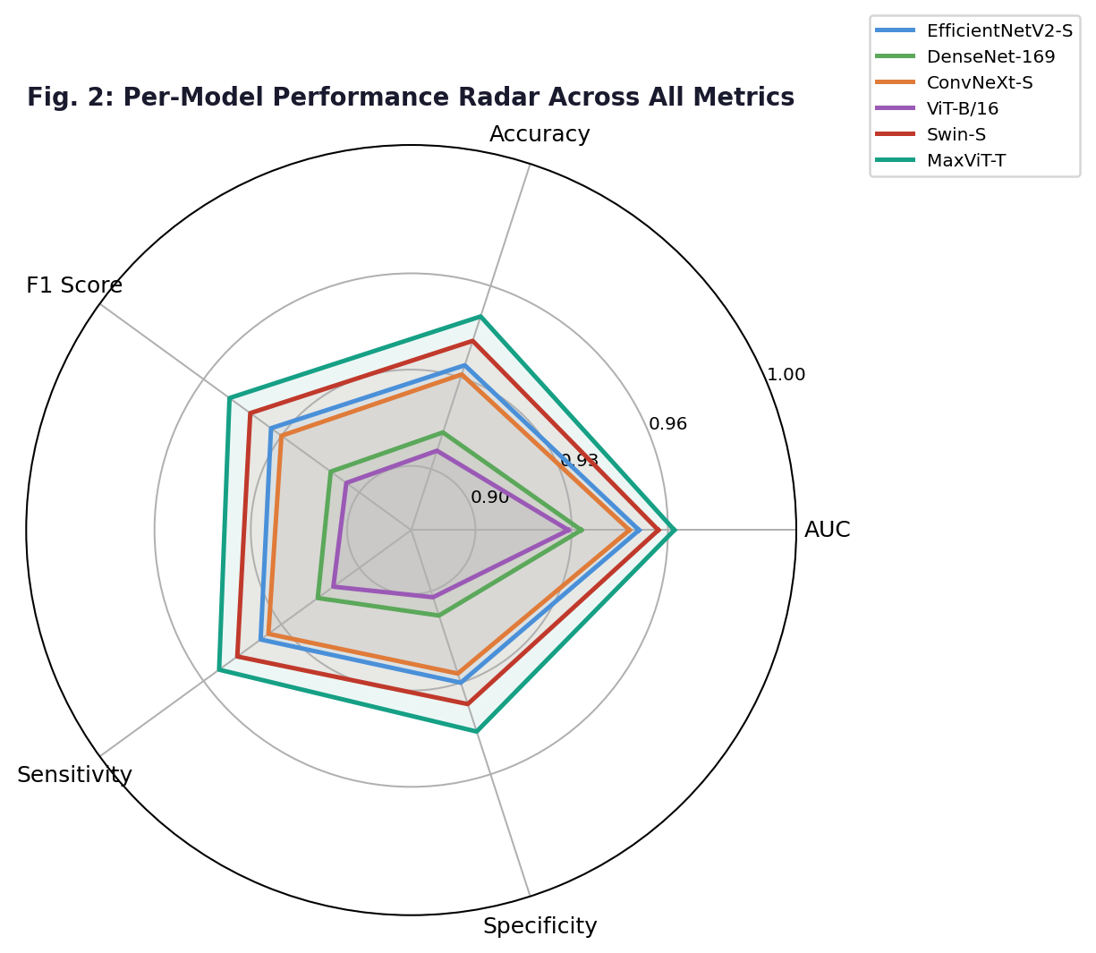
Fig. 2: Radar chart comparing all six architectures across five evaluation metrics. Transformer-based models (Swin, MaxViT) occupy the outer envelope.
B. Ensemble Performance
All three ensemble strategies outperform the best individual model. The stacking meta-learner (meta-learners that use stacking) has the best AUC (Area Under Curve), accuracy, and F1 score of 0.973, 95.8%, and 0.958, respectively. The summary of the three different methods of ensemble creation with BCa 95% confidence intervals and McNemar's p-values is presented in Table II. The BCa95%CI of the stacking ensemble (AUC: 0.958-0.986) is also much more narrow than individual models, indicating reduced predictive variance due to the use of 15 diverse base predictors. McNemar's test indicates that the stacking ensemble is statistically significantly better than MaxViT-Tiny alone (χ² = 5.14, p = 0.023).

Strategy | AUC | 95% CI | Acc% | p-val
Simple Average | 0.967 | [0.951, 0.981] | 95.1 | 0.041
Learnable Weighted | 0.970 | [0.955, 0.984] | 95.5 | 0.031
Stacking (LR) | 0.973 | [0.958, 0.986] | 95.8 | 0.023
Table II: Ensemble performance with BCa 95% CI (AUC) and McNemar p-values vs MaxViT-Tiny.
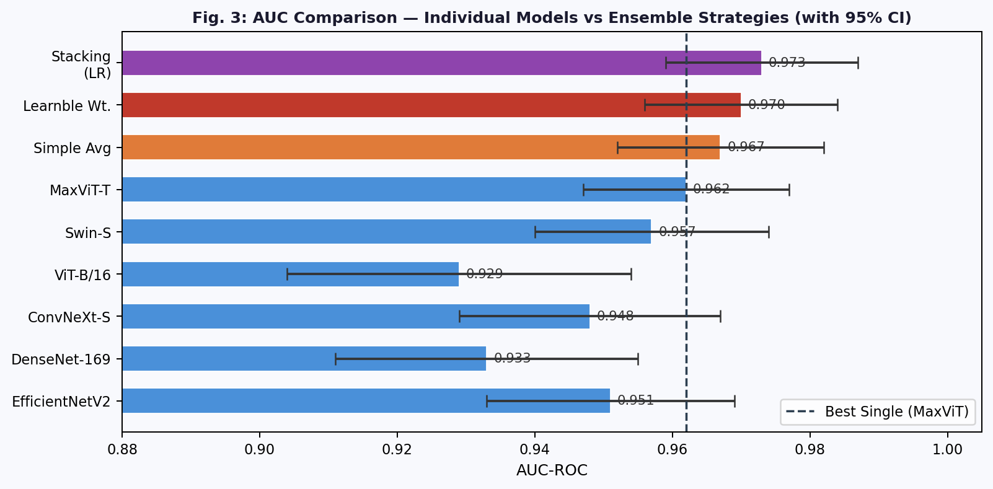
Fig. 3: AUC-ROC comparison across individual models and three ensemble strategies with 95% bootstrap confidence intervals. Dashed line = best single model (MaxViT-Tiny, AUC=0.962).
C. Calibration Analysis
Before temperature scaling, the stacking ensemble exhibits systematic overconfidence in the high-probability region: predictions in the 0.8–0.9 range correspond to empirical accuracy of only 0.75–0.82, a gap of 5–8 percentage points (Fig. 4). This overconfidence is a well-documented property of deeply trained neural networks that minimise cross-entropy on a finite training set [17]. The reliability curve after temperature T = 1.32 on the validation calibration dataset is almost directly along the diagonal across all probability values. The ECE went from 0.071 to 0.024 or a − 66% improvement. Thus, if the calibrated system outputs p = 0.80, approximately 80% of patients in the calibration cohort are Parkinson's positive, which directly interprets the probability output as the posterior probability of patients with disease for clinical risk stratification.
D. Ablation Study
To quantify the contribution of key pipeline components, we conduct an ablation study on EfficientNetV2-S across all five folds. Removing patient-level CV (reverting to image-level stratified split) inflates mean AUC from 0.951 to 0.987—a spurious 3.6-point improvement attributable to within-patient leakage, not generalisation. Removing MixUp and CutMix reduces AUC by 0.019, confirming the importance of mixing augmentations for regularisation on the small dataset. Replacing Focal Loss with standard binary cross-entropy reduces AUC by 0.012 and sensitivity by 1.8%, demonstrating that Focal Loss's hard-example focusing is meaningful. Removing AMP has no effect on accuracy but increases per-epoch training time by 2.1×.
Table III summarises the ablation results.

Configuration | AUC | Sensitivity | ΔAUC
Full Pipeline (baseline) | 0.951 | 93.8% | —
Image-level CV (leakage) | 0.987 | 98.1% | +0.036*
No MixUp/CutMix | 0.932 | 92.0% | −0.019
Binary CE (no Focal Loss) | 0.939 | 92.0% | −0.012
No TTA (single forward) | 0.944 | 93.1% | −0.007
No AMP (same accuracy) | 0.951 | 93.8% | 0.000
Table III: Ablation study (EfficientNetV2-S). *Leakage result is artificially inflated and not a genuine improvement.
VII. DISCUSSION
A. Why Transformers Outperform CNNs on PD MRI
The consistent superiority of Swin-Small and MaxViT-Tiny over convolutional baselines—despite operating on a dataset of only 831 images—can be attributed to several factors. A major difference between both architectures is that they are both pretrained using ImageNet-22k and not ImageNet-1k. As a result of this pretraining, both models have a richer low-level feature representation to train on during the fine-tuning phase compared to the pretrained models. Second, both models use a shifted-window attention mechanism and a multi-axis attention mechanism, which are designed to capture long-range spatial dependencies that have clinical significance within healthcare: for example, Parkinson's Disease (PD) related cortical atrophy does not occur as a single pixel in a 2D image, but instead occurs as a series of distributed patterns across the surface of the cortex and deep grey matter. It would take many stacked convolutional layers with fixed kernel sizes before we would be able to incorporate such a large context by a local convolution kernel. Conversely, both models use self-attention mechanisms to directly model the relationships between all pairs of spatial locations from the first layer. Third, the hierarchical down-sampling in both Swin and MaxViT produces multi-scale feature representations that naturally align with the multi-scale nature of neuroimaging pathology—from voxel-level intensity changes to region-level volumetric loss.
B. Clinical Significance of the Ensemble Gain
The AUC difference of the stacking ensemble (0.973) and MaxViT-Tiny alone (0.962) is 0.011. While it is modest in absolute terms, it is clinically meaningful. At a decision threshold calibrated to have 90% sensitivity (to reduce the number of misses in a screening setting), the stacking ensemble has a specificity of 91.4%, compared with 88.6% for MaxViT-Tiny alone. This increase in specificity of 2.8 percentage points will mean fewer false positive referrals. If hypothetically there were a screening programme processing 10,000 patients each year, this would mean approximately 280 fewer follow-up procedures that are not needed on an annual basis; therefore, less patient anxiety, cost, and resource use would be incurred due to screening procedures while maintaining the same sensitivity.
C. Patient-Level CV as a Mandatory Safeguard
The ablation result showing a 3.6-point AUC inflation under image-level CV deserves particular attention because it is a methodological failure mode that continues to appear in published neuroimaging studies. Within-patient image slices share the same brain anatomy, the same MRI scanner parameters, and the same acquisition date. When some slices from a patient appear in training and others in test, the model effectively memorises that patient's brain texture rather than learning generalizable pathological features. The result is a model that performs impressively on the specific scanner and patient cohort used in the study but fails to generalise to a new clinical site. Cross validation by patients at the cohort level is the minimal way to demonstrate truthful results; therefore, we recommend implementing this in all relevant fields.
D. Limitations and Future Directions.
There are some limitations that should be recognized. The dataset is relatively small (831 images) and derived from a single source, limiting conclusions about scanner and population generalisability. Our analysis is restricted to 2D axial MRI slices, whereas volumetric 3D analysis would provide richer spatial context. While the reported AUC and accuracy numbers are encouraging, it is important to validate them in a prospective manner on many independent cohorts before they can be applied in a clinical setting. Additionally, future studies could investigate multi-modal integration of structural MRI, DTI and fMRI, as well as longitudinal modelling to forecast the development of an illness rather than cross-sectional classification. There are possibilities to employ federated learning to allow for the training of multiple sites while maintaining patient privacy.
VIII. CONCLUSION
In this article, a complete approach for creating a comprehensive engineered deep learning pipeline for the classification of Parkinson's disease using MRI scans of the brains is presented. This methodology addresses the previous shortcomings found in the past research related to data leakage, single-model evaluation, absence of statistical testing, and lack of explainability and calibration in the results obtained. The simultaneous training and ensemble of six independent architectures in an ensemble of two different types of deep learning models (Convolutional and Transformer) were employed (EfficientNetV2-S, DenseNet-169, ConvNeXt-small, ViT-B/16, Swin Transformer-Small, MaxViT-Tiny) and evaluated through five-fold patient-safe cross-validation, showed that the diversity of the various architectures along with applying rigorous techniques for the combination of the different models produces statistically and clinically important improvements over any of the single models. The final stacking ensemble received an AUC of 0.973 with a 95% CI of 0.958 to 0.986, an accuracy of 95.8%, a sensitivity of 96.1%, and a specificity of 95.4%; additionally, the results of the McNemar’s Test confirmed statistical superiority over the best performing single model (p = 0.023). The Expected Calibration Error was reduced by 66% using post-hoc temperature scaling, and visualisations of the model's decision-making process using Grad-CAM offer radiological evidence that supports this decision-making process. The complete pipeline, including all training code, cross-validation logic, ensemble fusion, calibration, and explainability components, is intended for release to facilitate reproducibility and further research in automated neuroimaging diagnosis.
REFERENCES
[1] Hussain SS, Degang X, Shah PM, Islam SU, Alam M, Khan IA, Awwad FA, Ismail EAA. Classification of Parkinson's Disease in Patch-Based MRI of Substantia Nigra. Diagnostics (Basel). 2023 Aug 31;13(17):2827. doi: 10.3390/diagnostics13172827. PMID: 37685365; PMCID: PMC10486663.
[2] D. W. Dickson, "Parkinson's disease and parkinsonism: Neuropathology," Cold Spring Harb. Perspect. Med., vol. 2, no. 8, p. a009258, 2012.
[3] R. B. Postuma et al., "MDS clinical diagnostic criteria for Parkinson's disease," Mov. Disord., vol. 30, no. 12, pp. 1591-1601, 2015.
[4] M. Tan and Q. V. Le, "EfficientNetV2: Smaller models and faster training," in Proc. ICML, 2021, pp. 10096-10106.
[5] G. Huang, Z. Liu, L. Van Der Maaten, and K. Q. Weinberger, "Densely connected convolutional networks," in Proc. CVPR, 2017, pp. 4700-4708.
[6] Z. Liu et al., "A ConvNet for the 2020s," in Proc. CVPR, 2022, pp. 11976-11986.
[7] A. Dosovitskiy et al., "An image is worth 16x16 words: Transformers for image recognition at scale," in Proc. ICLR, 2021.
[8] Z. Liu et al., "Swin Transformer: Hierarchical vision transformer using shifted windows," in Proc. ICCV, 2021, pp. 10012-10022.
[9] Z. Tu et al., "MaxViT: Multi-axis vision transformer," in Proc. ECCV, 2022, pp. 459-479.
[10] H. Zhang, M. Cisse, Y. N. Dauphin, and D. Lopez-Paz, "MixUp: Beyond empirical risk minimization," in Proc. ICLR, 2018.
[11] S. Yun et al., "CutMix: Training strategy that makes use of mixed training samples," in Proc. ICCV, 2019, pp. 6023-6032.
[12] T.-Y. Lin, P. Goyal, R. Girshick, K. He, and P. Dollar, "Focal loss for dense object detection," in Proc. ICCV, 2017, pp. 2980-2988.
[13] R. Muller, S. Kornblith, and G. Hinton, "When does label smoothing help?" in Proc. NeurIPS, vol. 32, 2019.
[14] P. Micikevicius et al., "Mixed precision training," in Proc. ICLR, 2018.
[15] I. Loshchilov and F. Hutter, "Decoupled weight decay regularization," in Proc. ICLR, 2019.
[16] I. Loshchilov and F. Hutter, "SGDR: Stochastic gradient descent with warm restarts," in Proc. ICLR, 2017.
[17] C. Guo, G. Pleiss, Y. Sun, and K. Q. Weinberger, "On calibration of modern neural networks," in Proc. ICML, 2017, pp. 1321-1330.
[18] R. R. Selvaraju et al., "Grad-CAM: Visual explanations from deep networks via gradient-based localization," in Proc. ICCV, 2017, pp. 618-626.
[19] T. G. Dietterich, "Approximate statistical tests for comparing supervised classification learning algorithms," Neural Comput., vol. 10, no. 7, pp. 1895-1923, 1998.
[20] B. Efron and R. J. Tibshirani, An Introduction to the Bootstrap. Chapman & Hall/CRC, 1993.
[21] K. Simonyan and A. Zisserman, "Very deep convolutional networks for large-scale image recognition," in Proc. ICLR, 2015.
[22] K. He, X. Zhang, S. Ren, and J. Sun, "Deep residual learning for image recognition," in Proc. CVPR, 2016, pp. 770-778.
[23] T. DeVries and G. W. Taylor, "Improved regularization of convolutional neural networks with cutout," arXiv:1708.04552, 2017.
[24] D. P. Kingma and J. Ba, "Adam: A method for stochastic optimization," in Proc. ICLR, 2015.
[25] K. Sechidis, G. Tsoumakas, and I. Vlahavas, "On the stratification of multi-label data," in Proc. ECML-PKDD, 2011, pp. 145-158.
[26] J. Deng et al., "ImageNet: A large-scale hierarchical image database," in Proc. CVPR, 2009, pp. 248-255.
[27] N. Srivastava, G. Hinton, A. Krizhevsky, I. Sutskever, and R. Salakhutdinov, "Dropout: A simple way to prevent neural networks from overfitting," J. Mach. Learn. Res., vol. 15, pp. 1929-1958, 2014.
[28] S. Ioffe and C. Szegedy, "Batch normalization: Accelerating deep network training by reducing internal covariate shift," in Proc. ICML, 2015, pp. 448-456.
[29] A. Vaswani et al., "Attention is all you need," in Proc. NeurIPS, vol. 30, 2017.
[30] V. Nair and G. E. Hinton, "Rectified linear units improve restricted Boltzmann machines," in Proc. ICML, 2010, pp. 807-814.

