WEEK 3 Work flow for lab Conduction
Objectives:
1. Demonstrating Collaborative coding.
2. To resolve conflicts when collaborating on same part of code.
3. Demonstrating how to create and apply patch
4. Scenario Based Questions
1. Collaborative coding.
Code collaboration refers to the process of multiple people working together on the same codebase. This typically involves sharing code changes and reviewing each other's work in order to improve the quality and reliability of the code.

There are two ways of collaborative coding:
a. Creating Organization
b. Coordinating with others through a shared repository

a. Facilitating Collaborative Work by creating Organization
Organization - Organizations are shared accounts where businesses and open-source projects can collaborate across many projects at once. Owners and administrators can manage member access to the organization's data and projects with sophisticated security and administrative features. Steps to facilitate collaborative work by creating organization are:
Step 1: Click on New organization in Git hub
Click on Create a free organization.
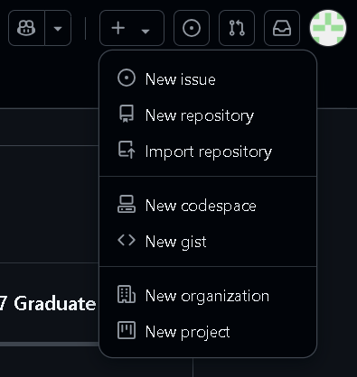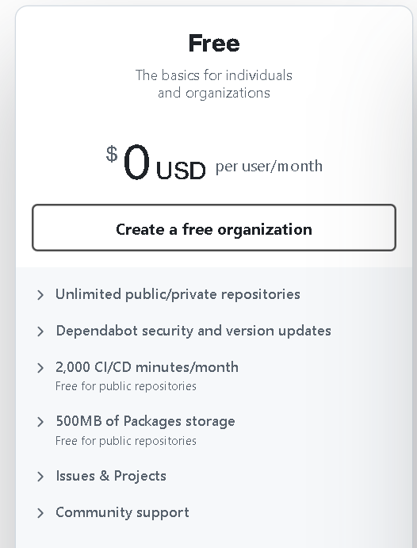

Step 2: Set up your organization by entering the details like name, associated email, account verification, etc.
Click on Next
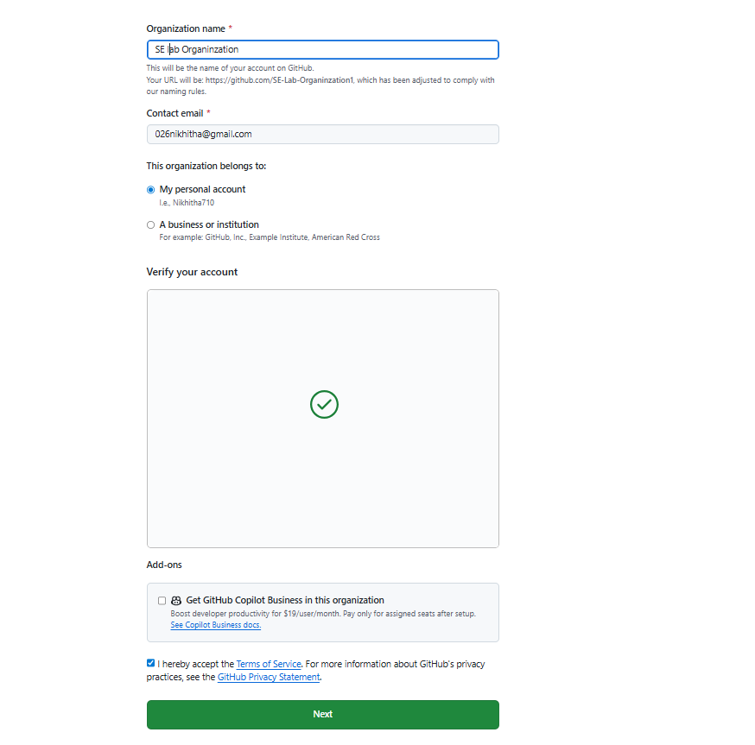

Step 3: Complete the setup by
1)adding members to the group.
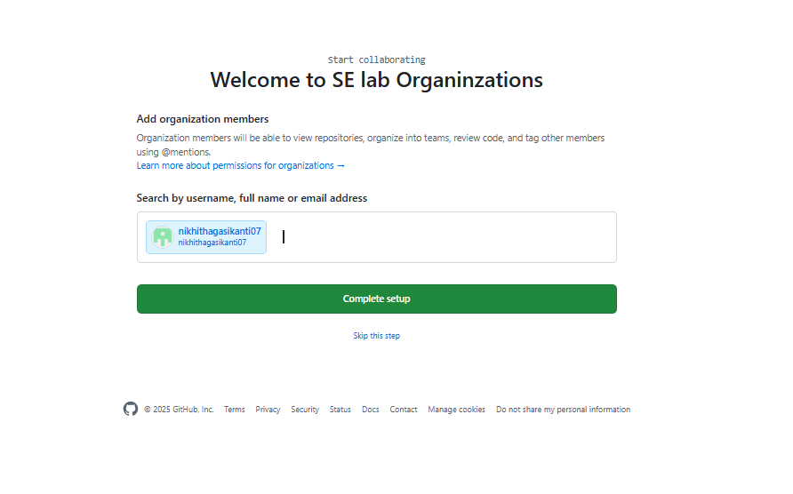

2)Now, the invitation goes to other collaborator and they must accept.
3) Next click on complete setup
4) Goto Github and click on

Settings à Member privileges à Base permissions à select write à change base permission to “Write”
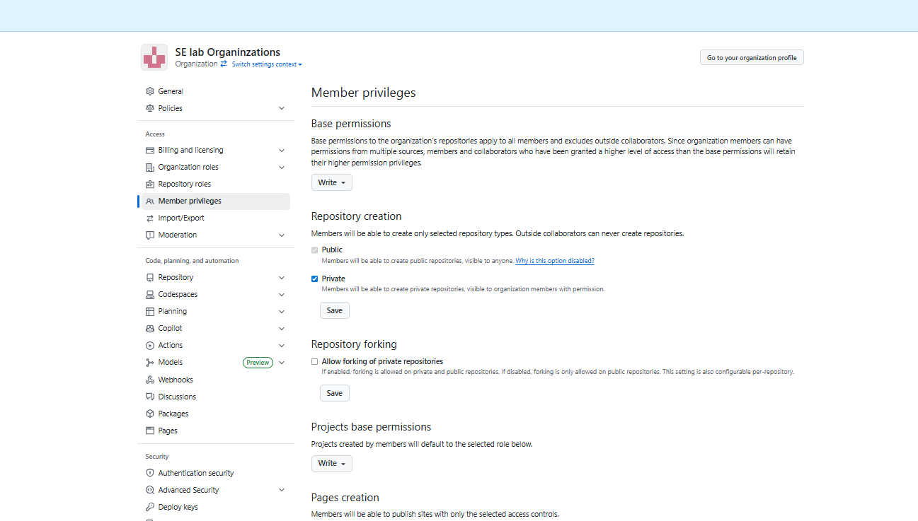

Next under,

Projects base permissions àselect Write à change base permission to “Write”
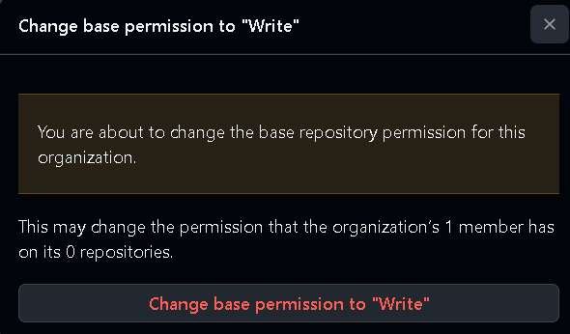

Step 4: Create the remote repository for storing the project related files in Organization. This repository is accessible to every member of the team as per the permissions given.
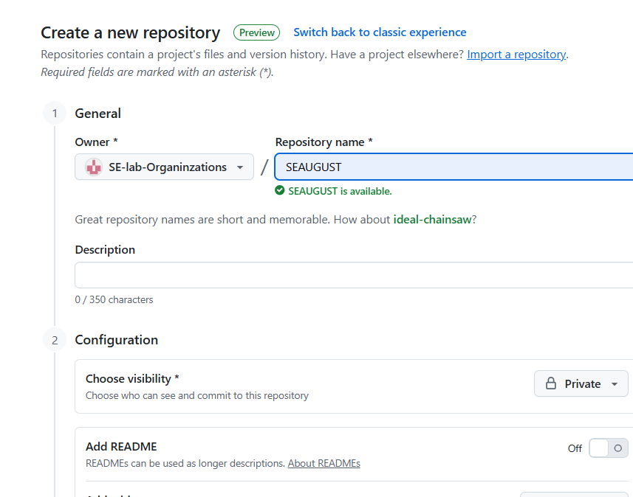

Note: The repository can be made private so that it is accessible only to the group members rather than being in a public domain.
Now all the members of the team can contribute to the development of the project and the different files with all the versions and modification notices will be available in the respective repositories and is accessible to all the members
b. To collaborate effectively on GitHub shared repository by sharing code and coordinating with others through a shared repository.
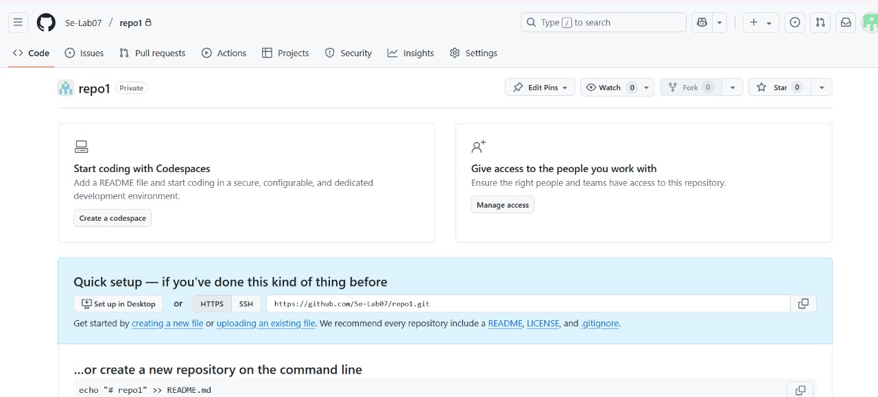

àSteps for Collaborator 1 are: (collaborator-1 has repository that he wants to share with
collaborator-2)
1) Go to Settings > collaborators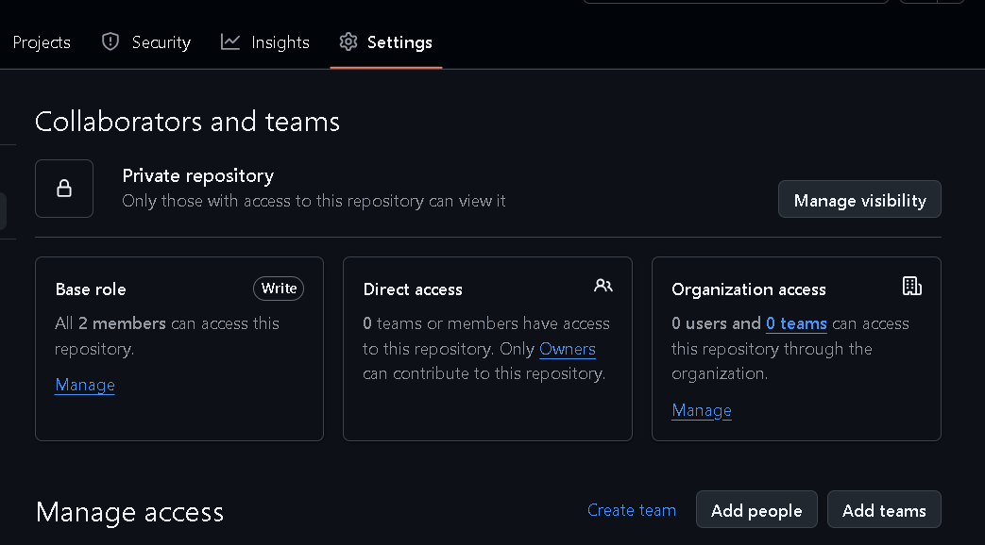
2) Now in Manage Access click on Add people
3) Now you will be able to see ONE collaborator added

4) After this invitation goes to collaborator 2 and they need to accept it.

àSteps for Collaborator 2 are:
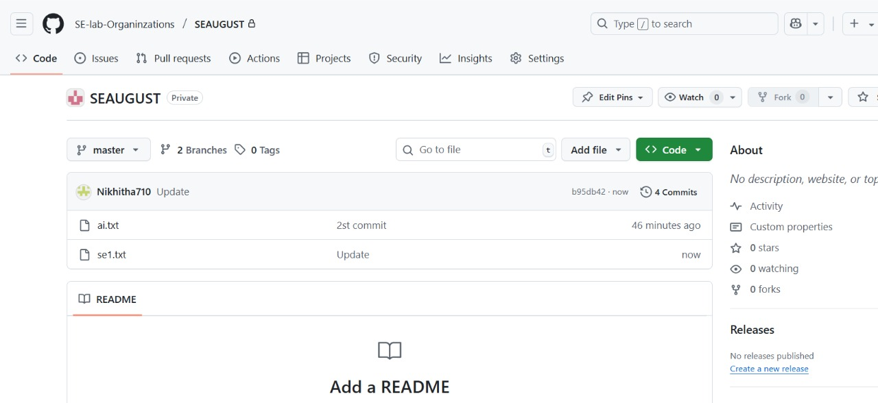
✅ 1. Set Up Git and GitHub
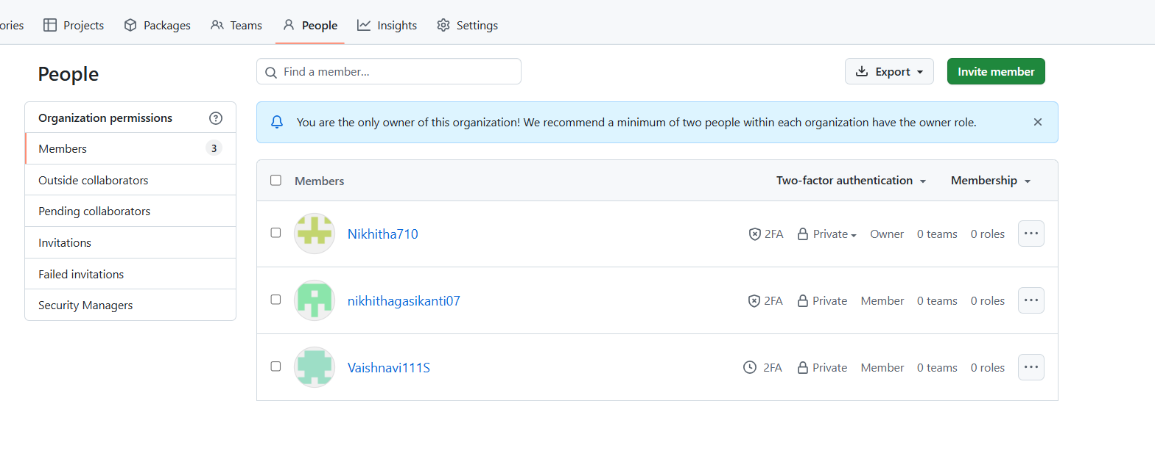

In git bash
git config --global user.name "Your Name"
git config --global user.email you@example.com

Note : run $ git remote -v
If origin git@github.com:OrgYOG/commonREPO.git (fetch)
origin git@github.com:OrgYOG/commonREPO.git (push)
then
$ git remote –v // Note now, not connected to any remote
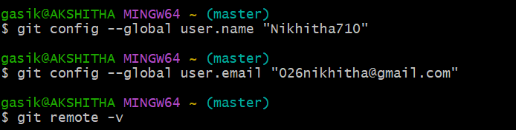

✅ 2. Goto Git hub and copy url of shared repository by collaborator 1
· Copy url (option 1)
✅ 3. Clone the Repository
Get a local copy of the repo:
In git bash
git clone https://github.com/username/repository-name.git
cd repository-name
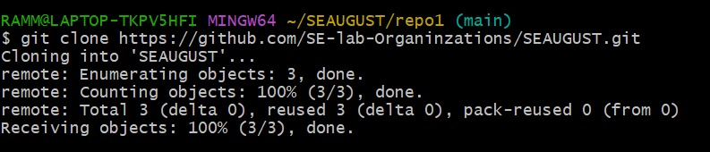
✅ 4. Create a Branch for Your Work
Always work on a separate branch:
In git bash
git checkout -b feature/your-feature-name
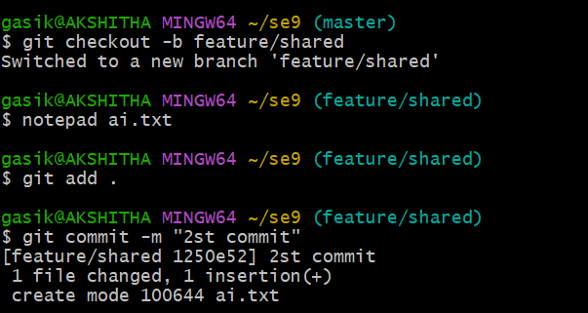
✅ 5. Make Changes and Commit
Edit files, then stage and commit your changes:
In git bash to existing file / new file
git add .
git commit -m "Add a clear and descriptive commit message"
✅ 6. Push Your Branch to GitHub
In git basè git push origin feature/your-feature-name
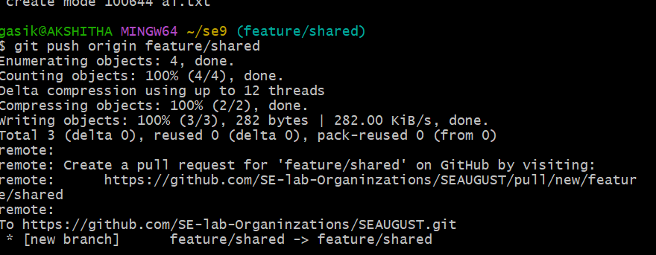
✅ 7. Keep Your Branch Updated (has to be done by owner collaborator 1)
Before making new changes:
In git bash
git checkout main
git pull origin main
git checkout feature/your-new-feature
git merge main

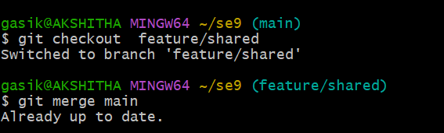

2. To resolve conflicts when collaborating on same part of code.
Resolving conflicts when collaborating with GitHub (or Git in general) is a normal part of team development. Conflicts happen when two people make changes to the same part of the code, and Git doesn't know which version to keep.
✅ Steps to Resolve a Conflict
1. See Which Files Are in Conflict (Say f1.txt)
In git bash
git status
Conflicted files will be marked like:
In git bashboth modified: (Say f1.txt)
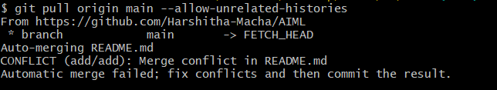

3. Open the File and Look for Conflict Markers by clicking on

Git will insert conflict markers in the file like this:
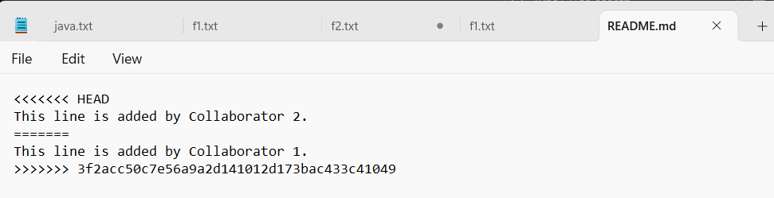

3. Edit the File to Fix the Conflict
ü Choose one version or combine them:
ü Then delete all the conflict markers (<<<<<<<, =======, >>>>>>>).
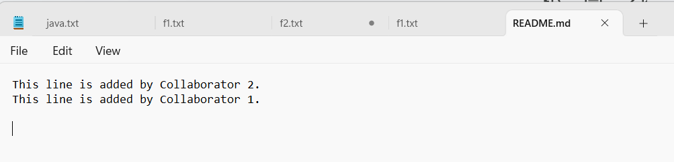

4. Mark the Conflict as Resolved
Once you've edited and saved the file:
ü git add README.md
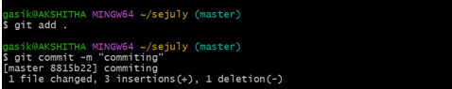

5. Complete the Merge or Pull
ü git commit # Only needed if you're merging
Or if you're rebasing:
ü git rebase --continue
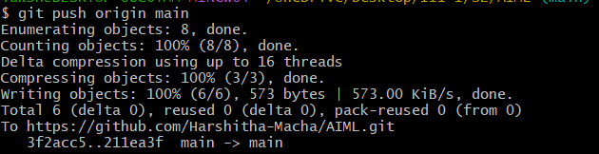
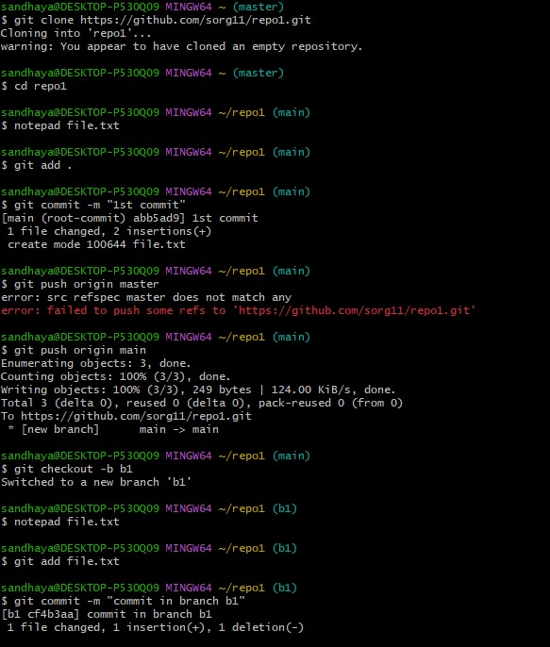
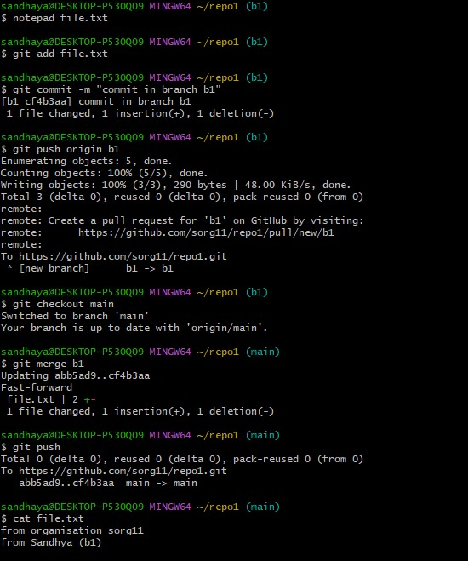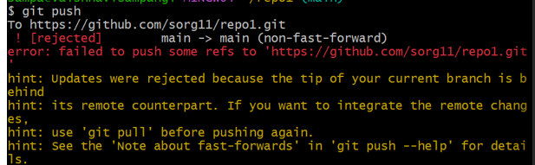

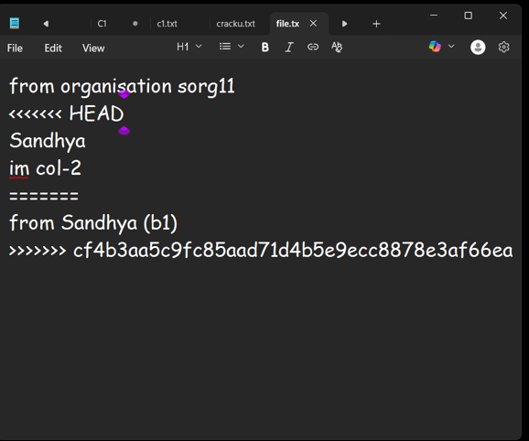
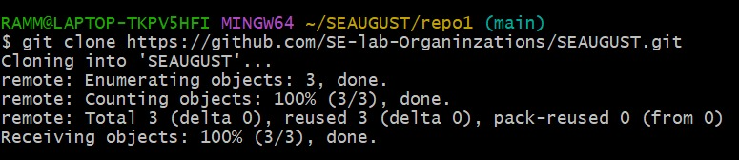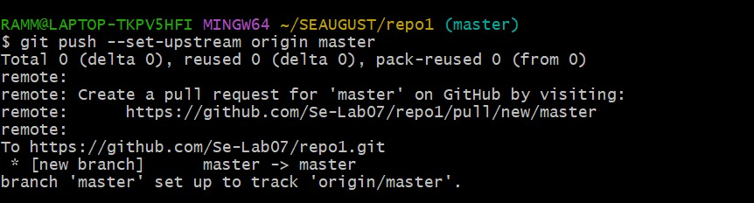

3. What is patch
A patch in Git is a text file that represents changes between two sets of files, or commits. It's essentially the output of the git diff command, packaged in a format that can be applied to another set of files.

Steps:
1. Goto github and take public project url
2. Clone into git bash
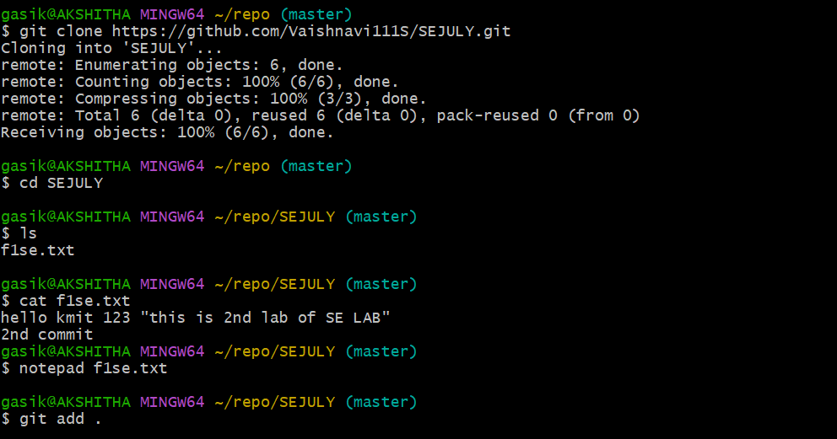
3. Now open file and edit it, add, commit
4. Run git log
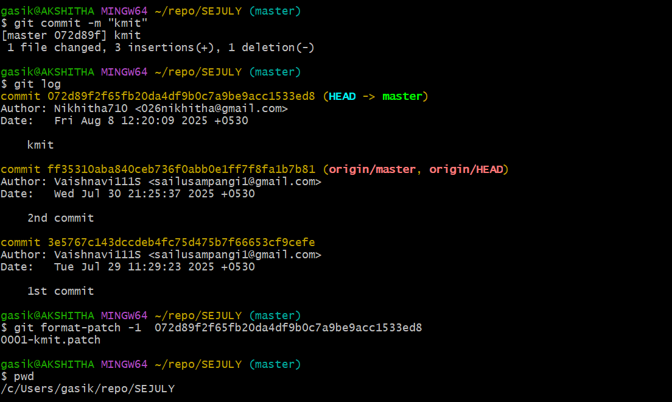
5. Create patch with commit hash code as:
git format-patch -1 commit-hash-code 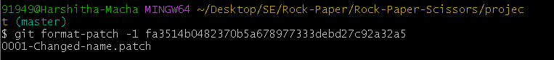
This creates 0001-commit-from-cloned-person.patch file.
6. Get the path of above patch file and email or what’s up to the remote owner of file.
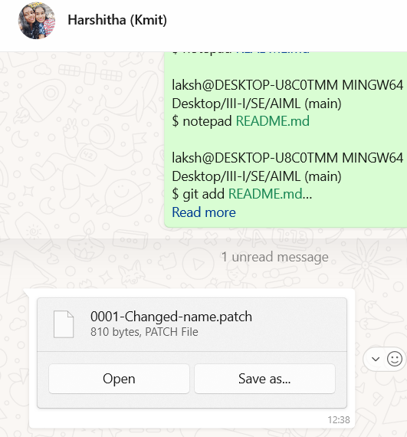
7. Once the remote owner gets the patch file 0001-commit-from-cloned-person.patch next the owner need to apply patch file in his git bash using git command below:

Syntax:
git apply my-changes.patch
Or, if it's a patch made by git format-patch, use:
git am 0001-Your-commit-message.patch

è git apply 0001-Your-commit-message.patch
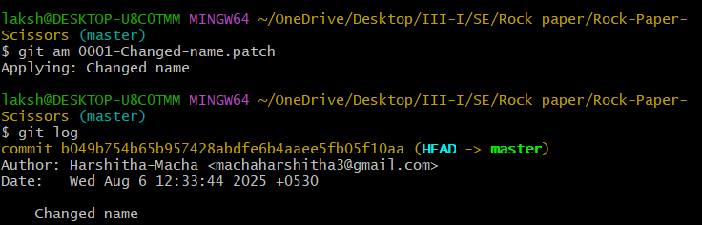

Scenario based questions on working with remote repository

You've cloned a repository and made some changes to a local branch. Now you want to push these changes to the remote repository, but you're getting an error saying "rejected - non-fast-forward." How would you resolve this?

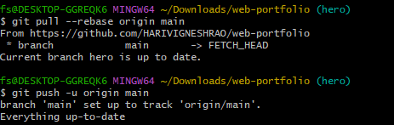

2.You’ve been working on a feature branch, and now you need to push it to the remote repository. However, the remote repository already has a main branch. How do you push your feature branch without affecting the main branch?

git checkout -b feature-branch

git push origin feature-branch

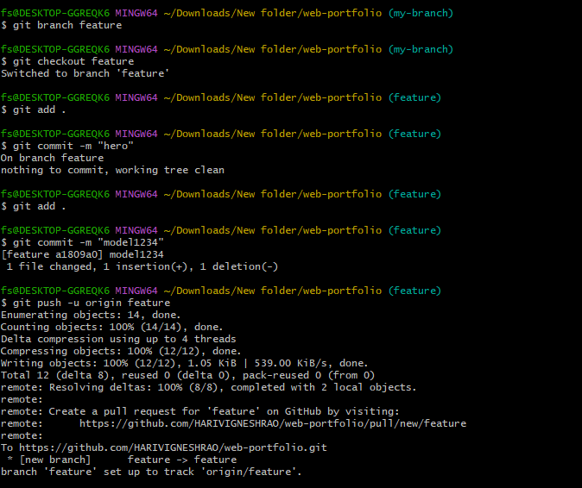

3. You cloned a remote repository, but after a while, the repository’s structure changed and new branches were added. How would you keep your local repository updated with the latest changes from the remote repository?

git fetch --all –prune

git branch -r

git checkout -b new-branch origin/new-branch

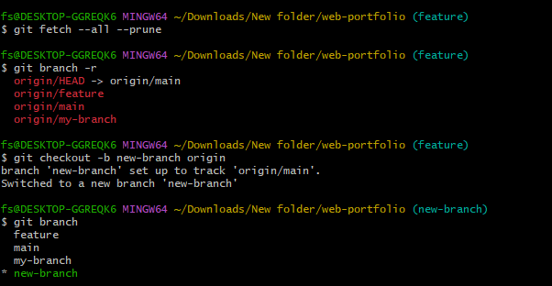
4. A colleague has pushed some changes to the main branch, but you have local changes in the same branch. You want to pull their changes, but you want to avoid merge conflicts. What steps would you take?
git stash
git pull origin main –rebase
git stash pop

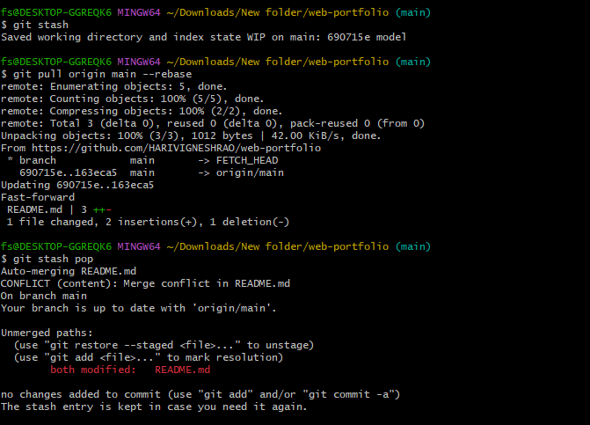

5. You accidentally pushed a sensitive file (e.g., API keys) to the remote repository. How would you fix this situation

git push origin --force --all

git push origin --force --tags

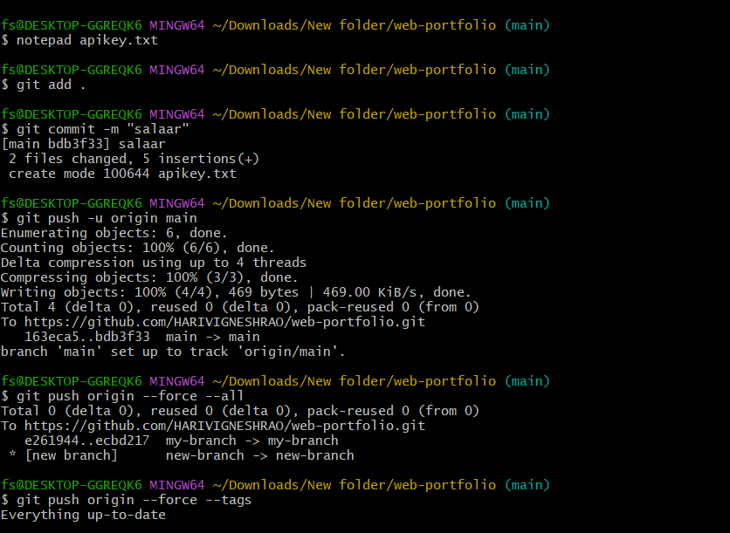

6. You’re working on a feature branch, and your manager requests that you integrate the latest changes from main into your feature branch. What steps would you take?

git checkout feature-branch

git pull origin main –rebase

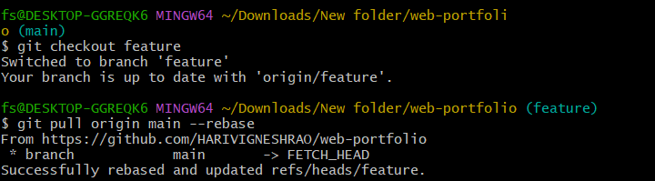

7. You cloned a remote repository, but later you find that you need to push your changes to a different remote repository. How do you configure your local repository to push to this new remote

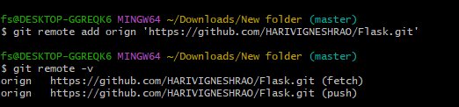

8. After running git pull, you notice that your local branch is behind the remote branch. How would you proceed to bring your local branch up to date without losing your local changes?

git stash

git pull origin main --rebase

git stash pop

9. You’re working on a project with multiple collaborators, and you notice that your local changes conflict with changes that have been pushed by others. How would you resolve the conflicts?

git pull origin <branch-name> --rebase

git add <resolved-file>

git rebase –continue

10. You’ve pushed a feature branch to a remote repository, but now you need to delete the branch from the remote. How would you do that?

git push origin --delete feature-branch

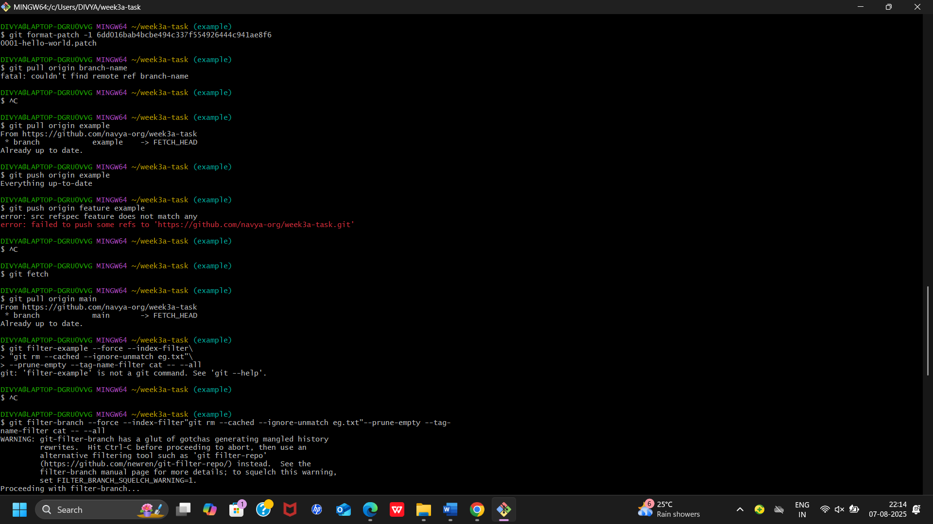

Exercise on Fork
- If you're contributing to an existing project: (in public repository say of Person1)
- Note: Person 1means other public repository already exit that is pushed by person 1.
Person 2 is you who want to contribute.

Note: Following steps needed if you forked from any public repository to contribute to Person 1

1. Go to: `https://github.com/Person1/awesome-project` (of Person 1)
2. Click the “Fork” button at the top-right of the page.
3. GitHub will create a copy of that repository in your account (say Person2):
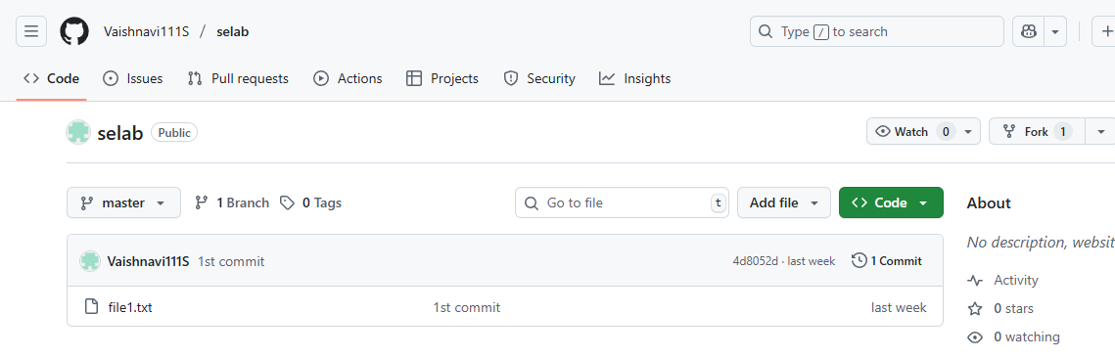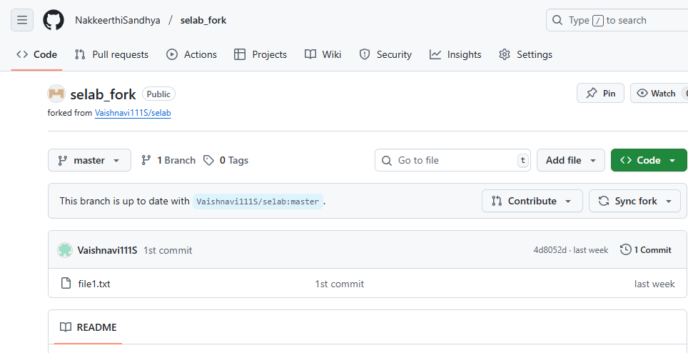
https://github.com/your-username/awesome-project
as
https://github.com/Person2/awesome-project

4. Clone your forked repo: in bash (by Person 2)
- git clone https://github.com/your-username/awesome-project
- Make changes.
- git add .
- git Commit
- git push origin main

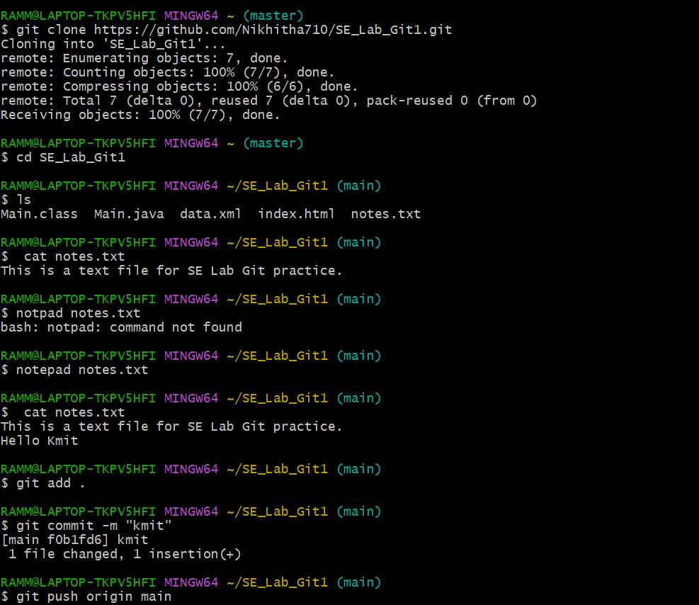

- Create or a “pull request” back to the original repo (`othername/awesome-project) to suggest your changes. (by Person 2)

- Click at top “Pull request” or click on at top or click on repo “awesome-project” then click on Contribute at top then click on “open pull request”
- Add title and Add a description if you want. Below it shows what changes you made to file
- Click on Create pull request

Now you see on page message “NO conflicts with base branch”

✅ 6. By Person 1
- Pull requests 1 appears at top in git hub account of Person 1
- Clicking on “Pull requests” shows:
Commit by Person 2. Click on this commit message.
It redirect to repository (say awesome-project)
- Click on “File changed 1” to see changes made by Person 2
- Click on “Review Changes”, add review and click on “submit review”
- Click on Merge pull request
- Confirm merge

Note: It displays “Pull request Successfully merged and closed” to Person 1

- Now go to Code and see changes have been merged to the file.
- In commit it shows: Commit by Person 2
Merge commit by Person 1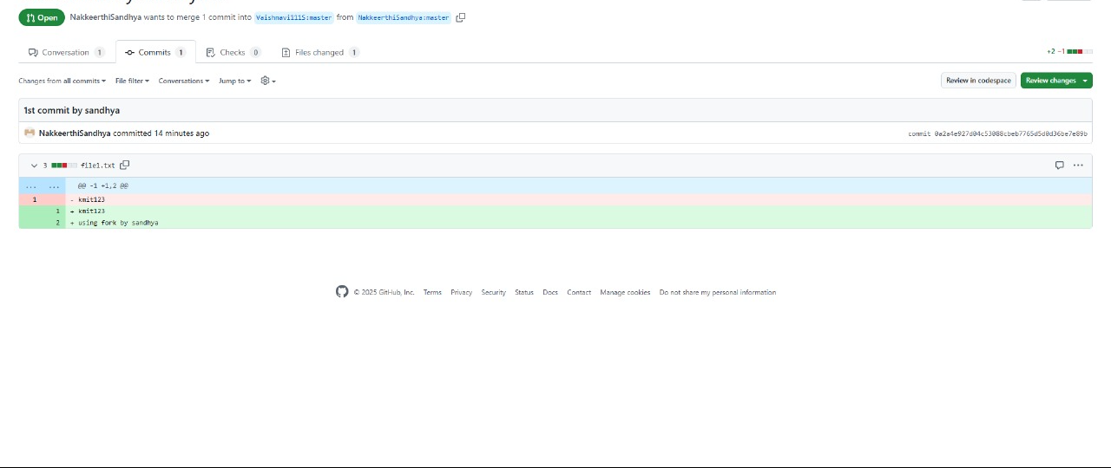

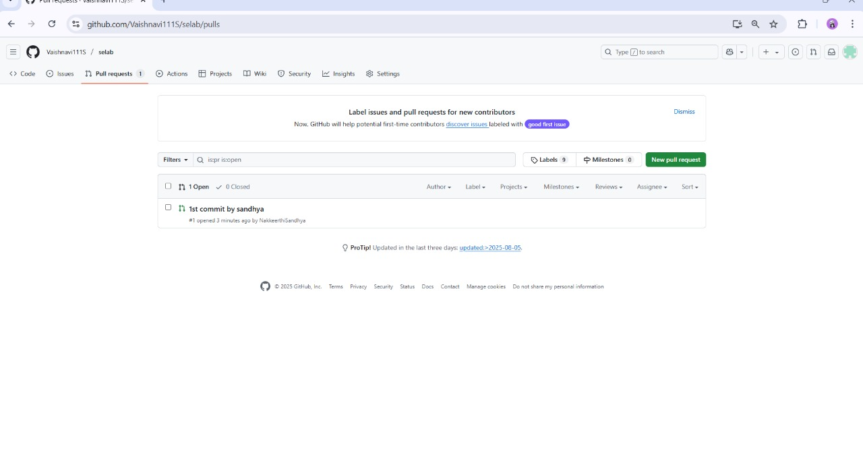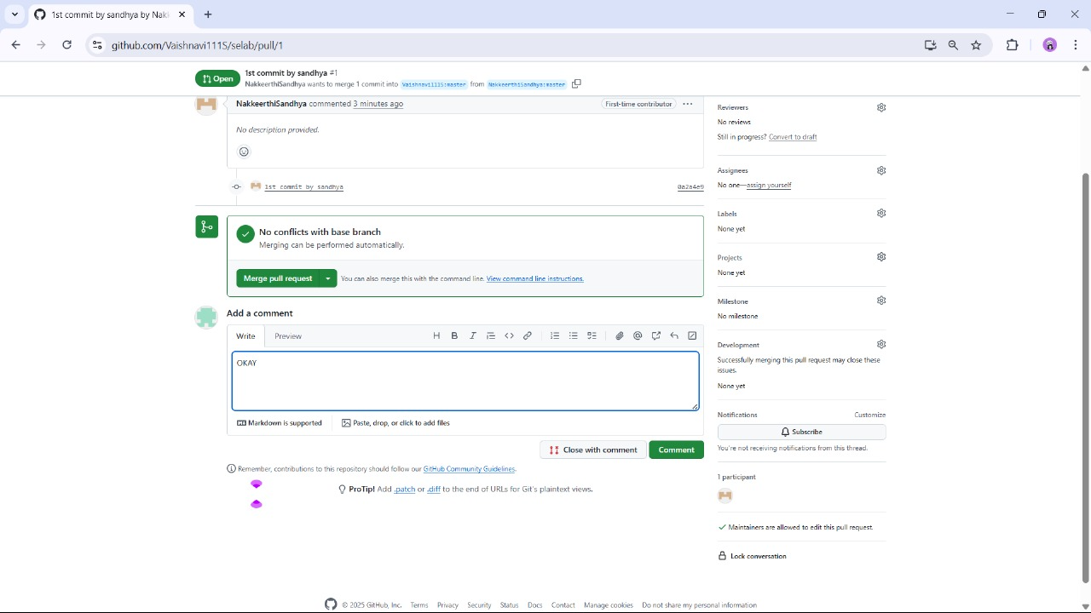

✅ 7. Merge the Pull Request (has to be done by both collaborators)
Once approved:
- The repo owner can click Merge pull request

✅ 8. Keep Your Branch Updated (has to be done by Person 1 and Person 2)
Before making new changes:
In git bash
git checkout main
git pull origin main
git checkout feature/your-new-feature
git merge main
cd repository-name
