LAB ACTION PLAN FOR WEEK 6
Example:

services:
web:
image: nginx
ports:
- "8060:80"
db:
image: tomee
ports:
- "8050:8080"

Example Docker Compose File (Simple)
Here’s a basic example of a Docker Compose file that runs WordPress and MySQL together:
version: '3.8' # Docker Compose file format version

services:
wordpress: # WordPress service
image: wordpress:latest
ports:
- "8080:80" # Map port 80 of the container to port 8080 of the host
environment:
WORDPRESS_DB_HOST: db:3306 # Database host
WORDPRESS_DB_USER: wordpress
WORDPRESS_DB_PASSWORD: wordpress
WORDPRESS_DB_NAME: wordpress
depends_on:
- db # Ensures the db service starts first

db: # MySQL service
image: mysql:5.7
environment:
MYSQL_ROOT_PASSWORD: rootpassword
MYSQL_DATABASE: wordpress
MYSQL_USER: wordpress
MYSQL_PASSWORD: wordpress

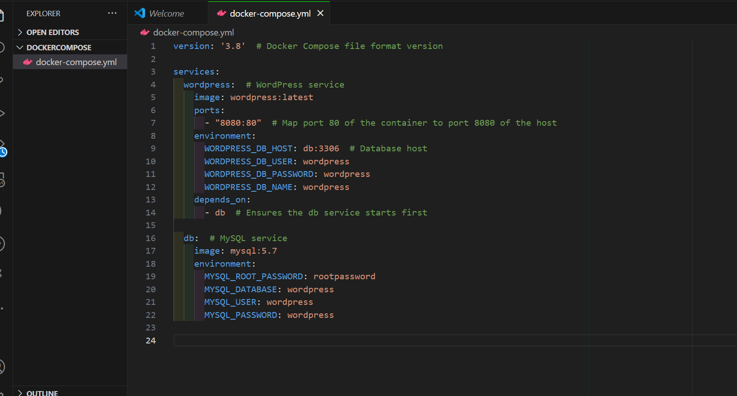

How to Run It
To run a multi-container setup like the one above:
- Save the file as docker-compose.yml.
Or
docker-compose.yaml
- To Start the compose

docker-compose up –d
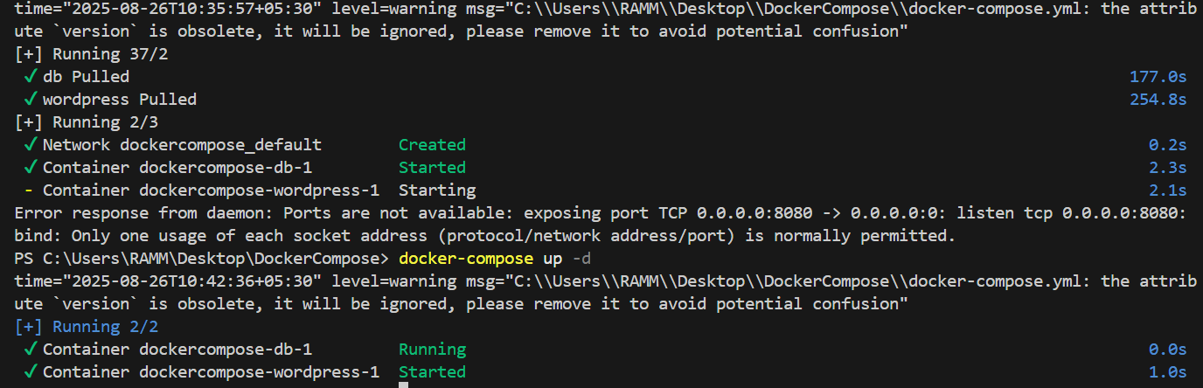

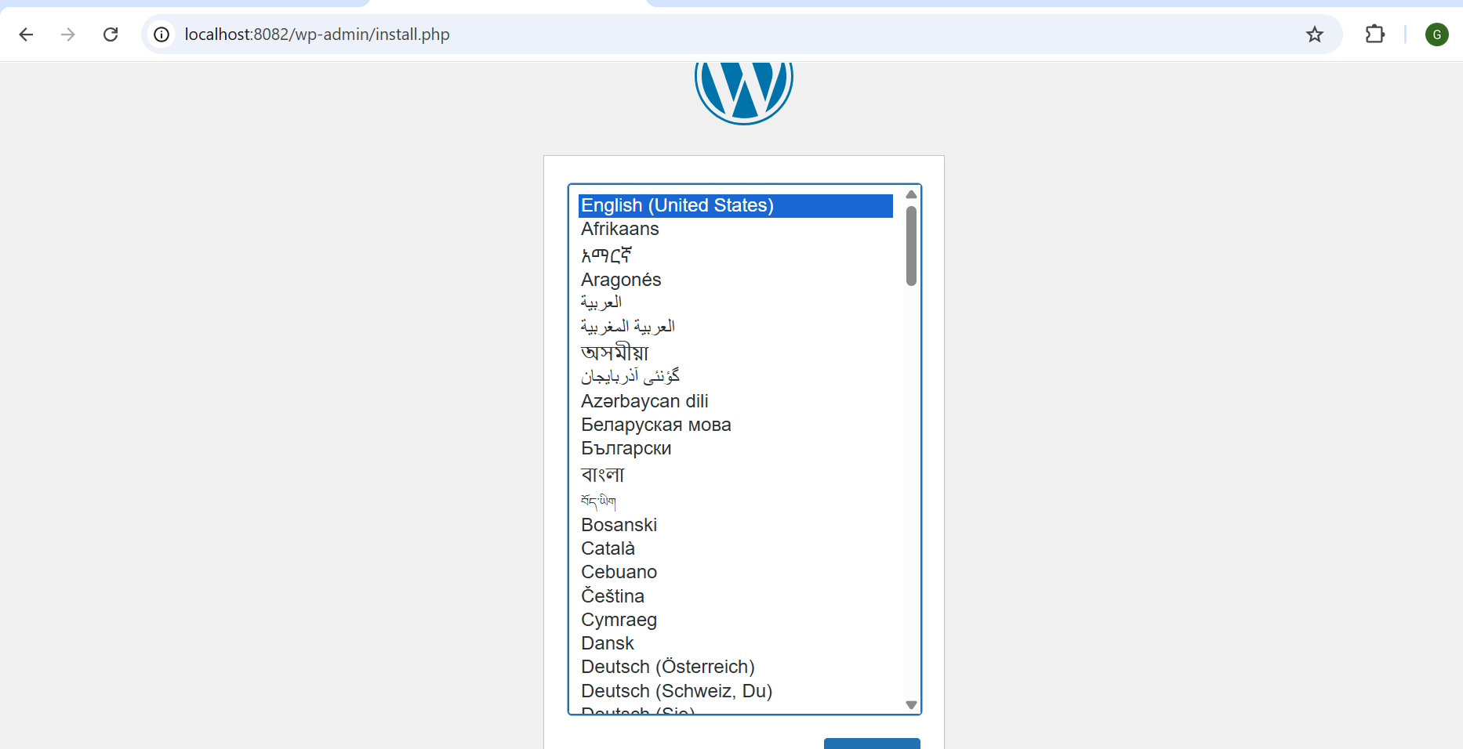

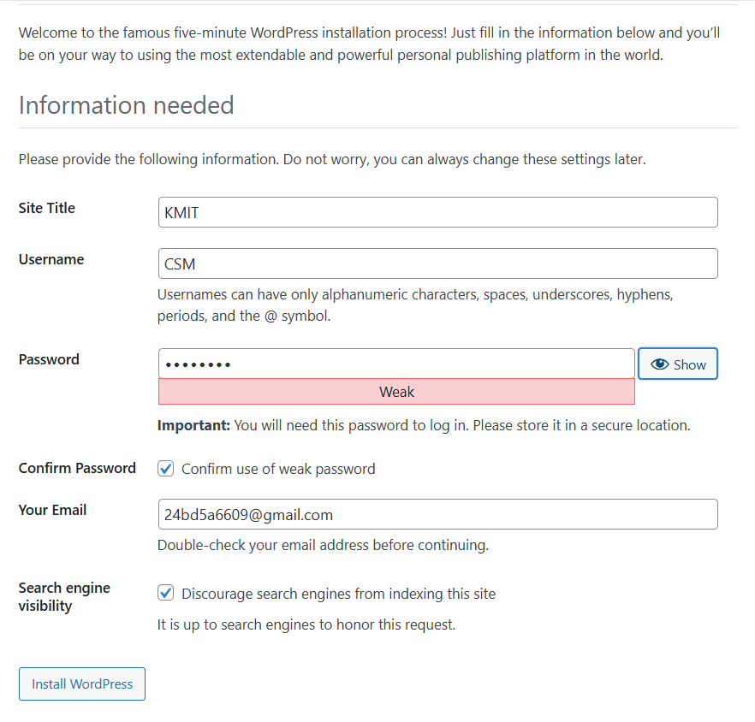


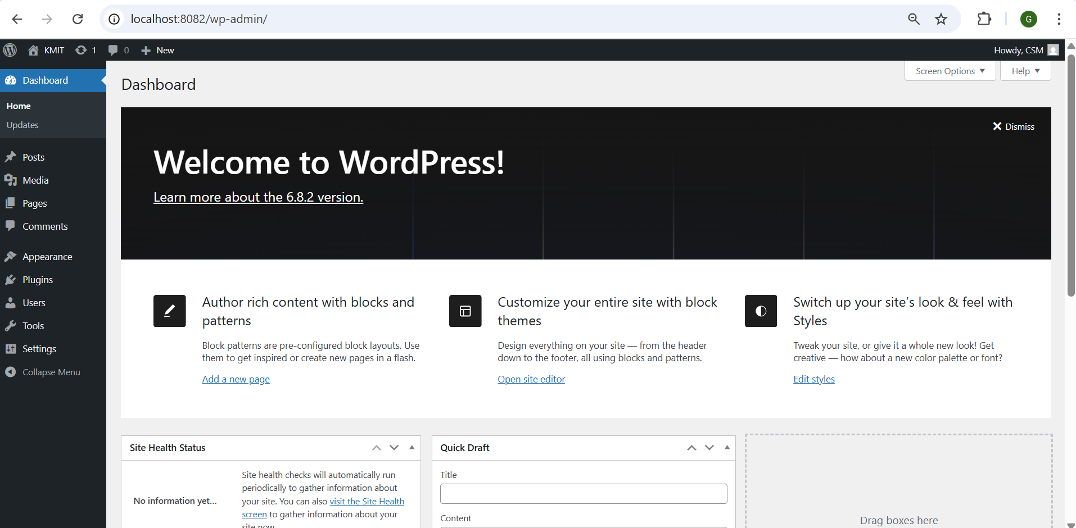

- To stop the containers
docker-compose down
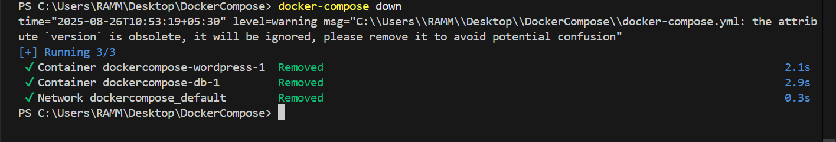
- To scale the container

docker-compose up --scale <service name>=2 -d
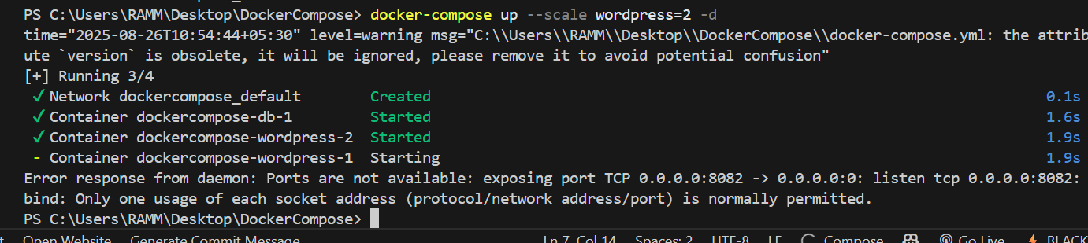
1.Define and run multiple interdependent services

Task:
- Create a new folder compose-lab
Inside it, create a file docker-compose.yml with the following content:

version: "3.9"
services:
web:
image: nginx:latest
ports:
- "8080:80"

db:
image: postgres:15
environment:
POSTGRES_USER: demo
POSTGRES_PASSWORD: demo
POSTGRES_DB: demo_db
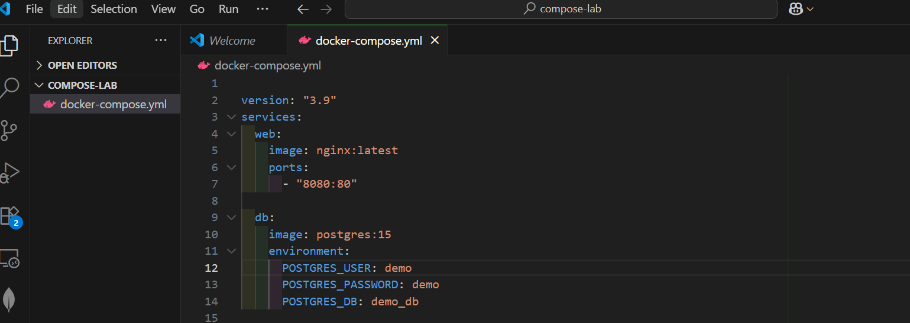

II. Run the setup:
docker compose up –d
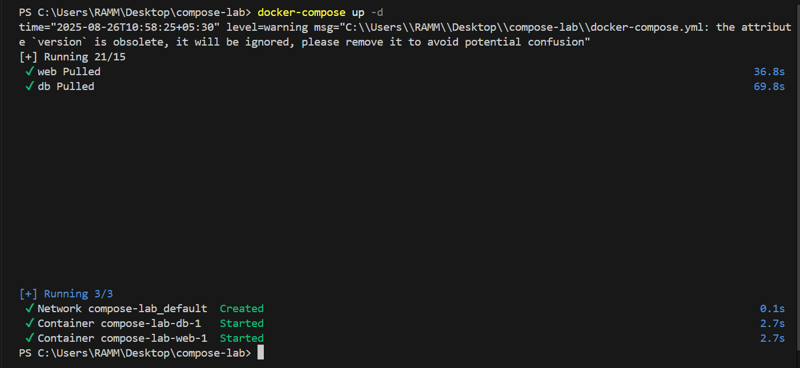

III. Open your browser and visit: http://localhost:8080.

IV. Expected Output:

Nginx welcome page is displayed.
db container runs in the background.


2.Write and interpret docker-compose.yml files
Task:
- Modify docker-compose.yml to add a Redis cache:

redis:
image: redis:alpine

II. Add a depends_on so web waits for Redis:
web:
image: nginx:latest
ports:
- "8080:80"
depends_on:
- redis
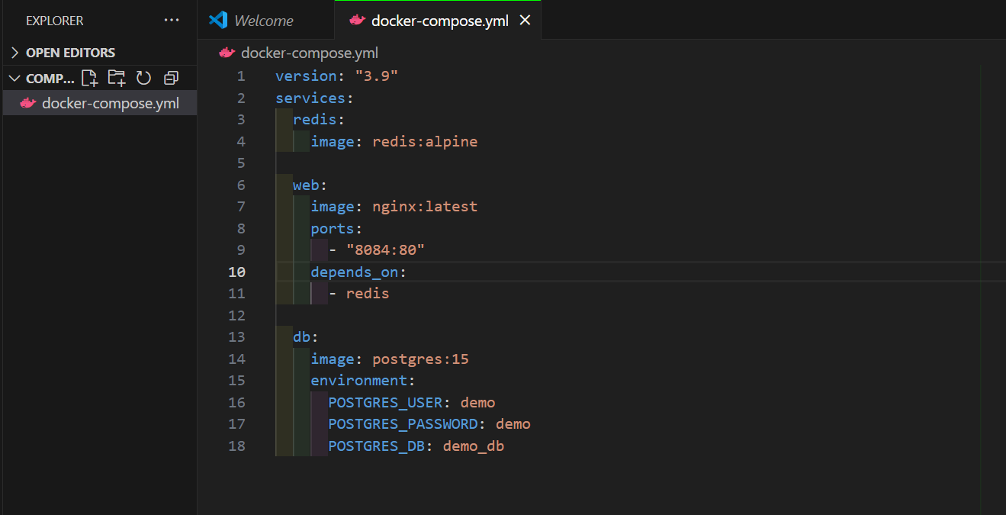

III. Restart the setup:
docker compose up -d
docker compose ps
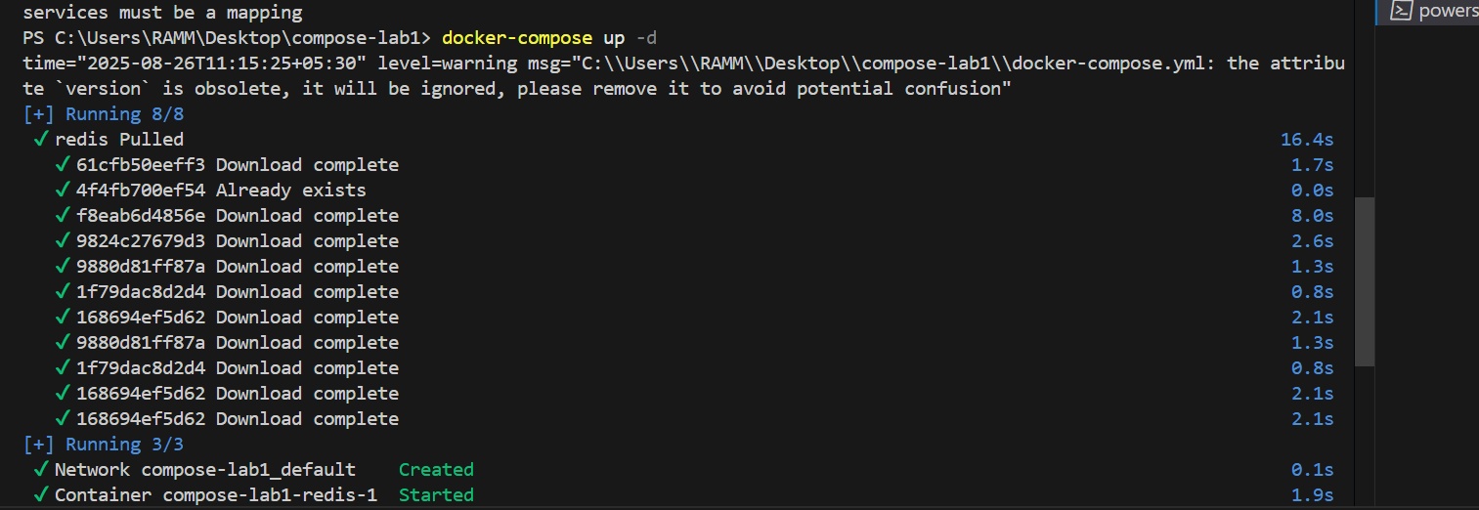

IV. Expected Output:

Three services (web, db, redis) are listed as running.
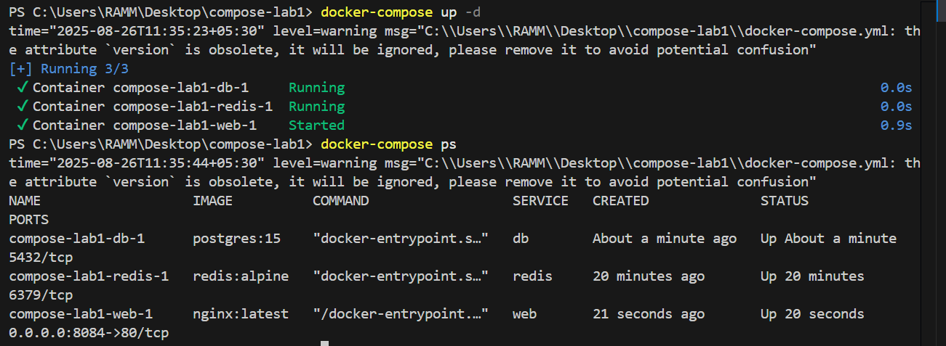

3.Deploy across different machines
Task:
- Zip your compose-lab folder.

Transfer it to another machine with Docker Compose installed.

- Run: another person on different machine unzip and run it
docker compose up –d
Check that Nginx and Postgres work there as well.
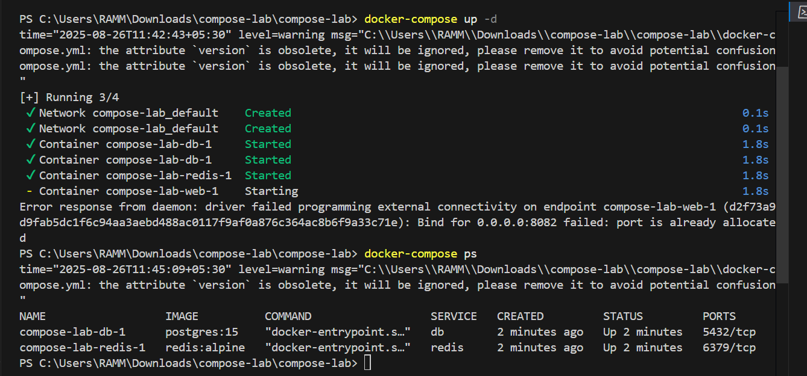

III. Expected Output:
The same services run on the new machine without changes.
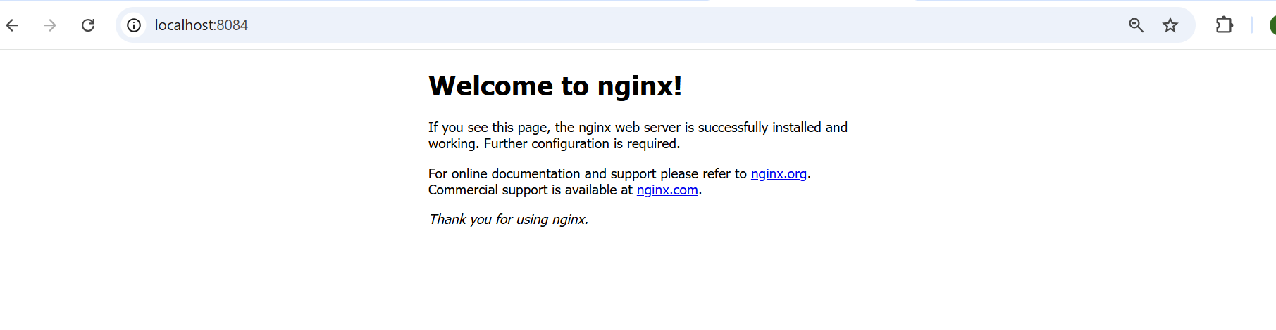

4.Networking and persistent storage
Task:
- Update your docker-compose.yml to add a custom network and volume:

networks:
app-net:

volumes:
db-data:

services:
web:
image: nginx:latest
ports:
- "8080:80"
networks:
- app-net
depends_on:
- db

db:
image: postgres:15
environment:
POSTGRES_USER: demo
POSTGRES_PASSWORD: demo
POSTGRES_DB: demo_db
volumes:
- db-data:/var/lib/postgresql/data
networks:
- app-net
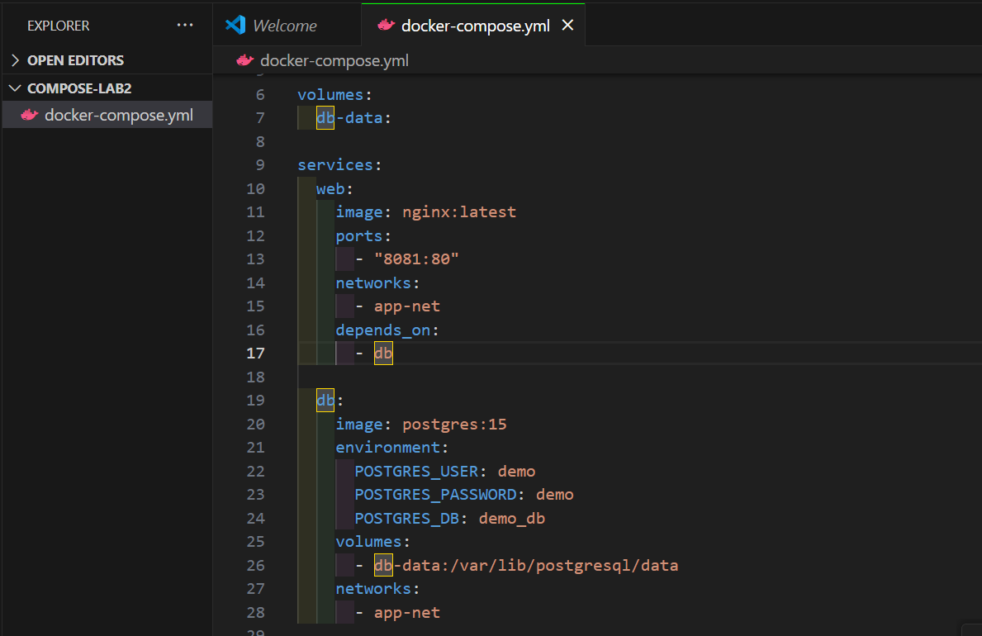

II. Run:
docker compose up –d
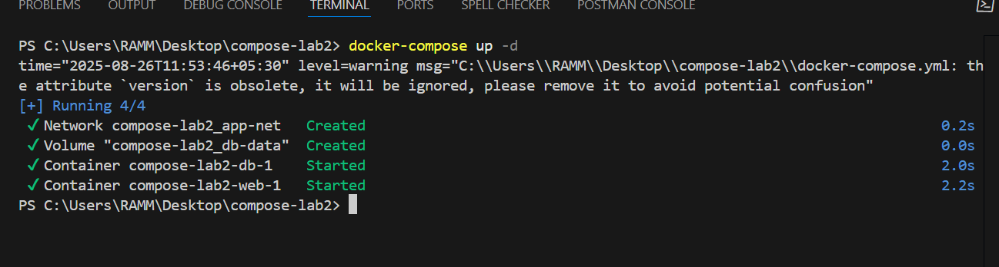
III. Insert some data into Postgres (optional with psql).

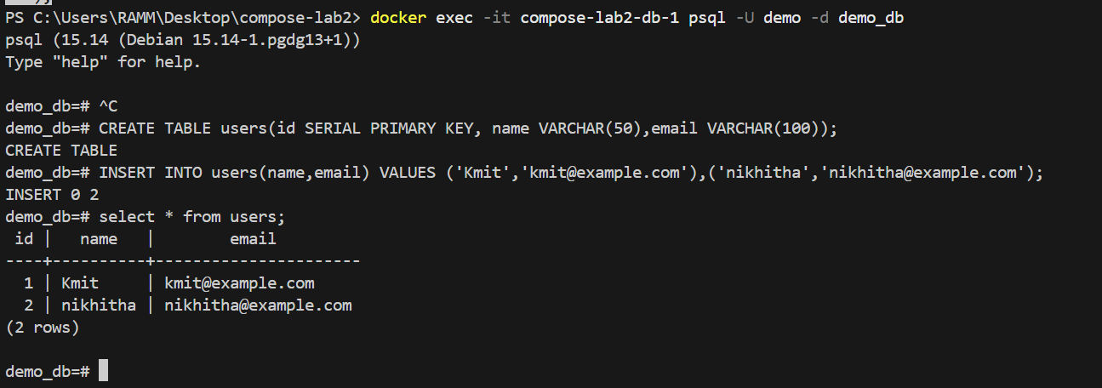
IV. Remove containers:
docker compose down
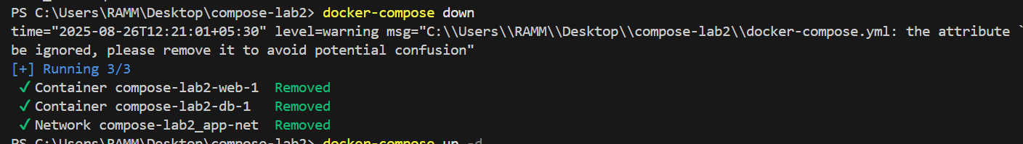
V. Start again:
docker compose up -d
VI. Expected Output:
Database data persists across restarts.
Services communicate via the app-net network using service names.
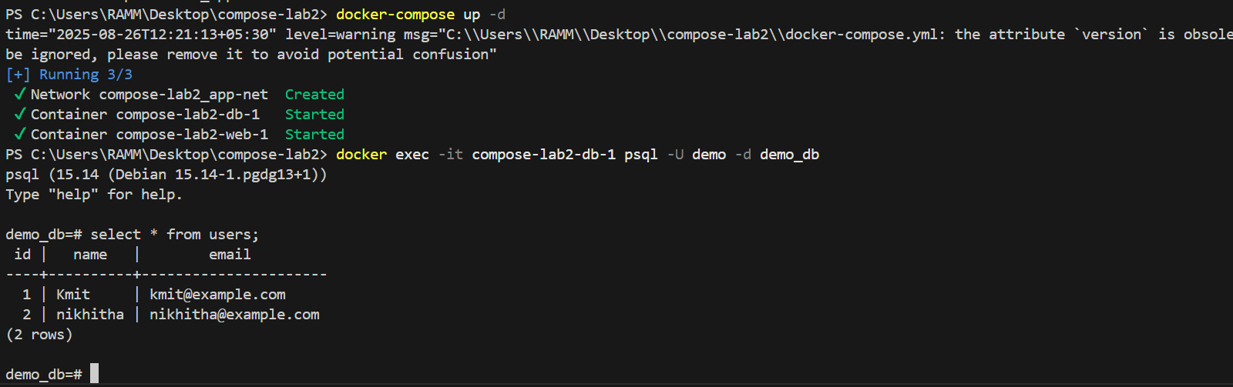

5.Faster iteration during development
Task:
- Create a simple Flask app in app.py:

from flask import Flask
app = Flask(__name__)
@app.route("/")
def home():
return "Hello from Flask + Docker!"
if __name__ == "__main__":
app.run(host="0.0.0.0", port=5000)
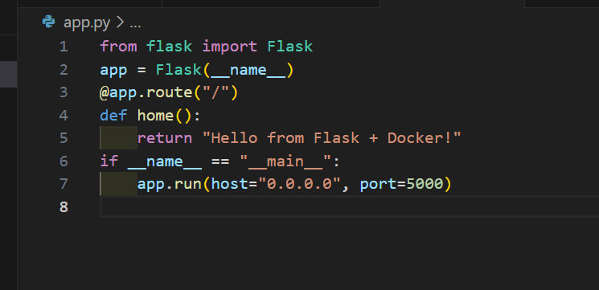

II. Add a Dockerfile in the same folder:

FROM python:3.10-slim
WORKDIR /app
COPY app.py /app/
RUN pip install flask
CMD ["python", "app.py"]
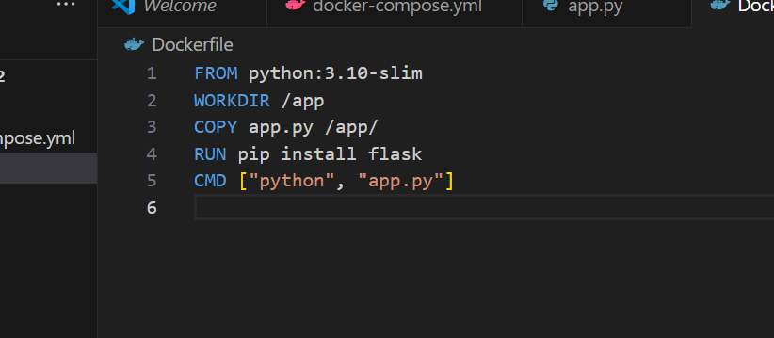

III. Update docker-compose.yml:
web:
build: .
ports:
- "5000:5000"
depends_on:
- db
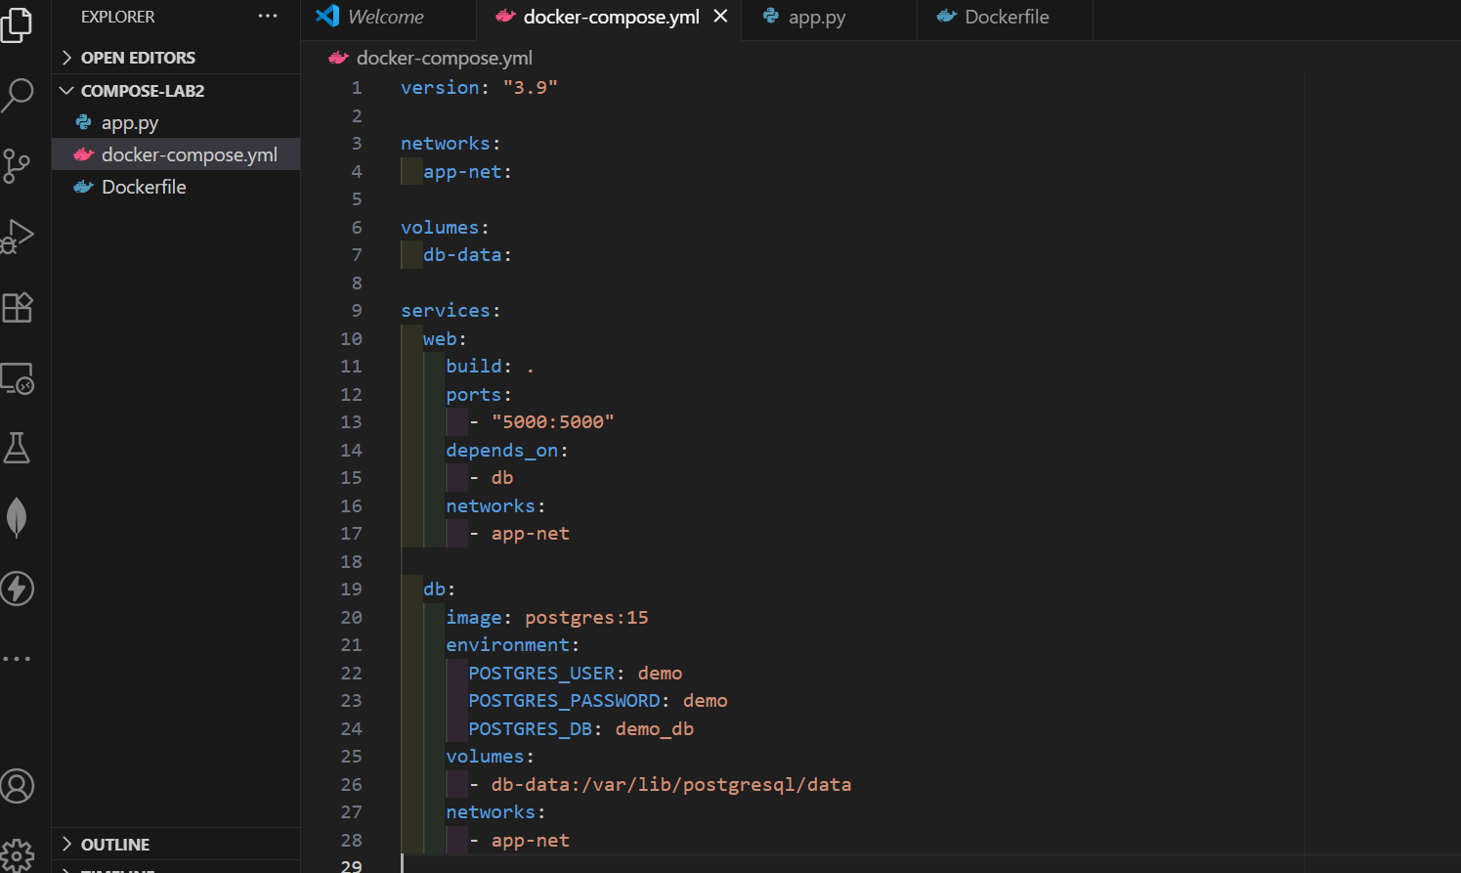
IV. Run:
docker compose up –build
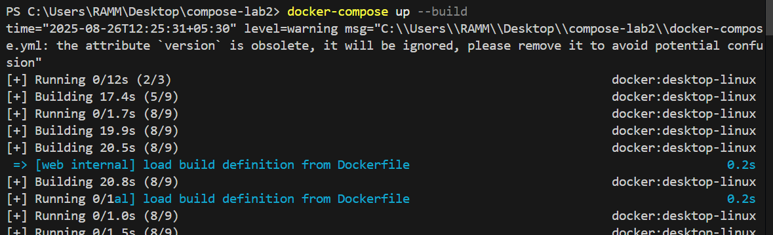
Visit http://localhost:5000.
Change the return text in app.py (e.g., "Hello Docker Compose!").
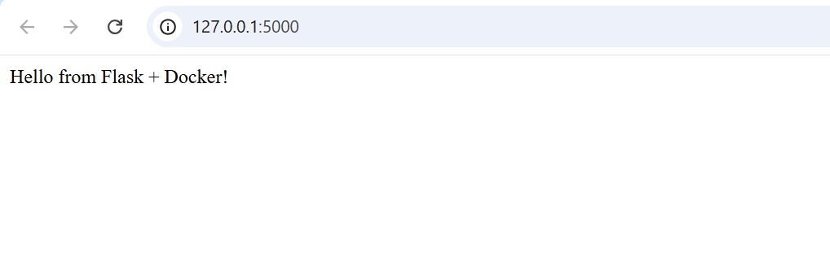
V. Rebuild:
docker compose up --build
VI. Expected Output:
New message appears instantly after rebuild.


