Initial Question:
Does the number of daily confirmed cases correlate with current hospitalizations in Zürich?

How did you proceed to arrive at an answer:
First, I calculated the daily confirmed cases and then plotted a scatterplot between those and the current hospitalizations.

Results:
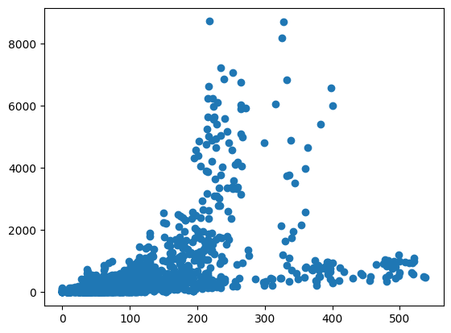
Both hospitalizations and confirmed cases correlate in a positive correlation. There is considerable scatter through, due to various factors. But an upward trend is visible.

Code:
covid_data_zurich = covid_data.loc[covid_data['abbreviation_canton_and_fl'] == 'ZH'].copy()
covid_data_zurich['case_conf_daily'] = covid_data_zurich['ncumul_conf'].diff().fillna(0)
plt.scatter(covid_data_zurich['current_hosp'], covid_data_zurich['case_conf_daily'])

