EXOASIA INNOVATION HUB
Market Research & Strategic Insight
Thought Leadership Content Pack
The Digital Front Line: New Threats Demand Immediate Action
Based on MRSI Daily Insight — March 11, 2026
5 Platforms · 5 Content Pieces · Ready to Publish
Prepared by MRSI Content Team

Content Overview

# | PLATFORM | FORMAT | BASED ON QUESTION
1 | LinkedIn | Long-form text post | All 5 Questions
2 | YouTube / Video Script | Video Script | All 5 Questions
3 | Instagram Carousel | 6-Slide Instagram Carousel | All 5 Questions
4 | Facebook | Long-form text post | All 5 Questions
5 | TikTok | 2-minute script | All 5 Questions

01
💼 LinkedIn · Data Breakdown / Stat-Led

FORMAT

Text-only post. No link in body — drop URL in first comment

OBJECTIVE

Make senior security and technology executives feel the weight of this week's threat data — and prompt them to ask whether their organization would survive contact with any one of these three attacks, let alone all three simultaneously.

IMAGE



COPY

Three threats. One morning. No margin for error.

This week's intelligence dropped three confirmed, active threat campaigns — and if your security posture hasn't changed since Friday, you're already behind.

Here's what the data says:

FortiGate exploits are no longer theoretical. Threat actors are actively breaching networks and walking away with service account credentials — the keys to your entire estate. Confirmed. Ongoing. Right now.

14,000+ edge devices have been silently drafted into the KadNap botnet. These aren't servers in a foreign country. They are routers, gateways, and appliances sitting at the perimeter of organizations exactly like yours — transformed into stealth proxy nodes routing malicious traffic you cannot see.

BlackSanta malware doesn't just attack your HR department. It kills your EDR first. It removes your ability to detect the attack before it steals payroll data, personnel files, and credentials.

These are not emerging risks. They are confirmed, active campaigns — identified in the last 48 hours.

The question your board should be asking isn't 'could this happen to us?' The question is: 'How would we know if it already has?'

Leaders who act on intelligence before the breach have a name: prepared.
Leaders who react after? They have a different name.

The Exoasia MRSI Daily Insight delivers exactly this kind of intelligence — seven minutes every morning, before the market opens, before your competitors have read their first headline. The edge isn't luck. It's information, timed right.

What's your current patch status on FortiGate? Drop it below — or DM me if you'd prefer the conversation stays off the feed.

#Cybersecurity #CyberThreatIntelligence #CISO #ExecutiveLeadership #FortiGate #ZeroDay #ExoasiaMRSI

POSTING NOTES

Tuesday–Thursday, 7:00–9:00 AM local time. Catch decision-makers before their first meeting. Format of the long-text post is plain text. No carousel. The data speaks without decoration. The closing question invites CISOs and CTOs to self-assess publicly — which drives comment volume and signals expertise.

COMMENTS:

02
🎬 YouTube / Video Script · Executive Decision Framework

FORMAT

16:9 horizontal · 4–6 minutes at natural speaking pace · presenter-led

OBJECTIVE

Give CxO-level viewers a practical three-part decision framework for triaging this week's three threat clusters — and position Exoasia MRSI as the daily intelligence infrastructure that makes this kind of rapid response possible.

THUMBNAIL

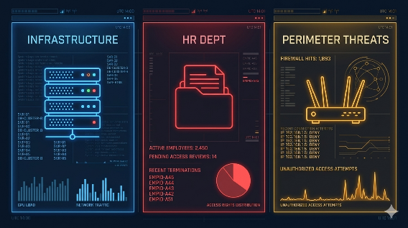

SCRIPT

Three confirmed, active cyber campaigns landed in the last 48 hours. Not theoretical. Not projected. Confirmed. And each one targets a different layer of your organization.
Here is the decision framework every executive should be running right now.
FortiGate devices are being actively exploited. Attackers are extracting service account credentials — meaning lateral movement across your entire network is already possible. This is not a patch advisory. This is an active incident response trigger.
Decision question one: When did you last audit FortiGate patch status? If the answer is not 'this week,' your first call today is to your infrastructure team.
BlackSanta's architecture is deliberate. It disables your endpoint detection and response tools first — creating a blind spot — then moves on payroll data, personnel files, and internal credentials. Your HR department holds the most sensitive non-financial data in the organization. It is consistently under-defended.
Decision question two: Is your HR environment isolated from your core infrastructure? Does it have independent security controls that function even if EDR is compromised?
Over fourteen thousand edge devices — routers, gateways, perimeter appliances — have been silently recruited into the KadNap botnet. These devices are now routing attacker traffic. They are inside your network boundary. And in most organizations, they are the least monitored assets you own.
Decision question three: When did you last run an edge device inventory audit? If the answer is 'never' or 'I'm not sure,' schedule it today.
Three threats. Three decision points. All of them actionable before lunch.
This is exactly the kind of intelligence that separates organizations that respond to breaches from organizations that prevent them. The Exoasia MRSI Daily Insight exists for that seven-minute window every morning — before your first meeting, before the market opens — when a leader with the right information can get ahead of a threat that will blindside everyone else by noon.
Subscribe for daily cyber intelligence briefings. The leaders who see threats first are the ones who aren't managing a crisis on Friday afternoon.

PRODUCTION NOTES
The ideal length for the video should be 4–6 minutes. This script reads at approximately 5 minutes at a measured executive pace. Start with: 'Three active cyber-attacks confirmed this week. Here's the exact framework CISOs should be using right now.'

COMMENTS:

03
📱 Instagram Carousel · Myth-Busting

FORMAT

6 slides · 1080×1080px · each slide standalone and shareable

OBJECTIVE

Shatter the dangerous assumption that endpoint detection tools provide sufficient protection — and make security professionals and informed executives feel urgency around layered defense strategy.

IMAGE

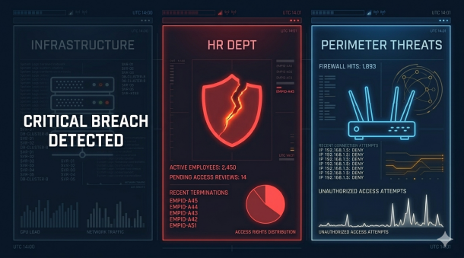

SLIDE BREAKDOWN

Slide 1 — Hook
"My EDR will catch it."
Not anymore.
[Subtext: BlackSanta kills your endpoint protection first.]
Slide 2 — Myth #1
MYTH: EDR tools catch everything.
FACT: BlackSanta disables EDR before attacking.
Blind spot first. Data theft second.
Slide 3 — Myth #2
MYTH: Edge devices are low-risk.
FACT: 14,000+ already compromised.
KadNap botnet. Active. Invisible.
Slide 4 — Myth #3
MYTH: Only high-profile targets get hit.
FACT: HR departments are the new target.
Payroll. Personnel files. Credentials.
Slide 5 — Myth #4
MYTH: Patching can wait until next sprint.
FACT: FortiGate exploits are live now.
Credentials are being stolen today.
Slide 6 — CTA
Seven minutes every morning.
That's how long it takes to know this.
Exoasia MRSI Daily Insight. Before the breach finds you.

CAPTION

'Your security stack has a gap. These are the myths that put it there. Swipe before your Tuesday standup.

#CyberSecurity #CISO #ThreatIntelligence #InfoSec #ExoasiaMRSI'

POSTING NOTES

Monday or Tuesday 8:00–10:00 AM. Professionals scroll before entering the office. The presentation should have 6 slides and make the background dark, single-color accent per slide. Keep text large — 40px+ equivalent. Swipe friction is your friend here. Pull Slide 1 as a standalone Story with a poll: 'Do you trust your EDR to catch everything?' Yes / No.

COMMENTS:

04
👍 Facebook Post · Hot Take / Contrarian

FORMAT

Narrative post, strategic lesson, closing question, hashtags.

OBJECTIVE
Provoke mid-market business owners and non-technical executives into reconsidering whether their organization's cybersecurity investment is sized for the actual threat environment — using APT28's geopolitical activity as the forcing function.
IMAGE
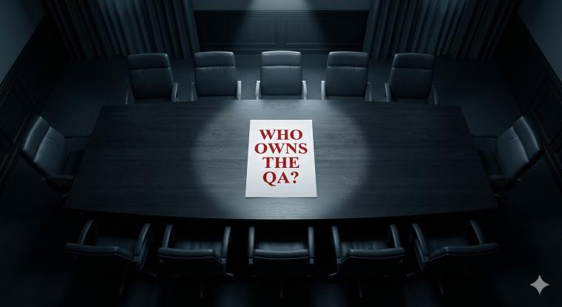
COPY

Unpopular opinion: most organizations are not investing in cybersecurity for the threat environment that actually exists in 2026.

APT28 — a Russian state-sponsored group — is deploying custom malware called BEARDSHELL and COVENANT against the Ukrainian military. You may think that has nothing to do with your business.

State-sponsored tools don't stay in warzones. They get repurposed, leaked, and commercialized. The techniques proven on military targets become the playbook for civilian infrastructure within 18 months. This is the pattern. It has never not been the pattern.

What are you actually prepared for?

#AI #Leadership #EnterpriseStrategy #AIGovernance #ExoasiaMRSI

POSTING NOTES

Wednesday or Thursday, 12:00–2:00 PM. Facebook's business audience is most active at lunch. The length should be under 100 words because this post is a conversation starter not a briefing. The boost target of the post are Business owners, C-suite, IT managers aged 35–60. Avoid boosting to purely technical audiences — this angle plays best with the business-risk crowd. Pin a comment 30 minutes after posting: “The Exoasia MRSI Daily Insight tracks state-sponsored threats like APT28 every day. Seven minutes. Before your first meeting.”

COMMENTS:

05
🎵 TikTok

FORMAT
Conversational talking-head · 9:16 vertical · ~60-75 seconds · direct to camera, presenter-led
OBJECTIVE
Make a younger, digitally-native audience feel that the edge device and botnet threat trajectory is personally relevant to them — and plant Exoasia MRSI as the source that saw it coming first.
THUMBNAIL
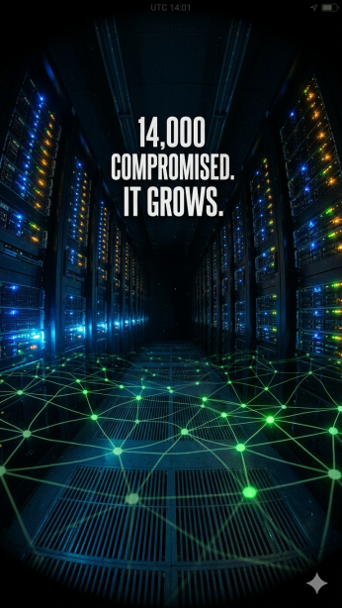
SCRIPT

Here is where this goes next — and almost no one is talking about it.
Fourteen thousand edge devices — routers, gateways, the hardware sitting between you and the internet — are already inside the KadNap botnet. They are routing attacker traffic right now. The owners have no idea.
Here is the prediction. As AI-assisted attack automation scales, botnets like this become self-expanding. They don't need human operators to recruit new devices. They find vulnerabilities, compromise devices, and grow — autonomously. Fourteen thousand becomes one hundred and forty thousand. The attack surface stops being something you manage. It becomes something that manages you.
Attack surface reduction. Proactive audits. Treat every edge device like a potential insider threat. This isn't paranoia. It's the playbook that was already published — this week — by researchers tracking exactly this campaign.
The intelligence on KadNap dropped Monday morning. The organizations that read it had a head start. The ones who didn't are in the botnet's growth path. Follow for the daily brief that gets you ahead of what's coming next.

CAPTION
'14,000 devices. Already in the botnet. Here's the trajectory.

#CyberSecurity #TechTok #ThreatIntel #HackerNews #ExoasiaMRSI'

PRODUCTION NOTES
Tuesday–Thursday 7:00–9:00 AM or 7:00–9:00 PM. TikTok's algorithm rewards early engagement velocity. First 2 seconds must include the stat or the promise. 'Here is where this goes next' + the graphic overlay creates a pattern interrupt. For the sound, use a tension-building ambient track — not music with lyrics. The spoken word needs to carry.

COMMENTS:

