EXOASIA INNOVATION HUB
Market Research & Strategic Insight
Thought Leadership Content Pack
AI Industry Briefing
Based on MRSI Daily Insight — May 19, 2026
5 Platforms · 5 Content Pieces · Ready to Publish
Prepared by MRSI Content Team

Content Overview

# | PLATFORM | FORMAT | BASED ON QUESTION
01 | LinkedIn | Text-only post with crisp paragraphs, approximately 150-250 words. No link in the body. | All 5 Questions
02 | YouTube / Video Script | Aspect ratio: 16:9, Duration: 1 minute (max 150 words), Delivery style: Direct, authoritative, confident. | All 5 Questions
03 | Instagram Carousel | 6-slide carousel. Slide dimensions: 1080x1350px. Shareability note: Designed for screenshotting and sharing individual slides. | All 5 Questions
04 | Facebook | Short, conversational post, maximum 100 words. | All 5 Questions
05 | TikTok | Aspect ratio: 9:16, Duration: 30-45 seconds (max 150 words). Camera style: Talking head, direct address, high energy. | All 5 Questions

01
💼 LinkedIn · Executive decision framework

FORMAT

Text-only post with crisp paragraphs, approximately 150-250 words. No link in the body.

OBJECTIVE

To prompt senior decision-makers to rethink their comprehensive AI strategy, integrating governance, competitive intelligence, and security, rather than treating them as isolated challenges.

IMAGE

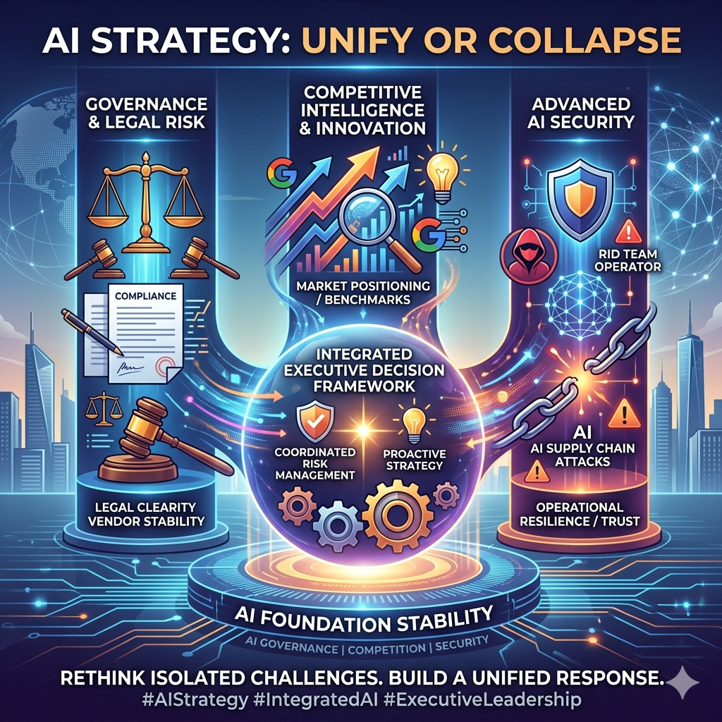

COPY

The foundational stability of your AI strategy is being tested from three fronts simultaneously, demanding a unified executive response. OpenAI's high-stakes legal battle between Elon Musk and Sam Altman reveals deep governance fault lines impacting its future, while Google prepares to unveil innovations this week that will redefine competitive benchmarks. This isn't just news; it's a systemic shift where legal clarity, market positioning, and operational resilience are intrinsically linked.

The implication most leaders underestimate is the cascading risk: a single vulnerability in one area can destabilize the entire AI initiative. For example, relying on an AI partner whose internal governance is contested creates unpredictable long-term partnership risks, irrespective of their tech prowess. The "how" here involves a critical re-evaluation of your existing and planned AI deployments through an integrated lens: assessing vendor stability, competitive response, and security posture in concert.

If current trends continue, organizations neglecting this integrated view will face unexpected disruptions, increased compliance overhead, and critical security breaches that erode trust and market share. Four AI supply chain attacks in 50 days expose a stark reality: current red team protocols are insufficient, leaving release pipelines dangerously exposed. This demands immediate, proactive investment in advanced security frameworks specifically tailored for AI supply chain integrity. For you, if your organization views AI governance, competitive strategy, and security as separate departmental concerns, you are critically exposed to a coordinated threat landscape that demands a singular, top-down executive decision framework for holistic risk management. This moment demands a shift from reactive problem-solving to proactive, integrated strategic planning.

This post is produced by Exoasia's Market Research and Strategic Insight. Leaders stay ahead as they receive Daily Insights. Ask us how.

POSTING NOTES

Optimal posting time: Tuesday morning (9-11 AM SGT) when executives are typically reviewing strategic updates. Format presentation advice: Ensure short, digestible paragraphs with clear, concise sentences. Audience targeting or boost guidance: Target CxOs, VPs of Innovation, Legal, and Cybersecurity in sectors heavily investing in AI. Pinned comment instruction: "For a deeper dive into AI governance frameworks and supply chain security audits, visit [YourExoasiaReportURL.com/AI-Risk]."
Hashtags: #AIStrategy #AIGovernance #AISecurity #TechLeadership #ExoasiaMRSI #DigitalTransformation #SupplyChain

COMMENTS:

02
🎬 YouTube / Video Script · Trend prediction/future scenarios

FORMAT

Aspect ratio: 16:9, Duration: 1 minute (max 150 words), Delivery style: Direct, authoritative, confident.

OBJECTIVE

To provide a concise, high-impact overview of critical AI trends, explaining their immediate relevance and offering actionable "if/then" scenarios for leaders.

THUMBNAIL

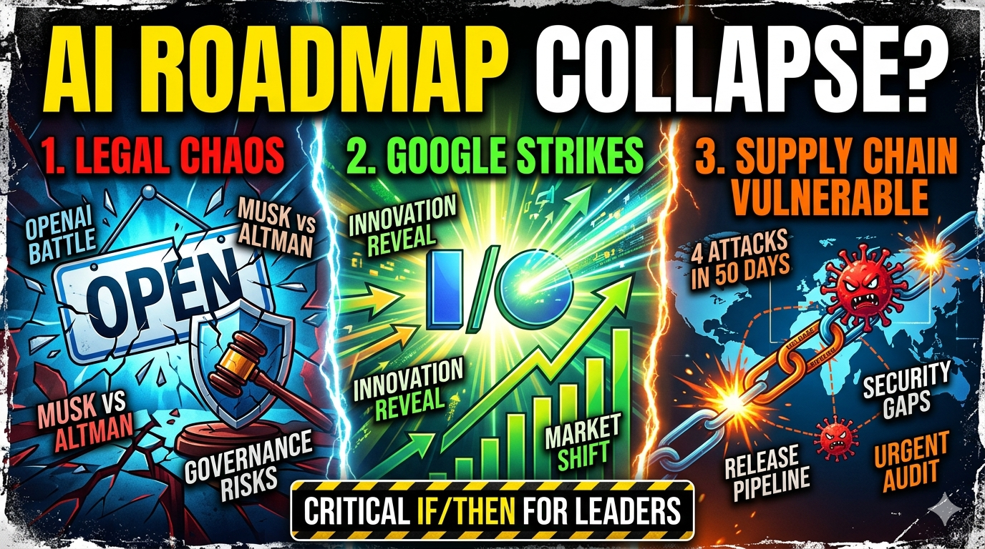

SCRIPT

HOOK
Your AI roadmap is about to be violently reshaped by three unavoidable forces, and most leaders are unprepared.

WHAT
A high-stakes legal battle over OpenAI's future direction, involving Elon Musk and Sam Altman, is exposing profound questions about AI governance, or how AI companies are controlled and run. Simultaneously, Google is poised to reveal significant AI innovations this week, directly impacting market competition. Underneath it all, the AI supply chain, the interconnected steps from development to deployment, has suffered four separate attacks in just 50 days, revealing severe security gaps in release pipelines.

WHY IS IT IMPORTANT
This isn't just isolated news. These developments are fundamentally altering the risk profile, competitive dynamics, and operational security requirements for every organization using or building AI, right now. The vulnerabilities are systemic, and the competitive shifts are imminent.

WHAT DOES THIS MEAN FOR LEADERS
If your organization relies on third-party AI models, expect turbulence from legal disputes like OpenAI’s to disrupt service continuity or strategic direction. If you’re planning significant AI investments, Google’s new announcements will redefine what "leading edge" means, demanding rapid strategic recalibration. And critically, if you haven’t audited your AI supply chain for release pipeline vulnerabilities, you are an open target, meaning your existing red team protocols are likely insufficient and need urgent re-evaluation.

This post is produced by Exoasia's Market Research and Strategic Insight. Leaders stay ahead as they receive Daily Insights. Ask us how.

PRODUCTION NOTES

Recommended video length: 60 seconds. Opening line suggestion: Start immediately with the hook: "Your AI roadmap is about to be violently reshaped by three unavoidable forces, and most leaders are unprepared." Pacing and tone notes: Deliver quickly, authoritatively, and without hesitation. Maintain a serious but informative tone. Sound or visual overlay direction: Use subtle, impactful sound effects for key revelations (e.g., a short "ping" for an announcement, a low "thump" for a vulnerability). Visuals should reinforce the urgency – flashing red alerts for security, dynamic graphs for market shifts.
Hashtags: #AITrends #AISecurity #TechNews #GoogleAI #OpenAI #ExoasiaMRSI #FutureofAI

COMMENTS:

03
📱 Instagram Carousel · What most people get wrong

FORMAT

6-slide carousel. Slide dimensions: 1080x1350px. Shareability note: Designed for screenshotting and sharing individual slides.

OBJECTIVE

To challenge common assumptions about AI stability and security, providing shareable, bite-sized insights that reveal deeper truths and actionable lessons for an executive audience.

IMAGE

SLIDE BREAKDOWN

Slide 1
AI'S BIGGEST LIE: YOUR STRATEGY IS SECURE. It's not.

Slide 2
(MYTH / TRUTH):
MYTH: OpenAI's internal battles are just boardroom drama.
TRUTH: The legal dispute involving Elon Musk and Sam Altman isn't just about personalities; it's about the fundamental governance and future trajectory of a foundational AI player. This directly impacts the stability, reliability, and long-term partnership viability for ANY enterprise built on their tech. Understand this: a firm's internal structure can be your external risk.

Slide 3
(REVEAL):
REVEAL: Google's upcoming announcements are not just product launches.
They are a strategic pivot point that will immediately redefine the enterprise AI competitive landscape. This shift means market leaders could be obsolete overnight if they don't anticipate and adapt. The 'what' from Google this week will be less about features and more about a new competitive playbook.

Slide 4
(LESSON):
LESSON: Your AI supply chain is ALREADY under attack.
Four AI supply-chain attacks in just 50 days confirm existing "red team" security protocols are failing. The lesson is simple: security cannot be an afterthought in release pipelines. You must assume compromise and build resilience from the ground up, not just at the perimeter. The threat is internal, to the core of your AI development.

Slide 5
(UNCOVER):
UNCOVER: The overlooked mechanism exposing your AI systems.
Current red team security tests focus heavily on deployed systems, neglecting the *release pipeline* – the process from development to deployment. This mechanism, where code is compiled and integrated, is precisely where 4 recent AI supply chain breaches occurred. It's the soft underbelly, and it's being actively exploited because it's out of typical red team scope.

Slide 6
DON'T WAIT FOR THE NEXT BREACH. Stay ahead of the curve.
This post is produced by Exoasia's Market Research and Strategic Insight. Leaders stay ahead as they receive Daily Insights. Ask us how.

CAPTION

AI isn't just evolving; it's revealing its fault lines at an alarming rate. From internal governance disputes at OpenAI to critical vulnerabilities in the supply chain, the landscape demands more than just innovation – it demands a brutally honest assessment of risk. Swipe through to confront what most people are getting wrong about AI's current state and what it truly means for your enterprise.

This post is produced by Exoasia's Market Research and Strategic Insight. Leaders stay ahead as they receive Daily Insights. Ask us how.

POSTING NOTES

Optimal posting time: Mid-week afternoon (Wed/Thu, 2-4 PM SGT) for maximum engagement as leaders catch up on insights. Slide design specs: Background color: Dark professional blue (#1A2B3C), Font size guidance: Main headlines 48pt, body text 24pt, using a clean sans-serif font like Lato or Montserrat. Story or poll suggestion: Use Slide 1 as a dramatic opener for an Instagram Story, asking "Is YOUR AI strategy truly secure?" with a yes/no poll before directing to the carousel.
Hashtags: #AIStrategy #AISecurity #TechRisk #Cybersecurity #OpenAI #GoogleAI #ExoasiaMRSI

COMMENTS:

04
👍 Facebook · Storytelling/narrative arc

FORMAT

Short, conversational post, maximum 100 words.

OBJECTIVE

To engage a broader business audience with a relatable narrative about AI security risks, driving awareness of the urgency and the need for proactive measures.

IMAGE

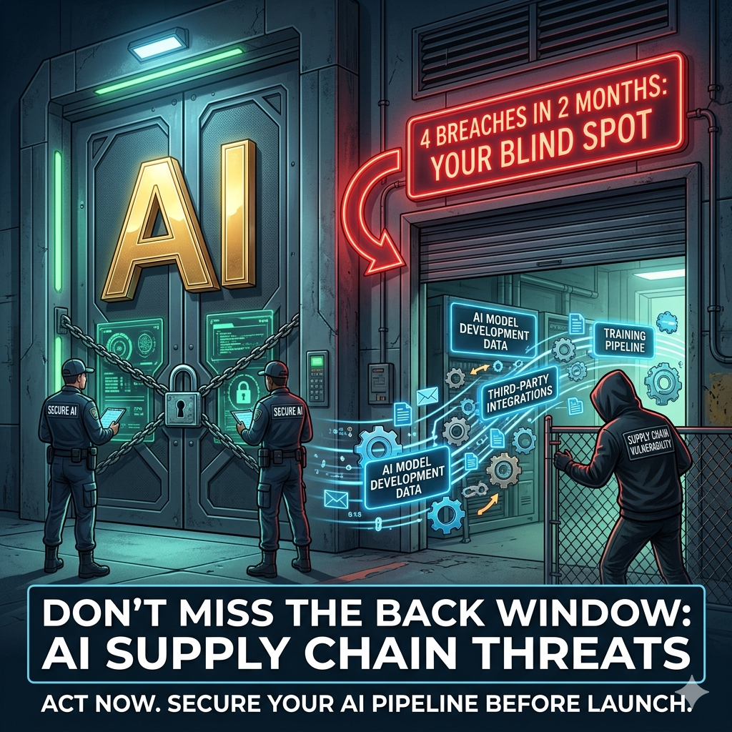

COPY

Imagine this: In less than two months, four separate breaches targeted your AI operations where you least expected them – deep within the supply chain, not just at the final product. These aren't abstract threats; these are real attacks, like those recently hitting AI supply chains, exposing how current security tests miss the crucial "release pipeline." It's like locking the front door but leaving the back window wide open while your most valuable assets are moved. This reveals a dangerous blind spot. What if your next big AI initiative is already compromised before it even launches because your security is looking in the wrong place?

This post is produced by Exoasia's Market Research and Strategic Insight. Leaders stay ahead as they receive Daily Insights. Ask us how.
#AISecurity #SupplyChainRisk #TechVulnerabilities #AIInnovation #ExoasiaMRSI #CyberThreats

POSTING NOTES

Optimal posting time: Early afternoon (1-3 PM SGT) for general engagement. Format presentation advice: Keep sentences short and direct. Start strong with the narrative. Audience targeting or boost guidance: Target business owners, IT managers, and innovation leads interested in tech news and business resilience. Pinned comment instruction: No pinned comment needed for this format.
Hashtags: #AISecurity #SupplyChainRisk #TechVulnerabilities #AIInnovation #ExoasiaMRSI #CyberThreats #BusinessRisk

COMMENTS:

05
🎵 TikTok · Hot take/contrarian opinion

FORMAT

Aspect ratio: 9:16, Duration: 30-45 seconds (max 150 words). Camera style: Talking head, direct address, high energy.

OBJECTIVE

To deliver a rapid, attention-grabbing, and contrarian view on AI security, forcing viewers to immediately question their assumptions about current protective measures.

THUMBNAIL

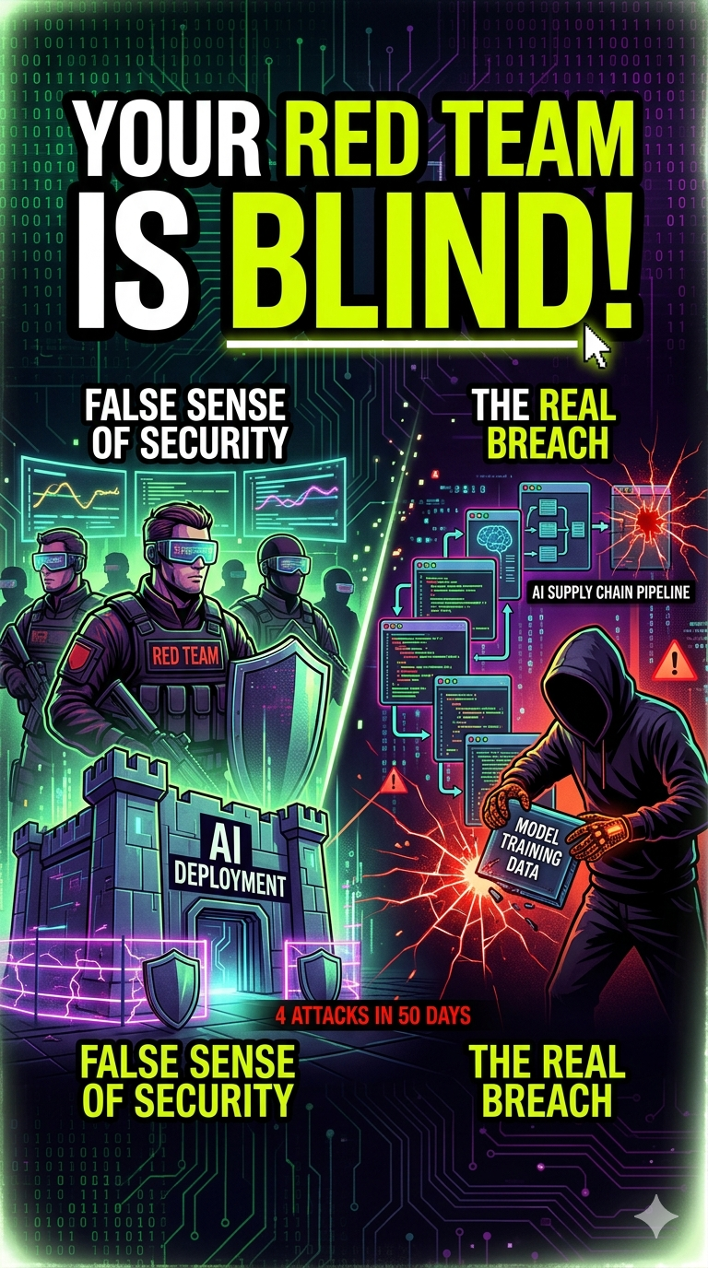

SCRIPT

Four AI supply chain attacks in 50 days prove your red team security is BLIND.

You think your AI systems are protected? Think again. The biggest vulnerability isn't a hacker trying to break into your finished product; it's happening right now, deep inside your development process – the "release pipeline." Our security protocols, the red teams, are built to protect the final deployment, but they're completely missing where the real breaches are occurring. This isn't theoretical; we've seen four major incidents in less than two months where the bad actors exploited this exact gap. If you're building or using AI, your current security measures are leaving the back door wide open for sophisticated attacks that compromise your systems before they even launch. It's time to drastically rethink how you secure AI.

This post is produced by Exoasia's Market Research and Strategic Insight. Leaders stay ahead as they receive Daily Insights. Ask us how.

CAPTION

Your AI security might be a total illusion. 🚨 Four supply chain attacks in 50 days prove existing protocols are missing the BIGGEST threat. It’s not where you think. Watch to understand why your "red team" is blind and what you need to do NOW. #AISecurity #Cyberattack #TechTruth #AITech #ExoasiaMRSI

POSTING NOTES

Optimal posting time and algorithm note: Post mid-day (12-3 PM SGT) for peak engagement. TikTok algorithm favors engaging, informative content that creates dialogue. First-2-seconds rule: Start with "Four AI supply chain attacks in 50 days prove your red team security is BLIND." Pacing guidance: Fast, dynamic, and direct. Maintain high energy throughout. Sound or music direction: Use a trending, slightly dramatic or investigative background sound that doesn't overpower the voice.
Hashtags: #AISecurity #Cyberattack #TechTruth #AITech #ExoasiaMRSI #SupplyChainSecurity #AIStrategy

COMMENTS:

