EXOASIA INNOVATION HUB
Market Research & Strategic Insight
Thought Leadership Content Pack
Crypto, Fintech & Web3 Briefing
Based on MRSI Daily Insight — May 19, 2026
5 Platforms · 5 Content Pieces · Ready to Publish
Prepared by MRSI Content Team

Content Overview

# | PLATFORM | FORMAT | BASED ON QUESTION
01 | LinkedIn | Text-only post with a single declarative opening claim. Link to be dropped in the first comment. | All 5 Questions
02 | YouTube / Video Script | 16:9 aspect ratio, 60-90 seconds duration, direct-to-camera delivery in a confident, authoritative tone. | All 5 Questions
03 | Instagram Carousel | 6-slide carousel. Slide 1 is a bold hook. Slides 2-5 use distinct framing devices. Slide 6 is the CTA. Dimensions 1080x1080px. Design for shareability to stories and DMs. | All 5 Questions
04 | Facebook | Short narrative post structure, ending with an inline question. | All 5 Questions
05 | TikTok | 9:16 aspect ratio, max 30 seconds duration, direct-to-camera, conversational talking-head style. | All 5 Questions

01
💼 LinkedIn · What most people get wrong

FORMAT

Text-only post with a single declarative opening claim. Link to be dropped in the first comment.

OBJECTIVE

To challenge the common misconception that crypto market health is solely tied to asset prices, highlighting the resilience of underlying infrastructure and diversified business models.

IMAGE

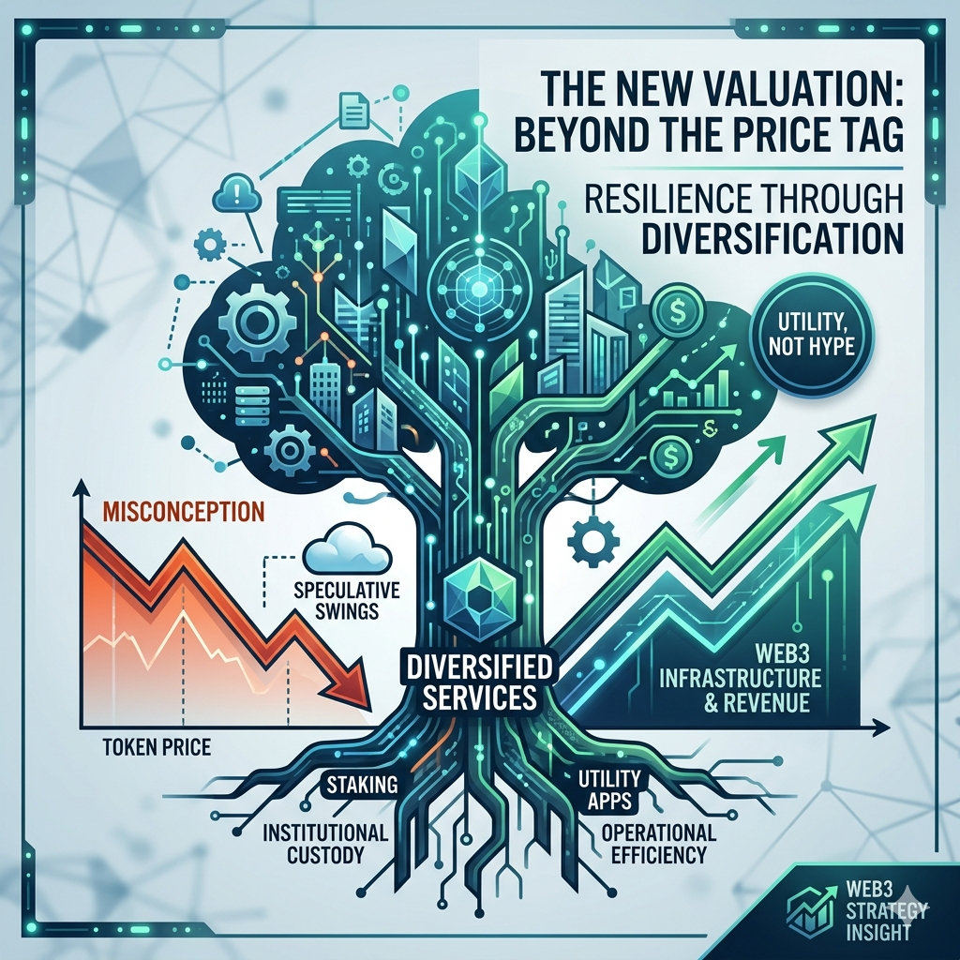

COPY

Kraken’s parent company, Payward, reported a rise in first-quarter revenue, defying a crypto market where XRP slipped below $1.40 and Bitcoin Cash dropped 13%. Most executives mistakenly equate crypto market performance solely with asset prices. Payward’s numbers reveal the underlying infrastructure and diversified business models are thriving, decoupling from speculative asset swings.

The true growth opportunity in Web3 is no longer in chasing token pumps, but in building robust, utility-driven services that generate revenue independent of volatile asset prices. Exchanges that adapt and offer a range of services—from staking to institutional custody—will consolidate market power, leaving those reliant on pure trading fees vulnerable to inevitable downturns. This trend will force a critical re-evaluation of valuation metrics for Web3 businesses. Payward achieved this by likely expanding institutional offerings, new product lines, or optimizing operational efficiencies, stabilizing cash flow even when retail trading volumes dip. If your organization’s Web3 strategy is still tied to token price speculation, you are missing the fundamental shift. Focus your investment and talent acquisition on utility, infrastructure, and and diversified service models to build sustainable value, not just temporary gains. The market demands operational resilience, not just hype.

This post is produced by Exoasia's Market Research and Strategic Insight. Leaders stay ahead as they receive Daily Insights. Ask us how.

POSTING NOTES

Optimal posting time: Tuesday, 10 AM HKT. Rationale: Mid-week, mid-morning for high engagement among business professionals. Format presentation advice: Ensure crisp paragraphs and sufficient white space for readability on mobile. Audience targeting: CxO level, innovation heads, digital transformation leads in financial services, technology, and corporate strategy. Boost guidance: Target custom audience lists of finance and tech executives. Pinned comment instruction: "For a deeper dive into market resilience, visit [Link to Exoasia report/blog post]."
Hashtags: #Web3 #CryptoMarkets #FintechInnovation #BlockchainStrategy #EnterpriseBlockchain #MarketInsights #ExoasiaMRSI

COMMENTS:

02
🎬 YouTube / Video Script · Trend prediction/future scenarios

FORMAT

16:9 aspect ratio, 60-90 seconds duration, direct-to-camera delivery in a confident, authoritative tone.

OBJECTIVE

To clearly articulate the immense, often underestimated, financial shift driven by tokenization into DeFi, providing leaders with actionable insights for strategic positioning.

THUMBNAIL

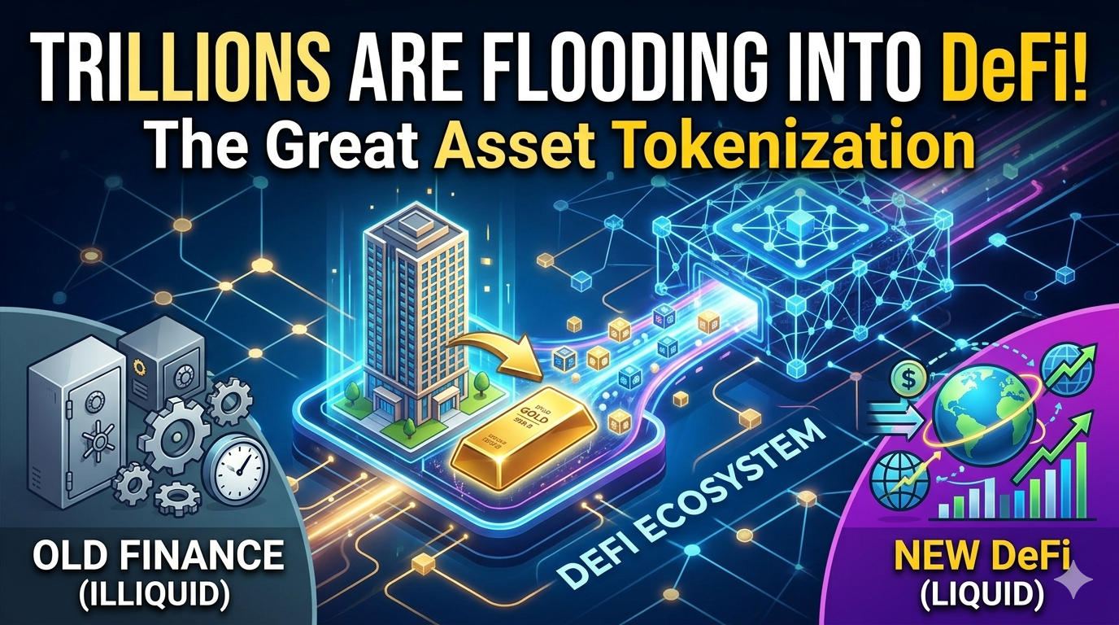

SCRIPT

HOOK
Your understanding of decentralized finance is about to be redefined by trillions, not millions.

WHAT
Standard Chartered projects that integrating traditional assets, known as tokenization, could channel several trillion dollars into the decentralized finance sector, or DeFi. Tokenization means converting real-world assets—like real estate or private equity—into digital tokens on a blockchain, making them programmable and globally tradable.

WHY IS IT IMPORTANT
This isn't just a crypto niche; it’s a fundamental re-architecture of global finance, enabling unprecedented liquidity for currently illiquid assets. It unlocks capital that has been trapped in slow, opaque systems.

WHAT DOES THIS MEAN FOR LEADERS
If your organization manages significant real-world assets, then you are sitting on untapped liquidity that tokenization can unlock. Explore strategic partnerships with blockchain infrastructure providers now. If your organization is a financial institution, then your competitive advantage will soon shift to who can build the most secure and efficient tokenization platforms, integrating these new digital assets into your existing offerings. If you are developing new fintech products, then your focus should immediately pivot to building solutions for asset tokenization and the subsequent DeFi integrations.

CTA
This post is produced by Exoasia's Market Research and Strategic Insight. Leaders stay ahead as they receive Daily Insights. Ask us how.

PRODUCTION NOTES

Recommended video length: 75 seconds. Opening line suggestion: Start with a strong, confident gaze directly into the camera. Pacing and tone notes: Maintain a brisk, professional pace, slowing slightly for emphasis on "trillions of dollars." Deliver with a tone of urgent clarity. Sound or visual overlay direction: Use subtle, futuristic sound design when discussing "trillions" and "re-architecture." On-screen text for "tokenization" and "DeFi" should appear when spoken, with brief, crisp animations.
Hashtags: #DeFi #Tokenization #FutureOfFinance #Web3Trends #StandardChartered #Fintech #ExoasiaMRSI

COMMENTS:

03
📱 Instagram Carousel · Data breakdown/stat-led

FORMAT

6-slide carousel. Slide 1 is a bold hook. Slides 2-5 use distinct framing devices. Slide 6 is the CTA. Dimensions 1080x1080px. Design for shareability to stories and DMs.

OBJECTIVE

To present multiple critical insights from the briefing in a visually engaging, shareable format, prompting decision-makers to rethink foundational assumptions about Web3 security, market dynamics, and future growth.

IMAGE

SLIDE BREAKDOWN

Slide 1
THE UNSEEN RISK TO YOUR WEB3 PORTFOLIO
Bitcoin, the perceived stronghold, is facing a greater quantum threat than Ethereum, according to Citi. This isn't theoretical; it's a long-term existential vulnerability.

Slide 2
(REVEAL):
THE HIDDEN DECOUPLING
While Bitcoin Cash dropped 13% and XRP slipped below $1.40 due to profit-taking, Kraken's parent company, Payward, saw Q1 revenue RISE. The market isn't monolithic; operational strength can defy price dips. This reveals that the value is shifting from pure asset speculation to robust, diversified business models.

Slide 3
(MYTH / TRUTH):
MYTH: All digital assets are equally secure in the long term.
TRUTH: Citi warns Bitcoin faces a GREATER quantum computing risk than Ethereum. Their cryptographic foundations, though similar, have varying resilience to future quantum attacks. This isn't a small distinction; it's existential for long-term holders.

Slide 4
(LESSON):
LESSON FROM VOLATILITY
XRP's slip below $1.40 demonstrates that even established tokens are acutely sensitive to profit-taking. This isn't just about market sentiment; it's about the deep liquidity dynamics and whales' influence. Build risk models that account for rapid, sentiment-driven corrections, not just macro trends.

Slide 5
(UNCOVER):
UNCOVERING DEFI'S TRILLION-DOLLAR ENGINE
Standard Chartered projects that tokenization—converting traditional assets like real estate into digital tokens—could inject trillions into DeFi. The mechanism? Fractional ownership, instant global settlement, and new liquidity pools, fundamentally changing how capital flows and who can access it.

Slide 6
YOUR STRATEGY DEMANDS THIS.
IGNORING THESE SHIFTS IS NOT AN OPTION.
This post is produced by Exoasia's Market Research and Strategic Insight. Leaders stay ahead as they receive Daily Insights. Ask us how.

CAPTION

The Web3 landscape is not what it seems. While some assets face sharp drops and existential threats, others reveal unexpected resilience and multi-trillion dollar opportunities. Are your strategies keeping pace? Swipe to confront what you might be missing.

POSTING NOTES

Optimal posting time: Wednesday, 1 PM HKT. Rationale: High engagement for carousel content mid-week, after lunch. Slide design specs: Background color deep navy (#0A0A2A), font size for main text 28pt, headline text 48pt, with a sharp, modern sans-serif font (e.g., Montserrat or Lato). Story or poll suggestion: Share Slide 1 to your Instagram Story with a poll: "Is your portfolio quantum-ready?" (Yes/No/Unsure).
Hashtags: #Web3Insights #BlockchainSecurity #DeFiGrowth #CryptoNews #QuantumRisk #Tokenization #ExoasiaMRSI

COMMENTS:

04
👍 Facebook · Storytelling/narrative arc

FORMAT

Short narrative post structure, ending with an inline question.

OBJECTIVE

To deliver a concise, relatable strategic lesson through a narrative example, prompting thought about overlooked opportunities.

IMAGE

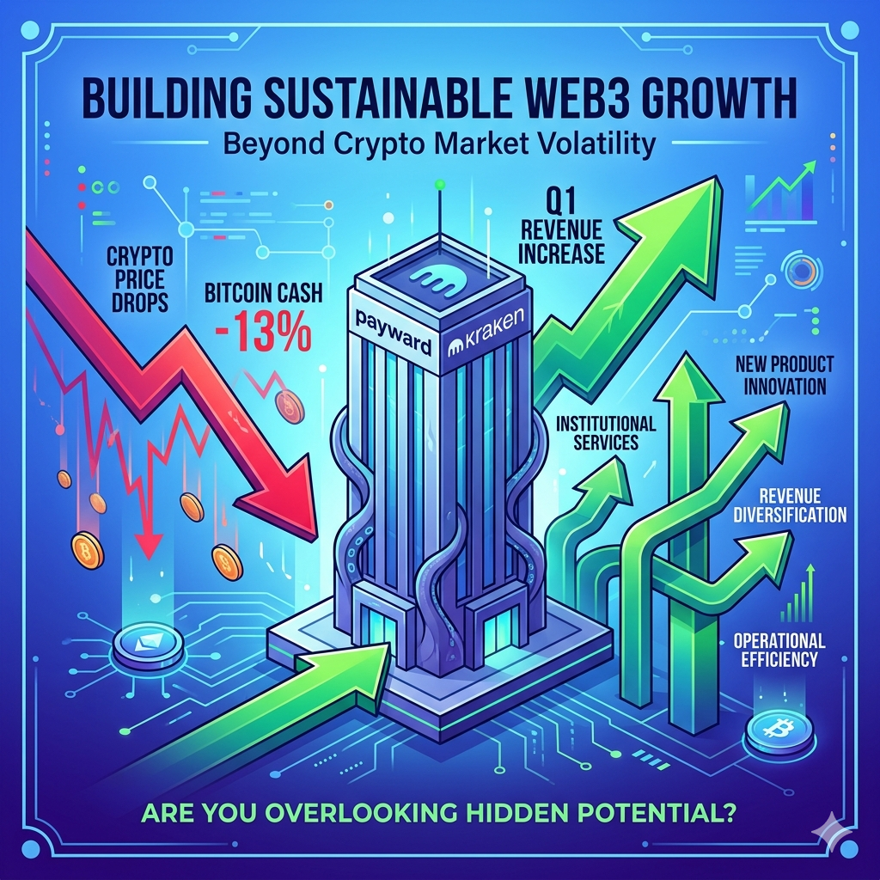

COPY

Kraken's parent company, Payward, just navigated a tough market, reporting a rise in Q1 revenue despite widespread crypto declines, like Bitcoin Cash's 13% drop. This story isn't about crypto price charts; it's about strategic resilience. Payward demonstrates that a Web3 company can thrive by diversifying services beyond mere trading fees. The era of easy money from pure speculation is over. Sustainable growth in Web3 demands robust, value-generating business models, not just market hype. Companies prioritizing utility and diversified offerings will become the new industry titans, reshaping the competitive landscape. They achieved this by likely expanding institutional services, developing new products, or optimizing operational efficiencies, creating revenue streams insulated from price volatility. What hidden revenue potential are you overlooking within your own Web3 strategy by focusing too narrowly on token performance? #Web3Strategy #CryptoResilience #MarketInsight #Innovation #ExoasiaMRSI

This post is produced by Exoasia's Market Research and Strategic Insight. Leaders stay ahead as they receive Daily Insights. Ask us how.

POSTING NOTES

Optimal posting time: Monday, 3 PM HKT. Rationale: Mid-afternoon for Facebook, capturing users after work for more thoughtful engagement. Format presentation advice: Keep paragraphs short and conversational. Audience targeting: Business owners, entrepreneurs, and decision-makers interested in fintech and innovation. Boost guidance: Target Lookalike audiences based on past post engagement with financial news. Pinned comment instruction: "Discover more strategies for market resilience: [Link to relevant article]."
Hashtags: #Web3Strategy #CryptoResilience #MarketInsight #Innovation #ExoasiaMRSI #FintechNews

COMMENTS:

05
🎵 TikTok · Hot take/contrarian opinion

FORMAT

9:16 aspect ratio, max 30 seconds duration, direct-to-camera, conversational talking-head style.

OBJECTIVE

To deliver a high-impact, provocative claim quickly, immediately followed by critical context and a direct call to action, suitable for TikTok's fast-paced environment.

THUMBNAIL



SCRIPT

HOOK
Bitcoin is NOT the ultimate safe haven you think it is.

WHAT
Citi warns that Bitcoin faces a GREATER risk from quantum computing than Ethereum. This means its fundamental cryptographic security, the very basis of its value, is more vulnerable to future supercomputers.

WHY IS IT IMPORTANT
For years, Bitcoin was touted as unhackable digital gold. This assessment from Citi upends that, revealing that older blockchain designs may be critically exposed in the long term compared to more adaptable networks.

WHAT DOES THIS MEAN FOR YOU
If your long-term treasury strategy or institutional investment portfolio relies heavily on Bitcoin as an immutable store of value, you must immediately audit your quantum readiness and diversify. Don't assume inherent security; VERIFY it against future threats.

CTA
This post is produced by Exoasia's Market Research and Strategic Insight. Leaders stay ahead as they receive Daily Insights. Ask us how.

CAPTION

Think Bitcoin is secure forever? Citi has a stark warning. #QuantumComputing #Bitcoin #Ethereum #Web3Security

POSTING NOTES

Optimal posting time: Thursday, 8 PM HKT. Rationale: Peak TikTok engagement hours, catching users relaxing. Algorithm note: Focus on strong hook and fast information delivery to maximize watch time within the first 3 seconds. First-2-seconds rule: Deliver the "Bitcoin is NOT the ultimate safe haven" line with strong conviction immediately. Pacing guidance: Fast, energetic, and punchy delivery throughout. Sound or music direction: Use a short, attention-grabbing, slightly suspenseful audio clip in the background, keeping it low enough not to obscure speech.
Hashtags: #QuantumComputing #Bitcoin #Ethereum #Web3Security #CryptoRisks #InnovationHub #ExoasiaMRSI

COMMENTS:

