EXOASIA INNOVATION HUB
Market Research & Strategic Insight
Thought Leadership Content Pack
Cyber Security Briefing
Based on MRSI Daily Insight — June 01, 2026
5 Platforms · 5 Content Pieces · Ready to Publish
Prepared by MRSI Content Team

Content Overview

# | PLATFORM | FORMAT | BASED ON QUESTION
01 | LinkedIn | Text-only post. URL for further reading or a company resource to be dropped in the first comment. | All 5 Questions
02 | YouTube / Video Script | Aspect Ratio: 16:9. Duration: 60-75 seconds. Delivery Style: Direct, confident, and slightly urgent talking head, no visual aids unless text overlays. | All 5 Questions
03 | Instagram Carousel | 6-slide carousel. Dimensions: 1080x1080 pixels (square). Shareability note: Design each slide to be individually shareable and impactful. | All 5 Questions
04 | Facebook | One idea, short narrative, specific anchor, clear strategic lesson, closing question. Conversational tone. | All 5 Questions
05 | TikTok | Aspect Ratio: 9:16. Duration: 45-60 seconds. Camera Style: Engaging, direct-to-camera, talking head. | All 5 Questions

01
💼 LinkedIn · Executive decision framework

FORMAT

Text-only post. URL for further reading or a company resource to be dropped in the first comment.

OBJECTIVE

To prompt senior leaders to re-evaluate their cybersecurity posture and strategy in light of the recent botnet takedown, moving beyond surface-level relief to deeper systemic implications.

IMAGE

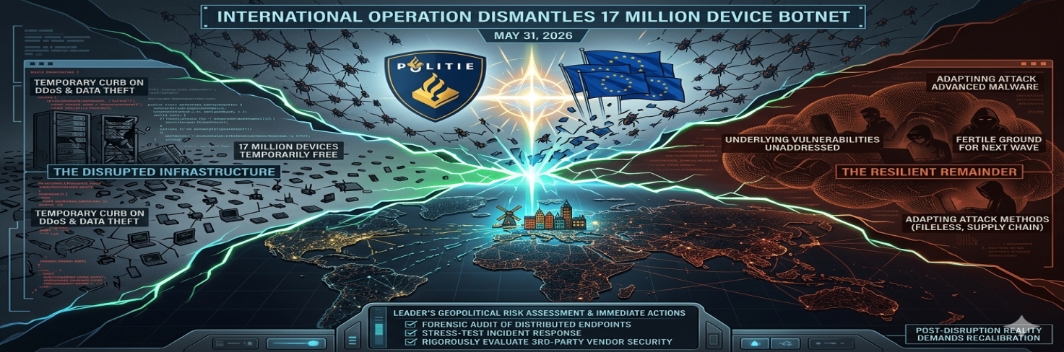

COPY

Dutch authorities, in a significant international operation, recently dismantled a botnet that had compromised an astonishing 17 million devices globally. This isn't just another news headline; it's a stark revelation of the pervasive reach of cyber adversaries and a direct challenge to any leader underestimating the threat. While the disruption of this infrastructure on May 31, 2026, temporarily curbs large-scale cybercrime like DDoS attacks and data theft, the critical implication is that the fundamental vulnerabilities allowing such widespread infection are still unaddressed. Many organizations mistakenly see such takedowns as a 'win,' when in reality, they reveal the sheer scale of devices operating without adequate protection, making them easy targets for the next wave of sophisticated threats.

What this means is the underlying ecosystem of compromised endpoints and IoT devices remains fertile ground. Cybercriminals will swiftly adapt, rebuilding their networks with greater stealth, possibly leveraging more complex, fileless, or supply chain attack vectors to bypass current defenses. The mechanism is simple: a temporary void is created, prompting rapid evolution in attack methods that exploit known gaps. For you, if your organization relies on a distributed workforce or extensive IoT infrastructure, this demands an immediate, forensic audit of all endpoints to identify potential infection among the 17 million. This also means stress-testing incident response plans against widespread compromise scenarios and rigorously evaluating third-party vendor security, as their compromised systems could be your next breach. The real danger isn't the botnet that was, but the more resilient one that is already being engineered.

This post is produced by Exoasia's Market Research and Strategic Insight. Leaders stay ahead as they receive Daily Insights. Ask us how.

POSTING NOTES

Optimal posting time is Tuesday or Wednesday, 9-11 AM local time, when decision-makers are actively engaging with strategic content. Format as a series of short, impactful paragraphs for readability. Target audience: Cybersecurity leaders, CIOs, CISOs, board members, and risk management professionals in mid to large enterprises. Boost guidance: Focus on job titles and industry verticals highly susceptible to large-scale cyber threats (e.g., manufacturing, finance, critical infrastructure). Pinned comment instruction: Pin a comment with a link to a detailed analysis or a readiness checklist provided by Exoasia.
Hashtags: #Cybersecurity #Botnet #RiskManagement #DigitalSecurity #CxOInsights #ExoasiaMRSI

COMMENTS:

02
🎬 YouTube / Video Script · What most people get wrong

FORMAT

Aspect Ratio: 16:9. Duration: 60-75 seconds. Delivery Style: Direct, confident, and slightly urgent talking head, no visual aids unless text overlays.

OBJECTIVE

To challenge the common misconception that a major botnet takedown signifies a lasting victory, instead highlighting the ongoing and evolving nature of cyber threats.

THUMBNAIL

SCRIPT

HOOK
Most people think a massive botnet takedown is a cause for celebration. They are wrong.

WHAT
Dutch authorities just spearheaded an international operation, dismantling a huge botnet. This network had infected around 17 million devices globally, a botnet is simply a network of hijacked computers controlled by criminals. This takedown on May 31, 2026, aims to disrupt their malicious operations.

WHY IS IT IMPORTANT
This isn't a victory; it's a momentary pause. The sheer scale, 17 million devices, exposes the widespread vulnerability still present in our digital infrastructure. It matters right now because cybercriminals are not pausing; they are adapting, looking for new weaknesses to exploit.

WHAT DOES THIS MEAN FOR LEADERS
If your organization assumes this makes you safer, then you are dangerously complacent. It means if your current incident response plans haven't been stress-tested for 17 million potential infections, they are inadequate. If your vendor risk management doesn't account for massive third-party compromises, then your supply chain is a ticking bomb. This takedown demands a fundamental re-evaluation, not relief.

This post is produced by Exoasia's Market Research and Strategic Insight. Leaders stay ahead as they receive Daily Insights. Ask us how.

PRODUCTION NOTES

Recommended video length: 60-75 seconds. Opening line suggestion: Start immediately with the hook for maximum impact. Pacing and tone notes: Deliver at a brisk pace, maintaining a serious but accessible tone. Explain terms like "botnet" immediately and concisely. Sound or visual overlay direction: Use subtle, impactful sound design for the hook and conclusion. Text overlays should appear briefly to highlight numbers or key terms (e.g., "17M Devices"). Ensure clarity and conciseness, avoiding jargon where possible.
Hashtags: #CybersecurityThreats #BotnetTakedown #DigitalSecurity #CIOInsights #CyberRisk #ExoasiaMRSI

COMMENTS:

03
📱 Instagram Carousel · Data breakdown/stat-led

FORMAT

6-slide carousel. Dimensions: 1080x1080 pixels (square). Shareability note: Design each slide to be individually shareable and impactful.

OBJECTIVE

To visualize and break down the implications of the "17 million devices" statistic, challenging conventional thinking about digital security.

IMAGE

SLIDE BREAKDOWN

Slide 1
17 MILLION DEVICES: What this botnet takedown REALLY means for your business.

Slide 2
(REVEAL):
THE HIDDEN SCALE OF COMPROMISE
The Dutch-led takedown of a massive botnet on May 31, 2026, revealed 17 million infected devices globally. This number isn't just large; it exposes a terrifying truth: the global digital ecosystem is far more vulnerable than previously acknowledged. It shows that endpoint protection and IoT security are failing on an industrial scale.

Slide 3
(MYTH / TRUTH):
MYTH: Botnet takedowns make us safer.
TRUTH: They expose the underlying infection.
The disruption removes one network, but the 17 million infected devices are still out there, often undetected. This leaves a vast pool of vulnerable systems ripe for re-infection by the NEXT generation of cyber threats, forcing a cycle of reactive defense.

Slide 4
(CONTRARIAN VIEW):
YOUR INCIDENT RESPONSE ISN'T READY
Most incident response plans are built for targeted attacks, not for assessing whether your assets are among 17 million potentially compromised. This event demands a complete overhaul of how we prepare for, and respond to, global-scale digital compromise. Your plan needs to scale immediately.

Slide 5
(LESSON):
THE SUPPLIER RISK IS GLOBAL
The lesson from this takedown is clear: your third-party vendors and supply chain partners are not immune. Their 17 million potential infections translate directly to YOUR increased risk. Robust vendor risk management isn't optional; it is fundamental to operational continuity.

Slide 6
DON'T WAIT FOR THE NEXT ATTACK. ACT NOW.
This post is produced by Exoasia's Market Research and Strategic Insight. Leaders stay ahead as they receive Daily Insights. Ask us how.

CAPTION

A single botnet infecting 17 million devices isn't just a number; it's a wake-up call for every executive. The recent takedown by Dutch authorities on May 31, 2026, gives us a rare glimpse into the true scale of global digital compromise. Swipe through to understand why this moment demands more than just a sigh of relief – it demands immediate strategic action on endpoint security, incident response, and vendor risk. #Cybersecurity #Botnet #DigitalDefense #RiskManagement #DataSecurity #ExoasiaMRSI

POSTING NOTES

Optimal posting time is Thursday, 10 AM PST, when engagement rates for strategic content tend to be high. Slide design: Use a dark background color with contrasting white or light-colored text for optimal readability. Font size guidance: Titles at 32pt, body text at 18-20pt. Maintain strong visual hierarchy. Story or poll suggestion: Post Slide 1 to your Instagram Story asking, "Does your organization feel immune to a 17M device botnet attack?" with yes/no poll options, then link to the full carousel post.
Hashtags: #Cybersecurity #Botnet #DigitalSecurity #EndpointSecurity #SupplyChainRisk #ExoasiaMRSI

COMMENTS:

04
👍 Facebook · Storytelling/narrative arc

FORMAT

One idea, short narrative, specific anchor, clear strategic lesson, closing question. Conversational tone.

OBJECTIVE

To convey the impact of the botnet takedown through a concise narrative, highlighting a strategic lesson for businesses.

IMAGE

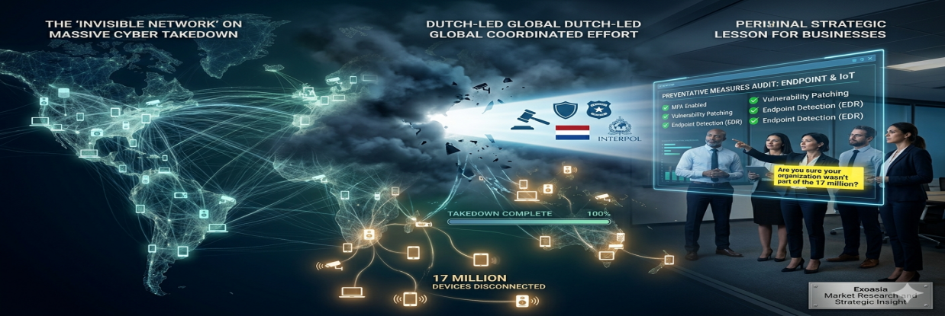

COPY

Imagine an invisible network of 17 million compromised devices, quietly controlled by criminals, ready to strike. That was the reality until Dutch authorities, in a global coordinated effort on May 31, 2026, dismantled a major botnet operation. This decisive action prevented countless DDoS attacks and data thefts. The strategic lesson here is clear: even as law enforcement scales its efforts, the sheer numbers reveal how many devices globally are still susceptible. This means every business must re-evaluate its preventative measures, especially for endpoint and IoT devices. Are you sure your organization wasn't part of the 17 million? #Cybersecurity #BotnetTakedown #DigitalSecurity #ExoasiaMRSI

This post is produced by Exoasia's Market Research and Strategic Insight. Leaders stay ahead as they receive Daily Insights. Ask us how.

POSTING NOTES

Optimal posting time is Monday afternoon, 1-3 PM local time, when users are back online and looking for digestible insights. Format as a single paragraph to maintain narrative flow. Audience targeting: Business owners, IT managers, and local community leaders who may not be cybersecurity experts but need to understand the impact. Boost guidance: Target small to medium-sized business owners, emphasizing local relevance. Pinned comment instruction: Pin a comment with a link to an Exoasia blog post about basic cybersecurity hygiene for SMBs.
Hashtags: #Cybersecurity #BotnetTakedown #DigitalSecurity #SMBsecurity #DataProtection #ExoasiaMRSI

COMMENTS:

05
🎵 TikTok · Trend prediction/future scenarios

FORMAT

Aspect Ratio: 9:16. Duration: 45-60 seconds. Camera Style: Engaging, direct-to-camera, talking head.

OBJECTIVE

To quickly deliver a forward-looking perspective on the botnet takedown, focusing on future cybercrime trends and what organizations should prepare for.

THUMBNAIL

SCRIPT

The recent botnet takedown, impacting 17 million devices, isn't a victory; it's a warning shot. Cybercriminals learn.

Dutch authorities took down a massive botnet on May 31, 2026. This disrupted large-scale cybercrime. But here's the future trend: criminals will shift tactics fast. They will abandon large, easily traceable botnets for smaller, more stealthy, and decentralized networks. Think "swarms," not "empires."

This means tomorrow's threats will be harder to detect. They will target supply chains and use more sophisticated, low-footprint malware. Your traditional defenses, designed for yesterday's threats, will be ineffective. You need to upgrade your threat intelligence and focus on proactive hunting. Don't wait for the next big takedown; anticipate the next big evolution.

This post is produced by Exoasia's Market Research and Strategic Insight. Leaders stay ahead as they receive Daily Insights. Ask us how.

CAPTION

A massive botnet got dismantled, but don't get comfortable. 🚫 This isn't the end, it's a pivot point for cybercriminals. Get ready for the next wave of stealthier, harder-to-detect attacks. Your cybersecurity strategy needs to evolve NOW. #Cybersecurity #FutureThreats #Botnet #CyberDefense #TechTrends #ExoasiaMRSI

POSTING NOTES

Optimal posting time and algorithm note: Post Tuesday-Thursday, 1-3 PM local time for maximum reach. TikTok's algorithm favors early engagement and concise, high-value content. First-2-seconds rule: Open immediately with the shocking claim "The recent botnet takedown, impacting 17 million devices, isn't a victory; it's a warning shot." Pacing guidance: Fast, energetic, and confident delivery. Keep sentences short. Sound or music direction: Use a trending, upbeat but non-distracting background track. Consider a subtle sound effect for the "warning shot" moment.
Hashtags: #Cybersecurity #FutureThreats #Botnet #CyberDefense #TechTrends #ExoasiaMRSI

COMMENTS:

