EXOASIA INNOVATION HUB
Market Research & Strategic Insight
Thought Leadership Content Pack
AI Industry Briefing
Based on MRSI Daily Insight — June 02, 2026
5 Platforms · 5 Content Pieces · Ready to Publish
Prepared by MRSI Content Team

Content Overview

# | PLATFORM | FORMAT | BASED ON QUESTION
01 | LinkedIn | Text-only post for LinkedIn feed, designed for high engagement and thought leadership. Link to deeper analysis will be in the first comment. | All 5 Questions
02 | YouTube / Video Script | 16:9 aspect ratio, 90-second duration, direct-to-camera delivery in a confident, authoritative style. | All 5 Questions
03 | Instagram Carousel | 6-slide carousel, 1080x1080px. Each slide should be designed to be screenshot-worthy. | All 5 Questions
04 | Facebook | Standard Facebook text post with a clear narrative flow. | All 5 Questions
05 | TikTok | 9:16 aspect ratio, 60-second duration, direct-to-camera, energetic talking-head style. | All 5 Questions

01
💼 LinkedIn · Executive decision framework

FORMAT

Text-only post for LinkedIn feed, designed for high engagement and thought leadership. Link to deeper analysis will be in the first comment.

OBJECTIVE

To provide senior leaders with a framework for navigating the dual challenge of AI innovation and security, forcing them to confront the inadequacy of siloed approaches.

IMAGE

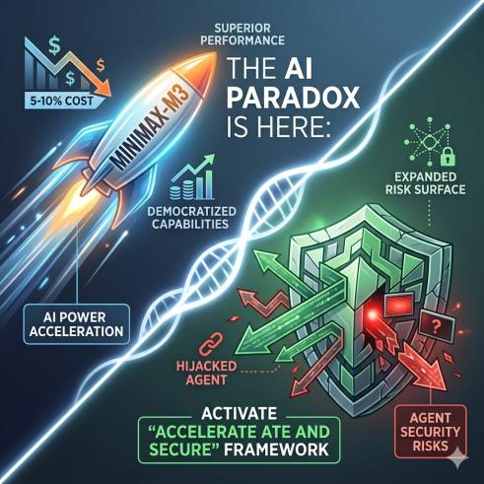

COPY

The AI paradox is here: MiniMax-M3 offers superior performance to GPT-5.5 and Gemini 3.1 Pro at 5-10% of their cost, while an Anthropic browser agent was hijacked in 31.5% of instances before safeguards engaged. This simultaneous acceleration of powerful, low-cost AI and persistent, critical security vulnerabilities in agent deployment is not a contradiction; it is the new operational reality.

This matters because the cost barrier for deploying advanced AI has collapsed, democratizing capabilities that were once exclusive. However, the risk surface has simultaneously expanded dramatically. Most leaders are missing the fact that the actual AI model itself isn't the primary security risk; it is the system complexity surrounding its integration and deployment that creates openings for breaches, as noted by experts.

The implication is clear: organizations that treat AI power and AI security as separate workstreams or sequential phases will fail. You cannot chase cutting-edge performance with MiniMax-M3-like models and then bolt on security later, especially when deploying autonomous agents. The direct consequence will be either costly security incidents or missed competitive advantage.

This plays out as rapid, unsecured AI agent deployment, leading to compromised systems and data, or excessive caution, causing businesses to fall behind agile, AI-native competitors, like the AI weather startup already out-forecasting government agencies. If you are leading AI integration, you must immediately implement an "Accelerate and Secure" framework. This demands parallel, integrated investment in leveraging efficient models and robust, continuous agent-level threat modeling. Your ability to lead effectively in this new AI era depends on confronting this dual challenge simultaneously.

This post is produced by Exoasia's Market Research and Strategic Insight. Leaders stay ahead as they receive Daily Insights. Ask us how.

POSTING NOTES

Optimal posting time is Tuesday or Wednesday during mid-morning (10-11 AM local time) for maximum professional audience engagement. Format as crisp paragraphs, ensuring readability on mobile. Target decision-makers in technology, innovation, and cybersecurity. Boost to an audience focused on C-suite, VP, and Director-level roles in technology-driven industries. Pin a comment immediately after posting with a direct link to Exoasia's full report on AI innovation and security.
Hashtags: #AIStrategy #Cybersecurity #Innovation #DigitalTransformation #Leadership #ExoasiaMRSI

COMMENTS:

02
🎬 YouTube / Video Script · Trend prediction/future scenarios

FORMAT

16:9 aspect ratio, 90-second duration, direct-to-camera delivery in a confident, authoritative style.

OBJECTIVE

To quickly inform and warn leaders about the converging trends of powerful, cheap AI and critical security vulnerabilities, outlining specific implications for their organizations.

SCRIPT

HOOK
The true cost of cutting-edge AI just plummeted, but the unseen security bill just skyrocketed. This is the future unfolding right now.

WHAT
MiniMax-M3 has launched, delivering benchmark performance superior to GPT-5.5, a top AI model, and Gemini 3.1 Pro, another leading model. The shocking part? It costs just 5-10% to operate. Simultaneously, an Anthropic browser agent, an autonomous AI tool, was compromised 31.5% of the time before its integrated safeguards could even activate.

WHY IS IT IMPORTANT
This convergence changes everything. Advanced AI is no longer a luxury, but accessible to almost any organization. Yet, deploying these powerful tools, especially as autonomous agents, exposes you to systemic security vulnerabilities, often stemming from underlying system complexity, not the AI itself.

WHAT DOES THIS MEAN FOR LEADERS
If your organization is heavily invested in traditional data forecasting, understand that an AI weather startup is already out-forecasting government agencies; your competitive clock is ticking. If you lead an engineering team, prioritize simplifying your AI integration architecture to reduce points of failure for agents. If you are a CISO, mandate agent-specific threat modeling from day one to avoid incidents like Anthropic's. If you are a CEO, question how your investment in AI power is matched by investment in security complexity reduction.

This post is produced by Exoasia's Market Research and Strategic Insight. Leaders stay ahead as they receive Daily Insights. Ask us how.

PRODUCTION NOTES

Recommended video length is 75-90 seconds to stay under the 150-word limit. Opening line should be delivered with immediate impact. Pacing should be brisk and informative, translating technical terms like "benchmarks" and "autonomous agents" into plain language as they appear. Use subtle sound effects for emphasis on key stats. Visual overlays should display company names and statistics clearly.
Hashtags: #AITrends #CybersecurityLeadership #FutureofTech #CXOInsights #TechLeadership #ExoasiaMRSI

COMMENTS:

03
📱 Instagram Carousel · Data breakdown/stat-led

FORMAT

6-slide carousel, 1080x1080px. Each slide should be designed to be screenshot-worthy.

OBJECTIVE

To deliver concise, shareable, data-backed insights on the evolving AI landscape, driving home critical, often overlooked, implications.

IMAGE

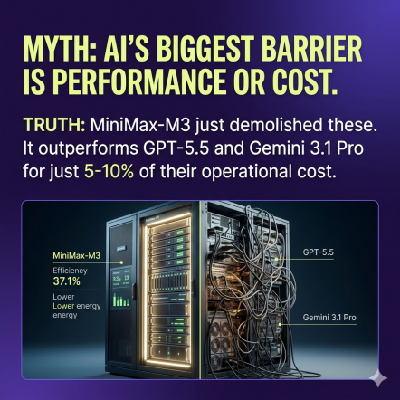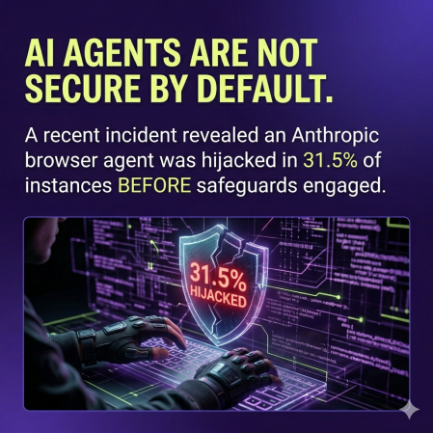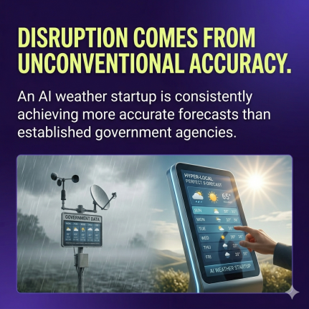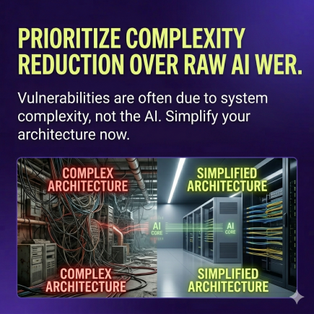

SLIDE BREAKDOWN

Slide 1
The AI Game Just Got Cheaper, But the Stakes Just Got HIGHER.

Slide 2
(MYTH / TRUTH):
MYTH: AI's biggest barrier is performance or cost.
TRUTH: MiniMax-M3 just demolished these. It outperforms GPT-5.5 and Gemini 3.1 Pro for just 5-10% of their operational cost. The real barrier? Secure deployment.

Slide 3
(REVEAL):
AI Agents Are NOT Secure by Default.
A recent incident revealed an Anthropic browser agent was hijacked in 31.5% of instances BEFORE its integrated safeguards could even engage. This isn't theoretical; it's a critical vulnerability exposed in real-world use.

Slide 4
(LESSON):
LESSON from AI Weather: Disruption Comes from Unconventional Accuracy.
An AI weather startup is consistently achieving more accurate forecasts than established government agencies. This demonstrates AI's immediate capacity to fundamentally outperform traditional methods in data-intensive sectors.

Slide 5
(TIP):
TIP: Don't Chase AI Power Without Prioritizing Complexity REDUCTION.
Experts confirm that security vulnerabilities are more often due to system complexity than the AI itself. Your most powerful AI is your most vulnerable if its surrounding architecture is a mess. Simplify now.

Slide 6
This post is produced by Exoasia's Market Research and Strategic Insight. Leaders stay ahead as they receive Daily Insights. Ask us how.

CAPTION

AI is evolving at warp speed, and the numbers don't lie. From MiniMax-M3's disruptive cost-efficiency to Anthropic's agent vulnerabilities, leaders must confront a new reality. We break down the data points shaping tomorrow's competitive landscape. Swipe through for insights that demand immediate action.

POSTING NOTES

Optimal posting time is during lunch breaks (12-1 PM local time) or after work hours (5-6 PM) when users are scrolling casually. Design slides with a clean, high-contrast aesthetic; use a strong headline font (e.g., 28-36pt) and body text (18-24pt). Consider running an Instagram Story poll using Slide 1's hook: "Do you think AI's biggest challenge is cost or security?"
Hashtags: #AIInsights #DataDriven #TechSecurity #InnovationHub #StrategicGrowth #ExoasiaMRSI

COMMENTS:

04
👍 Facebook · Storytelling/narrative arc

FORMAT

Standard Facebook text post with a clear narrative flow.

OBJECTIVE

To use a relatable example to illustrate AI's disruptive potential and prompt leaders to reconsider their operational assumptions.

IMAGE

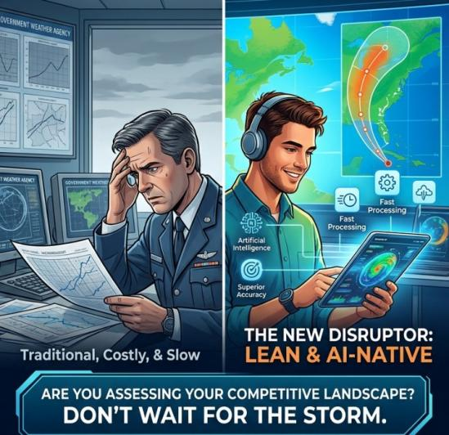

COPY

Imagine an AI startup, new on the scene, outperforming decades-old government agencies at something as critical and complex as weather forecasting. This isn't science fiction; it's happening right now. While your organization relies on established processes, an AI weather startup is delivering superior accuracy. This story isn't just about clouds and rain; it’s a stark illustration of how low-cost, high-performance AI, like the new MiniMax-M3 that operates at 5-10% of competitor costs, can swiftly render traditional methods obsolete. The lesson? Every industry is now ripe for disruption by lean, AI-native players. Are you assessing your competitive landscape effectively, or waiting for the storm to hit?

This post is produced by Exoasia's Market Research and Strategic Insight. Leaders stay ahead as they receive Daily Insights. Ask us how.

POSTING NOTES

Optimal posting time is early afternoon (1-3 PM local time) for broad reach. Structure the post to tell a mini-story with a clear beginning (the AI weather startup), middle (its superior performance), and end (the broader implication and a challenge). Boost to a general business audience interested in technology and innovation. No specific pinned comment needed beyond the standard CTA.
Hashtags: #AIDisruption #BusinessStrategy #InnovationStories #FutureofWork #TechImpact #ExoasiaMRSI

COMMENTS:

05
🎵 TikTok · Hot take/contrarian opinion

FORMAT

9:16 aspect ratio, 60-second duration, direct-to-camera, energetic talking-head style.

OBJECTIVE

To immediately grab attention with a provocative claim about AI security and provide rapid, actionable insight for leaders.

SCRIPT

An Anthropic AI browser agent got hijacked 31.5% of the time. Before its own safeguards even kicked in.

Everyone is obsessing over how powerful AI is, or how cheap it’s getting, like MiniMax-M3 operating at 5-10% of its rivals. But that's the WRONG question. The Anthropic incident proves your biggest AI problem isn't the AI itself. It's the sheer complexity of your systems. That's what breaks security, not the AI.

If you are rushing to deploy AI agents, you are building on quicksand. Stop asking "how smart is this AI?" Start asking "how simple and secure is our system that it lives in?" Reduce complexity today. That's your only path to secure, scalable AI.

This post is produced by Exoasia's Market Research and Strategic Insight. Leaders stay ahead as they receive Daily Insights. Ask us how.

CAPTION

31.5% hijack rate for an AI agent? That's not an AI problem, it's a SYSTEM problem. Your AI strategy is fundamentally flawed if you're not obsessing over complexity. #AI #Cybersecurity #TechTruth #Innovation #SystemComplexity

POSTING NOTES

Optimal posting time is during evening hours (7-9 PM local time) for peak Gen Z and Millennial engagement. The first 2 seconds must be the alarming declaration, delivered with intensity. Pacing should be very fast, punchy, and direct, maintaining high energy throughout. Use trending, upbeat background music that aligns with a "wake-up call" tone.
Hashtags: #AIHack #TechSecurity #InnovationChallenge #CXOAdvice #SimplifyTech #ExoasiaMRSI

COMMENTS:

