EXOASIA INNOVATION HUB
Market Research & Strategic Insight
Thought Leadership Content Pack
Cyber Security Briefing
Based on MRSI Daily Insight — June 02, 2026
5 Platforms · 5 Content Pieces · Ready to Publish
Prepared by MRSI Content Team

Content Overview

# | PLATFORM | FORMAT | BASED ON QUESTION
01 | LinkedIn | Text-only post. URL for sources will be dropped in the first comment. | All 5 Questions
02 | YouTube / Video Script | Aspect Ratio: 16:9. Duration: 60-90 seconds. Delivery Style: Direct, authoritative, and fast-paced talking head. | All 5 Questions
03 | Instagram Carousel | 6-slide carousel. Dimensions: 1080x1080px. Shareability note: Each slide is designed to be self-contained and impactful for individual sharing. | All 5 Questions
04 | Facebook | Short narrative post. | All 5 Questions
05 | TikTok | Aspect Ratio: 9:16. Duration: 30-45 seconds. Camera Style: Engaging, direct talking-head. | All 5 Questions

01
💼 LinkedIn · What most people get wrong

FORMAT

Text-only post. URL for sources will be dropped in the first comment.

OBJECTIVE

To highlight the common miscalculation regarding the speed and nature of current cyber threats and the inadequacy of traditional security approaches, prompting leaders to reassess their strategic posture.

IMAGE

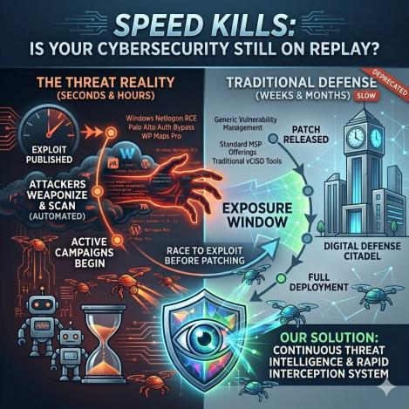

COPY

Many leaders fundamentally misunderstand the pace of cybersecurity threats: critical flaws are not just discovered, they are being actively exploited within hours or days, making traditional security frameworks obsolete. This isn't a future risk; it's the present reality, with active campaigns against Windows Netlogon RCE, Palo Alto authentication bypass bugs, and the WP Maps Pro plugin. Relying on generic vulnerability management or traditional MSP offerings that don't provide continuous, integrated threat intelligence is a dangerous miscalculation. The implication is that even known, patched vulnerabilities can lead to significant breaches if your organization's response time is measured in weeks instead of hours. Attackers are using automated scans to weaponize newly public flaws, targeting the brief window before universal patching. This means your current security posture, even with an MSP offering standard vCISO tools, is likely leaving you exposed to *active* attack campaigns. If you believe your current strategy is robust, you are underestimating the immediate, real-world danger and the demand for rapid, proactive threat interception.

This post is produced by Exoasia's Market Research and Strategic Insight. Leaders stay ahead as they receive Daily Insights. Ask us how.

POSTING NOTES

Optimal Posting Time: Tuesday or Wednesday, 9-11 AM local time, when decision-makers are actively reviewing strategic updates.
Format Presentation: Post as a concise, high-impact text update. Ensure crisp paragraph breaks for readability.
Audience Targeting/Boost Guidance: Target CxOs, VPs of IT/Security, and Board Members in enterprise and critical infrastructure sectors. Boost for reach among technology and innovation thought leaders.
Pinned Comment Instruction: "Sources for this briefing: [1] The Security Growth Platform: Why MSPs Are Moving Beyond vCISO Tools - Jun 01, 2026, [2] Critical WP Maps Pro Flaw Actively Exploited to Create Admin Accounts - Jun 01, 2026, [3] Critical Windows Netlogon RCE flaw now exploited in attacks - Jun 01, 2026, [4] Patch Now: Another Palo Alto Auth Bypass Bug Under Active Exploit - Jun 01, 2026"
Hashtags: #Cybersecurity #RiskManagement #DigitalTransformation #ExecutiveInsight #ThreatIntelligence #ExoasiaMRSI

COMMENTS:

02
🎬 YouTube / Video Script · Executive decision framework

FORMAT

Aspect Ratio: 16:9. Duration: 60-90 seconds. Delivery Style: Direct, authoritative, and fast-paced talking head.

OBJECTIVE

To provide leaders with a clear framework for evaluating and responding to the immediate and active cybersecurity threats identified in the briefing, translating complex issues into actionable insights.

SCRIPT

HOOK
Critical vulnerabilities in Windows Netlogon and Palo Alto products are not theoretical risks; they are being actively exploited RIGHT NOW.

WHAT
We are seeing a dual assault: specific web application flaws like the WP Maps Pro plugin, which allows unauthorized admin account creation, and foundational infrastructure gaps like the Windows Netlogon Remote Code Execution and Palo Alto authentication bypass bugs.

WHY IS IT IMPORTANT
This isn't about potential threats. It's about ongoing attacks leveraging known weaknesses, shortening the window for defensive action from weeks to days, or even hours. MSPs are shifting to security growth platforms because reactive measures are no longer viable.

WHAT DOES THIS MEAN FOR LEADERS
If your organization relies on standard patching cycles, you are already behind. You need a system that prioritizes and deploys critical patches for flaws like Windows Netlogon within hours. If you're using third-party web applications or plugins, demand a clear, immediate mitigation strategy for vulnerabilities like the WP Maps Pro flaw. If your security strategy hasn't moved beyond basic vulnerability management, you must adopt a proactive threat intelligence framework that anticipates and counters active campaigns.

This post is produced by Exoasia's Market Research and Strategic Insight. Leaders stay ahead as they receive Daily Insights. Ask us how.

PRODUCTION NOTES

Recommended Video Length: Approximately 75 seconds.
Opening Line Suggestion: Start with a confident, direct gaze into the camera, delivering the hook statement with gravitas.
Pacing and Tone Notes: Maintain a brisk, urgent pace throughout. The tone should be serious and authoritative, but with a clear intent to inform and empower, translating technical terms into immediate, understandable implications for business leaders.
Sound or Visual Overlay Direction: Use subtle, professional graphics to highlight product names and key vulnerabilities as they are mentioned. A low, constant background hum (not music) can add to the serious, urgent tone.
Hashtags: #CybersecurityStrategy #ExecutiveDecisions #InfoSec #CriticalInfrastructure #RiskManagement #ExoasiaMRSI

COMMENTS:

03
📱 Instagram Carousel · Myth-busting

FORMAT

6-slide carousel. Dimensions: 1080x1080px. Shareability note: Each slide is designed to be self-contained and impactful for individual sharing.

OBJECTIVE

To dismantle common misconceptions about cybersecurity, particularly around patching and third-party risks, using specific examples from the briefing to reveal sharper realities.

IMAGE

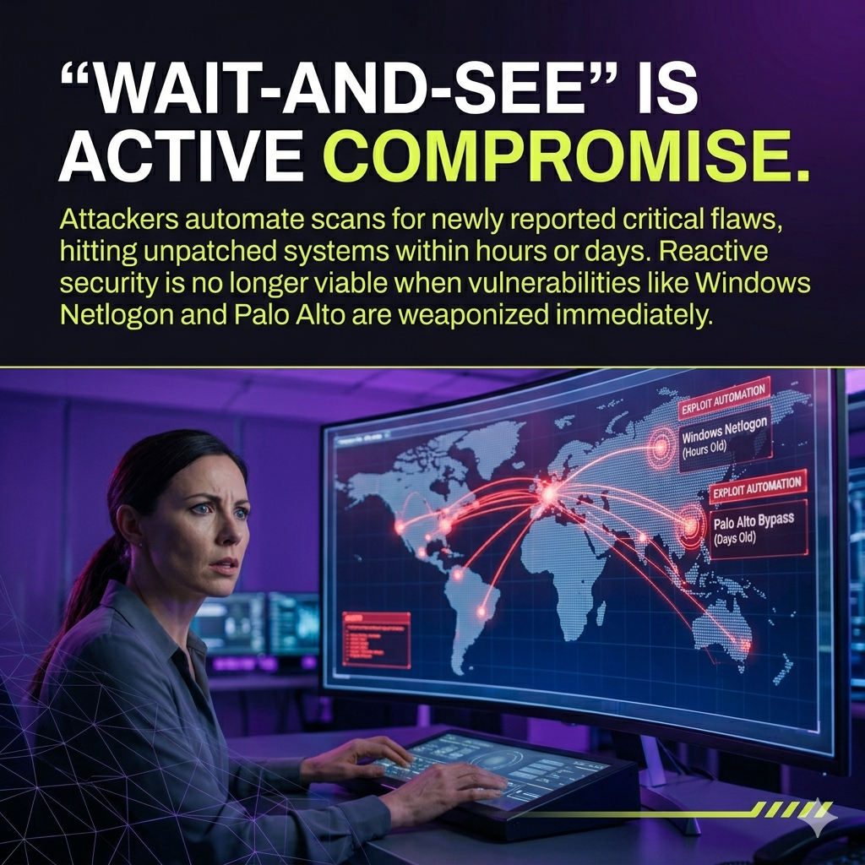

SLIDE BREAKDOWN

Slide 1
PATCHING ISN'T ENOUGH.

Slide 2
(MYTH / TRUTH):
MYTH: Applying patches solves the problem.
TRUTH: Attackers are exploiting critical flaws like Windows Netlogon RCE and Palo Alto authentication bypass *before* many organizations can patch. The window for exploitation is shrinking from weeks to hours. Being compliant isn't the same as being secure.

Slide 3
(CONTRARIAN VIEW):
Your MSP might be making you COMPLACENT.
While Managed Security Service Providers are moving to "security growth platforms," many still offer basic vCISO tools that don't cover the full spectrum of *active* threat intelligence and rapid response needed today. A bigger platform doesn't automatically mean better protection against zero-hour exploits.

Slide 4
(LESSON):
The WP Maps Pro incident teaches us: Every plugin is a POTENTIAL BACKDOOR.
This web application flaw allowed unauthorized admin account creation. The lesson is that third-party components are now primary attack vectors requiring aggressive supply chain risk management, not just perfunctory checks.

Slide 5
(REVEAL):
The true cost of "wait and see" is *active compromise*.
The mechanism is simple: attackers automate scans for newly reported critical flaws, hitting unpatched systems within hours or days. This dynamic reveals that reactive security is no longer viable when vulnerabilities like Windows Netlogon and Palo Alto are weaponized immediately.

Slide 6
This post is produced by Exoasia's Market Research and Strategic Insight. Leaders stay ahead as they receive Daily Insights. Ask us how.

CAPTION

The old rules of cybersecurity are DEAD. Active exploits of critical vulnerabilities in Windows Netlogon, Palo Alto, and even common plugins like WP Maps Pro show that delayed patching and static security frameworks are a recipe for disaster. Swipe to bust myths and sharpen your strategy.

POSTING NOTES

Posting Time and Rationale: Mid-day (12-2 PM local time) for maximum engagement during lunch breaks or afternoon scrolls.
Slide Design Specs: Use a dark background (e.g., deep blue) with white or light gray text for primary content. Headline text on Slide 1 should be large and bold. Font size for body text should be at least 24pt for readability.
Story or Poll Suggestion: Share Slide 1 to your Instagram Story asking, "Is your patching fast enough? Yes/No" or "Are you confident in your MSP's active threat response?"
Hashtags: #CybersecurityMyths #PatchManagement #SupplyChainRisk #InfosecTips #DigitalSecurity #ExoasiaMRSI

COMMENTS:

04
👍 Facebook · Storytelling/narrative arc

FORMAT

Short narrative post.

OBJECTIVE

To illustrate the immediate, tangible danger of a single software vulnerability through a narrative, driving home the urgency for leaders to scrutinize their digital assets.

IMAGE

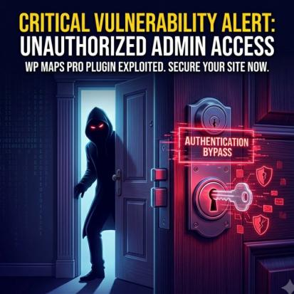

COPY

Imagine waking up to find an uninvited administrator on your most critical web application. This isn't hypothetical. A critical WP Maps Pro plugin vulnerability is currently being actively exploited, allowing attackers to create administrative accounts without authorization. This single flaw can unravel your entire web presence, granting full system compromise and data breaches. The mechanism is simple: a backdoor for bad actors to bypass authentication. This story isn't just about a plugin; it's about how quickly a seemingly minor component can become your biggest liability. What third-party components are you running unverified?

This post is produced by Exoasia's Market Research and Strategic Insight. Leaders stay ahead as they receive Daily Insights. Ask us how.

POSTING NOTES

Optimal Posting Time: Monday or Tuesday afternoon, 1-3 PM local time, when engagement for industry news is typically high.
Format Presentation: Keep the copy concise, direct, and conversational to encourage shares and comments.
Audience Targeting/Boost Guidance: Target business owners, IT managers, and web developers. Boost to reach audiences interested in digital security, web development, and small to medium enterprise news.
Pinned Comment Instruction: "The active exploitation of the WP Maps Pro plugin serves as a stark reminder. Check your systems immediately."
Hashtags: #WebSecurity #DataBreach #CyberAttack #DigitalRisk #WordPressSecurity #ExoasiaMRSI

COMMENTS:

05
🎵 TikTok · Hot take/contrarian opinion

FORMAT

Aspect Ratio: 9:16. Duration: 30-45 seconds. Camera Style: Engaging, direct talking-head.

OBJECTIVE

To deliver a sharp, provocative claim about the speed of cyber threats and the inadequacy of traditional responses, prompting immediate re-evaluation from viewers.

THUMBNAIL

SCRIPT

Your security team is probably already too slow. While you are prioritizing, attackers are actively exploiting critical Windows Netlogon RCE and Palo Alto authentication bypass bugs. These aren't future threats; they're happening now. The lag between patch release and enterprise application is a goldmine for attackers. This means relying on traditional, scheduled patch cycles is a recipe for compromise. You will face breaches from *known* vulnerabilities. Attackers weaponize new vulnerabilities instantly, scanning millions of systems within hours. You need real-time threat intelligence and a zero-day patch mindset, even for N-day exploits.

This post is produced by Exoasia's Market Research and Strategic Insight. Leaders stay ahead as they receive Daily Insights. Ask us how.

CAPTION

Stop assuming your cyber defense can keep up. Active exploits like Windows Netlogon and Palo Alto demand a mindset shift. Are you ready? #Cybersecurity #HotTake #InfoSec #CriticalInfrastructure #DigitalThreats #ExoasiaMRSI

POSTING NOTES

Optimal Posting Time and Algorithm Note: Post during peak TikTok hours, typically evenings (7-11 PM) or lunch breaks (12-1 PM), for maximum reach. TikTok favors direct, fast-paced content that immediately grabs attention.
First-2-Seconds Rule: The opening line "Your security team is probably already too slow" must be delivered with immediate impact and confidence to hook viewers.
Pacing Guidance: Maintain a very fast, energetic pace. Use quick cuts if possible. The speaker should be animated, direct, and convey urgency without being frantic.
Sound or Music Direction: Use a trending, fast-paced, non-distracting instrumental track that supports an urgent, informative tone. Ensure music volume is low beneath the spoken words.
Hashtags: #Cybersecurity #HotTake #InfoSec #CriticalInfrastructure #DigitalThreats #ExoasiaMRSI

COMMENTS:

