Real-Time Hand Gesture Recognition
using SVM and Computer Vision

Submitted To

SVKM’s NMIMS,
Mukesh Patel School of Technology Management & Engineering,
Shirpur Campus (M.H.)

Submitted By:
Nakshatra Paliwal Enrollment No: 70012400197

Under The Supervision Of:
Dr. Suyog Pande
(Artificial Intelligence and Machine Learning Dept.)

DEPARTMENT OF INFORMATION TECHNOLOGY
Mukesh Patel School of Technology Management & Engineering
ACADEMIC SESSION: 2025-26

CERTIFICATE

This is to certify that the project entitled 'Real-Time Hand Gesture Recognition using SVM and Computer Vision' has been carried out by 'Nakshatra Paliwal' (SAP ID: 70012400197) under my guidance and supervision for the subject Principles of Artificial Intelligence at MPSTME, SVKM’s NMIMS (Deemed-to-be University), Mumbai (M.H.), India.

Dr. Suyog Pande
Project Mentor
(Internal Guide)
Date: 08/04/2026
Place: Shirpur

DEPARTMENT OF INFORMATION TECHNOLOGY
Mukesh Patel School of Technology Management & Engineering

TABLE OF CONTENTS
Sr. No. | Chapter No. | Page
1 | INTRODUCTION
1.1 | Background Information | 1
1.2 | Motivation and Scope of the Report | 2
1.3 | Problem Statement | 2
1.4 | Objectives | 3
2 | METHODOLOGY AND IMPLEMENTATION
2.1 | Introduction | 4
2.2 | Flowchart and Pipeline Diagram | 5
2.3 | Data Collection and Feature Extraction | 5
2.4 | Model Training and Prediction | 6
3 | RESULT AND ANALYSIS
3.1 | System Output | 7
3.2 | Evaluation and Investigation | 7
4 | ADVANTAGE, LIMITATIONS AND APPLICATIONS
4.1 | Advantages | 8
4.2 | Limitations | 8
4.3 | Applications | 9
5 | CONCLUSION AND FUTURE SCOPE | 10
6 | REFERENCES | 11
Appendix A | Sample code | 12
Appendix B | Datasheets | 13

1. INTRODUCTION

1.1 Background Information
Hand gesture recognition is a branch of computer vision that enables a machine to identify and interpret human hand movements. It is one of the most natural forms of human-computer interaction because gestures are intuitive, contactless, and easy to demonstrate. In recent years, gesture-based interfaces have become important in areas such as virtual reality, assistive technology, interactive kiosks, smart classrooms, and gesture-controlled devices.
This project focuses on a simple real-time gesture recognition system that detects hand landmarks from a camera stream and classifies the gesture using a Support Vector Machine (SVM). Instead of depending on raw pixels, the system uses landmark coordinates as features, which makes the classification stage easier to train and faster to execute.

1.2 Motivation and Scope of the Report
The motivation behind this project is to build a small but meaningful artificial intelligence application that demonstrates both computer vision and machine learning. A gesture-based system is useful because it reduces the need for physical contact with input devices and supports accessibility-focused interaction. The same idea can be extended to larger applications in the future.
The scope of this report is limited to a prototype that recognizes a few predefined hand gestures such as fist, open palm, and thumbs up. The project explains the complete pipeline, the feature extraction method, the SVM classifier, and the real-time demonstration process.

1.3 Problem Statement
Traditional input methods such as keyboards and mice are not always suitable for situations where touch-free interaction is preferred. There is a need for a system that can detect a hand in a video frame, extract meaningful features, and classify the gesture in real time. The project addresses this problem by combining computer vision with a supervised learning model.

1.4 Objectives
- To detect a hand in a webcam frame using computer vision techniques.
- To extract hand landmark coordinates as feature values.
- To train an SVM model for gesture classification.
- To display the recognized gesture in real time.

2. METHODOLOGY AND IMPLEMENTATION

2.1 Introduction
The proposed system follows a simple processing pipeline. The webcam captures the input image, MediaPipe identifies the hand and extracts 21 landmarks, the coordinates of these landmarks are converted into a feature vector, and the SVM model predicts the gesture label. The output is then shown on the screen so that the user can observe the detected gesture immediately.

2.2 Flowchart and Pipeline Diagram
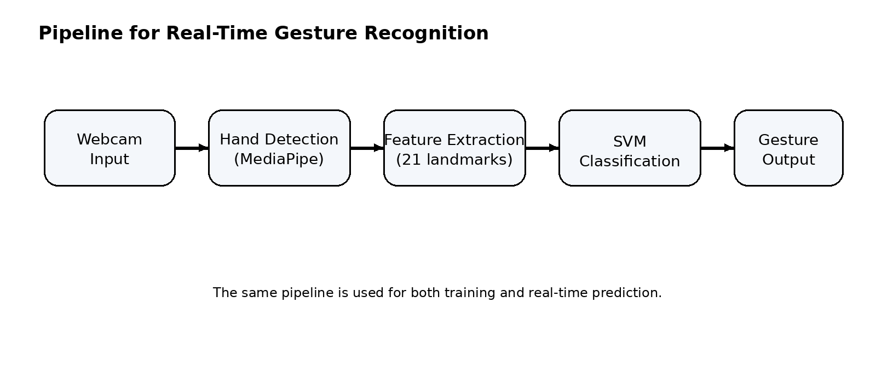
Figure 1: Overall pipeline for real-time hand gesture recognition.

2.3 Data Collection and Feature Extraction
For a small demonstration dataset, several sample frames are collected for each gesture class. During feature extraction, the hand landmark detector returns 21 points for a detected hand. Each point has x and y coordinates, and these values are flattened into a one-dimensional vector. This vector becomes the input for the classifier.
Table 1: Sample gesture classes used in the prototype.
S. No. | Gesture Class | Label | Purpose
1 | Fist | 0 | Closed-hand gesture
2 | Open Palm | 1 | Neutral open-hand gesture
3 | Thumbs Up | 2 | Positive gesture
2.4 Model Training and Prediction
Support Vector Machine is used because it works well on compact feature vectors and offers a clear decision boundary between classes. During training, the landmark vectors are paired with their labels. In the prediction stage, the same feature extraction process is applied to the live webcam feed and the trained model outputs the most likely class.
The implementation can be completed in Python using OpenCV for camera handling, MediaPipe for hand tracking, and scikit-learn for the SVM model. The design is lightweight enough for classroom-level demonstration and does not require a GPU.

2.5 Hardware and Software Requirements
Component | Specification / Tool
Programming Language | Python 3.x
Computer Vision Library | OpenCV
Hand Tracking Library | MediaPipe
Machine Learning Library | scikit-learn
Model | Support Vector Machine (SVM)

3. RESULT AND ANALYSIS
3.1 System Output
Thumbs Up
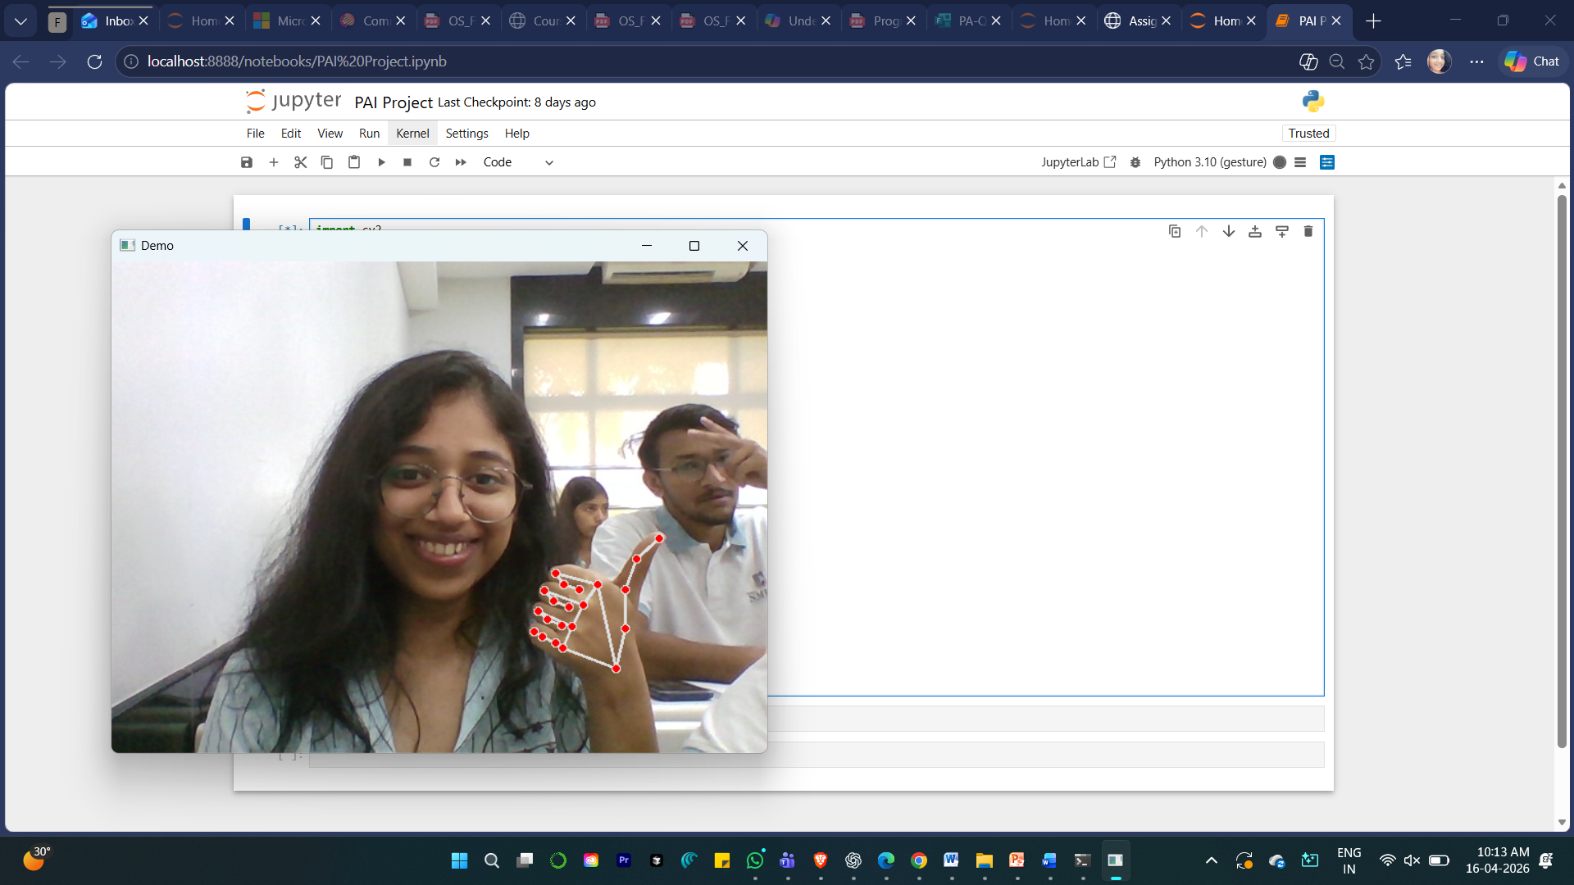
Victory Sign
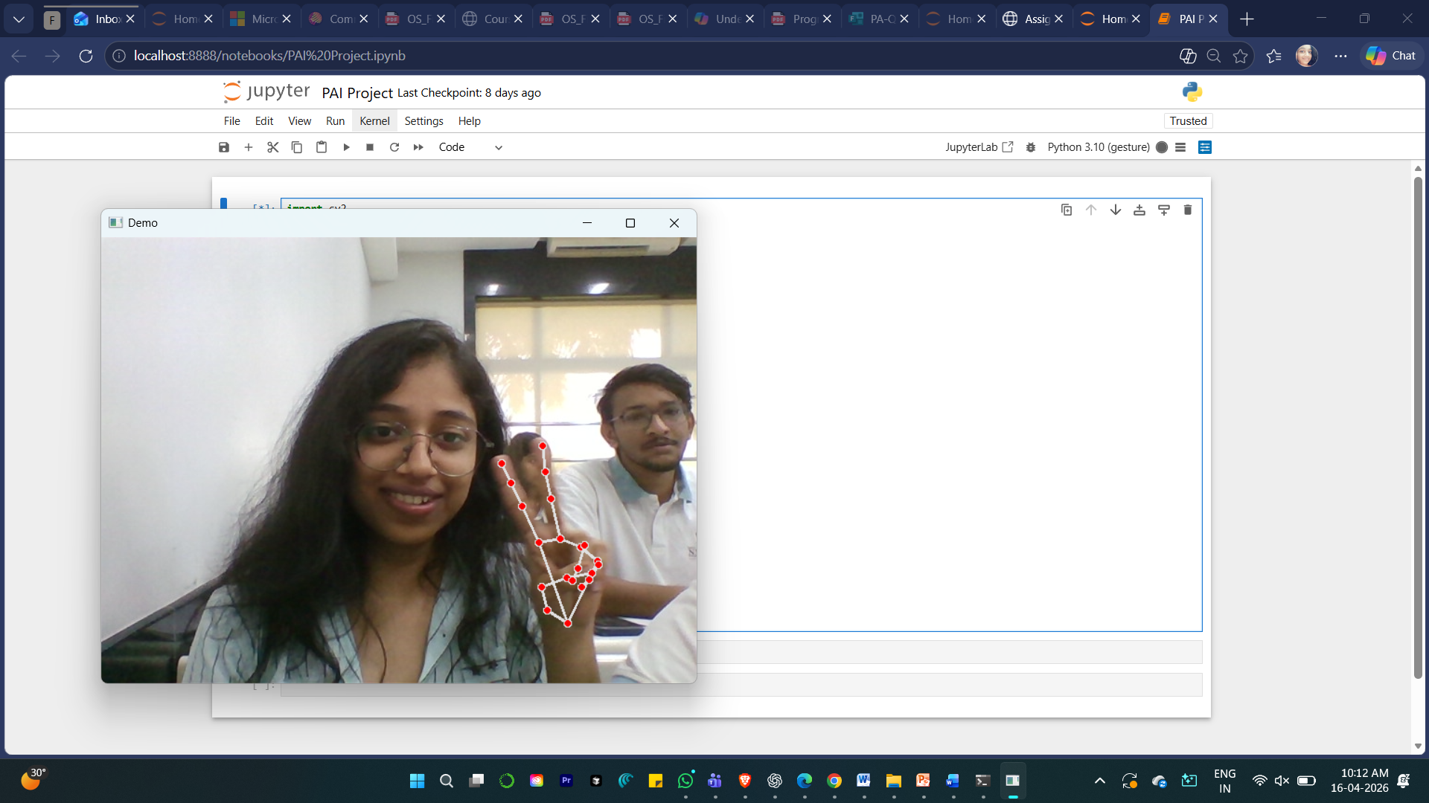

Open Palm
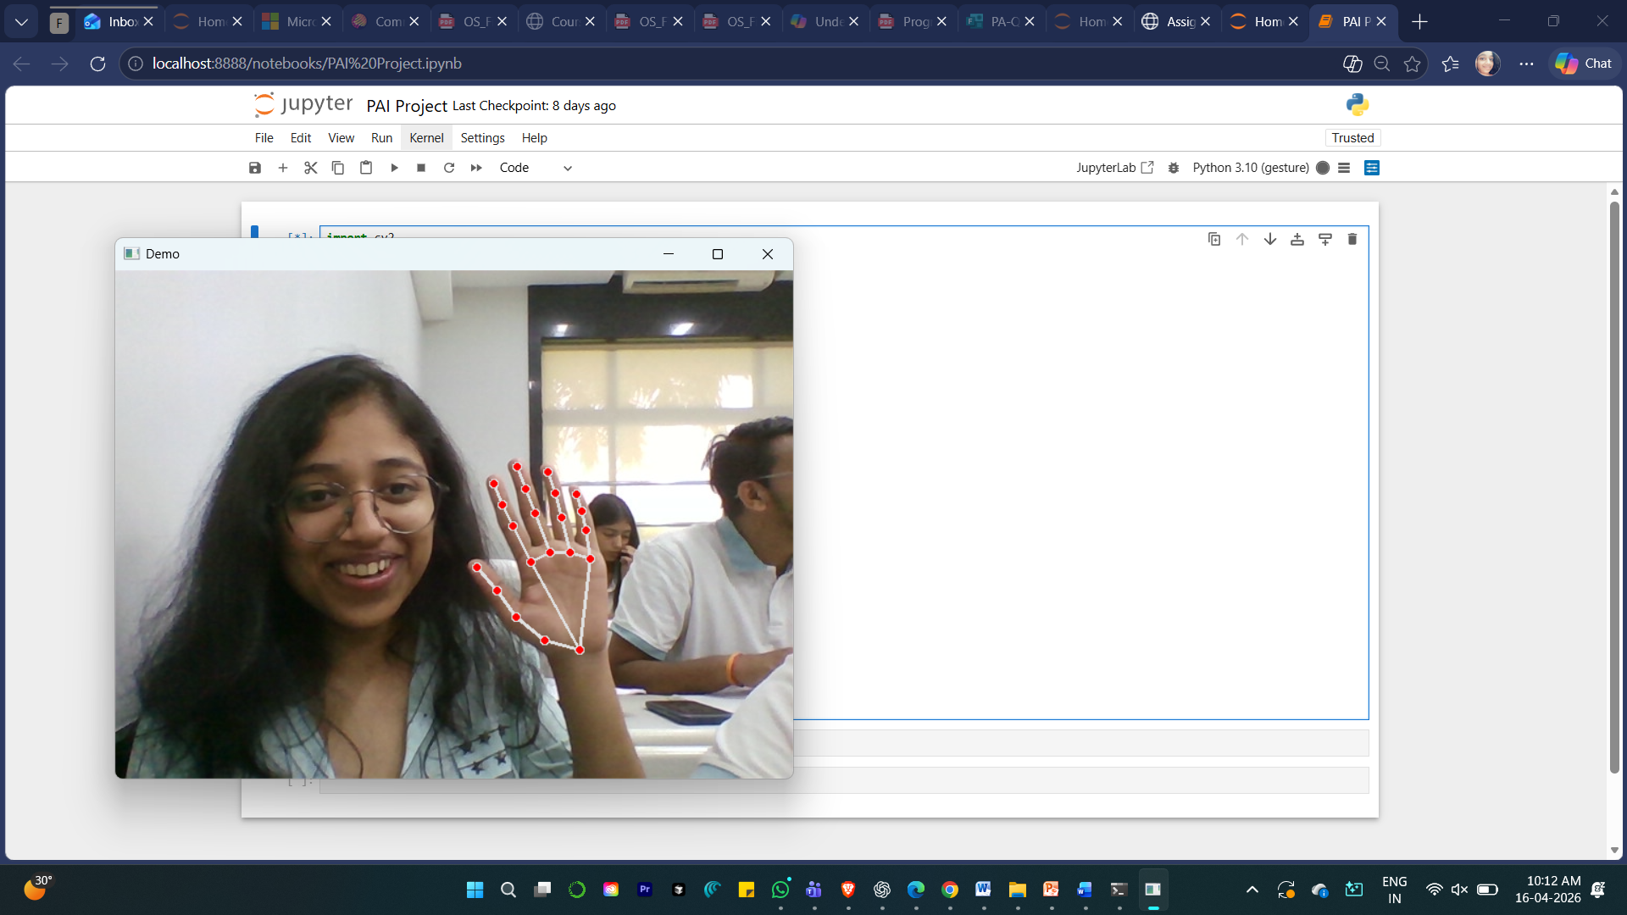
Fist Closed
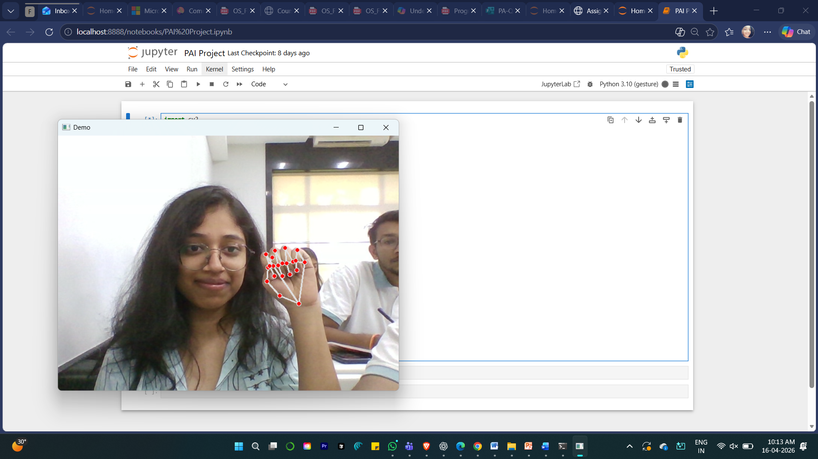

The prototype produces a visible landmark overlay on the hand whenever a hand is present in the camera frame. When the classifier is enabled, the recognized gesture name is displayed on the screen. This makes the output easy to verify during demonstration.
The system is intended for real-time interaction, so the output should appear with very small delay. Even with a limited gesture set, the pipeline clearly demonstrates how computer vision features can be used by a machine learning model.

3.2 Evaluation and Investigation

Table 2: Qualitative evaluation of the prototype output.

Test | Expected Output | Observation | Comment
1 | Hand landmarks visible | Landmark overlay appears | Detection is stable in good lighting.
2 | Gesture classified | Label shown on screen | Works best for a small set of gestures.
3 | Real-time response | Low delay during demo | Suitable for classroom presentation.

The analysis shows that the project is practical for demonstration purposes and clearly illustrates the role of feature extraction in AI-based classification. Performance depends on lighting, hand position, and the quality of the collected samples.

4. ADVANTAGE, LIMITATIONS AND APPLICATIONS

4.1 Advantages
- The system is contactless and easy to demonstrate.
- MediaPipe provides fast landmark detection.
- SVM is lightweight and suitable for small feature sets.
- The project combines both computer vision and machine learning in one pipeline.

4.2 Limitations
- Accuracy may reduce when lighting is poor.
- The prototype supports only a limited number of gestures.
- The system depends on a functioning camera and steady hand visibility.

4.3 Applications
- Gesture-controlled interfaces in smart systems.
- Accessibility tools for touch-free interaction.
- Learning demonstrations in AI and computer vision labs.
- Basic command input for games or interactive kiosks.

5. CONCLUSION AND FUTURE SCOPE

5.1 Conclusion
This project demonstrates a simple and effective method for hand gesture recognition using computer vision and SVM. By converting hand landmarks into features, the system avoids unnecessary image complexity and focuses on meaningful geometric information. The result is a clear and understandable AI application that can be shown in a live demonstration.

5.2 Future Scope
The project can be improved by adding more gestures, collecting a larger dataset, and comparing SVM with other classifiers such as Random Forest or neural networks. In the future, the same idea can be extended to gesture-based control for presentations, smart devices, and assistive interfaces.

6. REFERENCES
OpenCV Documentation - https://opencv.org/
MediaPipe Hands Solution Guide - https://developers.google.com/mediapipe
scikit-learn Documentation - https://scikit-learn.org/
Gesture recognition research articles on hand landmark based classification.

Appendix A: Sample code
The following sample code shows hand landmark detection using MediaPipe and OpenCV.
import cv2
import mediapipe as mp

mp_hands = mp.solutions.hands
hands = mp_hands.Hands()
mp_draw = mp.solutions.drawing_utils

cap = cv2.VideoCapture(0)

while True:
success, img = cap.read()
if not success:
break

imgRGB = cv2.cvtColor(img, cv2.COLOR_BGR2RGB)
results = hands.process(imgRGB)

if results.multi_hand_landmarks:
for handLms in results.multi_hand_landmarks:
mp_draw.draw_landmarks(img, handLms, mp_hands.HAND_CONNECTIONS)

cv2.imshow("Gesture Recognition", img)

if cv2.waitKey(1) & 0xFF == 27:
break

cap.release()
cv2.destroyAllWindows()

Appendix B: Datasheets
Sample data collection sheet for gesture samples.
Sample | Gesture | Label | Remarks
1 | Fist | 0 | Closed hand with stable landmark detection
2 | Open Palm | 1 | Visible fingers and wide hand pose
3 | Thumbs Up | 2 | Distinct positive gesture for demo
4 | Neutral | 3 | Optional class for extended dataset

