OPERATING SYSTEMS
WEEK-4 Practical
Name:- B.Bhavitha
Roll no:- 2520030120
Section no:- 9
4.Write a C program where a parent process creates multiple child processes and synchronizes their completion using wait() and waitpid(). Compare the behaviour of both functions.
Create a scenario where a child process becomes a zombie process. Investigate the process table and then modify the program to eliminate zombie processes using proper synchronization techniques.
Program:-
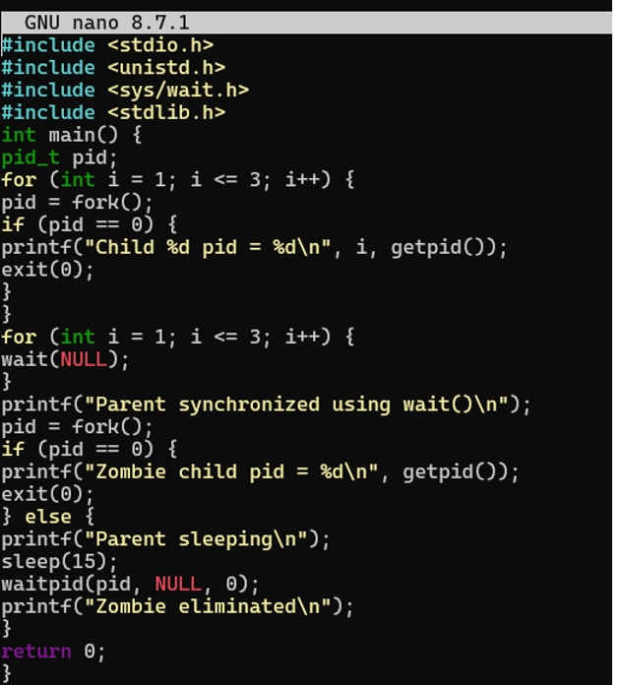
O

Output:- 